Accessible Mobile Devices Procurement Checklist Comment Form

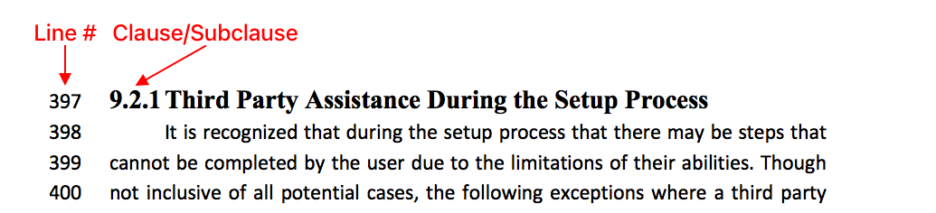Please email your completed comment form to [rd.info@neilsquire.ca](mailto:rd.info@neilsquire.ca) with "Accessible Procurement of Mobile Devices – Comments" in the subject line.

For each comment in the table below, please include the line number and clause/subclause your comment is referring to. The line number can be found in the left margin of the document. The clause/subclause number appears before each section title.

# Commenter Information

Full Name:

Affiliation:

Email:

# Comments Table

| Line # | Clause/Subclause | Comment (Justification for change) | Proposed Change |
| --- | --- | --- | --- |
|  |  |  |  |
|  |  |  |  |
|  |  |  |  |
|  |  |  |  |
|  |  |  |  |
|  |  |  |  |
|  |  |  |  |