Current Status of Next Generation 911 Services: An Accessibility Perspective for People With Disabilities

Copyrighted: © Neil Squire Society
March 2021

Table of Contents
Introduction 6
Definitions 6
Overview of Type of Emergency Services 10
General Services 10
Voice Communication 10
Short Messaging Service (SMS) 11
Multimedia Messaging Service (MMS) 13
Pre-defined SMS messages from an App 14
Real Time Text (RTT) 15
Live Video Stream 18
Icon Based Apps 22
Multimodal Emergency Contact Platforms (Total Conversation) 23
Disability Specific Services 25
Other Third-Party Accessibility Apps 25
Text Relay & Captioned Telephone 26
Video Relay Service 27
Speech to Speech Relay 29
Community-Based Initiatives 30
Other services 33
Facsimile (Fax) 33
North America (Canada and the United States) Status 36
Regulatory Framework in the United States 38
American Disabilities Act (ADA) 38
Next Generation 911 Advancement Act of 2012 38
Telecommunications Act 39
21st Century Communications & Video Accessibility Act (CVAA) 40
Regulatory Framework in Canada 40
Regulatory Environment 40
UN Convention on the Right of Persons with Disabilities 41
Differences Compared to the United States 41
Prevailing Standards 43
National Emergency Number Assocation (NENA) i3 43
NENA i3 Implementation in Canada 45
Services Available to Everyone 47
Voice Calls 47
Global Positioning System (GPS) or Trilateration Capability 51
Short Message Service (SMS) or Text to 911 51
MMS to 911 54
Real-Time Text 55
Multimodal Emergency Contact Platforms (Total Conversation) 57
Live Streaming of Video 58
Services for People with Disabilities 61
T911 – Canadian-Specific Text to 911 Services 61
Video Relay Services 61
Speech-to-Speech Relay 64
Third Party Apps 65
Europe (European Union) 67
Regulatory Environment 67
Prevailing Standards 69
Regional Differences 70
Relay Services 70
SMS to 112 71
Current Services (Deployed or Being Considered) 73
Not Disability Specific 73
Disability Specific Accommodations 76
Other Services Under Study 84
EMYNOS (Next Generation Emergency Communications) 84
Non-Voice Emergency Services (NOVES) 85
REACH 112 85
Asia Pacific Region 86
Regulatory Environment 87
East Asia 87
South Asia 87
Pacific Nations 89
Prevailing Standards 89
Regional Differences 90
Current Services (Deployed or Being Considered) 91
Voice 91
Email 92
Applications (Apps) 93
Disability Specific Accommodations 94
SMS or Text Messaging 94
Other Services Under Study 97
Analysis and Discussion 97
Voice call 97
SMS or Text to 911 98
MMS to 911 100
Real Time Texting 101
Video Relay Services 104
Speech-to-Speech Relay 105
Total Conversation 106
Third Party App Compatibility 108
Live Video Streams 111
Facsimile (Fax) 112
Community-Based Initiatives 113
Social Media PSAP Integration 114
Icon & Pictogram-Based Apps 115
Service Ranking Survey 117
Appendices 120
Appendix A.1 User Making Video Call From 119 App 120
Appendix A.2 Requesting Help from India 112 Website 121
Appendix E.1: Callers & Call Takers Using Carbyne 122
Appendix E.2: CELESTE demo applications 126
Appendix E.3 EU Standards for Key Emergency Services 127
Appendix NA.1 Third-Party Apps 130
AT&T Real Time Text App 130
Ideal Group Speech2RTT® Communicator 131
Rave Mobile Safety 132
Show Me for Emergencies App 136
Emergency Call App 138
Here I Am App 139
Beam Messenger/BeamCall (Abandoned) 140
Slatch 142

Introduction
Next Generation 911 (NG911) refers to an initiative aimed at updating the 911 service infrastructure in Canada and the United States to improve public emergency communications services. In addition to calling 911 from a phone, it intends to enable the public to transmit text, images and video to a 911 Public Safety Answering Point (PSAP), emergency call centre.
This migration to new services is facilitated by the move from simple analog methods of telecommunication and traditional phone lines to digital-based (Internet Protocol or IP) methods of telecommunications within North American. This migration is not solely isolated to North America; it is also happening in Europe, Asia and other geographic regions.
This document is intended to present the current thinking about how to address the needs of people with disabilities as new Next Generation 911 services (NG911) are designed and deployed. Each region and in some case a country or countries within a region are at different stages of the migration process. The objective of this paper is to capture the practices from jurisdictions around the world as it applies to people with disabilities. The infrastructure is discussed at a very high functional level. This document is not intended to provide an in-depth view of the underlying technology of the network capabilities of a particular service or the specific technical capabilities of the communications device the user is using to contact emergency services. Note that this document is intended to cover the topic of contacting emergency services only. The topic of emergency alerts is equally important but is not the focus of this paper.

Definitions
Canadian Radio-Television and Telecommunication Commission (CRTC): A Canadian regulatory body in charge of handling broadcast television and telecommunication related issues, which includes emergency services and alerts. The CRTC can issue directives for industries to follow, but it does not have direct enforcement abilities.
Emergency Response Organization (ERO): An organization that handles specific types of emergencies, e.g. the police, fire and rescue, emergency medical services, coast guard, etc.
Emergency Services IP Network (ESInet): “An IP network that is used for communications between emergency services, and which can be shared by all public safety agencies. It provides the IP transport infrastructure which independent application platforms and core functional processes can be deployed. This includes, but is not restricted to, those necessary for providing NG9-1-1 services. ESInets may be constructed from a mix of dedicated and shared facilities and may be interconnected at local, regional, state, federal, national and international levels to form an IP-based inter-network (network of networks). ”
ERO emergency number: A country or regionally assigned phone number used to contact a specific emergency service. For example, in addition to the national emergency number, there is another phone number just for police (See Asia-Pacific Region).
Federal Communications Commission (FCC): An American regulatory body that is in charge of handling broadcast television and telecommunication related issues. In addition to managing regulation created by the government, they are able to make rules and polices for the industry to implement. They have enforcement authority with the ability to levy fines in cases where the rules are violated. (http://www.fcc.gov)
General emergency number: A phone number that citizens can call for any type of emergency (e.g. 112, 911).
General emergency number PSAP: An organization that is in charge of handling all types of emergency calls. Its responsibilities and tasks may differ from one country to another.
Global Positioning System (GPS): A navigation system that uses satellites, a receiver, and algorithms to synchronize location, velocity, and time data for air, sea, and land travel.
Multimedia Messaging Service (MMS): A standard way to send messages that include multimedia content to and from a mobile phone over a cellular network. MMS can deliver a variety of media, including up to forty seconds of video, one image, a slideshow of multiple images, or audio
Next Generation 911 (NG911): A secure, IP-based, open-standards system comprised of hardware, software, data, and operational policies.
Public Safety Answering Point (PSAP): An organization under the responsibility of a public authority or a private organization under public mandate in charge of first reception of emergency calls.
Real Time Texting (RTT): A text-based mode of communication where each text character appears on the receiving device at roughly the same time it is typed. With RTT, a person on a call does not need to press “send” for the text to reach the other party.
Relay service: A telecommunications service that relies on a user communicating with a human operator through alternative modes of communication (e.g. text, sign, speech) in order to converse with a recipient.
Short Message Service (SMS): A service that allows for short text messages limited to 160 characters to be sent from one cell phone to another or from the internet to a cell phone.

Overview of Type of Emergency Services
This section gives an overview of the ways there are to contact emergency services. While there may be regional differences in the way the services are implemented and what the end user may see on their mobile device or landline phone, the overall concepts of the services are similar in nature.

General Services

Voice Communication
Making a phone call is still the most common way to reach emergency services. In just about every country in the world, region-specific and national emergency numbers can be called free of charge. In Canada, USA, and the EU, all urban regions have enhanced 911/112 services, which transmit the emergency caller’s location. This makes it easier for callers to get timely help.
For people with disabilities, devices for making phone calls, such as textphones (TTY) and text/video relays, are limited, outdated, slow, and not portable. Luckily, technology has become much more capable over the past decade and solutions now exist to allow for more ways to communicate.

Advantages
- Most supported and reliable way of contacting emergency services
- Emergency calls can be made for free even without an active mobile plan in some countries
- Most users are familiar and comfortable with this style of communications
- Enhanced emergency services standards provide facilities for emergency operators to get geo-location data in addition to the voice communication channel with a valid mobile plan
- Many countries have a wide array of language translators for this service unlike other contact methods

Potential Disadvantages
- Not everyone can use this form of communication. People who have hearing and speech related issues may not be able to use this
- Not effective in emergency situations where silent communication is needed (e.g. active shooting and hostage incident)

Short Messaging Service (SMS)
SMS or text messaging allows people to send short messages limited to 160 characters. Text-to-911/112 is implemented in some countries as a transitional method of communicating with emergency services until modern IP-based text messaging technology, such as RTT and RCS, become more popular.
For many countries, this feature is restricted to those with hearing impairments and who have registered their mobile phone with their local or national Text-to-911/112 service.
Depending on the country’s implementation, these calls may be handled by a text to speech relay, which then calls the emergency operator, or they are handled by the emergency operator directly.
Since SMS to emergency services are currently country-specific, travellers need to register their mobile number with local authorities, which can be as simple as sending an SMS message, filling a web form, or as onerous as creating an account with a national electronic ID. Registration may take one to three business days so this has to be done in advance.
Note: SMS and Multimedia Message Service (MMS) messages are routed through a SMS/MMS gateway whereas Real Time Texting (RTT) messages use a voice gateway. If the voice gateway goes down, SMS/MMS messages are not affected.

Advantages
- SMS is a widely adopted communication method and most people know how to use it
- SMS is available on all cell phones and requires no extra software
- Can be used to identify the caller’s location (with AML) if available
- Low-cost solution
- Uses an SMS/MMS gateway instead of a voice gateway
- Contacting emergency services via SMS does not require talking, which can be beneficial in hostage situations where speaking can put theirs and others lives in more danger

Potential Disadvantages
- SMS messages are transmitted over cellular networks. If the user’s cell phone cannot connect to a cellular network, SMS is unavailable. This requires a mobile texting plan (not the same as a data plan).
- Travellers need to get a local SIM card as sending an SMS to an emergency operator with international roaming or no mobile plan does not currently work.
- SMS messages may not be delivered or delivered in time. This means the order of messages may be incorrect, thus changing the meaning of the conversation and potentially resulting in the wrong emergency services being dispatched.
- Text only communication conveys less information. Emergency operators cannot get clues from the sounds of breathing, tone of voice, and background noises.
- Typing on an on-screen keyboard can be slower for some people and requires their messages to be concise.
- Call duration for SMS is longer than total conversation and voice-only calls so more PSAPs may be required if call volumes are high.
- Some people with disabilities do not use written language as a means of communication so their use of SMS as a means of communication is very limited
- SMS and MMS services are ‘best effort’ type services. That means that in the event of network congestion, the messages will be delayed, and in some cases without an available destination could be held for hours or days before being delivered.

Multimedia Messaging Service (MMS)
MMS is an extension of the legacy SMS protocol that allows users to send text messages. It can include multimedia content such as audio, images, video, and phone contacts. Both SMS and MMS can be used to contact emergency services, though not all PSAPs support it. Below are some differences of MMS compared to SMS.
- Can include multimedia content such as audio, video, and phone contacts versus SMS, which contains only text. Pictures or videos can provide the emergency operator with more context of the situation.
- Messages can be sent over a mobile data plan or a wireless Internet connection depending on the wireless service providers’ protocols. A mobile data plan is a connection to the Internet over a cellular network.
- Messages have a maximum size of 600KB, but wireless carriers can impose their own size restrictions.
- If the recipient cannot accept MMS messages, there is an SMS fall-back message so your message will always get through.
MMS notifications are still SMS messages, but instead of containing the actual message, it is a link to a “webpage” containing the MMS message. The app automatically displays the contents of the link. If the recipient cannot accept MMS messages, the recipient can open the link in the SMS message to view the content in their web browser. This means the problems with delayed and out-of-order message delivery can still occur.

Advantages
- Not a means of contacting an emergency operator by itself
- Can provide more information than other forms of communications to an emergency number operator

Potential Disadvantages
- SMS and MMS services are ‘best effort’ type services. That means that in the event of network congestion, the messages will be delayed, and in some cases without an available destination could be held for hours or days before being delivered.

Pre-defined SMS messages from an App
There are also third-party applications (Apps) that are designed to simplify the process of dealing with emergency situations.
One example is an app that keeps a list of emergency numbers by country and is designed to contact the correct number for an emergency service if the user is travelling outside their home country. This is useful because emergency numbers often differ between countries or regions. In addition, these apps allow users to specify their preferred method of contacting emergency services such as by SMS or voice to help work around disabilities.
There are also apps that will send a pre-defined SMS text message to pre-defined contacts with the press of a button. After the contact receives the message, it is up to them to determine whether to call emergency services. The use of pre-configured messages or pictograms is an alternative solution to allow people who are unable to write well or quickly to still communicate to some degree.

Advantages
- Pre-defined contacts and messages save time
- No need to remember region-specific emergency and non-emergency numbers (international embassy for lost passport)
- Beneficial to people with low literacy skills in the regional language or with cognitive related issues

Potential Disadvantages
- Limited vocabulary, it only covers the situations that have been pre-defined
- No way for the emergency operator to ask for additional information if the location of the caller is not well defined or to make a better assessment of the situation.
- Usable only for emergency or assistance, not for other communications (thus not widespread)

Real Time Text (RTT)
Real-time text is a replacement protocol for TTY. TTY was introduced in the 1960s and is now considered to be outdated, slow, and limited. Some of its limitations include: requiring the TTY device to be hooked up to a landline phone, not working reliably over IP networks, having to take turns typing replies and responses, and only being able to use American English characters.
RTT is a text messaging protocol that works on all new mobile devices, is designed to work over IP networks, and allows text messages to be transmitted right as they are typed. This allows recipients to immediately read the message as it is being written and interrupt as needed, thus speeding up the conversation and clarifying misunderstandings quicker. Conversations can happen in any language as the protocol supports Unicode, which has a large symbol set which can represent many languages. This protocol is an extension of voice calls and aims to make voice calls accessible.
To address interoperability concerns with RTT and TTY, some workarounds are devised. TTY has a single data channel so RTT apps need to switch between transmitting voice audio and text audio data. If the TTY and RTT users are typing simultaneously, the RTT characters need to be stored until the TTY user is given a turn, or they have to take turns sending messages . RTT to TTY connections do not work in all use cases. These issues need to resolved before emergency call centres can retire TTY equipment. An RTT-to-RTT terminal connection is more reliable currently.
RTT uses call minutes, just like a voice calls, so the user needs a voice plan. RTT can be used to meet the needs of people with hearing, vision, speech, and cognitive impairments. For people who are blind, text can be outputted to the Braille keyboard or to speech. Those who have mild cognitive impairment can take their time to read and re-read messages.
RTT is new technology that is still being deployed and adopted and has some hurdles to still overcome. Many vendors are still adding RTT support to their systems, not everyone has upgraded to mobile devices that have RTT, RTT is not enabled by default, and most PSAPs cannot accept native RTT messages. PSAPs need to adopt proprietary technology such as the nWise MMX RTT gateway to support calls with RTT or use a vendor that supports a web-based implementation (none exist currently).
RTT has been built into mobile devices since iOS 11.2 (Dec 2, 2017) and Android 9 (Aug 6, 2018). After enabling RTT and inputting the relay number in the phone settings App, iOS and Android users can initiate an RTT call just like any other call. The only difference is that after pressing the call button, there are three options shown: Call, RTT Call, or RTT Relay Call. A “Call” refers to a one party using voice in the conversation. An “RTT Call” allows both caller and recipient to send text messages directly to each other. In an “RTT Relay Call” the caller sends text messages to a relay operator who then talks to the recipient and relays responses back to the caller as text messages. When the other party picks up, a chat window appears where text messages can be typed. The microphone is enabled in the call, which is useful for a text relay operator to transcribe voice to text. In an emergency situation, the intention is that the caller will send text messages directly to the emergency operator.
Note: There is no equivalent functionality of a voice mail mailbox for RTT. If the other party does not answer the call, there is no way to leave an RTT text message.
Note: Some deaf-blind users prefer to sign but receive responses as real-time text.
Note: RTT for iOS is only available for plans from carriers in the United States. Users get charged at standard voice call rates.

Advantages
- Natively available in most modern smartphones
- Faster communication than traditional line-by-line text conversations
- Allows participants to interrupt to fix misunderstandings quicker

Potential Disadvantages
- RTT is not enabled by default in iOS and Android
- Conveys less information than other communication methods
- Limited adoption of the technology outside of disabled communities
- Still being adopted by disability community as SMS is more familiar
- No automated voice to text transcriber so a text relay is needed for those with severe hearing impairments

Live Video Stream
When making an emergency call, callers are often disoriented and under stress. This makes it difficult for emergency operators to locate the caller and assess the severity of the situation. A person’s level of distress makes it hard to determine the severity of the emergency. Currently, locating mobile phone callers is more difficult than land line phones as emergency operators cannot rely on the traditional Automatic Location Information (ALI) database lookup to find the phone subscriber’s registered location. Traditional landlines have a physical address associated with it.
When asking the caller where they are, the caller may have incomplete location information. For example, they may not know the building address, only the street they are at, or they can only describe landmarks.
One PSAP received a 911 call from a lady who was in a narrow alley of a strip mall between two businesses. The front of the alley was covered up to disguise it. The lady was unable to explain where she was at. In this situation, it would be easier for her to show her surroundings than tell where she was at.
Most mobile phones have GPS capabilities, which can provide location accuracy of up to 4.9 meters in ideal conditions . However, when indoors, where walls reflect the signal, the accuracy is not enough to be useful. The cell tower location the call came from can also be used to locate the caller as a last resort, but the coverage radius can be many kilometers away and perhaps in a different municipality .
In addition, it is often hard for untrained people to assess an emergency situation, whether it is a medical emergency, fire emergency or police emergency. They may also miss out on reporting pertinent information such as the number of victims, injuries, and scene hazards.
A 20-year-old man called 911 and saying his hip hurt and he was losing his mind from the pain. Based on the caller’s voice, it seemed like he had a compound fracture with blood spilling out. However, in reality, it was just a really bad bruise. With video, the call taker will be able to determine if there was actually a fracture by looking for deformities.
Sometimes emergency callers are unable to speak or articulate the problem due to a speech or cognitive disability, choking, a hostage situation, or language barriers.
One PSAP received a call where there was only an occasional cough or moan. The PSAP thinks the caller may be choking. In this case after a minute or so, the caller was able to say they do not speak English. Having video will help verify the nature of the emergency.
In these cases, having access to live video streamed from the caller's phone can help the emergency operators locate the incident, identify injuries and hazards, dispatch the appropriate first responder units, guide the caller into providing initial aid until help arrives, and give directions for major incidents until an incident commander arrives.
Most emergency call platforms allow callers to communicate with emergency operators using voice, video, and text without a pre-installed app. Upon calling 911, the caller will receive an SMS with a link. This link launches a website that allows the emergency operator to access the mobile device camera and microphone as well as allowing for text messaging. The video live stream is typically one-way where the emergency operator is not visible to the caller.
The choice to make the video stream one way takes load off the wireless network by reducing the amount of traffic for the video. This is also preferred by the emergency operators who are typically trying to digest a large amount of information from the caller, and potentially many different first responders simultaneously.
For people with disabilities, this may have added benefits. As interior maps of public spaces (buildings) become available in an emergency situation, it may be possible to guide a person with a vision impairment to a place of emergency refuge. It would also be possible for an emergency operator to assess a situation if a person with cognitive related issues cannot explain the situation.

Advantages
- Allows PWDs to more easily report incidents
- Video gives more clues to figure out the caller’s location rather than just verbal descriptions
- Video immerses emergency operators into the scene to more accurately assess the situation themselves
- Less time spent asking what is happening and more time spent defusing the situation and dispatching services

Potential Disadvantages
- Not all areas have a strong enough mobile signal to sustain video streams
- Streaming video can drain batteries quicker

Icon Based Apps
Not all emergency service-related Apps and services come pre-installed on phones. There are still many third-party Apps that are designed for specific target audiences. Icons are often used in these Apps to address specific regional and disability related issues. For example, Apps designed to support an international audience might use icons for police, fire, and ambulance in place of text in multiple languages.
Different regions have different phone numbers and protocols for accessing emergency services. While some regions have one central number (911 North America, and 112 Europe) for emergency services, other regions still maintain separate phone numbers for police, fire, ambulance, coast guard, and poison control.
Similarly, callers with cognitive related issues may find text difficult to understand. Icons can reduce the cognitive load on these callers and make the process easier to understand and utilize. There is still no internationally recognized and accepted set of iconographies for specific services. There may also be regional differences, similar to regional colloquial expressions, that need to be dealt with.

Advantages
- Language independent
- Reduced cognitive load with people who have cognitive related issues

Potential Disadvantages
- Can only deal with pre-defined situations
- Can convey only limited information
- Difficult to create universally recognized and accepted icons for specific situations (e.g. What is the symbol for poison control?)

Multimodal Emergency Contact Platforms (Total Conversation)
Total conversation is a concept where video, voice, and text can be used simultaneously in telecommunications to enable universal access to communication services. This allows people with disabilities to still contact emergency services. While all three methods must be available to contact an emergency service operator the user has the option to use one, two or all three methods.
Some technologies that make this possible are voice communication, text messaging services (SMS/MMS/RTT), relay services (text/video/speech), and disaster alert systems (SMS/siren/TV/radio/phone/email/web).
Vendors in the European Union (EU) need to adopt this as part of the EU Accessibility Act by 2025 to ensure everyone can communicate with emergency services and to allow emergency services across member countries to interoperate. There were trials of an American variant of this service in Illinois, but there are currently no regulations that require this in the United States or Canada. This service currently does not exist in Asia-Pacific countries.

Advantages
- Enables greater access to emergency services to work around disabilities
- Can benefit everyone as a way to enhance voice-only calls
- Enables new forms of communication with emergency services (video, text, sign-language, lip reading, etc.)
- Very conversational with the ability to interrupt
- Gives PSAP call-takers more information to make accurate assessments to dispatch the appropriate first responder units quickly
- Developed by deaf community and not by 112 emergency services I Europe
- Standardised, fast, and mobile service

Potential Disadvantages
- Emergency service platforms need software and infrastructure upgrades to support standards for the exchange of audio, video, real-time text, and other data (refer to ETSI TS 103 479)
- Need to train staff on new software, procedures, and how to communicate with callers with various disabilities
- PSAP call-takers need to cope with and filter more information in calls
- Total conversation calls take more time to handle than voice-only calls so more PSAP call-takers are needed in busy call centres
- Need PSAP call-takers who knows sign-language to implement Total Conversation (or use a platform that can invite relay operators into the call)

Disability Specific Services

Other Third-Party Accessibility Apps
Accessible smartphone apps for specific emergency communications that take into account the needs of persons with disabilities have been released. These apps can be easily downloaded by end-users and require account registration in most cases. Unfortunately, they usually only work in specific areas and tend to use proprietary technologies.
These Apps may use simple vocabulary to ensure the reader understands labels quickly and easily and to support users with mild cognitive impairments. Icons for specific actions may be replaced with pictures that are more familiar with the user to support people with higher levels of cognitive impairment.
An app designed for people with vision related issues could be used to integrate all of the most common actions in one app to reduce the amount of time flipping between apps and menus on the phone to make the process more efficient.

Advantages
- More conversational, may include audio, text, and video communication. This may enable several means of communication (text, sign language, lip-reading, etc.)
- Users are familiar with App services
- Many Apps are developed in cooperation with emergency services to meet the needs of citizens with specific disabilities.

Potential Disadvantages
- Usable only for contacting emergency services, not for other communications (thus not widespread)
- Most apps can be only used regionally or nationally, meaning that people would need to download several apps in case of travelling.

Text Relay & Captioned Telephone
Text relay services allow people who are hearing or speech impaired to communicate with others through a captioned telephone, a toll-free number, an IP relay website, or an IP relay mobile app. The interpreter transcribes voice calls to text and vice versa.
A captioned telephone is a special phone that has a bigger screen to show the captions, but otherwise looks and acts like any other traditional phone.
All calls go through a captioning service, where the operators or the operators using speech recognition technology transcribe everything the other person says into captions that appear on the captioned phone display. The user can hear the other person with whatever hearing ability they have and at the same time, read the captions to confirm what was said.
Captioned telephones appeal to those who have difficulty hearing but would not call themselves deaf or someone who needs hearing aids. Traditional solutions for the deaf, such as TTY equipment, is too extreme for this group. Studies have shown the importance of staying socially connected, especially as we age, but people with hearing loss tend to avoid using phones as they need to ask a hearing friend or relative to assist them. This technology can make people more confident in following phone conversations, knowing they will catch every word.
“SignVideo means I don’t have to bother hearing people to make telephone calls for me anymore. I can make all the calls I want myself, to my GP, or even to the cinema. I feel much more relaxed.” J.H. – Direct Payment customer, Surrey

Advantages
- Can ensure equal communication access to the telephone service for people who are deaf, deaf-blind, hard of hearing, or speech disabled
- Services can be made accessible without geographic limits, tailored to the needs of specific groups of users with disabilities

Potential Disadvantages
- Requires a developed infrastructure for service provision, including well-trained relay operators
- It is not possible to identify the exact location of a caller using an Internet service (IP relay service)
- Automated speech recognition technology may make transcription mistakes, which a person has to fix, potentially breaking the conversation flow
- Deaf callers do not know who is talking in a group conversation. Some solutions can automatically detect a new voice, male voice, or female voice, but does not identify who it is. A human interpreter can help in this .

Video Relay Service
Video relay services (VRS) enable people with hearing disabilities who use sign language to communicate with others and people with speech disabilities that needs Communications Specialist to be understood in a voice call.
To use the service, the sign language user connects to a VRS operator using Internet-based videoconferencing. The operator then places a voice telephone call to the other party and relays the conversation from sign language to voice and vice-versa.
People with speech disabilities call the relay operator using the 117 phone number or place a video call. A communications specialist, who is trained to understand distorted speech, will speak to the call recipient on their behalf. These services are usually provided for free by the government or health insurance to everyone with hearing or speech impairments. These services require the installation of an App that is available for PC, phones, and tablets.

Advantages
- Ensure equal communication access to the telephone service for people who are deaf, deaf-blind, hard of hearing, or speech disabled
- Enabling sign language users to communicate in their native language
- Vastly increased communication speed
- Enhanced communication with the use non-verbal cues such as facial expression and body language
- Removed communication barriers for slow typists and/or exclusive ASL users
- Ability to make interruptions to fix misunderstandings quickly
- Providing functional equivalency of making phone calls
- Relay service Apps can get the caller’s location using Wireless Location Information (WLI) if location capabilities are granted

Potential Disadvantages
- PSAP may not be able to see and hear the video relay caller’s video feed so they have to rely on the relay operator’s verbal descriptions and assume it is correctly interpreted
- Use of a relay service can introduce a time delay on the delivery of the question and/or the response
- Requires a developed infrastructure for service provision, including well-trained relay operators
- Speech recognition technology and the interpreter may not understand and accurately transcribe technical words resulting in an inaccurate transcription, which may cause misunderstandings
- Relay services may incur costs (e.g. sign language interpreters for video relay)
- These services may not always available around the clock, which is especially crucial in relation to emergency services

Speech to Speech Relay
Speech to Speech (STS) relay is a telecommunications service that enables people with speech disabilities to make telephone calls using their own voice (or an assistive voice device).
When making a call, a Communications Assistant (CA) will interpret the caller’s slurred, stuttered, or pictogram speech and speak to the other party on the call and vice-versa. This makes the caller’s words clear and understandable for everyone.
CAs are specifically trained in understanding a variety of speech disorders caused by life-long disabilities such as cerebral palsy, autism spectrum disorder, and Down syndrome, or acquired disabilities such as traumatic brain injury, aphasia after a stroke, and dementia.
Below is a video demonstrating the concepts:
Speech-to-Speech and Visually Assisted Speech-to-Speech Training Video

Advantages:
- Provides access to callers with distorted or slurred speech

Potential Disadvantages:
- Not globally deployed. It is available in the United States and some European countries like Sweden
- Requires trained speech interpreters
- Requires a new infrastructure if not already established

Community-Based Initiatives
Community-based initiatives are a form of volunteer-centric emergency service in which vetted members of the public, with the help of EMS and healthcare professionals, provide life-saving services. These services include practicing cardiopulmonary resuscitation (CPR) or using an automated external defibrillator (AED). Volunteer first respondents are required to sign up for an App that can alert them when crises are happening nearby. This auxiliary method of EMS is seen in Southeast Asia in countries such as Singapore and India.
The purpose of using methods such as this can vary. In Singapore, there is an existing national effort to improve the survival rate of out-of-hospital cardiac arrests (OHCA). This effort includes an initiative established by the Singapore Heart Association and the Singapore Civil Defense Force called Save-A-Life that aims to educate the public on how to perform CPR and use AEDs. Apps like this may cause concern for civilians worried about legal repercussions in case more harm is done. In this case, countries should refer to their Good Samaritan law equivalency. Singapore protects those who “[act] out of necessity, and with the care that can reasonably be expected of a person having his skill and experience.”
India’s Good Samaritan Law was passed and adopted by the Ministry of Road Transport and Highways to combat casualties caused by motor vehicle accidents due to the high volume of deaths resulting from injuries that could have been treated by bystanders. India currently features several examples of community-based initiatives. An example is a non-profit organization called ALERT, whose mission is to “create a community of responsible and responsive Good Samaritans, by ensuring the knowledge of First response is accessible to everyone by making it a practical, comprehensive, hands-on, and easily understood pedagogy.”
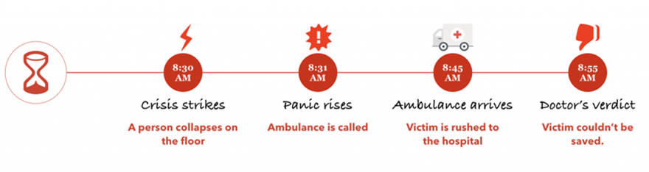
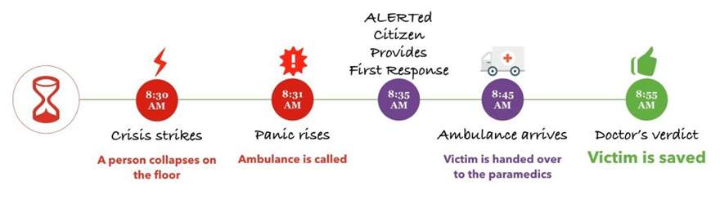
Figure 1: Screenshots about ALERT process solution

Advantages
- Increases public health knowledge, especially in rural communities without access to sufficient healthcare.
- Low-cost solution for the government and can be coupled with government initiatives to improve lifestyle in communities.
- Allows for fast application of first aid and minor disaster prevention methods, especially in locations where regular emergency services are scarce, expensive, or crowded.
- Increases likelihood of victim survival when safety measures are correctly applied in a timely fashion by trained civilian. (See reduced death rate of OHCAs in Singapore.)
- Prevents risk of disability (such as brain damage) in cases of cardiac arrest

Potential Disadvantages
- Creating training programs to vet users may be costly upfront.
- Lack of legislature in place in some countries may prevent users from wanting to participate out of fear that they will be held legally responsible in case of failure to neutralize situation.
- Civilians, while trained in basic first aid, are less effective than trained medical and emergency professionals on their own.

Other services

Facsimile (Fax)
In some countries, fax is a traditional way of contacting emergency services that is still supported. It is typically a one-way form of communication, so the information conveyed is limited and slow. Like TTY, it is slowly being phased out. It has typically been a contact method used in specific European states. In practice, deaf and hard of hearing citizens are provided with A4 sheets to be faxed in case of an emergency.
Sri Lanka previously used fax as part of their emergency communications system. An Economic and Social Commission for Asia and the Pacific (ESCAP) report found that using fax was a low-income solution, ten times lower than the use of a satellite phone.
Fax was still in use by the DMC as of 2015, but it has since been recommended that the Sri Lankan government push for newer technological methods of communication, preferably a people-centric multi-hazard method of emergency warning system.
One example of this switch was in 2017 where the Sri Lanka Disaster Management Centre alerted the public of elevated water threats via mobile SMS messages. SMS was much quicker to send and receive and 25 million Sri Lankans had mobile phones that can receive these messages.
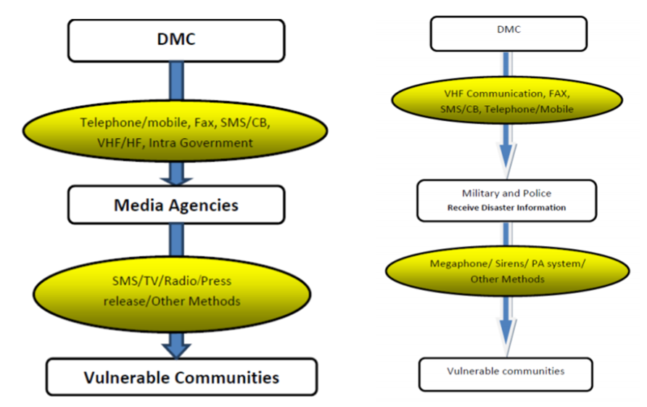
Figure 2: Model of Early DMC communications workflow.

Advantages
- Pre-filled sheets provide clear information about the intervention needed
- It might be an easier alternative for people who are already used to using fax.

Potential Disadvantages
- Fax is not widely used
- Very slow procedure
- Works only from home or office and at the local level only, assuming one has a fax machine
- Special number needed – cannot fax to central number like 911 or 112

North America (Canada and the United States) Status
Canada and the US both use 911 as a primary emergency number. Operators dispatch police, fire, and ambulance services as needed. Next Generation 911 (NG911) is the re-imagined version of that service now that the communications networks are more sophisticated and capable.
“Next Generation 911 (NG911) networks replace the existing telephone networks, which carry only voice and very limited data. Currently, there are difficulties in supporting such things as text messages for emergencies, images and video (including support for American Sign Language users), and easy access to additional data such as telematics data, building plans and medical information over a common data network.
In addition, the need for communications across states (provinces), between states (provinces), and across international boundaries requires the implementation of a more flexible 911 system design that can handle more data. A highly standardized system is essential and critical to seamlessly support communications and data transfer across county, state (province), and international borders. It also needs to work across the different emergency response professions and agencies, from traditional PSAPs to Poison Control Centers, trauma centers, Coast Guard, and disaster management centers. There will be numerous and varied steps toward the new NG911 system and vendors are already referring to their products as being aimed at, enabling, or being wholly NG911 compliant.”
NG911 is an open-standards system comprised of hardware, software, data, and operational policies and procedures that:
- provide standardized interfaces from emergency call and message services to support emergency communications;
- process all types of emergency calls, including voice, text, data, and multimedia information;
- acquire and integrate additional emergency call data useful to call routing and handling;
- deliver the emergency calls, messages, and data to the appropriate public safety answering point and other appropriate emergency entities based on the location of the caller;
- support data, video, and other communications needs for coordinated incident response and management; and
- interoperate with services and networks used by first responders to facilitate emergency response.”
This underlying infrastructure and series of policies means new ways for end users to contact and interact with the emergency number operator. With NG911 systems, callers will be able to send text messages and transmit photos, videos, and other forms of data to 9-1-1 centers, allowing call centers to better coordinate responses. Other emergency and public safety related entities will be able to interconnect to the NG9-1-1 network and system, and be able to receive calls and data sent by the NG9-1-1 system or PSAPs.

Regulatory Framework in the United States

American Disabilities Act (ADA)
Most of the disability specific legislation for technologies and services are based on the American Disabilities Act (ADA) of 1984. ADA is a civil rights law that prohibits discrimination against individuals with disabilities in all areas of public life, including jobs, schools, transportation, and all public and private places that are open to the general public. The purpose of the law is to make sure that people with disabilities have the same rights and opportunities as everyone else. ADA is divided into five titles (or sections) that relate to different areas of public life. Title IV of the Act covers telecommunications and provides the following coverage:
- Telephone and Internet companies must provide a nationwide system of interstate and intrastate telecommunications relay services that allows individuals with hearing or speech disabilities to communicate over the telephone
- Federally funded public service announcements must have closed captioning
The Federal Communication Commission (FCC) is empowered to regulate the process

Next Generation 911 Advancement Act of 2012
Within the ADA context, the principle regulatory framework put in place by Congress and regulated by the FCC for the deployment of NG911 services is the “Next Generation 911 Advancement Act of 2012” and the 21st Century Communications and Video Accessibility Act (CVAA). The first act provided funds for Next Generation 9-1-1 and began a multi-year process of building a public safety broadband network that must interconnect with NG9-1-1 systems. Additionally, the law requires studies examining current 9-1-1 fees and the costs associated with Next Generation 9-1-1. This is valuable information that will allow Congress to address NG9-1-1 system development, deployment, and maintenance funding issues. In addition, federal regulation 28 CFR Part 35 ensures non-discrimination on the basis of disability in state and local government services and the accessibility of NG911 services.

Telecommunications Act
Section 255 of the Telecommunications Act of 1996 requires telecommunications products and services to be accessible to people with disabilities to the extent that access is "readily achievable," meaning easily accomplishable, without much difficulty or expense . Examples of products Section 255 covers include wired and cellular telephone equipment and services such as pagers, fax machines, modems, voicemail and caller ID. The Federal Communications Commission (FCC) enforces Section 255.

21st Century Communications & Video Accessibility Act (CVAA)
The 21st Century Communications and Video Accessibility Act (CVAA) updates the Telecommunications Act to bring it up-to-date with new digital, broadband, and mobile innovations. It states that new IP technologies such as VoIP, electronic messaging, and video conferencing need to be accessible. It also requires mobile device manufacturers and wireless service providers to make and carry accessible mobile devices and ensure NG911 services are accessible to people with disabilities. Having mobile devices that can be used by people with disabilities is a critical first step in allowing them to make NG911 calls to PSAPs. It is important to note that the legislation language has been changed from “easily accomplishable, without much difficulty or expense” to “if technically feasible and achievable”. This was intended removed the rationale that accessibility cost too much so it could not be done.

Regulatory Framework in Canada

Regulatory Environment
At a federal legislation level, Canada did not historically have a formal legislative framework that addressed the rights of people with disabilities to access specific products and services. It was a patchwork of narrow legislation or agency directives that were used to address accessibility issues. In Canada, access to emergency services and alerts are explicitly regulated by the Canadian Radio-Television Telecommunications Commission (CRTC). Unlike the United States, there is no explicit reference to the accessibility of emergency services and alerts in any government legislation. Rather, the CRTC has created a series of directives that cover the deployment of these service with reference to the accessibility of specific services through these directives.

UN Convention on the Right of Persons with Disabilities
Accessibility to emergency services and alerts may improve in the future as the United Nations Convention on the Right of Persons with Disabilities was ratified by Canada in 2010. Canada is making progress in implementing the articles of the convention by creating Federal government policies that support the articles and creating standards and mechanisms for accountability (enforcement) . The Convention formally recognized an explicit right for people with disabilities to access specific products and service. The Convention creates a similar framework to the ADA in the United States.

Differences Compared to the United States
In Canada, there is currently no equivalent to the American CVAA, which created more specific obligations to dealing with the accessibility of mobile handset and emergency services for people with disabilities. Explicit standards that deal with the accessibility of services and products is still evolving in Canada and an enforcement mechanism is still not in place.
Unlike the FCC in the United States, the CRTC does not have the ability to levy fines except in the area of broadcasting. Also, unlike in the United States where legislation provides money for states to deploy NG911 through a fee imposed on wireless subscribers who live there, the CRTC mandate does not provide a similar mechanism. The funding of emergency services in Canada is a patchwork of funding models across the different provinces and territories. The CRTC only regulates the infrastructure for connecting callers to PSAPs, PSAPs to other PSAPs, and PSAPs to emergency responders. How the PSAPs deploy technology is usually handled at the provincial or municipal level.
Unlike the United States, the CRTC only had an implicit directive to request that Canadian wireless service providers offer at least one mobile handset for persons who are blind and/or have moderate to severe mobility or cognitive disabilities. Though the CRTC has the ability to regulate handsets, they have forborne (or defer using) that ability. Canadians with disabilities have benefits from the more explicit regulations in the United States through the CVAA that makes manufacturers and wireless service providers make and carry accessible handsets. Like the United States, the CRTC does not mandate the accessibility of those devices. Neither the FCC in the United States nor the CRTC in Canada are standards bodies.

Prevailing Standards

National Emergency Number Assocation (NENA) i3
The principal standards covering the deployment of NG911 in North America is governed by the National Emergency Number Assocation (NENA).
“NENA is an organization chartered to represent both public safety and the 911 industry, present and future, in its mission to focus on the development, evolution, and expansion of emergency communications. NENA is the organization responsible to define NG911, and to coordinate the development and support of NG911 as a system and a service to the public, the industry, and to Public Safety entities.
The conceptual base of NG911 is international in scope, designed to support all emergency codes, such as 911, 112, 111, and all others among the 62 access codes (at last count) used around the world.”
The most current draft of the standard created by NENA is NENA i3 Solution - Stage 3. The standards cover the following areas:
- Accessibility
- Agency Systems
- Data Management
- Data Structures
- 911 Core Services
- System Security & Resiliency
- PSAP Operations
- PSAP Logistics
- Communications
- Development Group Administrative
Early drafts of the standard introduced the concept of an Emergency Services IP network (ESInet), which is an IP-based (Internet Protocol-based) network shared by all public safety agencies that may be involved in an emergency. The network has core services that process 9-1-1 calls on that network (NGCS – NG9-1-1 Core Services). The i3 Public Safety Answering Point (PSAP) is capable of receiving IP-based signaling and media for the delivery of emergency calls conformant to the i3 standard. The network allows for the support of new NG911 services such as Real Time Text (RTT), video transmission from a caller or emergency responder, and the transfer of improved caller geo-location data.
The standard is designed to be a framework for the development of an NG911 system, but it is not prescriptive. The standard aims to do the following:
- Provide a framework to ensure information exchanged between PSAPs are compatible regardless of the geographic location and vendor equipment
- Provide guidance on basic operating policies and procedures with PSAPs for the emergency operators
- Provide guidance on training emergency operators to deal with hearing impaired callers (TTY/TDY and VRS).
- Provides guidance for third party emergency service-related app developers
This last point is important as there is an increasing number of Apps entering the market that impact public safety and emergency communications.

NENA i3 Implementation in the United States
Because the NENA i3 standard is just a framework, a PSAP can choose which portions to implement. In the United States today, the availability of NG911 services vary by region, so RTT may only be available in some counties. The New and Emerging Technologies 911 Improvement Act of 2008 (NET 911 Act) provides a mechanism to fund 911 and NG911 programs within individual states by allowing them to collect a fee or charge for each subscriber in a particular state.

NENA i3 Implementation in Canada
Canada has adopted the NENA i3 standard as its framework through a decision by the Canada Radio-Television and Telecommunications Commission (CRTC):
“In Telecom Regulatory Policy 2017-182, the Commission established a framework for NG9-1-1 (the NG9-1-1 framework). Once NG9-1-1 is fully implemented in Canada, emergency assistance requests will flow from originating networks to NG9-1-1 networks as defined in the National Emergency Numbering Association (NENA) i3 architecture standard.”
The timeline for the implementation in Canada is as follows:
- February 30, 2019: Bell and TELUS start conducting NG9-1-1 implementation trials
- June 30, 2020: NG9-1-1 network providers and telecommunication service providers support NG9-1-1 Voice service
- December 31, 2020: NG9-1-1 network providers and telecommunication service providers support NG9-1-1 Text Messaging service
- June 30, 2023: Current 9-1-1 networks are decommissioned
The deployed NG9-1-1 networks will be interconnected to form a national network of networks and NG9-1-1 network providers will ensure that their NG9-1-1 networks are highly reliable and resilient.

Differences Compared to the United States
Unlike the United States, Canada does not have a national mandate to fund its NG911 service. Canada is a patchwork of funding models. Some are funded regionally by municipalities and some are funded at a provincial level. It is anticipated that the rollout will lead to differences in what services are offered on a region-by-region basis.

Services Available to Everyone
These methods of contacting 911 are intended to be used by all users, not just for those with disabilities. Whether the specific implementation of a service is fully accessible to all users with disabilities will not be specifically discussed in this section of the report. For the purposes of this discussion, it is assumed that callers with disabilities can access the primary functions of their mobile device (placing a call, sending a text message, and interacting with an App or landline phone). Approximately 80 percent of 911 calls in the United States today come from mobile devices while in Canada, that number is over 50 percent. As a result, many of these services depend on the caller using a mobile device.

Voice Calls
Although voice calls convey less information than other communication methods, it is still the recommended way of contacting 911 in Canada and the United States, as all PSAPs support it. Most land line and mobile voice calls allow emergency operators to locate the caller with varying degrees of accuracy.

Land Line Calls
Traditional 911 calls from landlines or Plain Old Telephone System (POTS) lines are still supported in North America. They are the easiest to locate as PSAPs can do an ALI (Automatic Location Identification) database lookup to find the phone’s physical location . In addition, all land line phones are assigned a local telephone exchange, which will always route the call to the correct regional PSAP.

Mobile Phone Calls
With the introduction of mobile phones however, more people now use it instead for 911 calls. In Canada, approximately 50 percent of 911 calls are initiated by someone using a cellphone. The United States processes approximately 400,000 911 calls from cellphones per day. The problem though is that mobile phones have no physical address, making it difficult to quickly locate the caller and send help. Current solutions use the cell tower’s address the call was made from and the mobile device’s reported GPS location. The problem with these two solutions is that cell towers cover many kilometers of land making the search area too wide and GPS location accuracy drops when there are walls and buildings obstructing the signal, thus reporting the wrong location.
In 2014, a Find Me 911 Coalition surveyed emergency dispatchers in all 50 states and found that most (82 percent) are not confident in the location data automatically displayed for wireless calls. More than half (54 percent) said that the information is regularly inaccurate. To help resolve this, the United States and Canada introduced enhanced 911 (E911) regulations.
Under E911 regulations in the United States, mobile phones must report latitude and longitude information that are accurate within 50-300 meters and height data with 50-meter indoor horizontal accuracy. This location information must be available for at 70% of calls in 2020. This allows emergency responders to locate callers in buildings. While the enhanced location information is being phased in in the United States, there is no timeline for when it will come to Canada.

Voice Over Internet Protocol (VoIP) Calls
Voice over Internet Protocol (VoIP) is another method of placing phone calls to an emergency operator. VoIP was originally available in office environments but is now offered through non-traditional telephone providers such as cable companies (Shaw Cable for example).
Here is how VoIP works:
- Your phone connects to your switch or router in your Local Area Network (LAN).
- When you dial a telephone number, your IP phone tells your VoIP service provider to call the other party.
- Your VoIP service establishes the call and exchanges data packets from your IP phone.
- Your VoIP phone converts these digital signals back into the sound you can hear.
Voice over Internet Protocol bypasses the telephone company entirely. Wherever you have a broadband internet connection, you can use VoIP. It’s a significant upgrade from an analog phone system.
The disadvantage of using a VoIP call to contact an emergency operator is the caller needs to tell the operator their actual location. Unlike a land line call, no physical address is associated with a VoIP phone number. The caller may have a local area code displayed in the call, but the person making the call might actual be in another country. Voice over IP systems default to sending your company’s mailing address to public safety operators. In addition, VoIP phones do not work during power outages.
Voice calls obviously creates a barrier to those that have hearing related issues or have difficulties speaking. These users must use a relay interpreter who will convert the caller’s preferred mode of communication (text, sign language, pictograms, or slurred speech) to speech that the other party can understand and vice-versa. Relay services will be described in more detail in later sections.

Global Positioning System (GPS) or Trilateration Capability
With Enhanced 9-1-1, wireless carriers can use Global Positioning System (GPS) and/or trilateration technology to identify a 9-1-1 caller’s approximate location (generally within 50 to 300 meters of the cellphone). The emergency call and the caller’s approximate location are automatically transmitted to a 9-1-1 call centre serving that area.
Most mobile phone have GPS capabilities, although some feature phones sold today still omit this . If GPS is unavailable, wireless carriers can still locate the phone via trilateration, which locates the caller by measuring the cellphone signal’s distance from nearby cellphone towers. The location information will be provided to the 9-1-1 operator if the caller is using either a cellphone with pre-paid minutes or a wireless service plan. Cellphones that are not subscribed to any service can still call 9-1-1 and receive basic wireless 9-1-1 service.”

Short Message Service (SMS) or Text to 911

United States
In the United States, Text-to-911 is available to everyone and wireless service providers were required to implement this service by December 31, 2014. This requirement does not extend to PSAPs. To work around this, wireless service providers need to send a bounce-back notification if the regional PSAP does not support Text-to-911. This lets the person needing help know they have to use another method to contact 911. Barriers for the adoption of this service are cost, an inconsistent national funding model, and a reluctance for PSAPs to train staff. The FCC maintains a list of PSAPs that support Text-to-911.
There are a few variants of Text to 911 in the United States. The core feature set remains consistent across all wireless service provides (basic text message) but some wireless service providers support more features like MMS multimedia attachments, SMS texter location, and call reactivation
Call centers equipped to receive these emergency messages will be able to field the texts in a number of ways. For instance, centers that have not yet upgraded to the latest 911 technology will be able to start by receiving text messages via the TTY service previously reserved only for the hearing impaired. Those centers that can upgrade their systems, on the other hand, will be able to field the text messages through a browser-based technology that connects a secure virtual network to the text provider.
This service, when more widely supported by PSAPs, will provide more access to 911 for people with disabilities and those in situations where it is dangerous to make a voice call to request help.

Canada
In Canada, Text to 911 (called T911) has been implemented by wireless service providers as of 2013 . This implementation requirement does not extend to PSAPs as they are operated by municipal and provincial/territorial governments that the CRTC has no control over.
The service is currently restricted to hearing or speech impaired people, their family members, and close friends . Users have to pre-register their phone number to use the service. Unregistered phone numbers will receive an automatic reply advising the user to call 9-1-1 for emergency services.
To use this service, users need to first place a call to 911. This enables GPS services to help emergency number operators to locate the phone. Since the phone number is registered, the emergency number operator knows the caller prefers to be contacted by text message. The operator will then confirm the call by sending a text message back to the caller. The call will progress normally from there. If the local PSAP does not support text to 911 the CRTC has directed that the caller must receive a text message back telling the caller the service is not available.
Generally, a voice plan is not required to call 9-1-1. However, you will need to have a valid text messaging plan in order to use text-to-911. Text-to-911 calls require more time than a voice call to communicate with emergency services. During an emergency, time is of the essence and talking enables faster communication than texting, and there is a small chance that text messaging could be delayed or lost. For people who have hearing related issues it is an essential method of access.
The service is now available to the majority of Canadians in many areas of the country. Some 9-1-1 call centres are still making the necessary upgrades to their systems, but once you have registered the cell phone, you will have access to T9-1-1 in any area of the county where the service is available. The service will only be available in areas that have received wireless and 9-1-1 network upgrades and that has been implemented by the municipality or the province and their emergency centres. The complete rollout is scheduled to be complete by April of 2021. T9-1-1 will not work outside of Canada as the implementation is unique to Canada.

MMS to 911
MMS to 911 is an enhancement of Text to 911 that allows users to attach multimedia content such as pictures and short video clips to text messages. MMS would give first responders the much-needed situational awareness in many different types of situations, including accidents, fires, and active shooter and hostage scenarios.
Although most mobile devices today can send MMS messages, few mobile carriers and PSAPs in the United States and Canada support MMS to 911. For carriers, this is largely because standards are lacking and the current FCC rules only require that carriers accept and transmit SMS 911 text. For PSAPs, they are worried about the training costs, slower response times due to more complex workflows, and the emotional impact of graphic imagery.
Even though one of the first installations of MMS to 911 was in 2017, it may take time for this technology to be rolled out. In the United States, some mobile carriers such as AT&T and Sprint and PSAP equipment vendors such as Nice and West support this feature. For Canada, the researchers have not been able to identify any PSAPs that have adopted this technology and are promoting it to potential users in their region.
One PSAP platform that described their MMS to 911 feature is West. For the West system, MMS media files are received by the West Text Control Centre (TCC) and are automatically forwarded to three PSAP email addresses. Messages are limited to 5 MB or the mobile carrier limit, whichever is lower. Media files can be transferred between PSAPs as long as the recipient enabled this feature.
If an MMS message containing attachments is sent to a PSAP that does not accept it, the texting party will get a message informing them that the attachments were not delivered. Sending MMS messages to PSAPs is not free of charge yet.

Real-Time Text

United States
The FCC adopted rules to facilitate a transition from TTY to RTT in December 2016. A phased-out rollout started in December 2017 and will run until June 2021. The FCC required the four big phone companies, Verizon, AT&T, Sprint, and T-Mobile to support RTT by the end of 2017. They had to, at minimum, make a downloadable app available on one phone. The smaller phone companies have to be ready by 2021.
In addition, by 2019, all new phones had to have built-in RTT support, must support RTT and voice features in the same call, and had to be backwards compatible with TTY relay services (e.g., 911 and 711 in the US). Although wireless carriers that implement RTT are required to support RTT calls to 911, not all PSAPs can handle RTT calls to 911 yet. PSAPs that cannot handle RTT calls still rely on TTY technology to receive calls from people with disabilities. How well RTT can handle TTY’s limitations has yet to be seen.

Canada
Canada currently has no working implementation of real-time texting, but the mechanism to support it is being put in place. Telecom Regulatory Policy 2017-182 directs all incumbent local exchange carriers (ILECs) to establish their NG9-1-1 networks and be ready to provide NG9-1-1 Voice by 30 June 2020 wherever PSAPs have been established in a particular region. The Commission also directed these ILECs as NG9-1-1 network providers and wireless service providers (WSPs) to provide NG9-1-1 Text Messaging, a new service for all Canadians, by 31 December 2020. This deadline has now been extended to March 2022.
RTT-based NG9-1-1 Text Messaging is intended to replace the interim Text with 9-1-1 service. Unlike Text with 9-1-1, this new solution will not require pre-registration nor will it require a voice call followed by a text message from a PSAP. The routing of RTT-based emergency requests and the transmission of caller location information will be the same as for wireless NG9-1-1 voice calls.

Multimodal Emergency Contact Platforms (Total Conversation)
As both the United States and Canada are following the NENA i3 standard, the emergency services infrastructure should have the capabilities to support multimodal emergency contact platforms. This means that emergency callers can communicate with PSAPs in real-time with video, audio, and text. In Europe this is known as Total Conversation.
One obstacle for multimodal communication is network connection issues caused by the limited network bandwidth on mobile devices combined with the high network usage in urban areas. Inconsistent network speeds will cause video and audio segments and even the whole call to drop. Newer mobile network technologies like 5G, can improve reliability and provide the necessary bandwidth and speeds to support multimodal communication between callers and emergency service operators.
In Canada and the United States, there is currently no complete examples of multimodal emergency contact platforms that are available for all. The closest is Rave 911 and Carbyne, which allows for video, audio, and line-by-line text communication. See “Third Party Apps” in the North America section and “Disability Specific Accommodations” in the Europe section for more details. In Illinois, a video, text, and voice system was trialed as part of University study.
Video relay services (VRS) also comes close to implementing multimodal communication, but they are for sign language users and requires an App to be installed. Even then, the only VRS solution that supports real-time text is nWise MMX. The rest use traditional line-by-line text messaging. See the “Disability Specific Accommodations” in the Europe section for more details.

Live Streaming of Video
The concept of being able to stream video from the caller or first responder’s mobile device is fairly new. Rave Mobile Safety was the first to introduce a system that supports live streaming as part of the emergency service platform for PSAPs in 2019.
Live video helps the emergency number operator in the following tasks:
- Identifying the location of an emergency
- Understanding the nature & severity
- Communicating with non-verbal callers
- Coordinating an appropriate response quickly
- Allowing for expert assessment
In an emergency situation, people can be confused about their actual location. Though GPS location data from a mobile phone can locate the caller to within 4.9 m (16 feet) in ideal conditions, if the person is within a building the task can still be challenging. If the caller cannot provide an exact address and office number or only an intersection, then live video streaming can provide those extra pieces of information that will make locating the caller quicker. It can also help the emergency number operator better assess the situation by having actual live video from the scene.
The key considerations of PSAPs in regards to this service implementation are:
- Impact on the two sides of the video feed
- Overwhelming the system
- One-way vs two-way
- Training
- Data retention and evidence
This technology is still early in the deployment stage so best practices in using live streaming system is not established. Some PSAPs are prefer to have the live stream only come from the caller’s handset. The practice is to have a one-way video feed from the caller to the emergency operator. The emergency number operator could potentially view the live stream from the caller and the first responders on scene and take act as a coordinator.

United States
Though not a regulatory requirement, there are already implementations of live video streaming from caller handsets in PSAPs. It is not widespread, but we are already seeing advantages of this technology. The Eaton County 9-1-1 PSAP in Michigan is one of the few that has it deployed.

Canada
Live stream of video was envisioned in the presentation to the CRTC during their hearing on NG911.
“With NG911 Canadians in need of emergency services could ultimately send a text message or transmit photos, videos, and other types of data to 9-1-1 operators, in addition to making traditional voice 9-1-1 calls using wireline, wireless, or VoIP telephone services. For example, they could stream video from an emergency incident, send photos of accident damage or a fleeing suspect, or send personal medical information, which could greatly aid emergency responder.”

Services for People with Disabilities
This section discusses how services accommodate people with disabilities and whether alternative access needs to be provided to achieve equal access for specific services for people with disabilities (PWD).

T911 – Canadian-Specific Text to 911 Services
Please refer to the discussion in the “SMS or Text to 911 - Canada” section.

Video Relay Services

Canada
Video relay services in Canada are operated by Canada VRS . Canada VRS is for Deaf, Hard of Hearing or speech-impaired Canadians who wish to make telephone calls using Internet and cell-phone based technologies. VRS callers connect with a sign language interpreter who provides real time interpretation for these calls. The caller needs to pre-register for access to this service.
Canada VRS is free to use. It is supported by a fund established by the CRTC and funded by a charge added to the bill of each mobile device subscriber by their Canadian wireless service provider. The Canadian Administrator of Video Relay Service (CAV), Inc., or CAV, is a non-profit telecommunications services company with a mandate from the Canadian Radio-television and Telecommunications Commission (CRTC) to design, implement, and oversee the delivery of Video Relay Service (VRS) in Canada via Canada VRS.
“Canada VRS offers 9-1-1 support across Canada in both ASL/English and LSQ/French. All 9-1-1 calls are treated as urgent, go directly to first place in the Canada VRS queue and are answered within 30 seconds.
The Video Interpreter (VI) and emergency personnel will always confirm the customer’s location. That’s why it’s important that Canada VRS customers keep their home address up to date in the app.
Once the location and nature of the emergency is determined, the PSAP dispatches either fire, police or medical responders. The VI stays with the caller and assists the emergency services personnel as long as they are needed.”
“Because Canada VRS is internet or data service based, emergency calls made via VRS may not properly connect. For example, if there is an internet or data service failure or if you lose electrical power. Also, your 9-1-1 call may not be routed correctly if you have not updated your physical location information.
“Voice Carry Over (VCO) allows Deaf, Hard of Hearing and speech-impaired users to speak for themselves in VRS calls. When the VCO feature is enabled on the user’s app, it allows the customer’s voice to be heard by the other party. When the other party responds, the Video Interpreter signs in ASL or LSQ. The VCO option can be enabled in the user’s app Settings screen.”
On iOS and Android mobile devices, VRS is facilitated through an App that the user must install as it not supplied by wireless service providers in Canada. The relay service is available in French and English. The caller can reach any phone number including 911 through VRS. Using VRS to contact 911 services is a recognized method of placing an emergency call.
The Canada VRS App uses Global Positioning System (GPS) to provide Wireless Location Information (WLI). WLI helps 9-1-1 locate the caller when they have an emergency away from home or are in a remote location. To use WLI, the user must turn on the location feature in their smart phone’s settings and provide permission within the Canada VRS App. When they call 9-1-1 with WLI on, their location is automatically sent to emergency responders. However, that information is not always 100% accurate. So, when they call 9-1-1, they will still be asked for your location by the emergency number operator and if they are in a remote location, to describe the location in detail.
One issue identified by Canada VRS staff and hearing-impaired people from the community is that the service may sometimes have video issues due to network congestion. The extent of the issues is not known. Canada VRS currently handles about 300 callers to 911 per quarter.

United States
Video Relay Service (VRS), which began in the mid-1990’s, is now considered commonplace in the United States. This service pre-dates the VRS services in Canada by over a decade. Its operation is governed by directives from the FCC. It offers similar services as in Canada and allows people who are deaf and have speech related issues to communicate with a call recipient.

Speech-to-Speech Relay
Speech-to-Speech Relay is a service for speech-impaired callers. Callers connect through a trained relay operator who can understand their speech and pass on the information verbally. In the United States, the operation of Speech-to-Speech Relay services is governed by the Federal Communications Commission (FCC).
Speech-to-Speech Relay is approved and supported method of contacting 911 service.
“A person can make an STS call from any telephone. Dial 711 to call the relay center and indicate you wish to make an STS call. You are then connected to an STS CA who will repeat your spoken words, making the spoken words clear to the other party. Persons with speech disabilities may also receive STS calls. The calling party calls the relay center by dialing 711 and asks the CA to call the person with a speech disability. STS users have the option of muting their voices during an STS call (so that the party to whom they are speaking hears only the voice of the STS CA, and not the voice of the STS user). If you wish to use this option, please inform the STS CA to mute your voice for the other party to the call. If you choose this option, the STS CA will still be able to hear what you are saying, and will re-voice what you say to the other party.”
Canada does not currently have the equivalent Speech-to-Speech Relay service. The demographics do indicate a need though.
“There are over 440,000 Canadians who have significant speech, language and communication disabilities that are not caused by significant hearing loss.”

Third Party Apps
Below is a table of third-party apps by type. The table is provided to give an overview of what services are available, but is not complete. In addition to the government regulated services for contacting emergency services, there is the facility in the standards and regulation to provide third party developed and support emergency contact and emergency alert services. Some of these services are free and others require either a one-time fee or have a recurring monthly or yearly fee. Descriptions and screenshots of the Apps are available in Appendix NA.1.
App Name | Brief Description
AT&T Real-Time Text (RTT) | After market Real Time Text (RTT) app to be installed by AT&T customers.
Ideal Group Speech2RTT® Communicator | After market Real Time Text (RTT) App that can convert text messages to speech.
Rave Mobile Safety live video stream | This is not technically an App. After calling 911, a link is sent to the caller by text message and that opens a browser-based service that can stream video from the caller's phone to the emergency operator.
Show Me for Emergencies App | This App uses easy-to-understand icons for two-way communication during an emergency. It is intended for users with hearing impairments cognitive disabilities or people with low literacy skill or non-English speakers.
Emergency Call App | This is an emergency calling app for Android that uses icons. Using icons to supplement the text allows people who do not know English well to still be able to contact emergency services. To make an emergency call, the user selects the country they are calling from and the emergency service they need. There is no need to remember which emergency number to call. Although this app is not specifically intended to support users with other issues like cognitive disabilities, some aspects of this design can be used to support this group of users
Here I Am App | This app allows you automatically send a text message to 3 contacts that are pre-defined in the case of an emergency. The user needs to activate the App for the emergency message to be sent to the contacts.

Europe (European Union)
The Europe Union has many of the same methods of contacting emergency services as in the United States and Canada and is more advanced in certain areas in regards to developing standards and dictating adoption by member states. SMS, RTT, MMS, live streaming of video and multimodal emergency contact platforms (Total Conversation) are already deployed and scheduled to be deployed in the next few years in some form. There are some regional differences between what is happening in North America and the EU. Some of the differences are based on regional preferences and some are based on differences in standards.

Regulatory Environment
European legislation and directives explicitly put forward the current rights and obligations in terms of addressing the needs of people with disabilities to access emergency services:
- Persons with disabilities must be able to contact emergency services on an equivalent basis compared to other end-users.
- The concept of “equivalent access” has been clarified in the European Electronic Communications Code and the European Accessibility Act.
- As of June 2025, at least real time text will have to be deployed in the Member States. - Means of access to emergency services should be free of charge to the user.
- Location information of the person contacting 112 should be provided to the emergency services.
- Relevant authorities should seek to facilitate the way citizens with disabilities can contact emergency services in other EU countries, “where feasible without any pre-registration”.
- Current requirements might be completed by a delegated act in 2022.
All European Union countries subscribe to the United Nations' Convention on the Right of Persons with Disabilities (CRPD) and the European Accessibility Act. This ensures that people with disabilities can access, on an equal basis with others, all publicly available software and hardware.
The European Accessibility Act aims to create a common set of accessibility rules across all member countries. This removes barriers caused by differing rules used by member states. CRPD has been enforced in the EU since December 23, 2010 and the European Accessibility Act will be enforced in 2025. One caveat though is that the accessibility act does not apply to PSAPs . This have been addressed through the 2018 European Electronic Communications Code (EECC) which states that “PSAPs should respond with the same communications mean as the one received” .
The European Electronic Communications Code (EECC) is a directive that requires the European Commission and national regulatory authorities to ensure travellers can contact emergency services in an accessible manner without pre-registration or software downloads. At minimum, real-time text should be implemented. The directive was adopted in December 2018 and will serve as the main legal reference for emergency communications starting from December 2020.

Prevailing Standards
In Europe, standards are created by the ETSI, CEN, and CENELEC standard organizations. The European Commission proposes legislation, which the Council and European Parliament can make amendments to and give their consent for the laws to pass. Advisory organizations such as European Emergency Number Association (EENA) and European Disability Forum (EDF) make recommendations on standards and laws. Standards are enforced by law on all member countries by the European Union.
There a number of key standards that create an accessible eco-system around N911 services in Europe. The key standard in regards to ensuring the accessibility of mobile devices is ETSI EN 301 549. This is key as PWD can access an emergency operator without being able to operate a phone. ETSI TR 103 201 / ETSI TS 101 470 described Total Conversation systems which is made up of video, text and voice integrated into one platform. Emergency alerts are covered by ETSI TS 102 182/ETSI TS 102 900. For a more detailed list, refer to Appendix E.3.

Regional Differences

Relay Services
Not all European Union countries have implemented national public text or video relay services. Of the 27 member countries, only 11 have this service. The EU countries that do not have this service are Austria, Bulgaria, Croatia, Cyprus, Estonia, Hungary, Iceland, Latvia, Lithuania, Luxembourg, Malta, Poland, Portugal, Romania, Slovakia, and Slovenia.

Text Relay Differences
Text relay users in the UK have an 11-digit phone number (TextNumber) that will bring the relay service into the call automatically . This makes the relay service transparent for both the caller and callee. The introduction of TextNumbers solved the problem of people not dialing the 18002 prefix and thus bypassing the text relay.

Video Relay Differences
The account registration details that must be provided when registering for a VRS account differs between European countries. Tess in Germany requires users to provide their name, address, and email just like in Canada and the United States . Users have to keep their home address up-to-date. Bildtelefoni in Sweden does not require an address . All users are assigned a username and password to log into the VRS app. They may also be provided a SIP address (phone number) and customer number.
Depending on how the VRS in the country gets funding, payment methods differ. In some European countries like Germany, users pay a subsidized price . In Sweden, the service is provided for free with funding from the Swedish Post and Telecom Agency . In the Netherlands, a user’s BSN (SSN) needs to be provided as the Ministry of Health, Welfare, and Sport covers the cost of a certain number of interpreting hours . If the user’s health insurer covers the cost, the health insurer and policy number need to be specified .

SMS to 112
The current implementations and laws around SMS to 112 vary greatly across different EU member states and sometimes within regions of a country. SMS to 112 systems do not work across borders, use of the service may require calling unlisted or specific phone numbers other than 112, and the infrastructure required to make the service work may have some quirks. This is likely due to the lack of standards and regulations regarding the use of SMS to contact emergency services in the EU.

Usage Restrictions
For most European countries, this service is restricted to those with hearing or speech disabilities. For some countries like Sweden, use of the service is expanded to people or institutions that interact with hearing or speech impaired people. In some other countries like Estonia, Finland, Iceland, Latvia, and Lithuania, anyone can register for the service.

Service Registration
Since each country has their own distinct SMS to 112 implementation, users need to register ahead of time for each country they are visiting to use the service.
United Kingdom’s EmergencySMS service is the easiest to register for. To register for the service, text ‘Register’ to 999 and reply ‘Yes’ to the service agreement. There will be a confirmation message indicating the mobile device is registered.
Sweden and Georgia’s SMS to 112 service requires completing a registration form online. Registrants need to provide their name, personal ID number, address, mobile number, and email. An SMS confirmation will be sent in one to three business days. Travellers to Sweden can also register by putting their hotel address.

Infrastructure Quirks
In most European countries, SMS messages can be sent to 112. Austria, Cyprus, Denmark, Italy, Malta, Romania, Belgium, France, Portugal, and Spain have another phone number that must be used instead. Some countries, such as Belgium, Denmark, and Italy, go further by having these phone numbers unlisted and making disabled people request for them.
SMS to 112 services are usually limited to English and the country’s official language. In contrast, voice calls to 112 usually have translators that can handle English (21 states), French (11 states), German (12 states), and the language of neighbouring countries .
In the United Kingdom, to reduce system and infrastructure costs, the EmergencySMS service makes use of a text relay (18000) to integrate SMS messages sent to 999 or 112 to the traditional voice call system. In Spain, a voice call for identification and location information must be made before following up with SMS . Other European countries that have an SMS to 112 service have PSAPs that can receive SMS messages directly.
In the UK, unregistered users will not get any response if they send an SMS to 999 or 112. It is unknown if European countries have implemented bounce back messages when SMS to 112 is not available.

Current Services (Deployed or Being Considered)

Not Disability Specific
These are services being deployed as part of a regions Next Generation Emergency Service regardless of disability specific issues.
The call-taking module helps PSAPs manage events such as locating callers, viewing maps, categorizing events with questionnaires, making task lists, and uploading emergency procedures.

Google Live Relay (Not Released Yet)
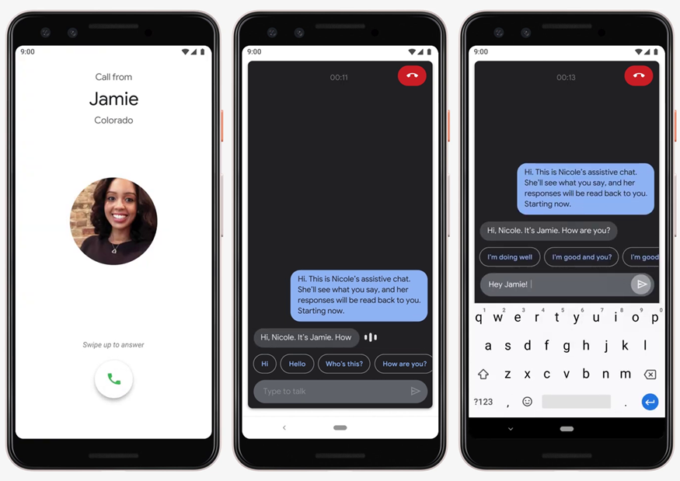
Google Live Relay, an automated text to speech relay, is meant to provide another option to RTT for things like incoming calls or for increased privacy. It Is still in the research phase as of May 7, 2019.
This service, if launched, can help those who are deaf, hearing-impaired, speech-impaired, or speech-disabled make and receive phone calls without requiring additional software for the caller. Voice calls will be converted to text and text responses will be converted back to speech. In addition, Google’s canned responses and predictive writing suggestions can help speed up responses to have a synchronous phone call.

Rogervoice
Rogervoice is a mobile app that allows users to make calls and get automatic voice to text transcriptions. Users can type their response or use their voice. Typed responses will be converted back to speech. Conversations can also be translated between French and sign language through the smartphone’s video camera. This app is beneficial for those who are deaf, hard-of-hearing, or in a noisy environment.
However, this product has a limitation where only the callee’s voice is transcribed into text. People with a cognitive impairment may not be able to remember what they said. From the demo videos, it is also not clear if typed responses are converted back to speech as it is typed or after pressing a send button.

Streaming Video From the Caller to the Emergency Operator
Allowing callers to stream live video from their mobile device to the emergency operator has several benefits over just voice calls.
- Geotagged video/pictures, visible landmarks help emergency operators determine caller’s location
  - Caller may have gotten lost and stranded
  - Caller may be blind
  - Caller may have cognitive/speech impairment
- Immerses emergency operators into the scene to more accurately assess the situation themselves
  - Number of victims involved
  - Severity of injuries
  - Identification of hazardous materials
  - Less time spent asking what is happening and more time spent defusing the situation and dispatching services
- Removes ambiguity from vague descriptions given by callers or sometimes conflicting details given by multiple callers
- Those with cognitive impairments may have some trouble constructing their thoughts into concise sentences and focusing on or remembering what the call-taker is asking them to do.

Disability Specific Accommodations
This section discusses how these new services accommodate people with disabilities and whether alternative access need to be provided to achieve equivalent access for specific services.

SMS to 112
There are various implementations of SMS to 112 across Europe. Generally, each country has their own implementation and users need to register ahead of time for each country they are visiting to use the service.
In Sweden, the SMS112 service is only open to people who are deaf or speech or hearing impaired or institutions that have pupils and/or staff who are deaf. To register, a web form at sosalarm.se needs to be filled out. The person’s name, personal ID number, address, mobile number, and email address needs to be provided. Travelers are welcome to apply as well. An SMS confirmation should be received in 1-3 business days.
In Finland, the SMS112 service is open for everyone. To prevent vandalism, pre-registration to use this service is required by law. To register, create an account on suomi.fi. All accounts require two-factor authentication (bank identifiers or mobile certificate). It is not clear if this service is open to travelers.
In the Netherlands, emergency services can only be contacted using the TolkContact app that is only available in Dutch or by using a SIP client and calling the teletolk@kpnteletolk.nl address. For the deaf or hard of hearing, health insurance pays for Tolkcontact subscription.
Contacting 112 via SMS can benefit people with hearing or speaking disabilities as it does not require the use of hearing or speech.

TolkContact
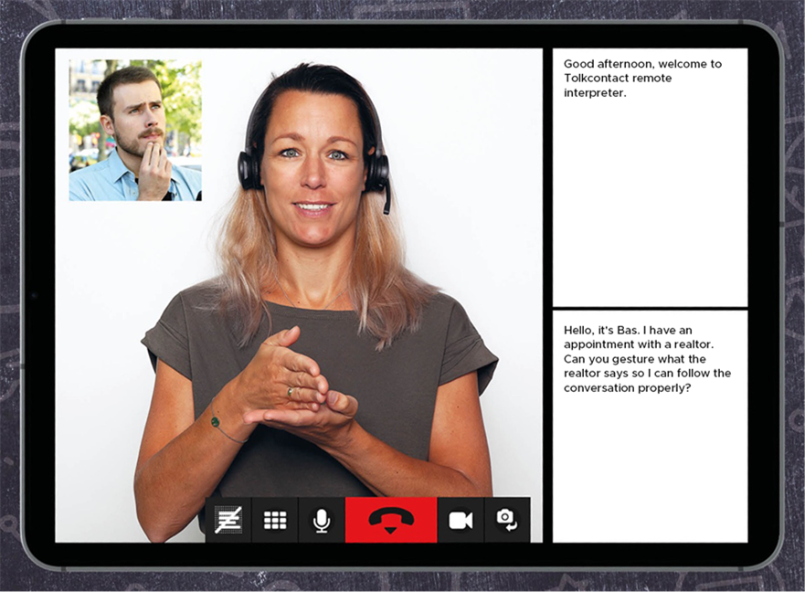
TolkContact is a Dutch app that allows having phone conversations using text, voice, and video. Although the service is meant for those with hearing impairments, anyone can use it for a subscription fee. Interpreter sessions can be up to 20 minutes long.
A form has to be completed to request an account. The person’s name, birth date, email, address, BSN (SSN), and health insurer details needs to be provided.
For the deaf or hard of hearing, health insurance pays for Tolkcontact subscription. Everyone else has to pay themselves.

Ntouch
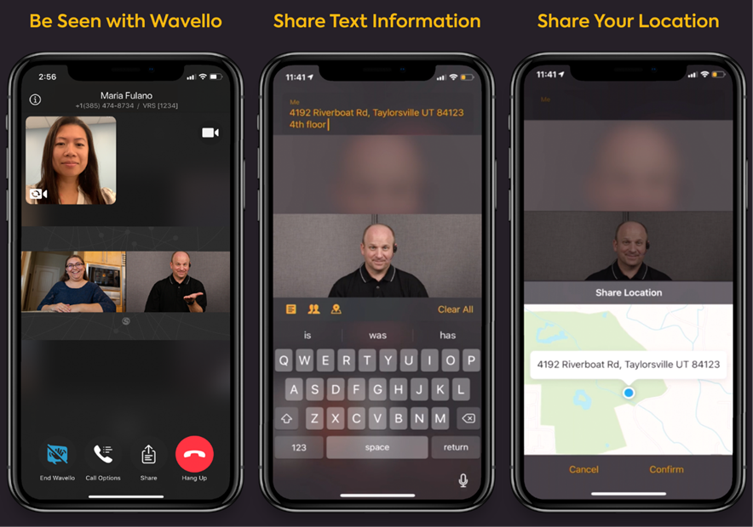
NTouch, just like TolkContact, allows those who are deaf or have hearing impairments to have video calls or meetings with others with the aid of a sign language interpreter. Sending text messages, SignMail (voicemail but with sign language video), and location details is also possible with this app.
A Ntouch account needs to be created on the Sorenson website before using the service. The disabled persons, name, address, SSN, phone number, disability details, and ISP details need to be provided.
This service is provided for free to all disabled people who need this service. It is paid for by the TRS Fund established by the FCC and funded by other telecommunications users.

112 Where Are U / EMMA Emergency App
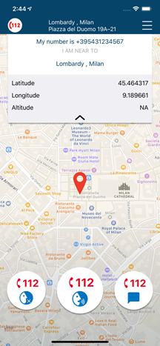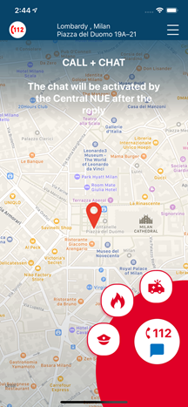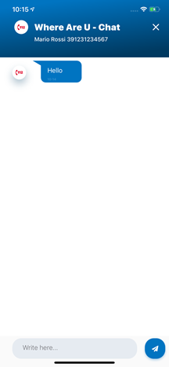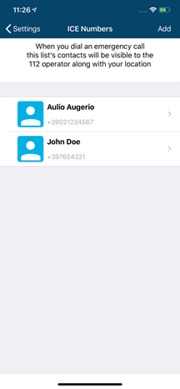
Beta 80’s Where Are U app makes it easier for people in Europe to contact emergency services with a press of a button no matter which European country they are visiting. It has dedicated icons to allow the user to ask for help for a requested service (fire, medical, or police) through voice, text chat, or silently. When making a call, the app sends the caller’s GPS location via mobile data or SMS to the local PSAP. The app allows creating profiles so personal data can be automatically shared with the emergency operator.
From the app’s product sheet, it is not clear how silent calls are handled, but it can be assumed that the requested service, caller’s location, and personal data and sent to the emergency operator with no further information given and no sound made.
This app can be useful for tourists who are unfamiliar with the area and do not know which emergency number to call. It can also help citizens with hearing, speaking, and cognitive impairments by providing different communication options to get help quickly. However, this app falls short of providing total communication as the support for real-time text messaging and video calls is missing.
The Where Are U app is currently only supported in certain regions in Italy right now. In the future, it can be used across Europe once networks are compliant with the European PEMEA standard.
This app can benefit everyone as users do not have to worry about if their mobile device supports NG112 features natively and they do not need to remember which phone numbers to call specific emergency services across Europe.
It would be better if the app enables total communication at the press of a button and then the user communicates using their preferred method (sound enabled manually). Right now, the app restricts the options to voice only, text only, or silent. Also, the video chat option is currently missing, which is important for the deaf or hearing impaired.
Some countries also have an emergency number for coast guard, which is important to know when boating. From the app screenshots, it does not look like contacting this service is available and Italy does have a coast guard.
The app will also be more useful if the country’s non-emergency phone numbers are also listed as those are not often memorized.

Carbyne C-Live
Carbyne c-Live allows 911 callers to communicate to emergency operators using voice, video, text without an app. Upon calling 911, the caller will receive an SMS with a link. This link launches a website that allows the emergency operator to access the mobile device camera and microphone as well as allowing for text messaging. Communication can be done by video, voice (from the initial call), and text. If sign language is needed, a relay can be invited into the video and text chat. Technology barriers due to smartphone version can be avoided due to the video and text chat running in a web application. (Please see Appendix E.1 for screenshots of callers and call takers using Carbyne.)
C-Live improves upon NG911 by implementing their patented real-time location tracking that provides up to five-meter accuracy in both elevation and floor level as well as location history. To get the most accurate device-based location with AML over HTTPS instead of over SMS, callers with no mobile data plan will be given data credits.
Calls can be broadcasted to first responders so they are fully aware of the situation before they arrive at the scene, thus saving valuable time. Sign language interpreters and translators can be looped into the call to offer assistance when needed.
First responder can also receive the same information as PSAPs so they know exactly what is happening before they arrive at the scene to reduce or eliminate asking questions. Additionally, smart routing information is provided to help the first responder get to the scene as quickly as possible by avoiding traffic congestions.

NWise MMX Platform
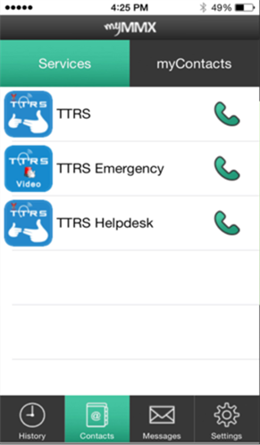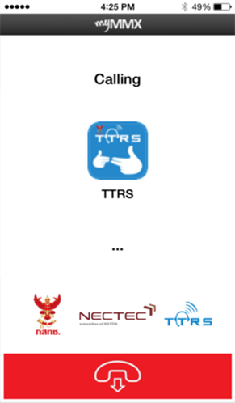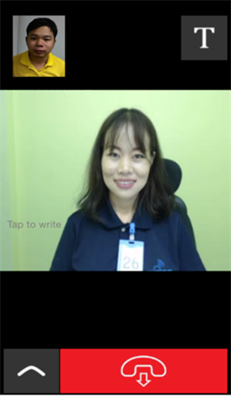
NWise MMX is a call center platform that supports total communication relay services. This means that video, real time text and voice can be used simultaneously within the same service. When the video relay is closed, the app will automatically switch to the text relay. This platform is currently used in Denmark, Norway, Sweden, Finland, Iceland, UK, Holland, Belgium, Germany, Switzerland, USA, Thailand, Brasil and Japan.
NWise MMX is the only relay solution currently that can do the following:
- Simultaneously handle video communication, real-time text, and captioned telephone
- Allow blind people to read Real-Time Text (RTT) on their braille reader
- Allow people to use RTT to communicate with emergency services that use the MMX RTT gateway
Users can connect to this platform via the myMMX iOS and Android mobile Apps or from the web browser to have voice calls, point-to-point calls with other VRS providers, and RTT calls.
The platform conforms to WAI and WCAG guidelines. Assistive devices such as braille displays, screen readers, and screen magnifiers can be used.

NGT Lite and Relay UK
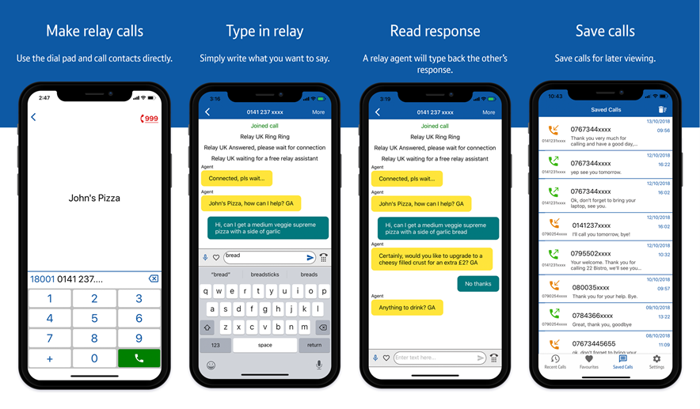
In the UK, British Telecom (BT) launched NGT Lite, its Next Generation Text Relay service, in October 2014 to fulfill an Ofcom regulation deadline. Using a computer or a free app for iOS and Android, deaf or speech impaired users can send and receive text through their mobile phone or landline connection. The text relay operator will translate the text to speech and vice-versa. This service is also compatible with existing BT Textphones, Minicom, TextLink, and Uniphone devices. BT has since released the Relay UK app that supersedes this app.

Other Services Under Study
This section is intended to discuss other services that might still be in the planning stage for generic NG911 service or parallel service that have been launched to provide equivalent access to people with disabilities (PWD) or service that are only provided to people with disabilities.

EMYNOS (Next Generation Emergency Communications)
Current 112 services are unable to handle the media rich communication methods popular today such as video, text messaging, and social media. Currently, only voice calls and SMS are accepted. Since most network infrastructure is being upgraded to be broadband IP-based, emergency systems need to be upgraded as well to take advantage of this and to fulfill regulatory requirements.
The main objective of the EMYNOS project was to design and implement a next generation platform capable of accommodating rich-media emergency calls that combine voice, text, and video. Such a platform would be a powerful tool for coordinating communication among citizens, call centers, and first responders.
The project also aimed to address issues such as call routing/redirection to the closest-available call center, retrieval of the caller location, hoax calls prevention, support for people with disabilities, and integration of social media.
EMYNOS would enable users to make emergency calls across heterogeneous devices (e.g. PCs, TV sets, mobile, AAC and haptic devices) using various mature technologies, including those making use of the Session Initiation Protocol (SIP), the IP Multimedia Subsystem (IMS), WebRTC framework. EMYNOS concluded in February 2018.

Non-Voice Emergency Services (NOVES)
Non-verbal communications such as text messaging and instant messaging via wireless devices is growing in popularity. Many people assume these technologies can be used to contact emergency services when it cannot.
Non-voice emergency services (NOVES) is a protocol to allow citizens to securely communicate with emergency services via real-time text messages (RTT), multimedia, and real-time videos. It also provides the caller’s location to emergency authorities so the call is routed to the appropriate PSAP.
NOVES is an IP-enabled messaging protocol unlike SMS and is only for user-facing apps. It was granted US patent 9467837 in October 2016.
This is one of the precursors for total communication, which can help deaf or hearing-impaired citizens or hostages communicate with emergency services.

REACH 112
REACH112 was a 12-month pilot in Sweden, UK, The Netherlands, France and Spain to allow disabled users to communicate at a distance with each other and directly with the emergency services. This is done by providing more communication options. It may it be via real-time text conversations, sign language, lip reading, voice, or any simultaneous combination of these methods.
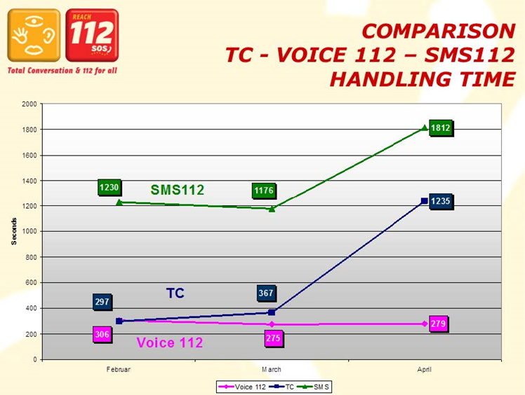
One thing noted in the study is that the total handling time for SMS-based calls is much greater compared to voice or Total Conversation calls. Over the three-month pilot period, 60% of the time was used for SMS112, 27% of the time was used for total conversation calls, and 12% of the time was used for voice calls. This means more PSAPs and EROs are needed to handle these calls if call volumes are heavy.
The pilot project was a success and become a blueprint for the extension of IP-based communications, Total Conversation and emergency services in the EU.

Asia Pacific Region
The Asia-Pacific region displays varying degrees of inclusion when it comes to supporting the needs of people with disabilities (PWDs) in their emergency medical services (EMS) systems. While some countries are not as advanced as those in Europe and North America in this, countries such as Australia, New Zealand, and Singapore exhibit advanced and accessible solutions that are easy to access. The findings in this report are not exhaustive, and in the wake of COVID-19, rapid development is occurring as this crisis has expediated demand for the revision of these systems.

Regulatory Environment

East Asia
East Asian laws typically include some protection for the disability community in their area. Often these are tied to welfare laws and grant PWDs access to telecommunication aids, usually at a reduced cost. Governments combat external barriers within the country, such as a lack of physical accessibility to businesses. And, in some cases, they use a portion of the national budget to create services and departments that improve the lives of PWDs through education, employment, and other means.

South Asia
South Asian laws mandate that public information be offered in auxiliary formats, such as Braille, so PWDs can access critical services during a crisis. Emergency medical facilities, in relation to EMS, are often protected under these laws. South Asian laws similarly distribute funds from their annual budget to create policies that benefit PWDs.. Some of these policies include: access to monthly allowance for nursing and care and access to healthcare.
Singapore is an example of a South Asian country that has advanced legal protection for PWDs. Singapore through its adoption of the UN Convention on the Rights of Persons with Disabilities (CRPD), explicitly requires that government protects PWDs during emergencies and natural disasters. The Singapore Police Force, aided by the Civil Defense Force, created an SMS helpline as an alternative mode of communication for the deaf and hard-of-hearing communities. This service allows users to text ambulance, fire and rescue, police, or civil defense departments during emergencies.
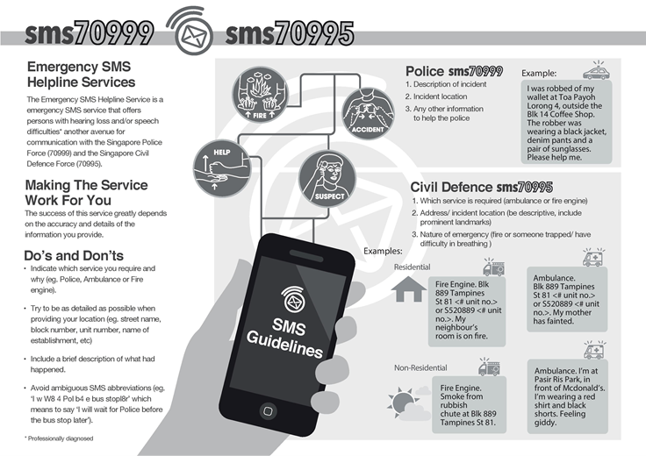
Figure 1: Infographic about SMS Helpline Service from the Singapore Civil Defense Force

Pacific Nations
Australia and New Zealand have adopted UN strategies for accommodating their population of PWDs. Australia established the National Disability Agreement (NDA) which mandates that the Australian and state/territory governments fund, monitor, and support public services for PWDs. Australia’s Disability Services Act protects specialist disability services including accommodation support services and respite care. The Council of Australian Governments issued a National Disability Strategy for 2010 to 2020, which enacted the National Broadband Network initiative that provides high speed broadband access across Australia. This initiative supported the rise of e-health services and emergency telecommunications for PWDs.

Prevailing Standards
In Australia, there are six national standards that must be upheld by all disability services. These standards are: Rights, Participation and Inclusion, Individual Outcomes, Feedback and Complaints, Service Access, and Service Management. While Australia‘s standards cover Aboriginal communities, in 2018, Aboriginal people were 1.5 times as likely to leave care prior to receiving emergency services after feeling like their cultural values were not recognized by the national healthcare system. 45% of the Aboriginal community have disabilities and these communities often live in overcrowded environments, without access to basic provisions, such as electricity. This has caused major concern during COVID-19 for those seeking emergency care for the virus.

Regional Differences
China, Japan and South Korea all use 119 for fire-related emergencies, however police access differs among the nations. South Korea uses 112, and China and Japan use 110 for the police. In South Korea and Japan, ambulance service is tied to fire and rescue services, whereas the designated number for ambulance services in China is 120.
Some South Asian emergency systems are fragmented, while others are ubiquitous. In 2017 Bangladesh created a united emergency services number, 999, that allowed access to fire, ambulance, and police services with one call. The following nations also use one integrated number: Myanmar, India, and Indonesia. Most nations in this region have two or more numbers, each regulated by different organizations.

Current Services (Deployed or Being Considered)

Voice
In 2019, China debuted a hotline service , which was released through the Beijing Tong app. Beijing Tong is used by citizens to access public services through the government. The hotline service can be reached by dialing the emergency number in the app. If the caller has a disability, dispatchers will inform EMS personnel of the case while staying in constant contact with the caller through text messages.
Japan has piloted 24-hour helplines to in larger cities, like Osaka, for crisis management. Tokyo has created an emergency consultation line run by the Tokyo Fire Department to provide callers clarity on who to contact during an emergency. This service can be reached by phone or through the internet.
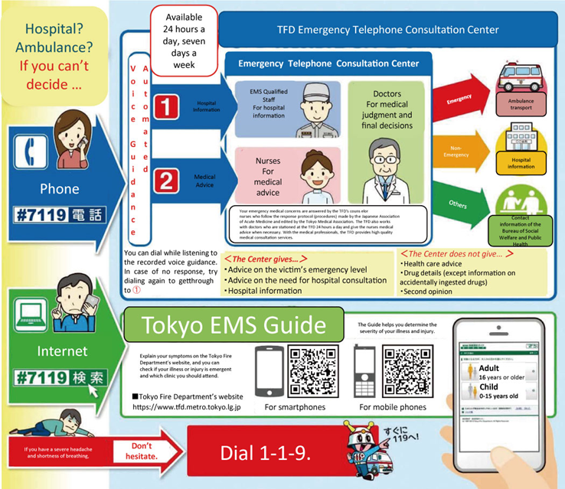
Figure 1: Infographic detailing 7119 consultation line in Tokyo
Not Disability Specific

Email
Japanese telecommunications carrier NTT Docomo has a feature available to customers called Disaster Message Board , a service that allows people to send messages during emergencies. This service relies on internet access or 5G and allows users to select short, pre-written statuses such as “Need help” through the carrier’s mail platform. This service can only be used when there is an emergency and it has been activated by the telecommunications carrier.

Applications (Apps)
Many countries in this region use software applications to connect people having emergencies and responders. Taiwan has an emergency services app called Video Call 119 which was released by the Taipei city government. The app uses video calling and GPS to connect users to the 119 dispatch centre. (Please see Appendix A.1 for screenshots of the app in use.)
In Singapore, an app developed by the Singapore Civil Defense Force (SCDF) called myResponder connects people in emergency situations with civilians trained to act as first responders. The way it works is civilian responders sign up with their SingPass, an account that grants them access to electronic government services, and receive training to certify them in first aid, CPR, or AED. The app uses GPS to locate callers as well as indicate automated external defibrillators (AEDs.) When a civilian receives a call, they have the ability to connect with medical professionals to guide them through first response, which is helpful when emergency services like ambulances are unavailable.
More information can be found here: myResponder
and in this video: IMPACT Ep1: Rex the Responder
Third party apps are also used by some countries. India 112 is an app created for for the Government of India’s Emergency Response Support System (ERSS) to provide medical aid. Since the app uses the Pan-India emergency number, it requires each state to possess and register emergency centres related to police, fire and rescue, and health services.
The app is available for free on Android and iOS mobile devices, but can also be used online (see Appendix A.2.) When in use, a contact’s information including their current location will be sent directly to local emergency services (and in some cases, volunteers). Help requests can be sent through voice call, SOS, SMS, and email. Pressing the phone’s power button repeatedly or selecting a designated button repeatedly will trigger the app to activate (similar to a panic button).
A video showing India 112 in action can be seen here: 112 India Mobile App | How to use panic button

Disability Specific Accommodations

SMS or Text Messaging
In Asia, there are some existing options for PWDs to contact emergency services. In Hong Kong, people with speech or hearing impairments can call for police, ambulance, and fire through sending an SMS to 992. This is exclusively for PWDs who have registered for the program. Malaysia has an app called SaveMe999 which offers PWDs 2 different accessible methods of contacting emergency services — one for deaf users and one for blind users. The app works with identification numbers, which users receive when they register with the Social Welfare Department. SaveMe999 Deaf is exclusively for users who are deaf or hard of hearing and uses GPS through internet to locate users, while making use of voiceless channels. SaveMe999 Blind is exclusively for users who are visually-impaired and also uses GPS. It also uses a voice-over function for communication. In the event that there is no internet, the user's location will be sent through SMS.
In addition to these active services in Asia, Japan began working on a new public service for their deaf and hard of hearing community members in 2020 . Under the system, people with hearing difficulties will be able to send messages in sign language or text using computers or smartphones, which will then be interpreted by operators in real time so those on the other end of the call can understand them. This new service would enable PWDs to contact the police in an emergency. It is proposed that this service will be active in 2021 during the fiscal year and comes as an alternative to an existing relay service created by the Nippon Foundation in 2013. It is only for emergency calls, and it is not available 24 hours a day, 365 days a year.
In the Pacific, both New Zealand and Australia have options for alerting emergency services for people with disabilities (PWDs). New Zealand’s TXT service is a free mobile feature that allows people with hearing and speech impairments to alert responders in cases of fire, crime, and medical emergencies. Users contact authorities and converse through text messages. This service makes use of Emergency Caller Location Information (ECLI), a service used by 111 operators to automatically generate the caller’s location by using their cellular network. This information then gets passed to emergency operators using the Location Area Service (LAS). A drawback to this service is that it requires the caller to have access to a mobile device and be within reach of a cellular network.New Zealand’s government provides a Disability Allowance that can be used to secure a phone.
New Zealand telecommunications company Spark has a service called Relay which enables PWDs who are “deaf, deaf-blind, or speech or hearing impaired” to make calls. Both of these services are compliant with the Commerce Commission's 111 Contact Code that ensures that vulnerable civilians can alert 111 emergency services during power outages.
In Australia, there are currently six methods for alerting emergency services. These include TTY, SMS and video relays, and captioned relay. The 106 TTY emergency service is a national text-based emergency service, and allows users to text and signal for ambulance, fire, and police services. Relay Officers are then put into contact with users and transfer their information to the appropriate EMS.
Australia’s National Relay Service (NRS) is a service for people with hearing or speech impairments. The NRS offers Text to Speech relay, Voice Carry Over, Voice Carry Over to Voice Carry Over, Hearing Carry Over, and Speech to Speech Relay. Users can contact emergency services by using the NRS’s Text Emergency Call Service.

Other Services Under Study
India has an emergency service helpline number specifically for women. 181 is a service can be reached at any time and offers the same access to police, medical, and fire rescue services but includes access to psychological care and shelter. It was reported by a former Indian chairwoman in 2015 that “[one] of the biggest challenges for women [with disabilities] is access [to services], not just physical but access across the board” (Goyal & Bhattacharjee, 2018.) Furthermore, in many cases, police were unhelpful and neglected to assist female victims of abuse on a perceived lack of ability to verify disability.

Analysis and Discussion
The researchers have identified the following classes of services designed for contacting emergency services:

Voice call
Placing a voice call to 911 via land line, mobile phone or VoIP call is still the primary way Canadians contact 911 today. A study completed in 2013 by the researchers showed that voice was still the preferred method of contacting 911 for those with no hearing or speech related issues. However, it should be noted that other methods of calling 911 such as video calls, text to 911, and RTT were not familiar and mainstream at the time of that study. It is estimated that 80 percent of 911 calls in the USA and 50 percent of calls in Canada are made via mobile phones. Voice calls still remain a barrier to individuals with hearing or speech related issues and they need to use other methods to contact 911.
Voice as a service for calling 911 is established and well known among the Canadian population. Except in the context of Total Conversation (described below) and video calls, it does not have to be studied explicitly other than to compare it in terms of efficiency and preferences with the other methods of contacting 911.

SMS or Text to 911
Canada’s implementation of Text-to-911 (called T911) differs from the implementation in the United States and some European countries. In Canada, T911 is restricted to hearing or speech impaired people, their family members, and close friends and requires pre-registration. It also requires that the caller place a voice call to the 911 operator first so location data can be transmitted by the mobile device. The operator having access to their registration information will then carry on the call using text messaging. In the United States, the Text-to-911 service is available to all and no registration is required. Network service providers support sending an SMS message directly to PSAPs. The FCC does not have regulations requiring PSAPs to support Text-to-911 fully. PSAPs that do not yet support this can receive text messages via the TTY service. Though a technology that is being phased out every PSAP is required to have a TTY system currently. If this service is not supported by the PSAP, the FCC requires network providers to send a bounce-back message. The use of this service is free, but it requires an active text messaging plan. Unlike the Canadian model no location data is exchanged. The caller must provide that information in their text message.
European Union countries use a combination of both of the models described above. In addition, in some regions like Spain, a fee is charged for sending text message to an emergency call centre. In Sweden, mobile devices have advanced location software (AML) deployed on mobile devices so it can be used to send the sender’s location to emergency services even when only SMS is used.
Although SMS is slower than voice calls as a communication medium, it is a popular among many Canadians. For some demographic groups, it is the preferred method of communications for contacting emergency services. One example that demonstrates this is the Virginia Tech University shooting rampage on April 16, 2007. Dozens of students and staff sent texts to 911 trying to get help. At that time no emergency call centre supported text messaging. SMS also has the advantage of allowing silent communication with the emergency operator, which is important in hostage situations and in cases of choking.
For people with hearing impairments, SMS is obviously an important primary method of communications. In discussions with emergency industry professionals who deal with accessibility in the United States, they feel that other methods of text message like RTT (first deployed in 2017) are still not broadly known or accepted. They feel SMS should remain supported even as other texting methods are deployed. The researchers feel it is important to see how T911, which is still a relatively new technology here in Canada, is accepted in the communities that have hearing and speech related issues but also contrast it with other methods of contacting 911 such as RTT and VRS.
Canada should consider keeping their T911 implementation even when RTT is deployed to provide more ways to contact emergency services. Lessons should be taken from the Text to 911 implementations of other countries such as the USA and Sweden, where emergency operators can locate the caller via the mobile phone’s AML service rather than requiring a phone call first followed by SMS.

MMS to 911
MMS to 911 is a way to send a picture or a short video clip to an emergency services operator. It by itself is not a way to contact 911 services, but rather an enhancement to the caller’s primary mechanism of contacting 911 (SMS, RTT, or voice). Usually, the emergency service operator will ask the caller to provide MMS content to help with the assessment of the situation. An advantage to this method is that most people’s phones have MMS capabilities. The disadvantage is it requires a mobile data plan. SMS and MMS services are also only ‘best effort’ type services. That means that in the event of network congestion, the messages will be delayed, and in some cases without an available destination could be held for hours or days before being delivered in a worst case scenario.
Only some PSAPs in the United States have upgraded their on-premise installed 911 equipment or 911 cloud infrastructure to handle MMS messages. MMS does not require any setup and typically uses less bandwidth than a live video stream as the user is either sending only a picture or short video clip.
PSAPs that do not support MMS can be more difficult to send text messages to. Most MMS-capable text messengers will send messages as MMS by default. If the message was not delivered, it will ask if it should retry sending it as an SMS message .
There have been no studies comparing the effectiveness of MMS to live video streaming. While MMS is popular and most understand what it is, some PSAPs are reluctant to adopt it. The researchers feel it would be valuable to collect information on the preference of users comparing MMS to live video streaming. Like SMS and RTT both may ultimately be supported. Access to data plans and the cost of streaming may ultimately slow down the adoption of these particular technologies. Policy changes in regards to cost and availability in an emergency may be required to ensure they get adopted.
Sending MMS messages to PSAPs is currently not supported in Canada. Adopting this technology will benefit everyone in cases where they cannot speak due to the situation (hostage/choking), thought processing (cognitive/cannot describe), or disability (hearing/speech).
Since sending MMS messages to some PSAPs in the USA is already supported, the effectiveness of MMS messages over SMS should be studied further. It is important to know if people know the difference between SMS and MMS as MMS messages will be rejected by PSAPs. MMS supports a subject line, multiple recipients, and attachments. Adding any of the three items will force an MMS message to be sent instead of SMS.
MMS and SMS are intended to be transitional technologies as better alternatives such as live video streaming and RTT as part of total conversation become popular. It should be analyzed whether people are comfortable enough with solutions like Facetime to skip MMS.

Real Time Texting
According to the CRTC NG911 roadmap, RTT deployment in Canada is already underway and is planned to be completed by March 2022. In the United States, as of December 31, 2017, Verizon, AT&T, Sprint, and T-Mobile all support RTT. Smaller network carriers have until June 30, 2021 to comply.
RTT has been built into mobile devices for a few years, iOS 11.2 (Dec 2, 2017) and Android 9 (Aug 6, 2018). According to GlobalStats statcounter, as of December 2020, 64.63% of Android users and 95.62% of iOS users have this feature built in.
Aside from the native iOS and Android dialer that supports RTT, there are few true real-world implementations of RTT for both regular use and for contacting emergency services. True implementation means all chat participants must be able to see or even hear the text the other party is writing without having to press the send button.
“Real-time Text is very different from SMS/MMS texting and it will be critical that the public understands the differences and how to use RTT to contact a 9-1-1 service provider for assistance.
To start with, the RTT User will not use the standard messaging application on their mobile device. The RTT 9-1-1 session will begin with the User opening the native dialer on their compatible smart phone device and tapping an RTT Icon to begin the session.
Once the session has begun, the user will dial 9-1-1 and the usual call routing/location identification processes will occur. The PSAP call taker will get a special notification that this is an RTT call and texting screens will open at both ends of the call.
Uniquely, the call taker will be able to see the characters being typed as they occur. There will not be a requirement to “send” the text after x number of characters. It will be a two-way text conversation (similar to voice) with all of the key board activities being visible to both parties.”
For casual use, there is Honk, a chat app where two participants type messages in their own chat bubble and erase their message to type a new one. This app was released globally in December 2020 for iOS devices. There was also BeamCall, a chat app that transcribes voice calls, converting spoken words to text, and speaks typed text messages. All messages are logged and tapping on a message will play the corresponding audio. This App disappeared after 2018. Please see Appendix NA.1 for more details about this App. For calling emergency services, nWise MMX has their own proprietary VRS app and RTT gateway to support calls with RTT.
The lack of adoption is likely because the technology is too new, still being deployed by vendors, and not well known outside and even within disability communities compared to technologies like SMS/MMS. A quick search for “real time text Android” or “real time text iOS” shows little to no videos about what it is or how it works. As for articles there is not much talk about it outside of mobile carrier websites.
In addition, there are some technical issues that need to be resolved. The intermediate implementation for PSAP is that RTT was supposed to be relayed to the PSAP’s TTY system if they do not yet able to accept RTT. That implementation does not currently fully work for all use cases. In talking to some emergency number industry professionals there is the impression that few actual RTT sessions to a PSAP are currently being completed due to the technical issues and the lack of visibility of the technology mentioned above.
In addition, while RTT is being rolled out, alternative protocols such as rich communication services (RCS) and over the top (OTT) are quickly gaining mass adoption. OTT is used by popular chat platforms such as iMessage, WhatsApp, WeChat, and Facebook messenger. None of these platforms have instant send features like RTT and messages sent from the OTT App cannot be received by another different, third party App.
Despite all these hurdles on adoption, the adoption of RTT is inevitable as there are regulations pushing for the rollout, TTY is limiting and does not work well on IP networks, and RTT to TTY interoperability workarounds does not work or at least not well enough.
From the end user's perspective, RTT implementations should look and act more or less like traditional line-by-line text chats to ease adoption and acceptance. It is important to study and test existing RTT implementations like the iOS and Android dialer, and Relay UK to test acceptance and gather feedback. It will also be useful to see which text-based communication method people with disabilities would prefer to use and why: TTY, SMS, MMS, RTT, or voice-to-text relay.

Video Relay Services
The number of providers in the video relay service field is fairly limited. The three main players as of 2012 are IVèS (SRV Canada), nWise (myMMX) and Sorenson (nTouch) .
When registering for a VRS account hosted in Canada and the United States, users have to provide their name, address, and email. All users are assigned a 10-digit phone number along with a username and password to login to the VRS app. Users have to keep their home address up-to-date. Tess in Germany requires the same registration information . Bildtelefoni in Sweden does not require an address . All users are assigned a username and password to log into the VRS app. They may also be provided a SIP address (phone number) and customer number.
The challenge with VRS is currently the Emergency operator is only hearing the interpretation of the sign language interpreter. Sometimes the interpretation is wrong and or the nuance of the statement is lost because the emergency operator cannot see the facial expression of the caller. Some people working on the NENA Accessibility Committee feel there is value in replacing VRS with a three-way video call process where the emergency operator would see and hear not only the sign language interpreter but the original caller. Comparing the existing VRS implementation with a video call similar to Zoom and defined within the Total Communication specification is important.
The researchers think it is important to study how to better integrate VRS into emergency calls by allowing three-way video calls between the caller, interpreter, and emergency operator.

Speech-to-Speech Relay
Speech-to-Speech (STS) is a form of Telecommunications Relay Service (TRS) that enables persons with a speech disability to make telephone calls using their own voice (or an assistive voice device). STS uses Communications Assistants (CAs) – to relay the conversation back and forth between the person with the speech disability and the other party to the call. STS CAs are specifically trained in understanding a variety of speech disorders, which enables them to repeat what the caller says in a manner that makes the caller’s words clear and understandable to the called party . STS relays only exist in some countries like the United States and Australia. In the United States you need to pre-register to use the STS Relay service. Then you dial 117 to access the service. In Australia, a comparable service is Speak and Listen; this service is exclusively for people with speech impairments that do not use a TTY. User registration through the Australian government is required for this service, including the disclosure of specific speech assistive requirements.
Canada current does not have this service but there are over 440,000 Canadians who have significant speech, language and communication disabilities that are not caused by significant hearing loss. In the context of further studies on emergency services it will interesting to see how many Canadians are aware of this service and feel there is potential value in having this service. It has not been brought up in previous CRTC consultations with the disability community.

Total Conversation
Total conversation is a concept where video, voice, and real-time text can be used simultaneously in telecommunications to enable universal access to communication services. This has been almost fully adopted in video relay services as they allow communication with video, audio, and traditional line-by-line text messaging.
In the US, RTT is not currently mandated for fixed services. There is some pushback from video relay service (VRS) and captioned telephone service (CTS) vendors like Sorenson and CaptionCall regarding including RTT in their app because of the following reasons:
- VRS and IP CTS already provides a way for hearing impaired people to communicate with 911 services without the use of RTT
- Video calls (FaceTime) and text relay calls on mobile devices already have RTT support
- VRS and IP CTS does not provide direct communication between the calling and called parties so it is unclear how RTT will fit in.
- The party that is not a VRS or IP CTS subscriber will likely not have an RTT-capable phone
However, there are some weaknesses to this argument as not all hearing and speech impaired people know sign language and may prefer to communicate using real-time text. Also, some deaf-blind users prefer to use sign language but receive responses as real-time text . Furthermore, although VRS and CTS does not allow direct communication between parties, it would be beneficial if a disabled person could see the text the relay operator was typing in real-time to speed up conversations .
It is important to explore the various use cases and see how relevant they are to sub-groups of users within the disability community. Potentially it may be that not all the use cases need to be supported or it may be that all the use cases must be supported.
Total Communication is on the roadmap for Europe and some testing has happened for a version of this technology in Illinois as part of a university study. As noted in the section on VRS, making the caller visible to the emergency operator in addition to the sign language interpreter can reduce the number of mistakes in conversations. Some research into whether the intended user community holds that view broadly will be important in informing the future NG911 roadmap.
Some things potentially worth looking into include:
- How many Canadians with disabilities know what relay services are available to them and how to use them?
- Do Canadians with disabilities prefer to communicate directly (Voice, TTY, RTT, SMS, or MMS) or through a relay?
- How relay service providers from different regions can contact PSAPs in Canada to work around regional sign language differences and offer services not offered in Canada such as speech-to-speech relay.
Further research can be done to create an enhanced chat client that takes the best of multiple third-party solutions such as the following:
- BeamCall’s automatic real-time text to speech and speech to text transcription and logging (See appendix NA.1)
- Slatch’s automatic text, audio, and video translation service (See appendix NA.1)
- Sorenson’s nTouch 3-way video relay or just multi-party video chat
- 112 Where are U’s saved profile/medical information and emergency contacts
- Wireless Location Information (WLI) and Advanced Mobile Location (AML) for real-time caller location during emergency calls
- DeveryWare GHALE/RapidSOS API for PEMEA compatibility

Third Party Apps
A number of third-party apps were discussed across the various geographic regions above. Some of them connected directly to an emergency services operator at a PSAP, some connect to a commercial call centre and some them were intended to connect to a close circle of friends and relatives. For North America, NENA has provided high level guidance in the design of third-party emergency apps. In regards to interacting with E911 infrastructure they provide the following guidance:
- E911 calls have voice data associated with an 8-or-10-digit phone number. The phone number is used route the call to the appropriate 911 center, which may not be the one closest to the caller. Jurisdictional responsibilities, local laws, and geographic relationships determine where the call is routed to.
- All E911 calls should transmit the caller’s location and phone number to 911 centres. However, due to call network limitations, the caller’s name, location, or callback number cannot be automatically provided. The caller’s location can be used to quickly locate the caller when the call is made. If the call was made on a land line phone, the phone number can be queried in an Automatic Location Identification (ALI) database to find the phone subscriber’s registered address. It should be noted that some 911 centres do not have E911 location and ALI phone number lookup capabilities.
- Most 911 centres cannot accept text, pictures, or videos, nor can they receive additional data such as personal information, medical history, or building floor plans.
- The E911 architecture currently has different interface techniques for calls from wireline, wireless, and Voice over Internet Protocol (VoIP). Developers should understand how calls and data are passed to E911 systems for the different service types.
- Apps that notify a caller’s family or friends of an emergency situation is not a solution for contacting 911. Callers should contact 911 directly to reduce the delay in getting help.
- Apps must not interfere in the user’s ability to make a voice call to 911. If the user makes a 911 call, some phones will block the usage of other phone apps such as texting or video.
In Europe, ETSI created the Pan-European Mobile Emergency Application (PEMEA) architecture to define the requirements and architecture for consumer chat apps to interconnect with emergency applications. This ensures apps pass accurate or properly formatted caller profile and location information to the local PSAP. The framework also provides ways to enable new communication mechanisms as they evolve. DeveryWare GHALE and RapidSOS provides an API for apps to tie their emergency call function with their solution to ensure PEMEA compliance.
By having developers adopt this standard, users can be assured that they can reliably contact emergency services from applications that have this feature such as Uber. For people with disabilities, there can be 911/112 emergency apps that stores profile information, medical information, emergency contacts, and has silent, voice, text, and video communication options.
Canada may need a more prescriptive standards like PEMEA to ensure third party apps are relevant and accessible to people with disabilities.
In addition, there are some concerns about privacy in third-party apps. Some are designed to only store contact information, medical information and the information of close contacts on the phone. Other apps use remote storage on their company servers. In this case the company has full access to critical, personal information.
Examples of App are:
- Apps that provide icons for people with cognitive impairment might be needed if they are not natively supplied by wireless service providers. The researchers anticipate that not everyone’s needs will be addressed by the native apps that are distributed with phones. However, a validation process is needed to ensure privacy is not compromised and the actual process is efficient and allows callers to reach 911 operators. Icon based App are a potential part of the eco-system. Their design and deployment should be studied more to ensure they meet the needs of people with cognitive impairments.
- Some Apps convert text messages to speech and speech to text messages. This may be relevant to users with low literacy skills, issues due to English or French not being their primary language or due to cognitive related issues
- Some Apps can send pre-defined messages describing the type of help needed reducing the cognitive load on the caller needing help.
- Web based Apps can provide Total Conversation abilities (video, voice and text) through a user’s browser without having to install a specific App on the mobile device. This opens the service to more users.
It is important to study what information is collected and displayed by these third-party emergency contact apps. There may be methods to keep the interface simple to make buttons easier to tap and prevent information overload. New interface and access methods may be relevant to specific disability communities but their relevance can not be determined without study.

Live Video Streams
Live streaming of video from the caller’s handset to the emergency services operator is a new service. It is currently not widely deployed in the United States but more broadly deployed in Europe. It is typically used in conjunction with a voice call or text-to-911 session or RTT session.
For PSAP platforms that support this feature, the process from the caller’s viewpoint is as follows. After calling 911, the caller is sent an SMS text message containing a webpage link. The webpage will ask for access to their phone’s camera and microphone to initiate the video stream.
A live video stream could help the emergency service operator better guide the first responders to the caller locations if the caller cannot provide an exact location and it helps the operator assess the situation – such as in a multi-car accident or situations that present a continuing danger to the caller and first responders. Early anecdotal evidence from conference presentations indicate it can be effective.
For current PSAP platform implementations, it is designed to be a one-way process. The video feed comes from the caller to the emergency services operator. Having a one-way feed reduces the load on the network but also maintains the anonymity of the emergency services operator. For a caller who is blind this might be the only way for the emergency operator to get more accurate information of the situation. It might also be way for the operator to guide that caller away from the immediate danger if the caller cannot see.
More studies need to be done to determine if there is a perceived need for this technology among people with disabilities and to identify the technology’s privacy concerns.

Facsimile (Fax)

Fax is recognized as a precursor to modern methods of emergency communication. In the past, Sri Lanka’s government used this method to communicate with civilians during emergencies due to its low cost, however this method lost popularity due to its slow nature. Several countries actively accept fax, particularly as an auxiliary method of communication for people with disabilities. A benefit to this method for users is that the use of telefax is free. Austria, Belgium France, Hong Kong, and New Zealand have emergency numbers for people with hearing impairments that rely on fax and SMS. Croatia, Cyprus, Germany, and Spain all accept fax from any emergency caller.
Canada has never used fax as a form of EMS contact but the researchers are trying to not pre-judge its relevance to specific disability communities. The researcher will leave it up the disability community to give feedback on what is relevant to them.

Community-Based Initiatives
The adoption of community-based initiatives can help people in rural parts of Canada, such as the Northwest Territories (NWT), Nunavut, and Yukon, get emergency help faster. Volunteers can step in to provide fire and medical assistance before officially trained first responders arrive. The community could also provide relay services for disabled people to communicate with emergency operators and first responders as T911 is unavailable in NWT and Nunavut , but is now available in Yukon .
Something worth finding out is how many Canadians know about the Good Samaritan law and if it is covered in their province. This is important because people are afraid of the liability issues if they tried to help someone but ended up causing more harm.
It is also worth looking at the average response time for fire and medical assistance to arrive in rural parts of Canada. The NWT emergency infrastructure has improved significantly with the introduction of a unified 911 emergency number , high-speed Internet, and 4G connectivity . However, they are still stuck with basic 911 service with no automatic caller location and the dispatch center only has one or two dispatchers working per shift . As of October 2019 in NWT, ”only Yellowknife has an emergency dispatch system. In the capital city, a call transfer from 911 to the proper emergency service is expected to take between 13 and 40 seconds.”
This type of emergency contact and response system may be viable in rural communities where emergency response may be limited in terms of resources and even availability. Some rural communities route 911 calls to local police after business hours and they may not be available 24 hours a days with full staffing. It is important to understand the need for this type of service and the acceptance by potential end users.

Social Media PSAP Integration

Users of the social media messaging app, WeChat, can call for emergency services in China through their official account. They can also send real-time messages to the Foreign Ministry of Affairs. These messages can be text based or multi-media based. Twitter was used as a mode of connecting to emergency services on numerous occasions, including in when Australian government tweeted updates during the natural disaster bushfires in Victoria. The New York Fire Department used Twitter as a means to locate and rescue victims of Hurricane Sandy.

Social media has been a popular platform for EMS organizations to reach out to members of the public, particularly during a crisis. The Australian Country Fire Association uses Twitter as a primary method for sending updates and alerts. During the 2011 Earthquake in New Zealand, concerned persons relied on a Google Person Finder to locate missing persons; this method was able to track and store data on thousands of records.

Social media is also a popular method for users to stay connected within their own communities, since so much of the population is active on at least one platform. Furthermore, in a report done by the Red Cross, 63 percent of Canadians wanted EMS responders to respond to their calls for help on social media. In 2012, then Iqaluit mayor, Madeleine Redfern, relied on Facebook to alert her community, as well as Twitter during emergencies such as a water crisis. She stated of her use, “It depends on the information, but if it’s timely and we can’t wait for a press release, then I can put a message on Twitter for the media and community.”
Since social media is such a popular communication medium, it is worth exploring how Canadians use it to report and be informed of emergencies. It is also worth seeing how many PSAPs support receiving help messages through common social media platforms like Facebook and Twitter to get information and video footage from multiple angles.

Icon & Pictogram-Based Apps
Icon and pictogram-based apps have the advantage that they do not rely on a specific level of literacy skills, are language independent and they are simpler to understand for those individuals that may have cognitive related issues.
These apps are a useful alternative in an emergency as users can tap a picture of a burning house and a text message can be sent to first responders alerting them of the fire. The app could include more levels of detail. For example, a picture of an apartment building and a means of indicating the floor and apartment number could be options. Symbols and pictures could be arranged to provide various levels of detail. When an icon is tapped, text data describing the emergency is sent to the local PSAP along with GPS location information.
Two existing apps include the “Show Me For Emergencies” and “Emergencies Call”. See icon-based apps in the United States section for more details. The use of pictograms apps to contact emergency services has also been studied in VUTE 2009 by NTT labs. Instead of relying only on icons like the other two examples, this one includes motion pictograms to give users better comprehension. It also is also unique in incorporating the expressive manner of sign language in the design of the motion pictograms. The prototype covers the scenarios of calling an ambulance or fire engine in an emergency such as a sudden illness or fire.
There have been previous systems like this. In 2013 NTT Docomo in Japan had a pilot system for Deaf users with the slightly different approach of using icons representing various emergency scenarios. When an icon is touched, text data describing the emergency is sent to the local PSAP along with GPS location information.
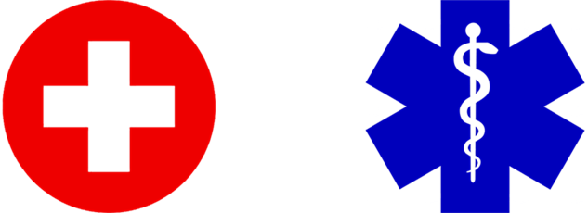
The challenge of these types of systems is there is no universal set of symbols that are recognized by everyone. Symbols though simpler to recognized still have to be learned and adopted through familiarity. The Red Cross and Star of Life for example is recognized as representing medical aid in most Western cultures.

Symbols for fire and police may be less clear depending on the region of the world you are in. The police symbol may be mistaken for a train conductor and some people may not recognize the police badge.

The researchers believe that in Canada these symbols would be a good starting point. Whether as part of a third-party App or some national emergency App released by a government agency, this could potentially address the issues of people with moderate levels of cognitive issues where comprehension and cognitive loading is critical. Depending on the number of symbols a variety of situation can be represented. Specifically for people with cognitive impairment or people with low literacy skills a rudimentary set of symbols represent basic generic situations is recommended. Further research in this area would help establish the symbol set.

Service Ranking Survey
To help narrow the scope of a subsequent study, the researchers are asking you to select the top 5 services that you feel are relevant to you and your disability or stakeholder community based on the relevance and usefulness to your community members. The focus should be on whether it solves a problem for your stakeholders and if they will use it as a means of contacting emergency services. Use the form in the separate Microsoft Word document that accompanied this report.

Appendices

Appendix A.1 User Making Video Call From 119 App
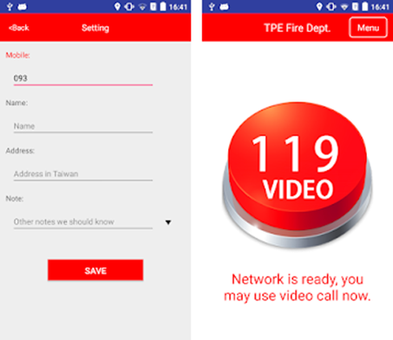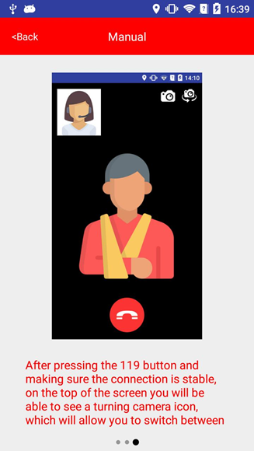

Appendix A.2 Requesting Help from India 112 Website
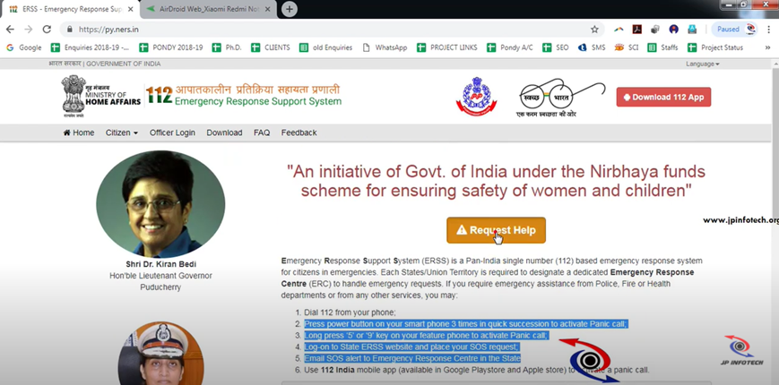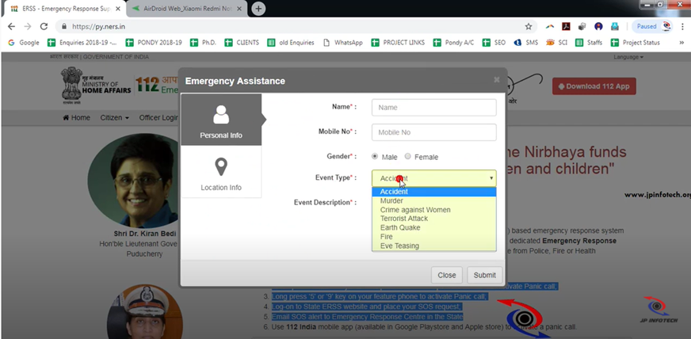

Appendix E.1: Callers & Call Takers Using Carbyne
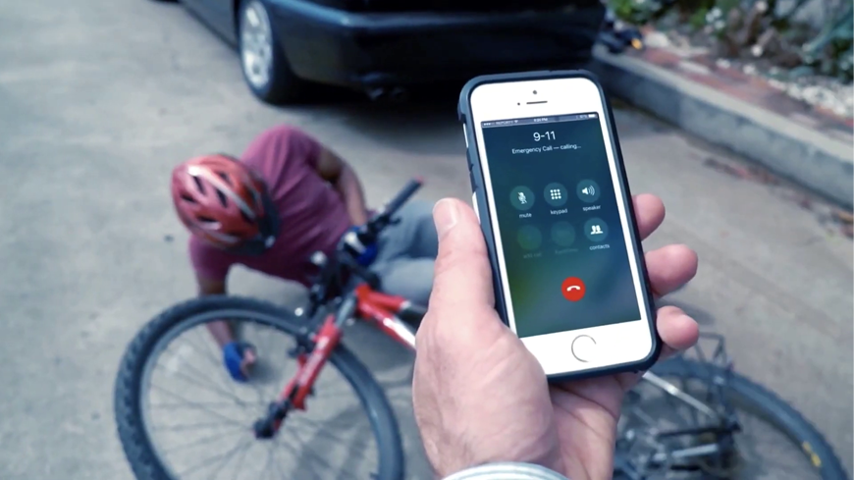
Figure 1 - Witness calls 911 after seeing an injured biker
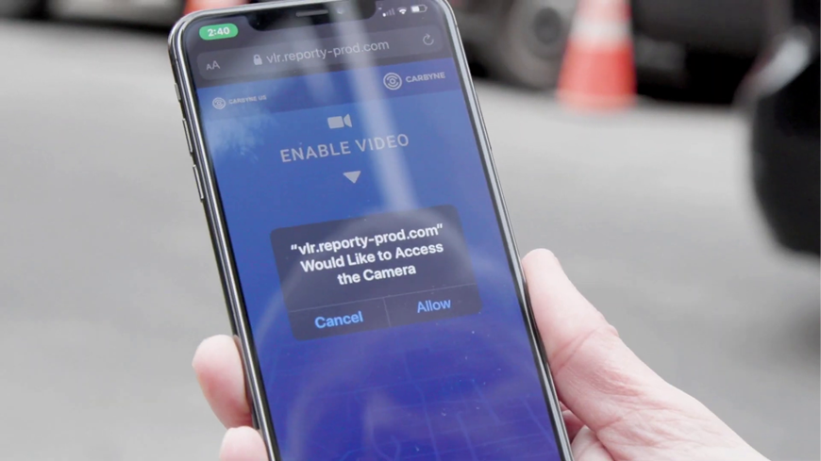
Figure 2 - Caller opens video chat web app link sent by PSAP by SMS
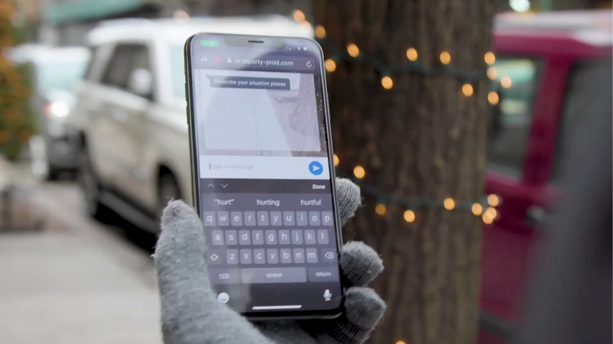
Figure 3 - Caller can use web app to chat with PSAP. Notice video feed running behind chat and chat is not using RTT.
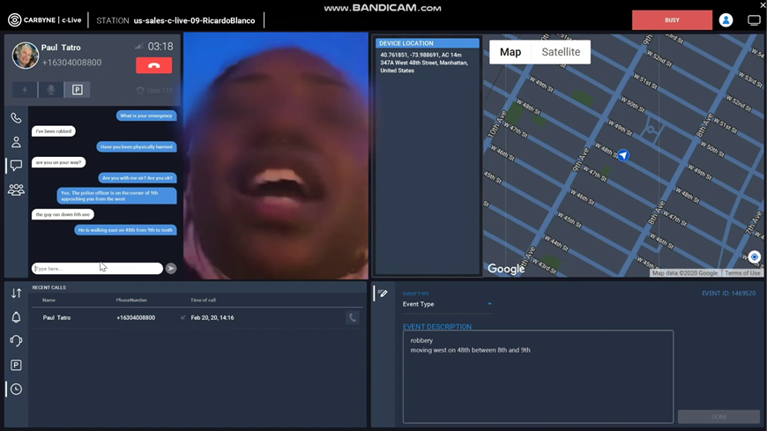
Figure 4 - Caller has been robbed and informs PSAP of robber's location by voice, video, and text chat.
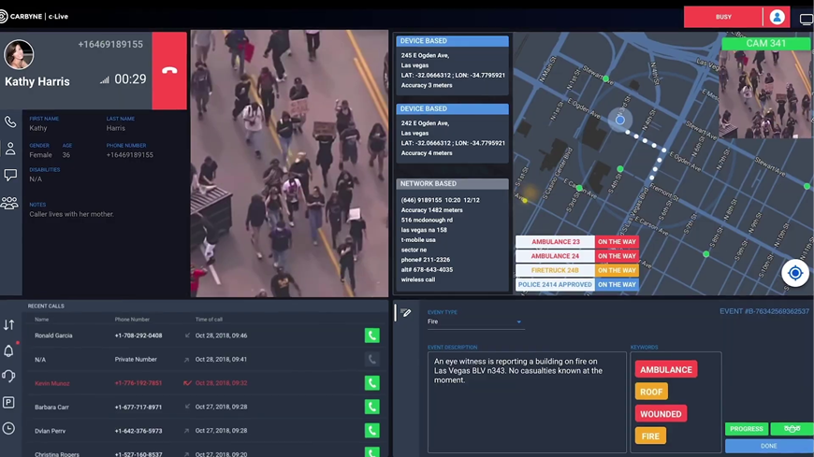
Figure 5 - Caller reports building fire by voice. Note caller info, real-time location, and city camera feed.
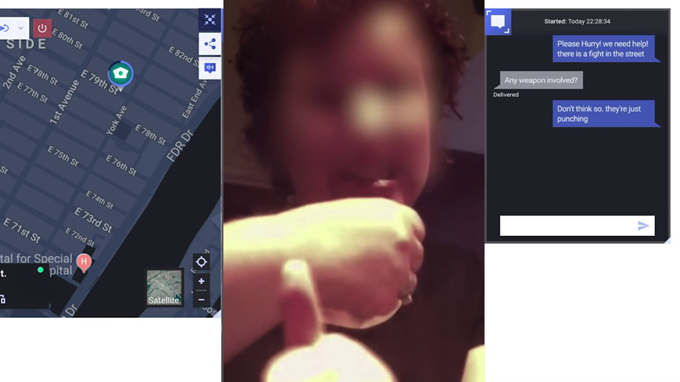
Figure 6 - Deaf caller reports street fight by sign language relay
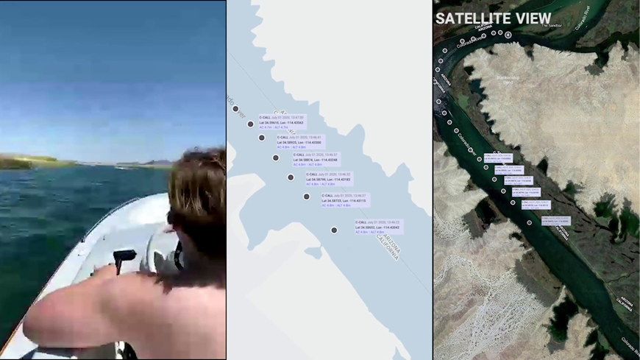
Figure 7 - Carbyne tracks caller's real-time location to send help to the right spot.

Appendix E.2: CELESTE demo applications
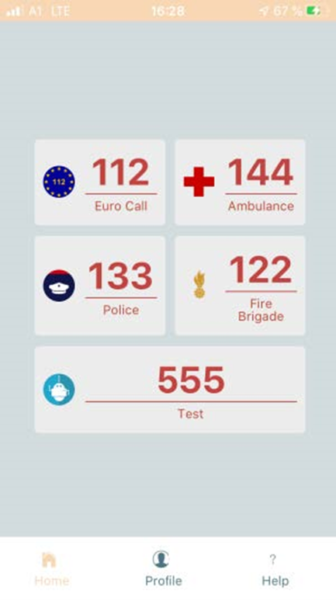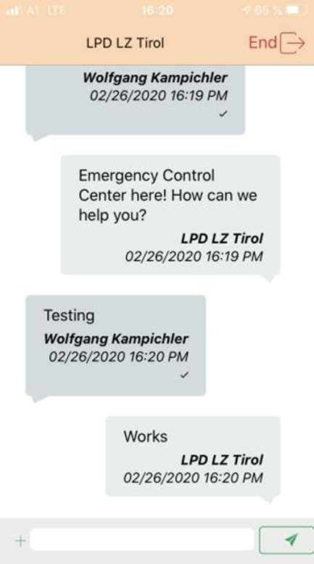
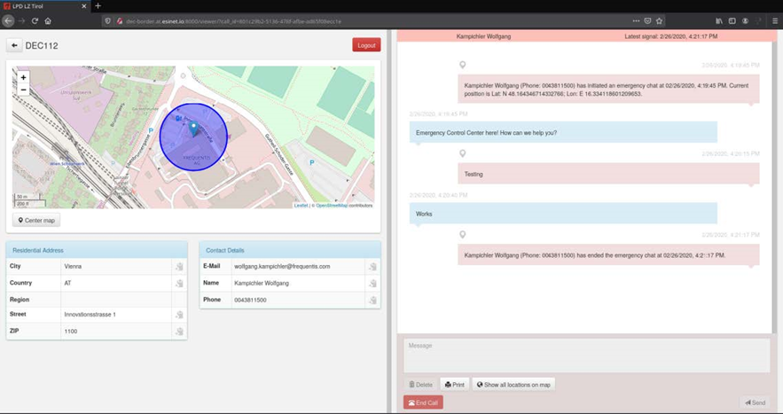

Appendix E.3 EU Standards for Key Emergency Services
ETSI EN 301 549: Accessibility requirements for ICT products and services covers the design of information and communications technology (ICT) to ensure they are accessible for people with disabilities who may have vision, mobility, hearing and cognitive related issues. This is an essential standard because if people with disabilities cannot use mobile phones, they cannot access emergency services.
ETSI TS 103 478: Pan-European Mobile Emergency Application (PEMEA) covers how applications can pass accurate and properly formatted caller profile and location information to the local PSAP. The standard does not provide explicit guidance on how to make the App accessible. Designers need to refer to ETSI EN 301 549 to ensure accessible Apps.
ETSI TR 103 201 / ETSI TS 101 470: Total Conversation systems incorporate simultaneous voice, video, and text message communication channels in one platform. The adoption of this standard will enable and improve access to emergency services by people with vision, hearing, speech, and cognitive disabilities.
RFC 5194 / RFC 4103 / ETSI TR 102 575: Reliable Real-Time Text (RTT) covers the RTT communication protocol and outlines a method to reduce the risk of missing message text caused by packet loss. This standard mentions how it can accommodate people with hearing and speech impairments along with how it can be used to contact emergency services.
ETSI ES 202 975 / ITU-T F.930: Harmonized relay services is a standard to assist in the implementation of various relay services for improved access to communication technologies for people with disabilities. The standard states that all relay services must allow users access to public emergency services. Relay services can have limited hours, but must at least by available during normal working hours. Relay providers must answer the call in less 10 seconds on average over a 24-hour period and 99% of calls must reach the conversion function in 2 minutes. The only accessibility requirement is that web-based services must be compliant with WCAG 2.0 AA guidelines.
ETSI TS 103 625: Advanced Mobile Location (AML) is a smartphone service that sends the caller's geolocation to emergency operators when a local or country emergency phone number is dialled. AML makes use of a mobile phone’s location capabilities (GNSS, Wi-Fi and cellular network information) to figure out the caller’s location at the time the call is made. These technologies can provide precision as fine as 5 metres outdoors (or approximately 25 metres radius indoors). This standard makes no mention of any accessibility requirements.
ETSI TS 126 267: eCall is a system installed in a vehicle that is activated automatically as soon as in-vehicle sensors and/or processors (e.g. airbag) detect a serious crash. When activated, the system calls the 112 emergency number and sends details of the accident (Minimum Set of Data) to the appropriate emergency call center (PSAPs). Currently, eCall makes no accessibility accommodations for deaf users.
ETSI TS 102 182/ETSI TS 102 900: Emergency Alert/EUALERT standards outline the requirements, technologies, and methods authorities and organizations will use to communicate to individuals, groups or the general public during emergencies. The goal is to alert 50% of the citizens in the relevant area in 3 minutes and 97 % of the citizens in that area in 5 minutes. For rapid emergencies (earthquakes) the goal is 10 seconds. The use of telephone voice, voice mail, fax, SMS, paging, broadcast radio, TV, email, and instant messaging can be used to transmit alerts. Considerations for the hearing impaired were mentioned. Hearing impaired persons receiving an alert on their mobile device may not hear warning sounds and cannot feel their device vibrating if it is not in contact with their body. A workaround may be to have the screen flash as a visual indicator.
ETSI TS 102 182: Common Alerting Protocol (CAP) is a standardized and now widely adopted protocol by which emergency notification messages may be conveyed from administration bodies who create emergency notification messages to TV, radio, and network operators who broadcast the notification to individuals. Some implementations of CAP include TV stations inserting “crawl text” with the warning message, radio stations inserting a recording from 105 authorities, web page ads being replaced with alert messages, and SMS alerts. No recommendations to make emergency notifications accessible were mentioned.

Appendix NA.1 Third-Party Apps

AT&T Real Time Text App
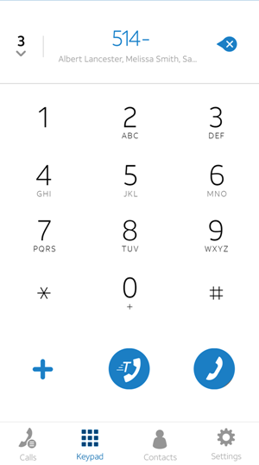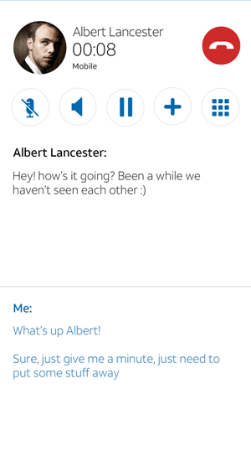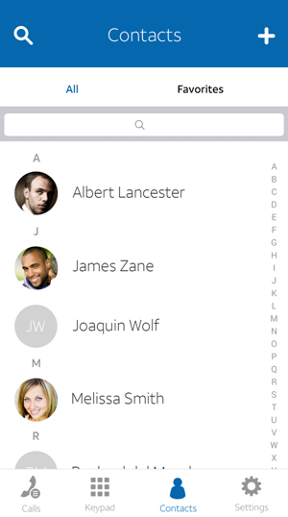
AT&T Real-Time Text (RTT) helps AT&T customers with disabilities communicate over the wireless network as an alternative to TTY. RTT uses a free-flowing mix of text and voice conversation, so as quickly as characters are typed on the sending device, they are displayed on the receiving device. RTT is a separate service from traditional text messaging (SMS).
- Great for everyday communication
- Supports 711 and 911 calls
- Eliminates the need to connect to mobile TTY devices
- Works on the AT&T cellular network and over Wi-Fi Calling
- Offers a more natural, conversational flow compared to TTY and relay service for persons with hearing or speech disabilities
- Supports simultaneous text and speech on RTT-to-RTT calls
- Automatically imports contacts from your phone
- Works on smartphones and tablets running iOS 9.1 and Android 4.4 or later

Ideal Group Speech2RTT® Communicator
Speech2RTT® is an Android app that enables people who are deaf, hard of hearing, and non-verbal to communicate with anyone using their Android smart phone. It transcribes and then streams the text of what is being said, in real time, between individuals. If a user cannot speak or opts not to speak, they can type what they want to say in real time. Speech2RTT® Communicator , an IDEAL Group innovation, is an Android-based mobile app that handles all of the following processes, locally, on smart phones:
- Speech recognition/transcription/in-context error correction;
- Immediate, real-time, streaming of the text, generated in step #1; and,
- Two-way, real-time text, communications.
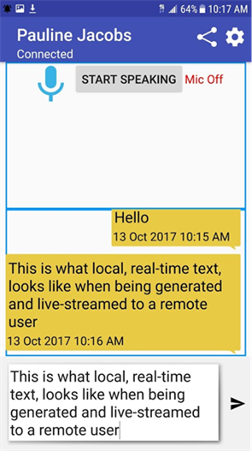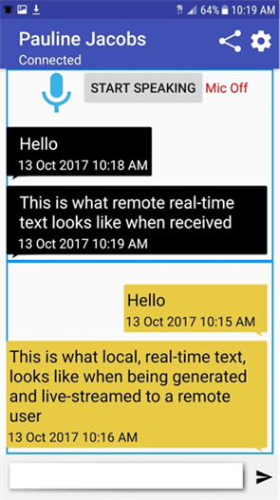

Rave Mobile Safety
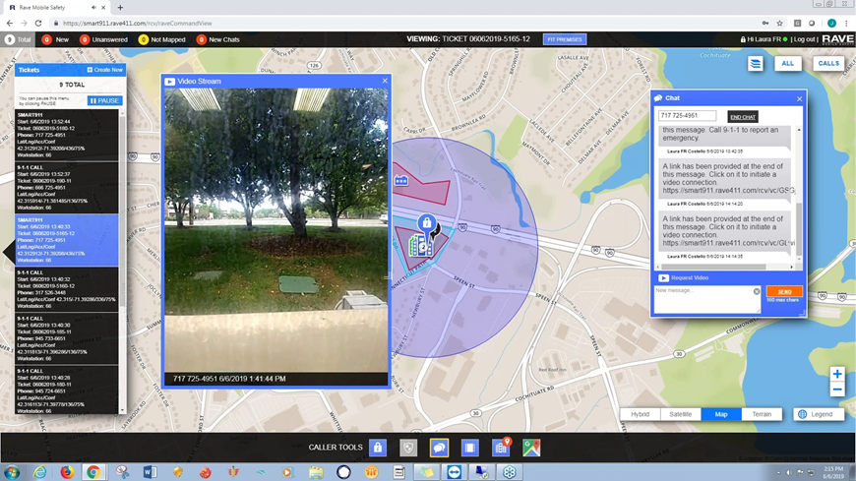
The concept of being able to stream video from the caller’s handset or from the cameras of first responders on site (live streaming of video) is fairly new. Rave Mobile Safety is the second company, after Carbyne, to introduce a system that supports live streaming as part of the emergency service platform for PSAPs in 2019.
“The feature enhances public safety officials’ ability to communicate, assess emergency situations, better deploy critical resources, collaborate and make more informed decisions during an event with real-time critical information.”
“Rave’s live streaming works with the existing 9-1-1 system and networks to provide telecommunicators, supervisors, emergency operations center (EOC) managers, field commanders, responders and emergency management officials the ability to request a live feed from any smartphone, without the need for a pre-loaded app or a NG9-1-1 network.”
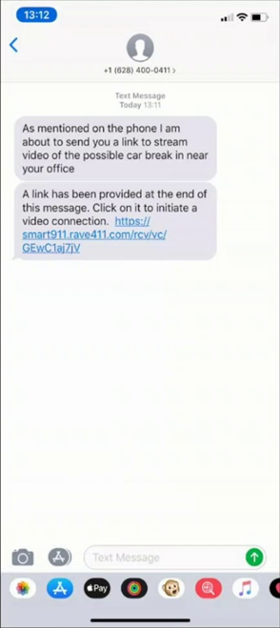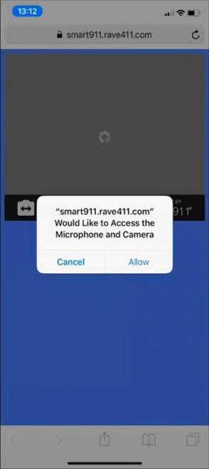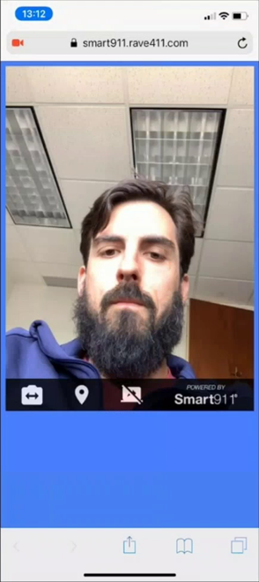“Rave’s live streaming enables the 9-1-1 call taker or other authorized public safety official to initiate live streaming by simply sending a text message to the caller with a link to establish the streaming video, putting the control of video into the hands of public safety. Once initiated on both sides, the call taker or first responder can use the live stream to gain situational awareness and determine what resources should be allocated. The feature will also help free up life-saving resources by identifying issues that may not require significant or urgent response.
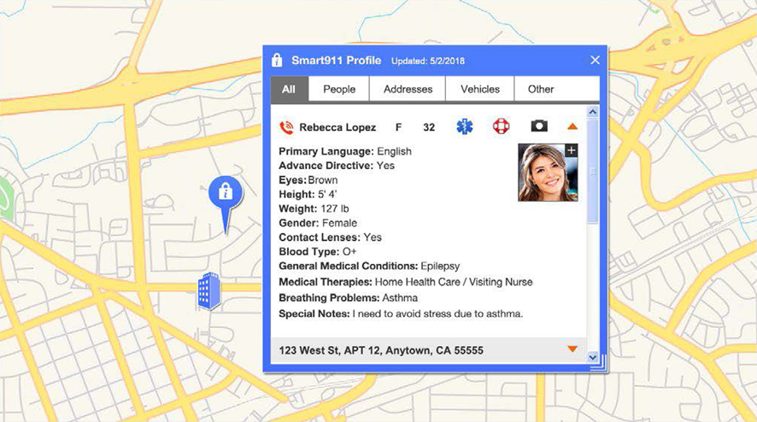
Rave 911 has two unique features compared to other competitors like Carbyne. Rave 911 integrates with the Smart911 community resident database to retrieve caller profile and medical information. It also supports importing site details and floor plans of schools and businesses to help first responders keep people safe and make evacuations easier .

Show Me for Emergencies App
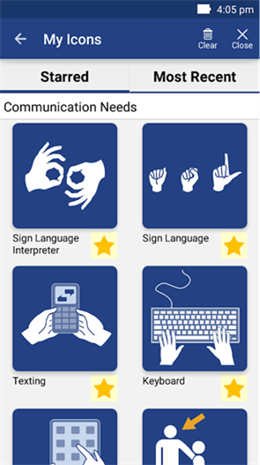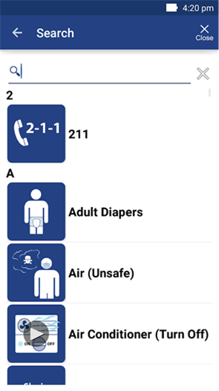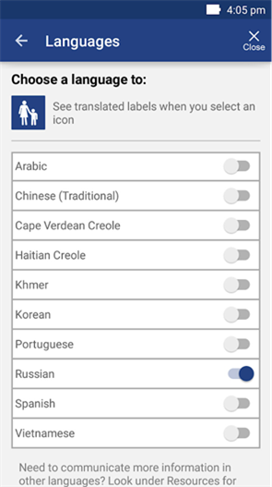
“Show Me for Emergencies is an essential free app for emergency workers and people with communication needs - like difficulty understanding English, hearing impairments, and cognitive disabilities. It uses easy-to-understand icons for two-way communication during an emergency.
Tailored icons for Emergency Shelters, Emergency Dispensing Sites (also called Points of Dispensing or PODs), Sheltering-in-Place, and Evacuating help emergency workers give clear directions. General communication icons for medical needs, personal needs, and feelings and support give people a way to express what they need - and help workers gather important information.
During an emergency, first responders and first receivers need to give information to and gather it from disaster victims. Show Me for Emergencies will help. Just pass the phone or tablet back and forth to show exactly what you mean.
- Communicate quickly during an emergency with a research-based augmentative and alternative communication (AAC) tool
- Overcome language barriers with clear, understandable icons
- Use the app even without mobile phone service or WiFi
For people with communication issues:
- Be prepared for any emergency - and confident that you’ll be able to get help
- Use big, easy-to-press buttons designed for people with physical impairments
For staff and volunteers:
- Get custom icons for different emergencies - blizzards, fires, hurricanes, disease outbreaks, and others
- Help people in need get around a confusing emergency shelter or other location
- Use the app as a conversation aid to save time, reduce confusion, and earn trust during an emergency
Developed by the Office of Preparedness and Emergency Management of the Massachusetts Department of Public Health.”

Emergency Call App
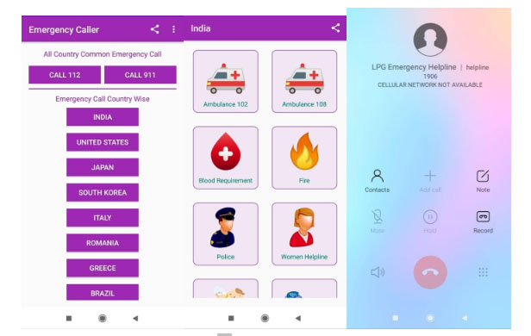
Emergency App by Jarin Apps is an emergency calling app for Android that uses icons. Using icons to supplement the text allows people who do not know English well to still be able to contact emergency services. To make an emergency call, the user selects the country they are calling from and the emergency service they need. There is no need to remember which emergency number to call. Although this app is not specifically intended to support users with other issues like cognitive disabilities, some aspects of this design can be used to support this group of users. More thought needs to be put into what icons are universal in nature within a specific country and do not require local cultural knowledge.
There are a number of different Apps available that deal with emergency situations. Some of them only send alerts to people on your emergency contact list. Its intent is that they then call an emergency number operator if it is deemed necessary. These apps are not covered here in this document unless there is a unique aspect to the design of the user interface or in the process the user used to contact emergency services.

Here I Am App
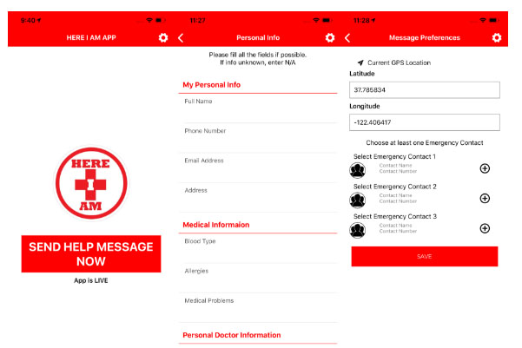The Here I Am App allows you automatically send a text message to 3 contacts that are pre-defined in the case of an emergency. The user needs to activate the App for the emergency message to be sent to the contacts. The contacts are intended to contact an emergency services operator. The App has a one-time up-front fee of $1.99 and provides lifetime support for that fee.
“When sent, the text message will relay the user or sender’s medical information to each of their contacts along with the precise GPS coordinates of the user
The idea is that the person(s) receiving the message would call their local 911 or EMS services on behalf of the person in need. As the person in need may be not in the same 911 or EMS service area as the person(s) receiving the message, by giving the 911 operator the person in need’s exact GPS location, the local 911 operator will be able to connect the person calling on behalf of the person in need with a 911 service local to where the person in need is located.”

Beam Messenger/BeamCall (Abandoned)
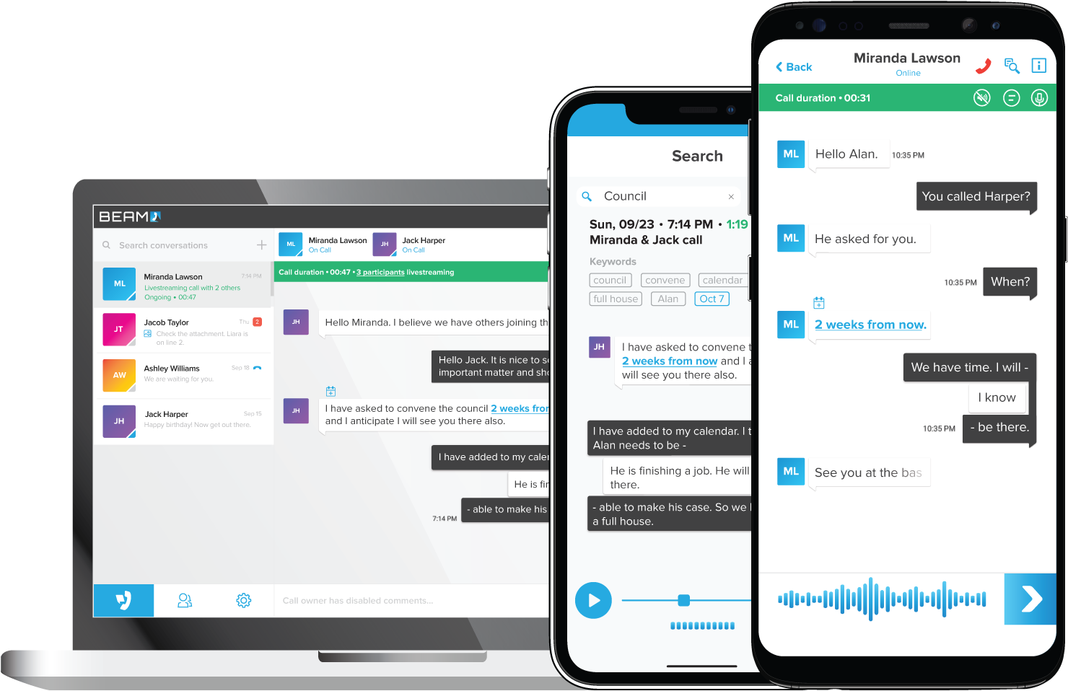
Beam Messenger is a real-time text messaging app released by Beam Propulsion Lab in November 2014. Unlike traditional texting apps, Beam shows both participants in a conversation what the other party is writing as they write it. Every character, every deleted character, every single pause, in real time. Since launch, it has racked up over 50,000 users. However, sometime in 2017, the product disappeared and was later relaunched as BeamCall.
A beta version of BeamCall was announced sometime in October 2017 and disappeared after 2018. It aimed to unify phone calls and text messaging. Voice calls are converted to text and text messages are converted to speech. Additionally, audio and text are synchronized so tapping on any message text will play back the audio from that moment.
These two useful features along with real-time text has the following benefits:
- Speed up text conversations by being able to read messages as they are typed
- Gives the ability to have conversations in noisy environments or where noise is not permitted
- Allows people to review past conversations with searchable voice transcriptions
- Enable the deaf or hearing impaired to have phone calls with others

Slatch
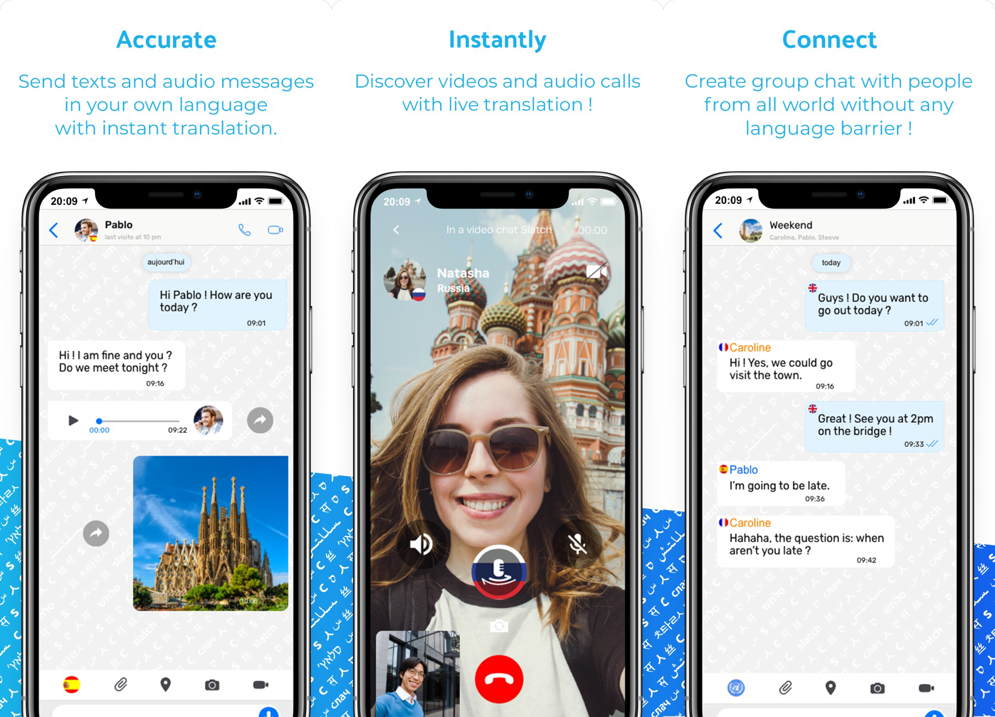
Slatch allows millions of users worldwide to speak with anyone no matter what language they speak. Slatch is the first instant messaging app with live translation featuring messaging, video chat and group chat.
This can help emergency operators get around the language barrier when travellers make emergency calls or send emergency text messages. If combined with real-time text, voice-to-text, and text-to-voice technologies, this can be very powerful.

https://transition.fcc.gov/pshs/911/Text911/APCO_Emerging_Tech_Text_911.pdf (pg. 8)
“What is GPS and how does it work?”. https://www.geotab.com/blog/what-is-gps/.
Louisa White. What Is MMS Messaging and How to Enable It (aiseesoft.com)
Linda Rosencrance.. What is MMS (Multimedia Messaging Service)? (techtarget.com)
Drew Wilkinson. SMS vs. MMS: The Difference Between MMS & SMS (simpletexting.com)
“Fact Sheet* What Public Safety Answering Points Should Know about Real-Time Text PSAP RTT Education Day Event on October 2, 2018”. fact_sheet_about_real-time_text_for_public_safety_answering_points.pdf (fcc.gov)
“Electronic Code of Federal Regulations: part 67 Real Time Texting”. Electronic Code of Federal Regulations (eCFR)
Adam Fedelman. Explaining SMS Messaging and Its Limitations (lifewire.com)
https://www.govinfo.gov/content/pkg/FR-2013-01-09/pdf/2013-00159.pdf (pg. 9)
if https://eena.org/knowledge-hub/documents/sms-communication-with-psaps-and-eros-updated/ (pg. 15)
https://www.911techadvisors.com/single-post/2020/01/18/real-time-texting-in-ng9-1-1-how-will-it-be-different-from-standard-sms-texting
https://www.911techadvisors.com/single-post/2020/01/18/real-time-texting-in-ng9-1-1-how-will-it-be-different-from-standard-sms-texting
https://beta80group.it/en/offer/emergency/public-safety-answering-points/computer-aided-dispatch/life-1st-apps/
“REACH112 – DISABLED USERS’ REQUIREMENTS FOR EMERGENCY SERVICES”. https://www.europarl.europa.eu/document/activities/cont/201104/20110413ATT17668/20110413ATT17668EN.pdf
Unicode – The World Standard for Text and Emoji
https://tap.gallaudet.edu/IPTransition/Real-Time%20Text%20and%20TTY%20interworking%20in%20various%20technical%20environments.pdf (pg. 6)
Use real-time text (RTT) with calls - Android Accessibility Help (google.com)
https://nwise.se/en/mmx/emergency-services/
https://www.etsi.org/deliver/etsi_es/202900_202999/202975/02.01.00_50/es_202975v020100m.pdf (pg. 14)
“Answer or make RTT or TTY calls from your iPhone ”. https://support.apple.com/en-us/HT207033
https://www.ravemobilesafety.com/webinars/using-live-video-to-overcome-challenges-in-emergency-communications-recording (5:06)
https://www.gps.gov/systems/gps/performance/accuracy/
https://www.ecomm911.ca/news/cell-phones-to-provide-caller-location-to-regional-9-1-1-centre/
https://www.ravemobilesafety.com/webinars/using-live-video-to-overcome-challenges-in-emergency-communications-recording (6:20)
https://www.ravemobilesafety.com/webinars/using-live-video-to-overcome-challenges-in-emergency-communications-recording (7:00)
Robert Stahelin II. Laura Costello. “NENA Ignite 2020 Presentation: How Live Video Streaming Helps 9-1-1 Improve Public Safety.” https://cdn.ymaws.com/www.nena.org/resource/resmgr/ignite/how_live_video_streaming_hel.pdf
Next Generation 9-1-1 (NG911) | IIT School of Applied Technology
News Release: S&T, DOT Select Universities to support 911 Comms | Homeland Security (dhs.gov)
https://eena.org/knowledge-hub/documents/sms-communication-with-psaps-and-eros-updated/ (pg. 15)
https://signvideo.co.uk/signvideo-for-the-community/
https://captioncall.com/
https://cdn.ymaws.com/www.nena.org/resource/resmgr/Docs/PSAPVRSIPRelayFAQs.pdf (pg. 1)
Speech to Speech Relay Service?”. Federal Communications Commission. https://www.fcc.gov/consumers/guides/speech-speech-relay-service
” People who have communication disabilities”/ Communications Disabilities Access Canada. https://www.cdacanada.com/resources/communication-disabilities/statistics/
”Speech to Speech Relay Service”. United States Federal Communications Commission. https://www.fcc.gov/consumers/guides/speech-speech-relay-service
”Speech to Speech Relay Access Numbers by State”. American Federal Communications Commission. https://www.fcc.gov/general/speech-speech-services-access-numbers
”ETSI TR 102 974 V1.1.1 (2009-09) Technical Report Human Factors (HF); Telecommunications relay services“. https://www.etsi.org/deliver/etsi_tr/102900_102999/102974/01.01.01_60/tr_102974v010101p.pdf
Singapore Heart Foundation. Save-A-Life Initiative. https://www.myheart.org.sg/programmes/save-a-life-initiative/
Lai, H., Choong, C. V., Fook-Chong, S., Ng, Y. Y., Finkelstein, E. A., Haaland, B., Goh, E. S., Leong, B. S., Gan, H. N., Foo, D., Tham, L. P., Charles, R., Ong, M. E., & PAROS study group (2015). Interventional strategies associated with improvements in survival for out-of-hospital cardiac arrests in Singapore over 10 years. Resuscitation, 89, 155–161. https://doi.org/10.1016/j.resuscitation.2015.01.034
Lateef, Fatimah. Ministry of Law, Singapore. 2012. Written Answer by Minister for Law, K Shanmugam, to Parliamentary Question on the introduction of a Good Samaritan law in Singapore. https://www.mlaw.gov.sg/news/parliamentary-speeches/written-answer-by-minister-for-law-k-shanmugam-to-parliamentary-question-on-the-introduction-of-a
Ministry of Road Transport and Highways. Good Samaritan. https://morth.nic.in/good-samaritan
Amenity Lifeline Emergency Response Team (ALERT). Overview. https://alert.ngo/overview/
https://www.nih.gov/news-events/nih-research-matters/bystanders-save-lives-using-defibrillator-cardiac-arrest
UN ESCAP. Enhancing National Capacity for early warning dissemination in Sri Lanka. https://www.unescap.org/sites/default/files/capacity-early-warning-sri-lanka-tor.pdf
Perera, Amantha. Reuters Media and Telecoms. 2017. As disaster hits again, early warning text messages fly in Sri Lanka. https://www.reuters.com/article/us-sri-lanka-floods-socialmedia-idUSKBN18Q23M
Hettiarachchi, S.S.L., Siriwardena, C.S., et al. Cabaret. 2018. THE CURRENT CONTEXT OF MULTI-HAZARD EARLY WARNING SYSTEMS (MHEWS) FOR COASTAL RESILIENCE AT NATIONAL LEVEL. http://cabaret.buildresilience.org/images/NPP-Sri-Lanka.pdf
What is NG911? (ems1.com)
Next Generation 9-1-1 — Thank You 9-1-1
https://www.dol.gov/general/topic/disability/ada.
” An Overview of the Americans With Disabilities Act :. https://adata.org/factsheet/ADA-overview
https://www.congress.gov/bill/112th-congress/house-bill/3630
Microsoft Word - 128701 (911.gov)
FCC Report on Legal and Regulatory Framework for Next Generation 911 Services. FCC Report on Legal and Regulatory Framework for Next Generation 911 Services
https://www.911.gov/pdf/Nondiscrimination_Disability_State_Local_Government_Accessibility_NG911_2010.pdf
”Telecommunications Act of 1996 ”. American Federal Communications Commission. https://www.fcc.gov/general/telecommunications-act-1996
”FCC Requirements for Telecommunications Manufacturers and Providers: Section 255”. https://www.levelaccess.com/fcc-requirements-telecommunications-manufacturers-providers-section-255/
Telecom Notice of Consultation CRTC 2016-116 | CRTC
CRTC reviewing next-generation 9-1-1 services - Canada.ca
”CRTC marks the start of Text with 9-1-1 services for hearing or speech impaired persons”. CRTC marks the start of Text with 9-1-1 services for hearing or speech impaired persons - Canada.ca
” Next-generation 9-1-1 – Modernizing 9-1-1 networks to meet the public safety needs of Canadians”. Telecom Regulatory Policy CRTC 2017-182 | CRTC
”Next-generation 9-1-1 network design efficiencies”. Telecom Notice of Consultation CRTC 2018-105 | CRTC
“Next-generation 9-1-1 network design efficiencies”. Telecom Regulatory Policy CRTC 2019-66 | CRTC ,
”UN Convention on the Rights of Persons with Disabilities: Making Domestic Implementation Real and Meaningful”. http://www.ccdonline.ca/en/international/un/canada/making-domestic-implementation- real-and-meaningful- feb2011
”CRTC Broadcasting and Telecom Regulatory Policy 2009-430”. Broadcasting and Telecom Regulatory Policy CRTC 2009-430 | CRTC
What is NG911? (ems1.com)
NENA i3 Solution - Stage 3 - National Emergency Number Association
NENA Releases NG9-1-1 i3 Standard Version 2 - National Emergency Number Association
”NENA Standard for 9-1-1 Call Processing. https://cdn.ymaws.com/www.nena.org/resource/resmgr/standards/nena-sta-020.1-2020_911_call.pdf
” Public Safety Considerations for Smartphone App Developers”.https://www.nena.org/page/SmartphoneApps
https://cdn.ymaws.com/www.nena.org/resource/resmgr/Docs/Smartphone_Apps_Consideratio.pdf
“New and emerging technologies 911 improvement act of 2008”. PUBL283.PS (congress.gov)
”Twelfth annual report to congress on state collection and distribution of 911 and enhanced 911 fees and charges for the period January 1, 2019 to December 31, 2019”. 12thannual911feereport2020.pdf
” Telecom Decision CRTC 2019-353 - CISC Emergency Services Working Group – Consensus report on matters related to compatibility, reliability, resiliency, and security for next-generation 9-1-1. ” October 22, 2019. Telecom Decision CRTC 2019-353 | CRTC
https://www.nena.org/general/custom.asp?page=911statistics
Wireless Communications and Health - An Overview”. Wireless Communications and Health - An Overview - Spectrum management and telecommunications
https://www.west.com/en_ca/safety-services/enterprise-e911-solutions/what-is-e911-faqs/
.”Wireless Communications and Health - An Overview”. Wireless Communications and Health - An Overview - Spectrum management and telecommunications
https://www.simplemost.com/say-first-calling-911-cell-phone/
”Smart911 Free Emergency Call Service is Now Available to a Majority of Morris County Residents”. https://morriscountynj.gov/2017/10/smart911-free-emergency-call-service-is-now-available-to-a-majority-of-morris-county-residents/
Herb Weisbaum https://www.cnbc.com/2014/05/07/why-calling-911-on-your-cell-is-not-always-a-good-idea.html
Krista Merry.”Smartphone GPS accuracy study in an urban environment”. https://www.ncbi.nlm.nih.gov/pmc/articles/PMC6638960/
https://www.ecomm911.ca/news/cell-phones-to-provide-caller-location-to-regional-9-1-1-centre/
https://www.gps.gov/systems/gps/performance/accuracy/
Emily Ferron. ”6 Things To Know About Calling 911 in 2019 (Hint: Alexa Can’t Do It For You)”. https://www.safety.com/calling-911/
“Telecom Decision CRTC 2020-150- CISC Emergency Services Working Group – Consensus report ESRE0089 regarding next-generation 9-1-1 mapping and addressing considerations.” Canadian Television-Radio and Telecommunications Commission.” https://crtc.gc.ca/eng/archive/2020/2020-150.htm
https://www.telus.com/en/business/medium-large/phone/cloud-phone-systems/cloud-phone
https://www.shaw.ca/uploadedFiles/Digital_Phone/About/Shaw_Home_Phone_vs_VOIP_Transcript.pdf
https://www.nextiva.com/blog/what-is-voip.html.
https://theinformr.com/cell-phones/p/best-basic-phone-10094/
” 9-1-1 Services for Traditional Wireline, VoIP and Wireless Phone Services”. Canadian Television-Radio Telecommunications Commission. https://crtc.gc.ca/eng/phone/911/can.htm
“PSAP Text-to-911 Readiness and Certification Form ”. https://www.fcc.gov/general/psap-text-911-readiness-and-certification-form.
Linda Haelsen. ”From SMS Text-to-911 to Photo & Video-enabled MMS: It’s Time to Think Ahead”. March 7th, 2017. https://www.nice.com/protecting/blog/from-sms-textto911-to-photo-videoenabled-mms-its-time-to-think-ahead-623/
https://www.fcc.gov/files/text-911-master-psap-registryxlsx
https://www.business.att.com/content/dam/attbusiness/briefs/att-ng911-intrado-text2-911-solution-brief.pdf
https://crtc.gc.ca/eng/archive/2013/2013-22.htm
https://www.textwith911.ca/en/faqs/#a17
https://www.west.com/wp-content/uploads/2016/02/TXT2911-Power-Svc-Guide.2017.09.28.pdf
”From SMS Text-to-911 to Photo & Video-enabled MMS: It’s Time to Think Ahead”. https://www.nice.com/protecting/blog/from-sms-textto911-to-photo-videoenabled-mms-its-time-to-think-ahead-623/
https://www.west.com/wp-content/uploads/2016/02/TXT2911-Power-Svc-Guide.2017.09.28.pdf
See paragraph 71 of Telecom Regulatory Policy 2017-182, as amended in Telecom Decision 2018-188, for specific obligations.
See paragraph 182 of Telecom Regulatory Policy 2017-182 for specific obligations.
Guy Caron. NENA IGINITE Conference: NG9-1-1 in Canada: Current Status and Lessons Learned. https://cdn.ymaws.com/www.nena.org/resource/resmgr/ignite/ng9-1-1_in_canada.pdf
” Investigating the effect of congestion on mobile networks in Poland”. Tutela. February 20201. Investigating the effect of congestion on mobile networks in Poland (tutela.com)
Pragyan Verma a,*, Preeti Sharma b,1, *, Sattyam Kishore Mishra c,1. ” Dropping of Call Due to Congestion in Mobile Network”. Journal of Computer Applications (JCA) ISSN: 0974-1925, Volume V, Issue 1, 2012. Dropping_of_Call_Due_to_Congestion_in_Mo.pdf
”The Negative Effects of Your Network Congestion Problem”. Datapath.io . July 12 2016. The Negative Effects of Your Network Congestion Problem | by Datapath.io | Medium
Dr. Jean-Claude Franchitti. ”Data Communication & Networks G22.2262-001 Session 9 - Main Theme Network Congestion: Causes, Effects, Controls”. New York University Computer Science Department Courant Institute of Mathematical Sciences. Microsoft PowerPoint - Network Congestion - Causes - Effects - Controls (nyu.edu)
https://appliedtech.iit.edu/real-time-communications-lab-information-technology-and-management/projects/next-generation-9-1-1
https://www.dhs.gov/science-and-technology/news/2020/08/03/news-release-st-dot-select-universities-support-911-comms
https://www.ravemobilesafety.com/
Laura Costello, “How Live Video Streaming Helps 9-1-1 Improve Public Safety”. PowerPoint Presentation (ymaws.com)
NENA Ignite 2020 Presentation: How Live Video Stream Helps 911 Improve Public Safety. PowerPoint Presentation (ymaws.com)
” Telecom Regulatory Policy CRTC 2017-182 - Next-generation 9-1-1 – Modernizing 9-1-1 networks to meet the public safety needs of Canadians”. https://crtc.gc.ca/eng/archive/2017/2017-182.htm
https://srvcanadavrs.ca/en/
9-1-1 - SRV Canada VRS
Frequently Asked Questions - SRV Canada VRS
https://srvcanadavrs.ca/en/resources/resource-centre/vrs-basics/install-app/
https://srvcanadavrs.ca/en/resources/resource-centre/app-features/9-1-1/
” Speech to Speech Relay Service”. Federal Communications Commission. Speech to Speech Relay Service | Federal Communications Commission (fcc.gov)
People who have communication disabilities. Communications Disabilities Access Canada. https://www.cdacanada.com/resources/communication-disabilities/statistics/
https://apps.apple.com/us/app/at-t-real-time-text/id1314605670
https://play.google.com/store/apps/details?id=org.idealgroup.communicator
https://www.ravemobilesafety.com/rave-911-suite
https://play.google.com/store/apps/details?id=gov.ma.dph.showme
https://play.google.com/store/apps/details?id=com.revenuesolutions.emergencydialer
https://play.google.com/store/apps/details?id=com.techiopia.hereiam
“Convention on the Rights of Persons with Disabilities (CRPD) United Nations.” https://www.un.org/development/desa/disabilities/convention-on-the-rights-of-persons-with-disabilities/optional-protocol-to-the-convention-on-the-rights-of-persons-with-disabilities.html
”Emergency Services Accessibility for Persons with Disabilities ”. European Emergency number Assocation. https://eena.org/knowledge-hub/documents/emergency-services-accessibility-for-person-with-disabilities/
https://eur-lex.europa.eu/legal-content/EN/TXT/?uri=CELEX%3A32019L0882
https://www.edf-feph.org/newsroom-news-emergency-call-council-accessible-emergency-communication-persons-disabilities/
”Emergency Services Accessibility for Persons with Disabilities”. European Emergency number Assocation. https://eena.org/knowledge-hub/documents/emergency-services-accessibility-for-person-with-disabilities/ (pg. 15)
” Emergency Services Accessibility for Persons with Disabilities”. European Emergency number Association. https://eena.org/knowledge-hub/documents/emergency-services-accessibility-for-person-with-disabilities/
https://www.etsi.org/deliver/etsi_ts/103400_103499/103478/01.01.01_60/ts_103478v010101p.pdf
https://www.etsi.org/deliver/etsi_tr/103200_103299/103201/01.01.01_60/tr_103201v010101p.pdf
https://www.etsi.org/deliver/etsi_ts/101400_101499/101470/01.01.01_60/ts_101470v010101p.pdf
https://www.etsi.org/deliver/etsi_ts/102100_102199/102182/01.05.01_60/ts_102182v010501p.pdf
https://www.etsi.org/deliver/etsi_ts/102900_102999/102900/01.03.01_60/ts_102900v010301p.pdf
https://berec.europa.eu/eng/document_register/subject_matter/berec/download/0/5549-update-of-the-report-on-equivalent-acces_0.pdf (pg. 53)
https://www.tess-relay-dienste.de/files/hilfehandbuch_fuer_kunden_0.pdf (pg. 10)
https://kund.bildtelefoni.net/webtc/#/registration
https://www.tess-relay-dienste.de/faq/allgemeines/warum-muss-ich-fuer-tess-bezahlen
https://www.bildtelefoni.net/anvand-tjansten/broschyr-och-manualer/
https://www.tolkcontact.nl/ik-zoek-een-tolk/vergoeding-en-tarieven/
https://www.tolkcontact.nl/tolkcontact-app/tolkcontact-tolk-op-afstand/aanvragen/
https://ec.europa.eu/commission/presscorner/detail/en/IP_09_240
https://www.sos112.be/en/faq-112.html
https://web.archive.org/web/20191229115013/http://pagina.jccm.es/justicia/112/accesibilidad/1810_audileng.html
Law for the Welfare of Physically Disabled Persons. 1948, Law No. 283. https://www.dinf.ne.jp/doc/english/law/japan/30select.html#support
Act on Welfare of Persons with Disabilities. 2014. https://www.un.org/development/desa/disabilities/wp-content/uploads/sites/15/2019/11/Korea-Republic-of_The-Welfare-Law-for-Persons-with-Disabilities.pdf
The Law on Persons with Disabilities. 2012. Article 5. https://dredf.org/wp-content/uploads/2012/08/Vietnam-the-law-on-persons-with-disabilities.pdf
Disabled People’s Association, Singapore (DPA). Singapore and the UN CRPD. 2015. Article 11. https://www.dpa.org.sg/wp-content/uploads/2015/06/Singapore-and-UN-CRPD.pdf
National Disability Agreement. 2009. http://www.federalfinancialrelations.gov.au/content/npa/national_agreements/national-disability-agreement.pdf.
Government of Australia. 1986. Disability Services Act. https://www.legislation.gov.au/Details/C2018C00146/Download
Commonwealth of Australia. National Disability Strategy for 2010-2020. 2011. https://humanrights.gov.au/sites/default/files/NDS%20PDF.pdf
Australian Government, Department of Social Services. National Standards for Disability Service. 2013. https://www.dss.gov.au/sites/default/files/documents/06_2015/nsds_full_version.pdf
NITV. Cultural spaces proposed for NSW hospitals welcomed. 2018. https://www.sbs.com.au/nitv/nitv-news/article/2018/04/04/cultural-spaces-proposed-nsw-hospitals-welcomed
Nichol, Emily. NITV. Urgent action needed to protect First Nations people with disability from COVID-19. 2020. https://www.sbs.com.au/nitv/article/2020/03/23/urgent-action-needed-protect-first-nations-people-disability-covid-19
BDNews24. 2017. Bangladesh officially launches 999 emergency helpline. https://bdnews24.com/bangladesh/2017/12/12/bangladesh-officially-launches-999-emergency-helpline
Sixth Tone. Beijing Introduces Emergency Hotline for People With Disabilities. 2019. https://www.sixthtone.com/ht_news/1004504/beijing-introduces-emergency-hotline-for-people-with-disabilities
https://www.tfd.metro.tokyo.lg.jp/ts/ems_e/page03.html
https://www.nttdocomo.co.jp/english/info/disaster/disaster_board/
https://www.tca.or.jp/information/disaster.html
Ministry of Home Affairs. "An initiative of Govt. of India under the Nirbhaya funds scheme for ensuring safety of women and children." https://112.gov.in/.
Shubham, Shaurya. Economic Times India. 2020. 112 India review: One-stop app with an easy interface to help people in distress. https://economictimes.indiatimes.com/magazines/panache/112-india-app-review-one-stop-shop-with-an-easy-interface-to-help-people-in-distress/articleshow/75351237.cms
https://www.gov.hk/en/nonresidents/visitinghk/usefulinfo/emergency.htm.
https://www.police.gov.hk/info/doc/smsemg_e.pdf
http://savemeprov.999.gov.my/
Hosaka, Tomoaki. The Asahi Shimbun. 2020. Japan to set up public service for deaf people to make phone calls. http://www.asahi.com/ajw/articles/13426729
Ministry of Business, Innovation & Employment. Emergency Caller Location Information. https://www.mbie.govt.nz/science-and-technology/it-communications-and-broadband/our-role-in-the-ict-sector/emergency-call-services/emergency-caller-location-information/
Work and Income, Government of New Zealand. Phones. https://www.workandincome.govt.nz/eligibility/health-and-disability/phones.html
Spark NZ. Help with Accessibility. https://www.spark.co.nz/help/accessibility
Spark NZ. Vulnerable Consumers. https://www.spark.co.nz/help/vulnerable-consumers/
Tasmania Fire Service School Fire Education. National Relay Service. https://www.tfseducation.com.au/national_relay_service
Jolley, William. Australian Human Rights Commission. 2003. When the Tide Comes In: Towards Accessible Telecommunications for People with Disabilities in Australia. 4.4. https://humanrights.gov.au/our-work/when-tide-comes-towards-accessible-telecommunications-people-disabilities-australia-7#nrs
Sengupta, Ananya. The Telegraph India Online. 2015. Ladies, dial 181, whenever in distress. https://www.telegraphindia.com/india/ladies-dial-181-whenever-in-distress/cid/1511652
Human Rights Watch. 2018. Invisible Victims of Sexual Violence: Access to Justice for Women and Girls with Disabilities in India. https://www.hrw.org/sites/default/files/report_pdf/india0418_web.pdf
https://www.nena.org/page/911Statistics
Wireless Communications and Health - An Overview”. Wireless Communications and Health - An Overview - Spectrum management and telecommunications
https://www.eztexting.com/blog/how-911-texting-works
https://en.wikipedia.org/wiki/Advanced_Mobile_Location#cite_note-12
https://www.911techadvisors.com/single-post/2020/01/18/real-time-texting-in-ng9-1-1-how-will-it-be-different-from-standard-sms-texting
https://apple.stackexchange.com/questions/260035/force-messages-to-use-sms-for-specific-contact-rather-than-imessage
https://old.reddit.com/r/UniversalProfile/comments/c8u0z0/how_to_sms_fallback/
https://android.stackexchange.com/questions/25971/can-i-force-a-message-to-be-sent-as-an-mms
https://www.apcointl.org/resources/ng911/text-to-9-1-1/
https://web.archive.org/web/20210126131756/https://gs.statcounter.com/ios-version-market-share/mobile-tablet/worldwide
https://www.911techadvisors.com/single-post/2020/01/18/real-time-texting-in-ng9-1-1-how-will-it-be-different-from-standard-sms-texting
https://crtc.gc.ca/eng/publications/reports/rp130307.htm
https://www.tess-relay-dienste.de/files/hilfehandbuch_fuer_kunden_0.pdf (pg. 10)
https://kund.bildtelefoni.net/webtc/#/registration
https://www.fcc.gov/consumers/guides/speech-speech-relay-service
People who have communication disabilities. Communications Disabilities Access Canada. https://www.cdacanada.com/resources/communication-disabilities/statistics/
https://ecfsapi.fcc.gov/file/10222044911001/2017-02-22%20Sorenson%20RTT%20FNPRM%20Comments.pdf
https://www.etsi.org/deliver/etsi_es/202900_202999/202975/02.01.00_50/es_202975v020100m.pdf (pg. 14)
https://docs.fcc.gov/public/attachments/DOC-316314A1.pdf
Next Generation 9-1-1 (NG911) | IIT School of Applied Technology
Bringing 911 to the Next Generation | Critical Infrastructure Resilience Institute | UIUC (illinois.edu)
NG911 Interoperability Testing Program | Critical Infrastructure Resilience Institute | UIUC (illinois.edu)
”Public Safety Considerations for Smartphone App Developers”, National Emergency Number Association. https://www.nena.org/resource/resmgr/Docs/Smartphone_Apps_Consideratio.pdf
”NENA Detailed Functional and Interface Standards for the NENA i3 Solution”. https://cdn.ymaws.com/www.nena.org/resource/resmgr/standards/NENA-STA-010.2_i3_Architectu.pdf
” How Live Video Streaming Helps 9-1-1 Improve Public Safety”.NENA Ignite Conference 2020. PowerPoint Presentation (ymaws.com)
https://www.unescap.org/sites/default/files/capacity-early-warning-sri-lanka-tor.pdf
https://eena.org/knowledge-hub/documents/sms-communication-with-psaps-and-eros-updated/
http://paguro.net/destinations/moving-to-hong-kong/all-documents-hong-kong/chinasar_hongkong_emergency
https://www.police.govt.nz/news/release/25738
https://eena.org/document/112-accessibility-for-people-with-disabilities/
https://ec.europa.eu/digital-single-market/en/112-your-country
https://www.textwith911.ca/en/service-availability/
https://www.theyukonreview.com/2019/10/16/text-to-911-services-now-available-in-yukon-area/
https://www.ctvnews.ca/canada/northwest-territories-rolls-out-911-service-for-the-first-time-1.4669613
https://www.newswire.ca/news-releases/high-speed-internet-and-4g-wireless-in-every-northwest-territories-community-682536281.html
https://www.uphere.ca/articles/911-11-languages
https://www.cbc.ca/news/canada/north/nwt-911-live-1.5340356
https://support.weixin.qq.com/cgi-bin/mmsupport-bin/readtemplate?t=wechatgo/safety.html&lang=EN
https://assets.publishing.service.gov.uk/government/uploads/system/uploads/attachment_data/file/85946/Using-social-media-in-emergencies-smart-tips.pdf
Panagiotopoulos, P., Barnett, J., Bigdeli, A. Z., & Sams, S. (2016). Social media in emergency management: Twitter as a tool for communicating risks to the public. Technological Forecasting and Social Change, 111, 86-96.
https://www.dhs.gov/sites/default/files/publications/Social-Media-EM_0913-508_0.pdf
https://www.redcross.ca/crc/documents/Social-Media-in-Emergencies-Survey-Oct-2012-English.pdf
(1) Development of Universal Communication Aid for Emergency Using Motion Pictogram (researchgate.net)
https://www.etsi.org/deliver/etsi_en/301500_301599/301549/02.01.02_60/en_301549v020102p.pdf
https://www.etsi.org/deliver/etsi_ts/103400_103499/103478/01.01.01_60/ts_103478v010101p.pdf
https://www.etsi.org/deliver/etsi_tr/103200_103299/103201/01.01.01_60/tr_103201v010101p.pdf
https://www.etsi.org/deliver/etsi_ts/101400_101499/101470/01.01.01_60/ts_101470v010101p.pdf
https://tools.ietf.org/html/rfc5194
https://tools.ietf.org/html/rfc4103
https://www.etsi.org/deliver/etsi_tr/102500_102599/102575/01.01.01_60/tr_102575v010101p.pdf
https://www.etsi.org/deliver/etsi_ES/202900_202999/202975/01.02.01_50/es_202975v010201m.pdf
https://www.itu.int/rec/T-REC-F.930-201803-I/en
https://www.etsi.org/deliver/etsi_ts/103600_103699/103625/01.01.01_60/ts_103625v010101p.pdf
https://www.etsi.org/deliver/etsi_ts/126200_126299/126267/08.00.00_60/ts_126267v080000p.pdf
https://www.etsi.org/deliver/etsi_ts/102900_102999/102900/01.03.01_60/ts_102900v010301p.pdf
https://www.etsi.org/deliver/etsi_ts/102100_102199/102182/01.05.01_60/ts_102182v010501p.pdf
https://apps.apple.com/us/app/at-t-real-time-text/id1314605670
https://play.google.com/store/apps/details?id=com.att.rtt
https://play.google.com/store/apps/details?id=org.idealgroup.communicator
https://www.ravemobilesafety.com/
Rave Mobile Safety Introduces Live Streaming Video | Business Wire
https://www.ravemobilesafety.com/rave-prepare-product
https://smart911.com/
https://www.ravemobilesafety.com/rave-911-suite
https://play.google.com/store/apps/details?id=gov.ma.dph.showme&hl=en&gl=US
https://play.google.com/store/apps/details?id=com.revenuesolutions.emergencydialer
https://play.google.com/store/apps/details?id=com.techiopia.hereiam

