Streaming Media Device Accessibility Audit

Copyright
Neil Squire Society

Date
November 10, 2025

This document may be used and shared provided that Neil
Squire Society is credited as the source, the contents are not modified, and the use is non commercial. For
permission to modify the content and/or use it for commercial purposes, please contact Neil Squire Society.

Table of Contents
Table of Contents 0
Executive Summary 7
Abstract 9
Background 11
I. Mobility Disabilities: 11
II. Visual Disabilities: 11
III. Hearing Disabilities: 12
IV. Cognitive and Neurodevelopmental Disabilities: 12
Four Key Accessibility Principles 12
Scope 15
Methodology 16
Streaming Media Device Overview 16
Table of Accessibility features by Stream Media Provider Platform 16
Google TV Streamer 19
Unboxing 19
Initial Setup 21
Settings 24
Home Screen 25
Amazon Fire TV Stick 27
Unboxing 27
Initial Setup 29
Settings 31
Home Screen 34
Roku Ultra 35
Unboxing 35
Initial Setup 36
Settings 39
App Store 41
Apple TV 4K (3rd Generation) 41
Unboxing 41
Initial Setup 43
Home Screen 45
Settings 46
App Store 46
Streaming Media App Overview 47
Table of software features including accessibility settings by service provider 47
Netflix 48
Netflix Home Page 49
Choose Subscription Plan 50
Create Account 51
Set Up Payment 52
Account Verification 53
Initial Setup 54
Welcome 57
Sign In 59
Select Profile 63
Edit Profile 64
Edit Profile Avatar 66
Edit Game Handle 66
Edit Profile Language 67
Search 68
Home 69
Shows 73
Movies 75
Games 78
Watchlist 79
Show Details 81
Video Player 85
Crave 90
Crave Promo Page 91
Sign In or Create Account 92
Choose Subscription Plan 95
Review & Pay 98
Welcome 101
Login 103
Select Profile 107
Enter PIN 108
Home 110
TV Shows 113
Movies 116
On Air 118
Watchlist 121
Show Details 123
Video Player 128
Search 133
Profiles 135
Add Profile 138
Edit Profile 140
Disney+ 143
Disney+ Home Page 144
Sign In or Create Account 145
Set Up Billing 146
Privacy Preferences 146
Login 150
Select Profile 152
Edit Profile 153
Add Profile 155
Set Profile PIN 157
Choose Profile Avatar 157
Settings 158
App Settings 159
Legal 160
Home 161
Show Details 164
Video Player 167
Search 172
Watchlist 174
Movies 175
Series 176
Originals 177
Prime Video 178
Prime Video Home Page 179
Website Sign In 179
Confirm Subscription Plan & Payment Method 180
Change Subscription Plan 181
Change Payment Method 181
Welcome 184
App Sign In 185
Select Profile 186
Edit Profile 187
Edit Profile Avatar 187
Edit Profile Streaming Language 188
Add Profile 189
Search 190
Home 192
Movies 195
TV Shows 195
Sports 196
Live TV 198
Prime Exclusive 199
Subscriptions 199
Watchlist 200
Settings 201
Show Details 203
Video Player 206
Video Player: X-Ray 212
ICI TOU.TV 214
Home Page 215
Create Account 216
Welcome 218
App Sign In 219
Home 222
Catching Up 223
Browse 225
Kids 226
Live TV 228
Show Details 230
Video Player 233
Settings 235
Search 237
Assistive Feature Conflicts 238
Discussion 239
Main Findings 239
The Need For Best Practice Guidelines 242
The Case for Performance Criteria 243
What’s Working 244
Easier Controls: Keyboards and Switch Access 244
Screen Readers and Voice Feedback 245
Captions, Languages, and Audio Descriptions 246
Clear Menus and Helpful Features 247
Accessibility Feature Summary 247
Input & Control Options 247
Screen Reader and Voice Feedback 248
Captions and Subtitles 249
Audio Description and Subtitles for the Deaf and Hard of Hearing 250
Interface and Navigation Features 250
Conclusion 251
Acknowledgments 252

Executive Summary
This report covers an audit of streaming media services available in Canada. It was created to fill an important gap in what we know about accessibility. For years, both governments and private companies have understood that websites and mobile apps often fail to meet accessibility needs. However, no one had taken a close, systematic look at how accessible streaming services are when used on smart TVs and set-top boxes in people’s homes. With funding from the Accessibility Standards Canada Research Grant Program, the researchers completed an independent study that focuses on how these devices actually work for users. The research examined the top five streaming media apps across the four most widely used streaming media devices. The goal is to uncover real accessibility challenges and use this evidence to build a practical set of best practices, helping Canada move closer to becoming fully barrier-free by 2040.
The audit employed a combination of standards-based evaluations and assistivetechnology trials. Each primary screen and task sequence was first assessed for structural and content compliance with the WCAG 2.1 and EN 301 549 accessibility standards. Subsequently, the same user tasks were tested using a range of assistive devices and tools, including a remote control, screen reader, external switch, keyboard and mouse, screen magnifier, and voice input. These trials aimed to evaluate perceivability, operability, and error recovery in practical settings.
Testing focused on five leading streaming services—Netflix, Prime Video, Disney+, Crave, and ICI TOU.TV—across four major devices: Google Streamer (Google TV), Apple TV 4K, Roku Ultra, and Fire TV Stick 4K. Because service registration typically occurs via desktop interfaces, the audit also examined website sign-up processes using a desktop screen reader. Broader evaluation of web and mobile applications is out of scope of the current study.
Throughout the assessment, the team documented whether each application adhered to system-level accessibility configurations, such as caption customization, motion reduction, autoplay control, and screen-reader verbosity. Observations were recorded from the perspective of a first-time, non-technical user.
The audit revealed that accessibility issues in streaming devices and apps consistently fall into the following five categories due to designers’ limited understanding of accessibility standards and how people with disabilities use technology:
- Task Obstruction: Critical actions like setup or playback are blocked for users with disabilities because designs prioritize visuals over assistive technology needs, often treating accessibility as an afterthought.
- Weak Assistive Technology Support: Screen readers, voice controls, and switch devices are only partially functional, lacking customization options like speech speed or navigation settings, frustrating users familiar with more robust assistive tools.
- Inconsistent Interface Structure: Incorrect or missing labels and poor coding of the semantic layer confuse assistive technologies, making navigation difficult or impossible for blind or low-vision users.
- Poor Navigation and Feedback: Grid-based layouts and inadequate audio feedback, like missing clicks or tones, hinder users who rely on sound or touch, as designs cater primarily to visual interaction.
- Lack of Recovery Options: Systems often lack accessible reset or recovery features, leaving users with disabilities stranded when apps or devices fail, as designers assume manual fixes are always possible.
The audit shows a clear way to improve accessibility for streaming devices and apps. Many fixes are straightforward: make sure buttons and labels are clear and consistent, announce errors properly, ensure the “back” button works the same everywhere, respect device settings for things like captions or autoplay, and support tools like external keyboards or mice.
As a first step, we recommend that designers use WCAG 2.1 and EN 301 549 to guide the design and testing of streaming media devices and apps. It is also recommended to check that streaming apps use the device’s accessibility settings instead of creating their own versions that might not work as well. These changes turn the audit’s findings into practical, testable steps to make devices and apps easier for everyone to use. Many of these issues could have been also caught at the design phase.
The researcher also recommends the creation of best practice guides and performance criteria guides to better inform and guide designers and accessibility testers for streaming media products.
A Best Practices Guide is a practical companion to technical accessibility standards. It translates formal rules (like WCAG or EN 301 549) into real-world design examples and user expectations. It explains how features should behave to be usable with assistive technologies and helps designers align products with the way people with disabilities actually interact with technology.
Performance Criteria are measurable conditions or outcomes used to evaluate whether people with various disabilities can effectively use a product or service. They define what users must be able to do (for example, “a person who is blind can independently select and play a video”) rather than prescribing specific technical methods. They also are the basis for a methodology to look at the workflows users using specific assistive technologies need to go through to complete specific tasks. By making designers walk through those workflows as part of the design process, it ensures that the workflow works the most efficiently with the assistive technology.

Abstract
With funding from the Accessibility Standards Canada Research Grant program, the researchers did an independent accessibility audit of five leading streaming media apps running on four major streaming media devices. The goal of this audit is to help researchers and Canadians understand the accessibility of streaming media devices and apps. The findings of this audit will be summarized and be used to create a list of best practices.
In general, the accessibility of websites and mobile apps is already known to be poor. A study conducted in 2019 tested the accessibility of 479 Android apps in 23 business categories from Google Play using the IBM Mobile Accessibility Checker. The results showed that only 5.2% of apps were WCAG compliant. The percentage of WCAG compliant apps is certainly lower because the automated testing tool only identifies about 67% of accessibility issues in mobile apps.
However, the accessibility of streaming media apps on streaming media devices has not been widely tested. This audit will help give stakeholders a better understanding of how accessible certain streaming media devices and apps are. It will highlight the accessibility barriers encountered by able-bodied and assistive technology users. This will also help inform the government of Canada’s push towards a barrier-free Canada by 2040.
Key screens and workflows in the selected streaming media devices and apps will be tested with a remote control, screen reader, switch, keyboard, mouse, and screen magnifier for conformance with the Web Content Accessibility Guidelines (WCAG) 2.1 and the EN 301 549 information and communication technologies (ICT) standard.

Notes will also be taken on how easy the streaming media device and app is to understand and use. This is from the perspective of a first-time novice user. People who use a screen reader, only a keyboard, only an external pointing device like a mouse, only the remote control, and people who have low vision will be part of the use cases tested. Apart from the instructions provided in the box and on screen, no other guidance is provided. If additional research and reading was required, it will be mentioned.

Background
Disabilities encompass a diverse range of conditions that can significantly impact individuals' mobility, cognitive state, vision, and hearing. Understanding and providing accommodations to the needs of major disability groups is of paramount importance for designers to create products, services, and environments that are inclusive and accessible to all individuals, fostering a more equitable and diverse society. An estimated 1.3 billion people – or 16% of the global population – experience a significant disability today.

I. Mobility Disabilities:
Mobility disabilities pertain to individuals with limited or impaired physical mobility, often due to conditions such as spinal cord injuries, muscular dystrophy, or amputation. Wheelchair users and individuals with mobility aids represent a substantial portion of this group. According to the World Health Organization (WHO), approximately 15% of the world's population lives with some form of a mobility disability. In regards to mobile devices and mobile device applications, the relevant group of users have dexterity and restricted range of motion issues with their arms.

II. Visual Disabilities:
Visual disabilities encompass a wide spectrum of impairments, ranging from partial sight to complete blindness. Conditions like age-related macular degeneration, cataracts, and diabetic retinopathy contribute to visual impairments. Globally, an estimated 2.2 billion people experience vision impairment or blindness, as reported by the WHO.

III. Hearing Disabilities:
Hearing disabilities involve varying degrees of hearing loss or deafness, which can significantly impact communication and engagement with the environment. The WHO indicates that around 466 million people worldwide experience disabling hearing loss.

IV. Cognitive and Neurodevelopmental Disabilities:
Cognitive and neurodevelopmental disabilities encompass conditions such as autism spectrum disorders, dyslexia, and intellectual disabilities. While the prevalence varies by specific condition and region, it is estimated that more than 15% of the global population is affected by these disabilities.

Four Key Accessibility Principles
In regards to accommodations that products and services need to provide in order to ensure they are accessible, the WCAG 2.1 guidelines propose 4 key concepts that apply to all product and service user interfaces not just web content. More specifically it asks the following questions of the user interface or a product or services:
- Are all elements of the user interface perceivable?
- Are all elements of the user interface operable by the user?
- Are all elements of the user interface understandable by the user?
- Are all the elements of the user interface robust so it meets the needs of all users?

Perceivable
The perceivable concept emphasizes making information and user interface components presented perceivable to all users, regardless of their abilities. This involves providing alternatives for non-text content such as images, audio, and to make the content accessible to individuals with visual or hearing impairments.
Some key considerations for perceivability include:
- Providing text alternatives (e.g., alt text) for non-text content for those with vision loss
- Ensuring that screen readers can convey the content to users with visual impairments.
- Ensuring that multimedia content has captions or transcripts for users with hearing impairments.
- Using a flexible and responsive design to adapt to various screen sizes and resolutions.

Operable
The operable concept in WCAG focuses on making content and navigation mechanisms operable for all users, including those with mobility impairments or who rely on alternative input methods. This involves ensuring that users can interact with and navigate through the product or service effectively.
Some key considerations for operability include:
- Providing keyboard accessibility to enable users who cannot use a mouse or touchscreen to navigate and interact with all elements on the website.
- Ensuring that sufficient time is provided for users to read and interact with content, avoiding time limits that might be challenging for some users.
- Designing navigation and interactive elements in a way that allows users to avoid mistakes or easily correct errors.

Understandable
The understandable concept aims to make content clear and easy to comprehend for all users, including those with cognitive or learning disabilities. The guidelines encourage straightforward and predictable content presentation.
Some key considerations for understandability include:
- Using plain language and avoiding jargon to ensure that the content is clear and easily understood by a wide range of users.
- Organizing content in a logical and consistent manner, making it easier for users to navigate and find information.
- Providing clear instructions and error messages to guide users in completing tasks successfully.

Robust
The robust concept focuses on ensuring that content is compatible with a wide range of user agents, including assistive technologies used by people with disabilities. This concept promotes future-proofing content to accommodate evolving technologies.
Some key considerations for robustness include:
- Using valid HTML, CSS, and other markup languages to enhance the compatibility of web content with different browsers and devices.
- Avoiding proprietary technologies or features that may not be supported by all user agents or assistive technologies.
- Providing fallback options for advanced features or content that might not be accessible to all users.

Each of the major disability groups typically have technology (assistive technology) that is built into the product or service to accommodate their needs. Typically, there are levels of disabilities that correspond to the level of abilities sub-groups within each of the disability groups have (mild, moderate, and severe). For the purposes of mobile devices and mobile applications the following assistive technology is used provided and tested with.
- Ability to use a screen reader which reads any content provided by the user interface aloud for people with vision loss.
- Ability to adjust text size to at least 8.4 mm high for the letter “H” to accommodate people with low vision.
- Ensure a minimum colour contrast ratio of at least 4.5:1 for normal text and images of text. This means that the luminance (brightness) of the foreground colour (usually text) should be 4.5 times greater than the luminance of the background colour. This contrast ratio ensures that most people with low vision can read the content comfortably.
- Ability to navigate each page of the application using only the keyboard. Some external assistive technologies for people with dexterity and range of motion issues with their arm use simulated keystrokes or combination of keystrokes to navigate through the user interface.
- Ability to interact with the user interface using switch access. Some users with extreme dexterity and range of arm motion issues may use a switch to interact with the product or service. Switch access relies on an external switch that connects to the mobile device via Bluetooth or a wired connection. The switch can take different forms, such as a large button, proximity sensor, or sip-and-puff pneumatic device. Users can activate the switch using various body parts, such as their hands, head, foot, or even their breath, depending on their capabilities.
  - Scanning Modes: Mobile devices with switch scanning support typically offer different scanning modes to accommodate users with varying needs. Common scanning modes include step scanning, auto scanning, and inverse scanning. In step scanning, users press the switch to move sequentially through on-screen options until they reach the desired item. Auto scanning automatically cycles through the options, and users activate

the switch when the desired item is highlighted. Inverse scanning works similarly to step scanning but allows users to reverse the scanning direction.
  - Time and Switch Customization: To cater to individual preferences and abilities, switch scanning settings often allow users to adjust the scanning speed and debounce time. This customization ensures that users have sufficient time to make selections without feeling rushed or encountering unintended activations
- Ability to use voice controls to help the user complete complex steps hands free using voice recognition. There is a difference between voice controls, voice commands and voice assistants. Voice controls only control rudimentary processes such as activating a menu within a page of an application. Voice commands can potentially combine multiple steps into a single command, such as “saving the current file to this filename”. Voice Assistants typical use web-based speech recognition to control complete processes such a “sending a text message to John Doe” which will launch the text messaging App, look up John Does in your contract list and ensure the text message is being send to the right John Doe and setting the focus to the edit field for you to start dictating your message by voice. Voice Assistants require a high level of integration with the mobile device operating system and the native applications on the device. For the purpose of this audit voice commands and voice assistant features are not being tested.

Scope
This report will cover the top five streaming media apps running on the top four streaming media devices. All streaming media apps are tested with a remote control, screen reader, switch, keyboard, mouse, and screen magnifier. They are also tested with all accessibility features that are made available in the system settings app. This includes text caption styles, bigger text size, increased contrast, voice dictation, reduced motion, and screen reader captions.
The subscription sign-up process is also tested with a screen reader on a desktop computer. However, due to the project’s pre-defined scope, the streaming media website and mobile app are not tested.

Methodology
The structure and contents of each screen is checked against the WCAG 2.1 checklist to identify accessibility issues. Afterwards, the content on each screen is perceived and operated on using the following assistive technology:
- Remote control
- Screen reader
- External switch
- External keyboard
- External mouse
- Screen magnifier

In this audit, we tested the Netflix, Amazon Prime Video, Disney+, Crave, and ICI TOU.TV streaming media apps on the Google Streamer, Apple TV 4K, Roku Ultra, and Fire TV Stick 4K streaming media devices. Attention was paid to how the screen reader conveyed content and to how easily interactions with the remote control were to follow visually.
Additionally, the streaming media apps were tested for how well it integrates with the streaming media device features and settings. Each streaming media device has a system app that allows users to configure accessibility features to their liking. Not all streaming media apps apply and respect these settings.
Issues are organized by the streaming media app, applicable screen, and streaming media device. For each issue, the issue will be described along with the assistive technology that is affected. If the problem is a software bug, it will be noted.
Some of the problems that are identified may be fixed through software updates so your experience may be different.

Streaming Media Device Overview
Below is a brief overview of the accessibility features offered by each of the streaming media devices that were tested. Some streaming media devices have accessibility features that do not work properly or are very confusing to use. These ones are marked with an asterisk.

Table of Accessibility features by Stream Media Provider Platform

Accessibility feature | Google TV | Fire TV | Roku Ultra | Apple TV
Screen reader | Yes* | Yes* | Yes* | Yes*
Screen reader captions | Yes* | Yes* | No | Yes
Preferred subtitle language | No | No | Yes* | Yes
Preferred audio language | No | No | Yes* | Yes
Caption styles | Yes | Yes | Yes | Yes
Voice control | No | No | No | No
Mono audio | No | No | No | Yes
Enhance dialogue | Yes | Yes | No | Yes
Volume leveler | Yes | Yes | No | Yes
Voice assistant | Yes | Yes | Yes | Yes*
Voice dictation | Yes* | Yes | Yes | Yes
On-screen keyboard | Yes* | Yes | Yes | Yes
Switch access | Yes | No | No | Yes*
Keyboard control | Yes | Yes | No | Yes
External keyboard | Yes | Yes | No | Yes
External mouse | Yes | No* | No | Yes
Remote control | Yes | Yes | Yes | Yes*
Bigger text size | Yes | No | No | No
Screen magnifier | No | Yes | No | Yes
High contrast mode | No | No | No | Yes*
Bold, high contrast text | Yes | Yes | No | Yes
Colour filters | No | No | No | Yes
Differentiate without colour | No | No | No | Yes
Reduce white point | No | No | No | Yes
Dim flashing lights | No | No | No | Yes
Reduce motion | Yes | Yes* | No | Yes
Disable autoplay | No | Yes | No | Yes
Fix display overscan | No | Yes | No | Yes
Ignore repeated taps | No | No | No | No
Hold arrow to keep moving | No | No | No | No
Parental controls | Yes | Yes | Yes | Yes
Simplified apps only mode | Yes | No | No | No
Feature count out of 32 | 18 | 17 | 9 | 27
Features with major problems | 22% | 18% | 33% | 19%
Table 1: Accessibility features offered by each of the streaming media devices that were tested.
* Has major accessibility problems or blockers.
None of the streaming media devices that were tested allowed the researcher to finish the initial setup process without glitches and accessibility issues. People with moderate to severe upper limb mobility loss and moderate to severe vision loss are unlikely to complete the initial setup process themself.
If I were to rate the streaming media device accessibility from best to worst, it would be the Apple TV 4K, Google TV Streamer, Fire TV Stick, and Roku Ultra. Below are some of the major roadblocks that were identified.
The accessibility of streaming media devices feels like the early days of smartphones where there are little to no accessibility features. The accessibility features in the streaming media devices we tested are limited, inconsistently implemented, not well thought out, and not well tested. For example, none of the streaming media devices have a feature to ignore repeated taps for people with finger tremors. Computers and smartphones already have this feature. Some screen readers cannot navigate by headings. Some screens allow using the left arrow buttons to go back while other screens require using the back button. Some commonly used features conflict with accessibility features and must be turned off first. Software problems that cause unexpected behaviour happens when accessibility features are turned on. There is no tip on how to turn on accessibility features during the initial setup process.
Some streaming media devices support an external mouse or keyboard, some have multiple text-to-speech voices for one language, some may have screen reader captions, some may allow bolded caption text styles. People who buy streaming media devices or smart TVs may not know what accessibility features exist without reading review articles, watching video reviews, or trying it out themselves. Many reviews do not cover accessibility features in depth. They may end up with a product that they cannot use or cannot comfortably use because of their disability. There should be a standardized accessibility feature set all streaming media devices and smart TVs must have. Additional features should be listed on the website and packaging.
Other than the name, the TalkBack screen reader on the Google TV Streamer has little similarity to the TalkBack screen reader on the Android smartphone. It is like the two teams developed the screen readers on their own. The Android version allows moving through all items as a one-dimensional list. The Google TV streamer version allows navigating through all items as a two-dimensional grid. Nothing happens after reaching the end of a row. To make things more confusing, some grids have merged cells, some cells move on their own, some cells change the whole grid. People who can see the screen will have no trouble moving around. However, people who cannot see will quickly become lost. This makes it apparent that none of the software developers who made the Google TV Streamer screen reader is legally blind or used blindfolds when testing. The screen reader technically works, but it all falls apart in practice. The Apple TV VoiceOver screen reader also has the same navigation problem.
One point of concern is that the 2024 Global Smart TV Operating System Market Share
Rankings report from the Connected TV Marketing Association shows that Roku TV and Fire TV both have 6.4% market share. Further down the list is Google TV (Google Streamer) at 5.9% market share and Apple tvOS (Apple TV) at 2.7% market share. This is concerning because the least accessible streaming media devices are the most popular.
Adding to the previous concern, Google is pulling back on their Google TV ambitions and will likely abandon it. This is because they are struggling to monetize it through ad sales, smart TVs with Google TV are pushed out of store shelves for competitors who pay retailers

more, and YouTube does not need Google TV to be successful. When this happens, the accessibility of streaming media will suffer greatly unless action is taken to require better accessibility and testing of streaming media devices and apps.

Google TV Streamer
The Google TV Streamer was launched on September 24, 2024. The device has USB C for power, an ethernet jack for Internet, and an HDMI port to connect to your TV. It has a remote control that allows you to control the device and TV wirelessly using Bluetooth and infrared light. The device runs the Google TV operating system, which is different from the Android mobile phone operating system.
The remote control has 15 buttons. One of them can be customized. There are up, down, left, right, and select buttons to move through the user interface and click buttons. There are buttons to go back, go home, use the voice assistant, turn up the volume, turn down the volume, mute the sound, open YouTube, open Netflix, put the device in standby mode, and a customizable action button.

Unboxing
A YouTube reviewer covered the unboxing in this video: https://youtu.be/hiTgKPj2I8U
Although the accessibility of the unboxing process is out of scope for this report, I might as well document the stumbling blocks of an able-bodied person unboxing the device. The packing design also says a lot about a company’s ethos, values, and design language. Some of this can affect usability, especially when the designers choose form over function.
The Google TV Streamer packaging is clean, modern, minimalistic, non-standard, and ecofriendly. Some design choices are made to look elegant and sophisticated even if a standard approach will be suitable and be easier to manufacture. In some cases, the nonstandard design compromises usability.
The front of the Google TV Streamer box has the product name and a photo of the Google TV Streamer and remote control. The front label is stuck onto a light greyish brown cardboard box that shows some paper fibers. The picture could be printed on the cardboard itself. The back of the box has the model name, a list of included items, and a bunch of hardware and network requirements printed in small text in both English and French. The side of the box has the model name in English and French. The bottom of the box has the product serial number. There is a lot of white space and no pictures aside from the front label. None of the text describes what this device is and what its main features are. Imagine seeing this on a store shelf and not knowing what this product is.
There is a flap at the top of the box that is part of the front label. The flap is held closed by what appears to be a pull tab in the middle that is marked with an arrow in the direction to pull. After removing the pull tab, I was confused that the flap remained shut until I noticed that there are two more pieces of adhesive on both ends of the flap. Google may have added the additional adhesive to prevent the package from opening so easily during transit. They should have made the pull tab span the full length of the flap like in many other designs.
Once the box is opened, there is a fold out tray covered in a removable piece of paper to prevent the items from falling out. The light greyish brown tray is made of moulded cardboard. If the box is opened upside down, there is a risk of items falling out of the tray. One YouTube reviewer got a box where the tray was mistakenly placed upside down. The paper is blank and the only indication on how to remove it is a tiny pull tab in the top right. The tray holds the remote control, streaming media device, and quick start guide in the middle, a USB A charger on the left, and a USB A to USB cable on the right. There are indentations in the tray for each of the items. The quick start guide is hidden underneath the Google TV Streamer so it is easy to miss.
The quick start guide is too brief, especially for someone who is not tech savvy. The guide gives the user a checklist of initial setup tasks and tells the user what each button on the remote does. The checklist has no list of included items, has no pictures guiding the user on how to add the batteries to the remote control, and has no pictures on how to connect the Google TV Streamer to the TV. There is another booklet that includes safety, warranty, and regulatory information. The quick start guide and booklet is offered in English and French.
It is important to have a checklist of included items to ensure that nothing is missing before throwing the packaging out. Sometimes items are missing due to packaging errors.
Including pictures are useful when guiding an inexperienced user, which this device is a prime target for. It is unwise to assume a user can figure things out by plugging things in until they fit. For example, a USB C cable can fit in a USB A port and cause electrical damage (Ask how I know).
If instructions are not included in the quick start guide, it should at least be on the device itself. For example, there are also no instructions on how to open the cover on the remote control in the quick start guide or on the remote control itself. The only marking is a slight indentation on the back cover.
The quick start guide should also cover different configuration options. Not everyone’s TV is set up the same way. The Google TV Streamer can also be plugged into an AV receiver if the TV does not have enough HDMI ports. Also, not all HDMI ports at the back of a TV are the same. Some HDMI ports have more capabilities like an audio return channel. Plugging the device into any HDMI port, may result in a suboptimal configuration. This quick start does not point these things out. To give Google credit, at the back of the back of the quick start guide is a link to their help page. On one of the help pages is a video on how to connect the device to the TV and complete the setup process.

Recommendations
We recommend the following changes to the Google TV Streamer packaging:
- Make the pull tab on the outer box span the full length of the flap like in many other designs. This will give the user’s fingers something to grip on to and remove all the adhesive.
- Move away from the fold out tray design. There is a risk of items falling out.
- Add a welcome message and instructions on how to remove the paper covering the tray.
- Move the quick start guide to the top where it is easier to find.
- Make the quick start guide more informative to people who are not tech savvy.
o Add a checklist for included items. o Add picture instructions on how to remove the battery cover for the remote control and the orientation of the batteries. o Add picture instructions on how to connect the Google TV Streamer to the TV and to an AV receiver. o Add picture instructions on how to connect the Google TV Streamer to the charger.
- Include the batteries in the remote and add a plastic pull tab to connect the battery circuit.

Initial Setup

First Attempt
Accessibility features like bigger text, the TalkBack screen reader and switch access are unavailable during the initial setup process. The voice assistant button is also disabled, so there is no way to ask the voice assistant to turn these accessibility features on. Some steps like connecting to a wireless network require typing, but the microphone is also unavailable. There is also no step to pair a Bluetooth keyboard or mouse with the Google TV streamer during the initial setup process. Using a USB keyboard, mouse, or external media storage device is not possible without purchasing a powered USB C hub. According to Amazon reviews and Reddit, not all USB C hubs work with the Google TV streamer or the older Chromecast with Google TV.
The setup process is silent. No text on the setup screens is read out. Some steps have a duration progress bar, but there is no audio indication that something is happening.
There is an option to set up the Google TV streamer on a smartphone using the Google Home app, but you have to first pair the remote with the Google device, select a language, and scan a QR code on the screen. None of these three steps is accessible to a person with vision-loss.

Second Attempt
I later learned that the back and down buttons on the remote control can be held down for three seconds to enable the TalkBack screen reader. This was not mentioned in the quick start guide or during the initial setup process. I had to do a web search to find this out. I decided to do a factory reset on the Google TV Streamer to check if the screen reader can be enabled during the initial setup process with this method. I can confirm that the TalkBack screen reader can be enabled, but there are a few minor problems.
The instructions to pair the remote are shown in both English and French. However, the French text is read with the English voice resulting in broken pronunciation. There is still no voice dictation for text field entry. Fortunately, entering text in a text field speaks out each letter, capital letters, and deleted letters. The text field entry is read out when the text field loses focus.
The “Choose your services” screen takes a few seconds to load. There is a spinning wheel shown, but the screen reader says nothing. Nothing is said even when the spinning wheel itself is selected.
On the “Google streamer remote is set up” screen, there is a picture showing the buttons to control the power and volume. However, there are no voice instructions on where these buttons are.

Software Bugs
On the Google services settings page, the left and right arrow buttons are allowed to be used even when TalkBack is enabled. For clarity, if TalkBack is enabled, the left and right arrow buttons do nothing in the settings app. This creates a bug where the section settings options can be selected and toggled even when the items are greyed out. People may think

the settings are disabled. If the select button is used to select sections, the bug does not happen and section options are not greyed out.

Recommendations
We recommend the following changes to the Google TV Streamer initial setup process:
- Add an official USB C powered hub with USB ports and an Ethernet port to the Google store. An official USB C charger with Ethernet exists already, but there is none with USB ports. This will guarantee the hub is compatible with Google devices.
- Pair the remote control with the Google TV Streamer from the factory.
- Make the first step an optional one to complete the device setup on a mobile app. Make this step read aloud. Once the setup steps are complete, connect to the streaming media device via Bluetooth to send the settings over. The streaming media device is set to always be in pairing mode while in setup. Although this means the streaming media device needs to support Bluetooth transmission in addition to receiving.
- Make the remote pairing setup step read aloud.
- Add the option to pair a Bluetooth keyboard or mouse as an alternative to the remote control.
- Add an accessibility setup step after the remote pairing step. This step will tell the user how to turn on accessibility features and it should be read aloud.
- Add an accessibility shortcut on the setup screens.
- Allow using the microphone button on the remote control to type letters, numbers, and symbols. Also include a command to delete characters, words, and sentences.
- When a step takes a while, give voice feedback to let the screen reader user know the system is doing something.
- Give voice instructions in addition to pictures showing where commonly used buttons on the remote are.
- When the TalkBack screen reader is enabled, allow the focus to wrap to the next row upon reaching the end of a row. If the last item on the screen is reached, play the end of list sound. This allows screen reader users to navigate through all items by pressing the left and right buttons like a traditional screen reader.
- Fix the software bugs that were identified.

Settings
The Google TV Streamer is missing some accessibility settings that smartphone users have come to expect. This includes voice access, magnification, user interface scaling, colour correction, colour inversion, and ignore repeated taps. This means people with severe mobility-loss, vision-loss, colourblindness, and finger tremors may not be able to use the Google TV Streamer.
The Google TV Streamer has the second most accessibility features after the Apple TV. However, some of the features like screen reader captions and reduce animations is hidden in the developer options where most users will not expect to find them.
Although Google TV has the Google voice assistant, it is not a substitute for voice access. Google voice assistant can launch apps, but it cannot be told to tap a button, scroll, input text, or edit text.
We are unsure why Google decided to hide the reduce animations option in the developer options. It can be enabled by setting the “Animator duration scale” to off. However, most people would not know about this. We will give Google credit though for having an option to turn off auto play trailers.
The Google streamer has a text banner accessibility feature, but it is hard to find. It is in TalkBack settings, advanced settings, developer settings, display speech output. The text size, text banner size, banner background colour, and banner position cannot be changed.
Since the researchers are from Canada, it is natural to set the default language to “English (Canada)” during the setup process. However, this language is not fully compatible with text-to-speech and so the speech rate cannot be adjusted. The language must be set to “English (United States)”, but the system does not tell the user this. This is not a problem for the “French (Canada)” language.
Some older TVs have an overscan mode that cannot be turned off. This can affect accessibility as buttons, text, and parts of the video on the screen edges are cut off. There used to be a system setting to apply a custom screen scaling. This will shrink the picture to be within the visible area. Unfortunately, it was completely removed from the Google TV Streamer. Other third-party Android streaming media devices may still have this feature.
Some settings pages such as “TalkBack settings” and “Ads” use a legacy single full-width column layout with a small page header. Other screens in the settings app are updated to use a two-column layout. The legacy pages should be updated to ensure a consistent navigation experience and to avoid text from being cut off around the screen edges.

The Google Streamer volume leveler and dialogue enhancer audio settings have no descriptions. It would be helpful to explain what it does.
There is no guide on keyboard shortcuts for the Google Streamer on the settings screen or on Google's website. The basic keyboard shortcuts are: arrow keys, tab, shift tab to move around. Spacebar, enter to select. Command left arrow to go back.

Recommendations
We recommend the following changes to the Google TV Streamer accessibility settings:
- Introduce accessibility features that users come to expect from using Android. This includes voice access, select to speak, reduce animations, magnification, display size, colour correction, colour inversion, and ignore repeated taps.
- If the default language is not fully compatible with text-to-speech, suggest switching the text-to-speech language to the closest fully supported alternative.
- Add back the custom screen scaling feature so the screen edges on older TVs are not cropped.
- Make all screens in the settings app use the modern multi-column layout for consistency and to avoid the edges of the screen being cut off.
- Include descriptions for the volume leveler and dialogue enhancer audio settings.

Home Screen
The Google TV Streamer home screen is accessible with the remote control. All controls can be selected with the remote. Selected elements are clearly highlighted. The home screen is somewhat usable with the TalkBack screen reader, but it will prove to be more difficult on more complex layouts that do not use a grid. Improvements should be made to make the user interface more accessible to people with vision and mobility-loss.
The Google TV Streamer home screen is divided into sections such as, “Top picks for you”, “Continue Watching”, “Because You Liked…”, and “Your Apps”. Under each section or group, there is one row of items. The up, down, left, and right buttons on the remote can be used to navigate through the groups of items. However, people with vision-loss have more difficulty perceiving these groups in two-dimensional space. These people are used to navigating through long lists. It would be better if they can navigate through all items using the left and right buttons. If the last item in a row is selected, the focus should wrap to the first item in the next row.
Unlike TalkBack on Android, TalkBack on the Google TV Streamer does not allow people to navigate by headings. This makes it more difficult for people with vision-loss to know what is on the screen and how things are arranged. If an item in a group is selected, the item name is read out first and then the heading name. When navigating through groups of items that span multiple rows, it can be slow and difficult to know when one group of items starts and ends. To address this, headings and child elements should be grouped like in iOS VoiceOver. When a group is selected, the group heading is read out. To select items in a group, press the select button. To get out of a group, press the back button.
Using the mouse with the TalkBack screen reader enabled does not work well with some apps. The TalkBack selection may override the mouse selection. If the mouse selection worked, the selected tab may not match the screen reader selection. TalkBack with the keyboard works well. Keyboard arrows can move the screen reader selection. The enter key can activate the selected item.
Right now, navigating the home screen using only the TalkBack screen reader is like navigating a complex ever changing maze. The walls of the maze move on their own (sometimes you can go left or right and sometimes you cannot), landmarks can appear and disappear (some carousels scroll automatically and some do not), trapdoors completely change the maze layout (header buttons that switch pages when pressing the left or right buttons without having to press select to confirm). The only people who can navigate this maze blind are the ones who created it. Other people will keep slamming into walls.

Software Bugs
If the “Apps only” mode and the TalkBack screen reader is enabled, when the home button is pressed using the remote control or keyboard, the home tab is selected. Visually, the settings icon is to the right. However, pressing the right arrow on the remote control or keyboard does nothing. I have to go down to the featured shows section then go back up to the home tab. Then I can press the right arrow to go to settings. This bug does not happen if the “Apps only” mode is disabled.
When the “Apps only” mode and the TalkBack screen reader is enabled, if the last app in the “Your apps” section is selected and I press the up arrow button, the featured shows carousel is selected. If I press the right arrow to advance the carousel, nothing happens. Normally the carousel loops back to the first show. This does not always happen.
When the “Apps only” mode and the TalkBack screen reader is enabled, if I press the home button to return to the home screen, I see a “Top picks for you” carousel. When I press the down arrow to try and select the first one in the list, the list automatically scrolls to the left and selects the second item. If I press the up arrow to select the featured show carousel above then go back down to the “Top picks for you” carousel, the list scrolls again to select the next item. If the TalkBack screen reader is not enabled, this bug does not happen.

Recommendations
We recommend the following changes to the Google TV Streamer screens: ● Make TalkBack on Google TV work similar to Android to make it more familiar to use.
- When TalkBack is enabled, allow the focus to wrap to the next row upon reaching the end of a row.
- If the last item on the screen is reached, play the end of list sound.
- After reaching the end of the list, focus should return to the top of the screen. o This allows screen reader users to navigate through all items by pressing the left and right buttons like a traditional screen reader. o Hold down the select button to make the reading control options appear. The menu should have options for reading by character, words, lines, paragraphs, headings, controls, links. There should also be options to change the speech rate and language. o The up and down buttons should then be usable to skip to the previous or next character, word, line, paragraph, heading, control, or link depending on what was selected in the reading control options menu.
- Group headings and child elements like iOS VoiceOver. With the group selected, the group heading is read out. If the user wants to select child elements, they must press the select button first.
- Allow header elements to be selected and read out separately from group items. This will make it easier to know what the heading is called instead of burying it within the group item label.
- Make all carousels on the home screen behave the same way. Right now, the “Top picks for you” carousel does not scroll automatically, but some other ones do.
- Fix the software bugs that were identified.

Amazon Fire TV Stick

Unboxing
A YouTube reviewer covered the unboxing in this video:
https://youtu.be/_WqwSepXtzs
Although the accessibility of the unboxing process is out of scope for this report, I might as well document the stumbling blocks of an able-bodied person unboxing the device. The packing design also says a lot about a company’s ethos, values, and design language.
Some of this can affect usability, especially when the designers choose form over function.
The front of the Fire TV Stick box has the product name and a photo of the Fire TV Stick and remote control. The cardboard is brown and the colour photo is glossy. The back of the box describes what is included in the box and the main features in English and French. The side of the box has the logos of supported video streaming services. There is a flap at the top of the box. The flap is held closed by a sticker that has a peel off strip. The sticker has nothing sticking out so I had to dig my nails underneath to peel it. The sticker should stick out on the side of the box so there is something to grip on to.
Once the box is opened, there is another box. There is a pull tab to pull the box out. The top of the box is open. Inside the box there is a quick start guide, short HDMI extension cable, a remote control, a USB A to micro USB cable, and the Fire TV stick. There is a hidden compartment at the bottom of the box for the charger. There are no markings on the front of the box to point out this hidden compartment. The box cardboard is brown and folded together. The remote control, Fire TV stick, and charger is wrapped in parchment paper.
The quick start guide is bright orange and peeks out from a cutout when the box is pulled out. This makes it easy to find. There is also a booklet containing safety information, product specifications, and warranty. The guide includes a picture checklist of what is included, a labeled picture covering the remote buttons, step-by-step pictures and text on how to connect the Fire TV stick to the TV, picture instructions on how to open the battery cover on the remote, and a link to a help page. The quick start guide and booklet are offered in English and French.
The quick start guide contains most of what one expects to find in a quick start guide. It even includes basic troubleshooting steps like switching the TV input to the Fire TV Stick and pairing the remote control to the Fire TV Stick. There are two things I think the quick start guide should add. The first is mentioning that the Fire TV stick can also be plugged into an AV receiver or if the TV does not have enough HDMI ports. The other is plugging the Fire TV stick into a regular HDMI port, if possible, not an HDMI port with an audio return channel.
There is only one complaint I have with the packaging. It is that there are no markings on the front of the box to point out that the charger is hidden at the back. It is easy for someone to take everything out of the packaging and throw it out. This reminds me of a coworker of mine who purchased a wireless mouse that came in a plastic clamshell case. He cut the packaging open, removed the mouse, and promptly discarded the rest. He later realized he forgot to take the wireless USB dongle out, but the garbage can was already emptied.

Recommendations
We recommend the following changes to the Fire TV Stick packaging:
- Make the peel off strip on the outer box sticker stick out on the side of the box. This will give the user’s fingers something to grip on to.
- Add the following to the quick start guide.
o Mention that the Fire TV stick can also be plugged into an AV receiver or if the TV does not have enough HDMI ports. o Mention that the Fire TV stick should be plugged into a regular HDMI port, if possible, not an HDMI port with an audio return channel.
- Add markings on the front of the box to point out that the charger is hidden at the back.

Initial Setup

First Attempt
Accessibility features like bigger text, the VoiceView screen reader and screen magnifier are unavailable during the initial setup process. The voice assistant button is also disabled, so there is no way to ask the voice assistant to turn these accessibility features on. Some steps like connecting to a wireless network and signing into an Amazon account require typing, but the microphone is also unavailable. There is also no step to pair a Bluetooth keyboard or mouse with the Fire TV Stick during the initial setup process. Using a USB keyboard, mouse, or external media storage device is not possible without purchasing a powered micro-USB hub.
The setup process is silent. No text on the setup screens is read out. Some steps have a duration progress bar, but there is no audio indication that something is happening.
There is an option to set up the Fire TV Stick on a smartphone using the Fire TV app, but you have to first pair the remote with the Fire TV device, select a language, and scan a QR code on the screen. None of these three steps is accessible to a person with vision-loss.

Second Attempt
I later learned from the Voice View tutorial that the Voice View screen reader can be enabled by holding the back and menu buttons for two seconds. This also works during the initial setup, but there are a few problems.
The “Choose your language” screen has a list of foreign language names to select from, but the text-to-speech voice does not automatically change the voice to pronounce the language names correctly. This broken pronunciation may make it harder for people to understand which language they are selecting.
On the “Set up with Fire TV app” screen, the alphanumeric device ID is read out as a word instead of being spelled out. There are also no breaks between reading the code and the next paragraph. The individual text block cannot be selected so the screen reader review mode cannot spell out the device ID.
When the onscreen keyboard appears for the first time, the keyboard layout is described.
Capital letters are said with a higher pitch. The delete key says the letter that is deleted. But it does not say the word ‘deleted’ unlike other screen readers. Also, unlike other screen readers, there is no voice dictation. Letters must be inputted using the remote control or USB keyboard. The onscreen keyboard text input field cannot be selected for text to be spelled or read out.
After successfully connecting to a wireless network, the Fire TV Stick searches for software updates and applies them. There is no way to opt out of these updates and no indication of how long it would take. The voice that says the Fire TV is restarting is cut off part way. When the Fire TV Stick reboots to apply the updates, there is no screen reader feedback on the progress or to not unplug the power cable during the update. There is no Fire TV Stick bootup chime. The update took five minutes for me. Without feedback, the person may hard reboot the device because they think the device froze up.
On the “Sign in with your Amazon Account” instruction screen, there is text at the bottom indicating to press the menu button once to sign in using your remote control. Pressing the menu button once reads the instructions again. I had to press the menu button twice as the screen reader says. If the screen reader is disabled, I only need to press the menu once. The control method should match what is shown on the screen and what is said.

Software Bugs
When a wireless network password is entered and the advanced button is pressed, an IP address dialogue appears. When I press the back button to cancel, the screen reader reads the wireless password as ‘dot’ for each letter of the password and then the password. The password is also spoken as a word instead of being spelled out. Since the password is not hidden, it should just spell out the password without saying ‘dot’.
After the Fire TV Stick restarts to apply updates, it checks for software updates again. Then it asks me to log into an Amazon account. I pressed the back button to see what would happen. I return to the screen to select wireless networks. I press the fast forward button to continue with the existing network. The Fire TV Stick checks for software updates again, but it fails. The screen shows a message that reads, “Unable to update your Fire TV Stick 4K Max” and instructs the user to hard reboot the device. Pressing the back button on the remote does nothing. It eventually goes back to the screen to select wireless networks after a few minutes where I can continue normally.

Recommendations
We recommend the following changes to the Fire TV Stick initial setup process: ● Pair the remote control with the Fire TV Stick from the factory.
- Make the first step an optional one to complete the device setup on a mobile app. Make this step read aloud. Once the setup steps are complete, connect to the streaming media device via Bluetooth to send the settings over. The streaming media device is set to always be in pairing mode while in setup. Although this means the streaming media device needs to support Bluetooth transmission in addition to receiving.
- Make the remote pairing setup step read aloud.
- Add the option to pair a Bluetooth keyboard or mouse as an alternative to the remote control.
- Add an accessibility setup step after the remote pairing step. This step will tell the user how to turn on accessibility features and it should be read aloud.
- Add an accessibility shortcut on the setup screens.
- Allow using the microphone button on the remote control to type letters, numbers, and symbols. Also include a command to delete characters, words, and sentences.
- Include the word ‘deleted’ when a letter or word is deleted.
- Allow the onscreen keyboard text input field to be selected for text to be spelled or read out.
- Support voice dictation.
- Fix the pronunciation of foreign language names.
- Spell out the device ID instead of reading it as a word.
- Give screen reader feedback while the Fire TV Stick is updating.
- Remember the last time the Fire TV Stick last checked for updates to avoid unnecessary update checks when moving between the setup steps.
- Make the control methods match what is shown on the screen and what is said.
- When the VoiceView screen reader is enabled, allow the focus to wrap to the next row upon reaching the end of a row. If the last item on the screen is reached, play the end of list sound. This allows screen reader users to navigate through all items by pressing the left and right buttons like a traditional screen reader.
- Fix the software bugs that were identified.

Settings
The existing accessibility features on the Fire TV Stick like the VoiceView screen reader, text banner caption, and external mouse feel like a glitchy, unusable alpha release that requires more testing before it can be used and relied upon. The Fire TV Stick is also missing some accessibility settings that Android users have come to expect. This includes voice access, reduced animations, user interface scaling, colour correction, colour inversion, and ignore repeated taps. This means that people with severe mobility-loss, cognitive-loss, vision-loss, colourblindness, and finger tremors may not be able to use the Fire TV Stick.
The Fire TV stick has the third most accessibility features after the Google TV Streamer, but using some of the features is not straightforward because it may require pressing a button multiple times or holding down a button. Sometimes the on-screen tips do not match the voice spoken tips. Some of the features may have too many software glitches to actually use.
Although Fire TV has the Alexa voice assistant, it is not a substitute for voice access. Alexa voice assistant can launch apps, but it cannot be told to tap a button, scroll, input text, or edit text.
The VoiceView screen reader controls are overly complicated. Certain features of the VoiceView screen reader require pressing a button multiple times quickly, holding down a button, or holding down multiple buttons. Quick button presses and holding down buttons can be difficult for people with mobility-loss and finger tremors to do. There is also no way to assign these actions to use another button combination. Some buttons like the menu button and play/pause button have too many actions assigned to them that can conflict with other functions or be turned on by accident. I took a photo of the VoiceView screen reader tutorial to refer back to in case I accidentally turned something on (and I did).
The text banner caption feature has the same problem as the VoiceView screen reader where a button is used for multiple actions. In this case it is holding down the rewind, play/pause, and fast forward buttons to toggle or control the text banner. When watching a video, the text banner must be hidden before the rewind and fast forward feature can be used.
Fire TV allows connecting an external keyboard, mouse, and trackpad via USB (with a dongle) or Bluetooth. Keyboard navigation with the arrow keys, enter key, and media keys (escape, back, home, search, rewind, play, pause, fast forward) work as expected. However, the mouse functionality is completely unusable with a trackpad, mouse, and trackball.
For starters, the mouse pointer is invisible. Apparently, you need to install an app using command line developer tools. Most users will not know how to do this. For the sake of testing with no system modifications, I turned on the VoiceView screen reader and text banner captions to hear and read what is currently selected. I also found the mouse to be too sensitive, often skipping over multiple items or selecting nothing. However, there is no mouse pointer speed setting. It is also difficult to tell what is selected because there are two selection rectangles, one voice cue, and one text banner that go out of sync or disappear. One rectangle is controlled by the remote control (white outline) the other is controlled by the VoiceView screen reader (green outline). Sometimes the highlighted item, the spoken label, and the label shown in the text banner is different. After experimenting, the item label that is read out is the currently selected item. However, even after pressing the left mouse button to activate the item, sometimes nothing happens and I get a no action sound. When navigating lists, sometimes I get a no action sound when moving the pointer and I am not at the end of the list. Other basic functions like scrolling do not work for some wired and wireless mice. Clicking works, but I have no idea what I clicked on until the screen changes. The right mouse button works like the back button instead of acting like a menu button.
Furthermore, when using a Bluetooth device with the Fire TV, sometimes I may want to unpair the device. To do this, I need to select the device and press the menu button to unpair it. Unfortunately, the VoiceView screen reader uses the menu button to turn on review mode. When I press the menu button, nothing happens. To unpair, I need to hold down the menu button a few times and hopefully I get the confirm unpair dialogue. If review mode is turned on, I need to hold down the menu button again to turn it off. The next problem is that the “confirm unpair” dialogue is not announced by the VoiceView screen reader. A person with vision-loss would not know there is another step involved to complete the unpairing process.
If the text banner is enabled, the screen reader selection rectangle disappears. The text banner selection indicator must be turned on separately and used instead. I had to check the help section to figure this out.

Software Bugs
There is also a bug with the VoiceView screen reader where the green selection rectangle suddenly disappears. I still do not know why it disappeared and how to get it back. Normally the green selection rectangle moves in sync with the white selection rectangle

controlled by the remote control. When this happens, I have to look for the white selection rectangle, listen to the labels being read out, or read the text banner captions.
Another bug with the VoiceView screen reader is where the voice sometimes switches from a natural sounding voice, to a basic robotic sounding voice, and back for no reason. I know some screen readers may have a different voice to distinguish between text, capitalized text, stylized text, controls, and alerts. However, the voice changes when automatically reading featured show titles on the home screen and repeating the same instructions in the VoiceView tutorial. When the VoiceView screen reader switches to the robotic voice and I navigate to other items, the robotic voice is still used for several seconds before it suddenly switches back to the more natural sounding voice. The robotic voice is also less verbose as it only reads the item label. The natural sounding voice speaks out the item number and row number.

Recommendations
We recommend the following changes to the Fire TV Stick accessibility settings:
- Introduce accessibility features that users come to expect from using Android. This includes voice access, reduced animations, user interface scaling, colour correction, colour inversion, and ignore repeated taps.
- Fix the external mouse feature so a pointer is visible, the pointer speed can be adjusted, pages can be scrolled, the pointer can be made bigger.
- Simplify the VoiceView screen reader and text banner caption controls. There should be a way to hold a button to show a menu where less commonly used screen reader and text banner caption features can be turned on or off. There should also be a way to assign these actions to use another button combination that is less complicated or easier to reach. A user programmable action button can also be added to the remote control. o Avoid doubling up on existing buttons for accessibility actions. If it must be done, only do it for essential actions. Non-essential actions should be moved to a menu. Assigning too many actions to a single button increases the chance of a mistake. It also makes it more difficult to remember. Also allow users to turn actions off or change it to use another button.
- Fix the software bugs that were identified.

Home Screen
At the top of the home screen is a carousel showing features shows and movies. The screen reader descriptions for some of the items do not match the text shown in the images. For example, “Yellowstone, watch with an add-on subscription on Prime video channels and Paramount+” is read as “Watch with a subscription”. “Here available on Prime” is read as “Here”. “Disney Moana 2, available to buy on Prime Video” is read as “The Prime Video Store – Thousands more movies, now available to rent or buy”.
Under the featured shows and movies carousel is another carousel with recommended shows. The screen reader description includes an abbreviation that is read as “Rated gamr_nr”. Abbreviations that are not commonly known should be avoided. In this case, the text should be replaced as “Rating: not rated”.

Software Bugs
If a wired or wireless keyboard is connected to the Fire TV Stick, pressing the Windows (Meta) key and the spacebar makes the screen go grey (not black or off). There is no screen reader notification that anything happened. The back or escape key is the only way to get out of this screen. This “feature” is not documented anywhere. Pressing the search button on the keyboard also does the same thing. There is no search field so typing does not do anything. Speaking to the remote control does not do anything.

Recommendations
We recommend the following changes to the Fire TV Stick screens:
- Ensure alternative text matches the text shown in the images.
- Fix the software bugs that were identified.

Roku Ultra

Unboxing
A YouTube reviewer covered the unboxing in this video: https://youtu.be/KRuNzzU-958
Although the accessibility of the unboxing process is out of scope for this report, I might as well document the stumbling blocks of an able-bodied person unboxing the device.
The Roku Ultra comes in a box with a front flap. The flap is held closed by a sticker. The sticker does not have a peel off strip, so I had to go get a box cutter. A peel off strip will make things easier since nothing else in the unboxing requires the box cutter.
Once the box is opened, I noticed the top lid has foam padding that protects the Roku device that sits on top. Under the Roku device is a paper tray. The tray has a hole in the top right to pull it out. Under that is a quick start guide wrapped in a parchment paper band.
The quick start guide has picture instructions on how to plug in the Roku Ultra to wall power, select the TV input, and pair the remote control to the Roku device. There is also a link to a help page to get the product manual as a PDF. It is good that the HDMI port shown in the picture is clearly marked as a regular HDMI port, not one with an audio return channel. Under the quick start guide is a sheet of Roku stickers and a booklet with product safety instructions, warranty information, and regulatory information.
Under the manual are two boxes. One box is for the remote control and the other is for the charger and HDMI cable. The box containing the remote control has a purple pull tab to pull it out. Unfortunately, the side that is facing the user is white and it is difficult to see the white pull tab against the white inside of the box. It took me a few seconds to figure out how to remove the boxes.
The box containing the remote control had a remote control wrapped in a plastic bag along with a USB A to USB C cable to charge its internal battery. The plastic bag was not sealed shut.
After I took out the box containing the remote control, I did the same for the box containing the charger and cable. To my surprise, when I did that, the charger slid out and fell on the floor. It turns out the box containing the charger and cable are open on both ends. The box containing the remote control is only open on one end. One would expect if one box had a bottom, the other would have too.
Since the remote control has an internal rechargeable battery, I plugged it in to charge. A white light flashes when I start charging it. However, the light never changed colour or stopped flashing even after a day of continuous charging. It turns out this means the remote control was not paired with a Roku device. However, the quick start guide never mentioned this.

Recommendations
We recommend the following changes to the Roku Ultra packaging: ● Add a peel off strip to the seal on the outer box.
- Make the pull tabs more visible for boxes designed to be pulled up. One way is to make the pull tab long enough to be flipped back so the printed side is visible. Another way is to make a hole in the box that is big enough to slip a finger through to pull it up.
- Add a bottom for boxes designed to be pulled out to prevent its contents from falling out.
- Add the following to the quick start guide.
o Mention that the Roku Ultra can also be plugged into an AV receiver or if the TV does not have enough HDMI ports. o Mention that the Roku Ultra should be plugged into a regular HDMI port, if possible, not an HDMI port with an audio return channel.

Initial Setup

First Attempt
The option to turn on the screen reader is unavailable during the initial setup process. The voice assistant button is also disabled, so there is no way to ask the voice assistant to turn these accessibility features on. I did not know pressing the asterisk button five times quickly would turn on the screen reader so I did not try that.
Some steps like connecting to a wireless network require typing, but the microphone is also unavailable. Using a wired keyboard and mouse via USB is unsupported. Apparently, this USB port can only be used for external media storage devices. Not being able to use alternative input methods would make the Roku Ultra difficult or impossible for people with mobility-loss to use. Unlike other streaming media devices, there is no option to set up the Roku Ultra on a smartphone using an app.
Aside from button press sounds and a speaker sound test, the setup process is silent. No text on the setup screens is read out. Some steps have a duration progress wheel, but there is no audio indication that something is happening.
Some steps take a while to load, but there is no loading indicator. The whole user interface freezes and the buttons on the remote control do not seem to work. This happens when detecting the TV brand to set up the TV control code and when resending an account activation code.
Near the end of the initial setup process, there is the requirement to log into a Roku account. Since I did not have an account yet, I looked for a link to create an account. The closest option is “Activate with QR code”. On the QR code page, there is a QR code that I can scan with my smartphone. However, I did not have a QR code scanning app and there is no website link shown where the QR code would go to. The sign-up page link is found in the “Get help” option. It would be helpful to have the text link under the QR code. There is no option to sign up for a Roku account on the TV.
In the Roku account creation process, one step asks for credit card information. There is no skip button. However, a credit card is not actually required. When I tried creating a Roku account again on another phone with the same email address, it said that the email address has already been used. I then entered the email address and password on the TV and it said it sent an account activation email. I checked my email and managed to activate my Roku account.

Second Attempt
After doing a software update and factory reset of the Roku Ultra, the initial setup screen mentions that the screen reader can be enabled by pressing the home button. After the screen reader is enabled, there is a dialogue box telling the user how to turn the screen reader on or off. Voice input is now available by selecting a text field, holding the microphone button, and spelling out things out a letter at a time. Speaking out upper case letters, lower case letters, numbers, and symbols are supported. Backspace is also supported. From photos I took, I can confirm this option was not shown the first time I ran through the initial setup process. Perhaps this change was introduced in a software update.
Unfortunately, even though the screen reader is available, a person with vision-loss may not be able to complete the initial setup process on their own. The ability to turn on the screen reader is not read out. The step to pair the remote control with the Roku Ultra is not read out. The location of remote buttons (arrows, select, back, home, microphone, asterisk, etc.) are not described. Voice input characters are not read back to the user to confirm the input is correct. Backspace operations are also not read out. Passwords are not spelled back out even when the password is shown on the screen. Other text field inputs are read out when the text field loses focus as expected. One of the setup steps tests if the Roku Ultra can change the TV volume level. It mutes the TV audio and then asks if the user can still hear the music. Unfortunately, this also mutes the screen reader audio. A person with vision-loss will not know what to do next.

Recommendations
We recommend the following changes to the Roku Ultra initial setup process: ● Pair the remote control with the Roku Ultra from the factory.
- Make the first step an optional one to complete the device setup on a mobile app. Make this step read aloud. Once the setup steps are complete, connect to the streaming media device via Bluetooth to send the settings over. The streaming media device is set to always be in pairing mode while in setup. Although this means the streaming media device needs to support Bluetooth transmission in addition to receiving.
- Make the remote pairing setup step read aloud.
- Allow the built-in USB port to be used for an external keyboard or mouse in addition to external media storage devices.

Add the option to pair a Bluetooth keyboard or mouse as an alternative to the remote control.
- Add an accessibility setup step after the remote pairing step. This step will tell the user how to turn on accessibility features and it should be read aloud.
- If the screen reader is on, describe where the buttons are on the remote as it is needed. For example, describe where the microphone button is when a text field is selected.
- Use the same shortcut to turn the screen reader on and off. On the initial setup screen, the user needs to press the home button. Outside of the setup, the user needs to press the asterisk button five times quickly. This makes it more familiar to use.
- Read back voice input characters to the user to confirm the input is correct. If it is a capital character, say “Capital X” instead of “X” with a higher pitch voice. If the password is shown on the screen, spell out the password after the text field loses focus. Read out backspace operations like “x deleted”.
- On the on-screen keyboard, the “ABC123” button should be read out as “letters and numbers” instead of “A, B, C, one, two, three”.
- When testing if the Roku Ultra can change the TV volume level, change the volume level instead of muting the audio. Tell the screen reader user what will happen and then confirm the change. For example, “The music will slowly get louder.” “Did the music go louder?” o If audio must be muted to test TV control codes, tell the screen reader user what should happen. For example, “If the music stops playing in the next five seconds, press the select button.” If the user does not press any button after ten seconds, unmute the audio and try the test again with another TV control code.
- Add a loading indicator when a step takes a while to let the user know the system is doing something.
- Add a web link under QR codes for where the QR code would go. This is in case the user does not have a QR code scanning app.
- Do not force users to add credit card information to create an account. Some people may only use free apps and services.

Settings
Roku Ultra is missing some accessibility settings that Android users have come to expect. This includes voice access, reduced animations, magnification, user interface scaling, colour correction, colour inversion, and ignore repeated taps. This means people with severe mobility-loss, cognitive-loss, vision-loss, colourblindness, and finger tremors may not be able to use the Roku Ultra.
Although Roku Ultra supports voice commands, it is not a substitute for voice access. Voice commands can be used to launch apps and control media playback, but it cannot be told to tap a button, scroll, input text, or edit text.

The control method to move between settings screens are inconsistent. Some settings screens allow using the back button or left button to go back to the previous screen. Some screens only allow the left button.
At first, I thought that an external keyboard and mouse is not supported for only the initial setup. However, I later found out that it is not supported at all. There is no option to add a Bluetooth keyboard and mouse in the settings. The USB settings page only has settings to launch a media player app when a USB media storage device is attached. Plugging in a keyboard or mouse does nothing.
On the caption style settings page, some text and background colour combinations do not have enough contrast. The system should automatically adjust the colour contrast and saturation to prevent this from happening. There is also no option to make the caption text and other text labels bolded to improve readability.
The screen reader only has one voice. The female voice pitch and speed can be changed, but it sounds unnatural. A male voice should be added. I also think some syllables are skipped when the speech rate is set to a faster setting. There should also be an option to change what details are included in screen reader descriptions (verbosity).

Software Bugs
The Roku Ultra has a bug where the screen reader does not speak even when it is turned on. Pressing the asterisk button five times quickly does not do anything. Button presses still make sound. After navigating through menus for a few minutes, the system crashed and rebooted.

Recommendations
We recommend the following changes to the Roku Ultra accessibility settings:

Introduce accessibility features that users come to expect from using Android. This includes voice access, reduced animations, magnification, user interface scaling, colour correction, colour inversion, and ignore repeated taps.
- Make sure the back button and left button can be used to go back to the previous screen on all screens.
- Allow the built-in USB port to be used for an external keyboard and mouse in addition to USB media storage devices.
- Allow a Bluetooth keyboard and mouse to be paired with the device.
- Ensure caption text and background colour combinations have enough contrast. If not, the system should automatically adjust the colour contrast and saturation to prevent this from happening.
- Allow caption text and other text labels to be bolded to improve readability.
- Add a male screen reader voice.
- Add speech verbosity setting.
- Fix the software bugs that were identified.

App Store
When adding a new app to Roku, I need to enter my email address and account PIN. Afterwards, an “app added” message appears, but none of the text is read out by the screen reader. The text cannot be selected to be read out by the screen reader.

Apple TV 4K (3rd Generation)

Unboxing
A YouTube reviewer covered the unboxing in this video: https://youtu.be/Qyrg-tuoEIo
Although the accessibility of the unboxing process is out of scope for this report, I might as well document the stumbling blocks of an able-bodied person unboxing the device.
The Apple TV 4K comes in a box with a lid that covers all sides of the inner box except for the bottom. The top of the box has a colour photo of the Apple TV and remote control. The photo is embossed. The bottom of the box has a brief description of the Apple TV’s main features in English and French. The original English-only version is covered by a sticker. The side of the box has the product name, model number, part number, and serial number. The bottom of the box is sealed with two peel-off strips. The strips have a pull tab marked with an arrow in the direction to pull. I removed the strips without trouble.
Once the strips were removed, I had to shake the box until the bottom of the box loosened from the lid. This was difficult because of the friction between the sides of the box lid and bottom box, the vacuum seal not allowing the surrounding air to rush into the box, and the lack of grip on the bottom of the box before it partially slid out. This could be solved by not having the lid extend all the way to the bottom of the box and adding an air hole.
Once the box is opened, there is an Apple TV sitting on the top. The sides and bottom of the device is covered by a protective sticker that must be removed before use. This is because the sticker covers the power, HDMI, and network ports.
Underneath the Apple TV is a paper tray with a pull tab. Under the tray is a remote control wrapped in parchment paper. There is a tab on either end to pull the remote control out. The pull tabs also help get the remote control out by holding the remote control up by one tab and letting it slide out.
Beside the remote control is a box holding the power cord. The box has holes on both ends to make it easier to pull out. Although the box is open on both ends, the friction between the box and cable is enough to prevent it from sliding out. The side of the box has a pull tab to open it, which then releases the power cord.
Underneath the power cord box is a quick start guide and a booklet with product safety instructions, warranty information, and regulatory information. The quick start guide and booklet is offered in English and French.
The quick start guide is too brief, especially for someone who is not tech savvy. The guide has a labeled picture of the ports at the back of the Apple TV and the various buttons on the remote control There is no picture checklist of included items, and no pictures on how to connect the Apple TV to the TV. Instructions on the cable setup, TV input selection, and remote control buttons are all in words. If the user is not familiar with English or French or are visual learners, they may have a harder time setting up the device. There is a text link to the Apple TV support and accessibility information, but no QR code. The support link is more detailed in explaining how to set up and troubleshoot the device. However, unlike other help guides, there are few pictures and no video guides. There are two things I think the quick start guide should add. The first is mentioning that the Apple TV can also be plugged into an AV receiver or if the TV does not have enough HDMI ports. The other is plugging the Apple TV into a regular HDMI port, if possible, not an HDMI port with an audio return channel.

Recommendations
We recommend the following changes to the Apple TV 4K packaging:
Make the box easier to open.
- Make the lid not extend all the way to the bottom of the box.
- Add an air hole at the bottom of the box.
● Add the following to the quick start guide.
o Include more pictures of how to connect the Apple TV to the TV. o Mention that the Apple TV can also be plugged into an AV receiver or if the TV does not have enough HDMI ports. o Mention that the Apple TV should be plugged into a regular HDMI port, if possible, not an HDMI port with an audio return channel. o Add videos and more pictures to the help guides.

Initial Setup
Accessibility features like bigger text, the screen magnifier, and switch access are unavailable during the initial setup process. The voice assistant button is also disabled, so there is no way to ask the voice assistant to turn these accessibility features on.
When the Apple TV was turned on for the first time, the remote control was already paired with the Apple TV. Although VoiceOver can be turned on during the initial setup, it is not enabled by default. There are also no voice or visual instructions on how to turn it on.
One step in the setup process is to connect to the local network by selecting a network and inputting the password. Although the remote control has a microphone button, voice input is not supported. There is also no option to show the password. This can make it difficult to know if a long or complex password is typed correctly. Also, the “keyboard” letters are all displayed as one row. The backspace button is all the way to the right beside the Z button. This requires a lot of button presses or swipes to input text. Holding an arrow button down only advances by one item. When typing capital letters, the screen reader will say “cap” followed by the letter.
Some progress messages are not read out by the screen reader. This includes the “Joining network” and “Activating Apple TV” messages. If the process takes a while, a screen reader user will not know something is happening.
Sometimes the screen reader will give erroneous hints. For example, when the “Location Services” screen appears, the select option is highlighted by default. There are two choices below it. The screen reader tells the user to “swipe right to hear options”. Nothing happens when I swipe right on the remote control because there are no controls to the right of the currently highlighted item. This problem also happens on the “See the World” screen where you can choose to use a video screensaver.
The “Terms and Conditions” screen has buttons to let the user view the terms and conditions and warranty text. The screen reader can speak the text, but the text does not automatically scroll to keep the text visible as it is read out. Links in the terms in conditions cannot be selected and accessed from the TV.

Software Bugs
The first time the screen reader is turned on in the initial setup, the selection rectangle does not surround the selected item. There is also a message that reads, “The Apple TV screen reader called VoiceOver is active. To turn VoiceOver off, triple-click the Menu button.”. This message can cover input fields and buttons and it does not disappear. When the TV input is switched, this bug no longer happens.

Recommendations
Improve the keyboard input method by making the following changes: ● Put the keyboard letters into multiple rows to reduce button presses and swipes.
- Allow holding down arrow buttons on the remote to move the selection continuously in a direction.
- Allow the use of voice dictation by pressing the microphone button while the onscreen keyboard is visible. For passwords, allow spelling out the password letter by letter.
- Allow showing text in secure input fields like for passwords.
Remove unnecessary steps from the initial setup process, especially steps that require keyboard input because that slows people down (high friction). For example, the time zone step to set the date and time. This can be figured out automatically using the device IP address since it is already connected to the Internet. The use of a VPN or proxy causing the device location to be inaccurate is not an issue here. This is because there is no option to configure a VPN or proxy during the setup process.
Make the layout of the setup screens consistent. Some screens have a select label that is automatically highlighted followed by two option buttons below. Some screens have two option buttons but no select label. Some screens have a select label, a list of links to the right, and two option buttons below. When the down button on the remote control is pressed, the first option button on the left is selected. Pressing the up button does nothing as the select label cannot be selected again.
On the "Terms and conditions" screen, there is a list of terms and conditions on the right, but it is not announced. A screen reader user may not know about it because they are used

to pressing the down button on the remote to select the option buttons. On the previous screens with the option buttons, pressing the right button did nothing.

Home Screen
Once the initial setup is done, the home screen appears. A toast message appears in the top right of the screen for a brief moment with instructions on how to open the control center. It is announced as, “Alert hold for control center.” The button image appears in the message, but the button name is not spoken. There is also no description on where this button is on the remote control.
On the home screen, if the featured shows carousel is expanded and the show details are visible on screen, pressing the back button hides the show details. However, there is no screen reader feedback that the screen changed.
On the Apple TV home screen, some featured apps have action buttons located in the "top shelf content" that can be accessed by pressing the up button. To get out of the top shelf content, I would expect to do the opposite by pressing the down button, which does nothing. To get out, I need to press the back button. The top shelf content may include important text aside from the action button label such as “3 months free, then $12.99/ month”. This additional text is not read out and cannot be selected to be read out. This is not good, but when the action button is pressed, there is another screen to describe the terms of the offer in more detail.
The Apple TV automatically updated when it was on standby. When it was turned on again, the “What's new” screen appeared. However, the screen reader only reads the see screensavers button label, not the title. This can be confusing for screen reader users.
Apple TV voice commands cannot be used to open apps such as “open Disney plus”. Moreover, I need to press the microphone button once to show the search field then hold the microphone button while saying the search query. Other streaming media devices only require holding down the microphone button.

Software Bugs
The VoiceOver screen reader speech is sometimes cut off at the beginning. For example, the “Start watching” button label or the show name in the featured shows carousel on the home screen.

Settings
The Apple TV is missing some accessibility settings that smartphone users have come to expect. This includes voice access and ignore repeated taps. This means people with severe mobility-loss and finger tremors may not be able to use the Apple TV.
The Apple TV has the most accessibility features of the four streaming media devices that were tested. However, the touch pad on the remote control is very sensitive to accidental swipes and the on-screen keyboard has no voice dictation. The reduce transparency mode is also of dubious value because turning it on reduces colour contrast. This option also makes it harder to see groups of items because it removes the group background colour.
The Apple TV remote is too touchy and slow to use. If I hold the up or down arrow buttons slightly too long, it adjusts the screen reader speech rate. The select button is also a touch pad that I sometimes accidentally swipe, which moves my selection when I do not want to. It is also slow to use because holding down the arrow buttons only moves the selection rectangle over by one. Moving through lists, selecting on screen keyboard buttons, and moving through the video timeline requires many button presses. The onscreen keyboard has no option to use voice dictation despite having a microphone built into the remote control.
The select button touchpad feature can be disabled, but there is no feature to hold down to move continuously unlike other remote controls.
The select button of my Apple TV remote control needs to be pressed much harder when the VoiceOver screen reader is enabled. This is the case even when the select button is set to click only instead of click and touch. This makes using the remote control more tiring.

App Store
When trying to get an app, the “Apple account sign in requested” screen appears, but the title is not read out. The screen reader just says, “keyboard alpha”. No voice dictation is allowed
Signing into an Apple account requires two factor authentication. When the “Two-factor authentication” screen appears, the screen reader does not announce what the number input is for.
If Apple ID has no iTunes store account, there is no link with instructions on how to create one. The message dialogue says, “No iTunes Store Account. Before using this Apple Account on your Apple TV, you must first log into an iOS device, Mac or PC to create an iTunes Store Account.”
After signing into the Apple TV website to create an iTunes store account, I log back in on the TV. When I choose to install the Disney+ app, the get app screen appears. However, the screen reader does not announce anything. Furthermore, the “Get” and “Cancel” buttons can be selected, but selecting it does not cause the screen reader to announce anything.

Streaming Media App Overview
Below is a brief overview of the screens and features that each streaming media app has. Some streaming media apps have features that have major accessibility issues, do not work properly, or are very confusing to use. These ones are marked with an asterisk.
Please take the score with a grain of salt because this oversimplified calculation ignores the frequency of accessibility issues, software bugs, and performance issues that are encountered.

Table of software features including accessibility settings by service provider

Feature | Netflix | Prime Video | Disney+ | Crave | ICI  TOU.TV
Sign up | Yes* | Yes | Yes | Yes* | Yes
Log in | Yes | Yes | Yes | Yes | Yes
Browse shows | Yes | Yes* | Yes | Yes* | Yes
View show details | Yes | Yes* | Yes* | Yes* | Yes
Add show to watchlist | Yes | Yes | Yes | Yes | Yes
Play and pause | Yes* | Yes* | Yes* | Yes* | Yes
Restart video | Yes | Yes* | Yes | No | Yes
Fast forward | Yes | Yes | Yes* | Yes | Yes*
Rewind | Yes | Yes | Yes* | Yes | Yes*
Change play speed | No | No | No | No | No
Toggle transcript | No | No | No | No | No
Multilingual audio | Yes | Yes* | Yes | Yes* | No
Multilingual captions | Yes | Yes* | Yes | Yes* | No
Multilingual descriptive audio | Yes | Yes | Yes | Yes* | No
Skip show recap | Yes | Yes | Yes | Yes | No
Change video quality | No | No | No | No | No
Toggle sign language | No | No | No | No | No
Exit video player | Yes | Yes | Yes | Yes* | Yes
Search for content | Yes | Yes* | Yes | Yes* | Yes
Set search filters | Yes | No | Yes* | No | No
Voice dictation search | Yes | No | Yes | Yes | Yes
Zoom in on video | Yes | Yes | Yes | Yes | Yes
Epilepsy & content warning | Yes | Yes | Yes | Yes | No
Edit account settings | Yes | Yes | Yes | Yes | Yes
Update subscription | Yes | Yes | Yes | Yes | Yes
No autoplay video & audio | No | Yes | No | Yes | Yes
Use system caption styles | No | No | Yes | No | No
Use high contrast mode | Yes | Yes | No | Yes | Yes
Use with screen reader | Yes* | Yes* | Yes* | Yes* | Yes*
Use with mouse | Yes* | Yes* | Yes* | Yes* | Yes*
Use with keyboard | Yes | Yes | Yes | Yes | Yes
Use with switch | Yes* | Yes* | Yes | Yes* | Yes*
Feature count out of 32 | 26 | 25 | 26 | 25 | 21
Features with major problems | 19% | 40% | 27% | 48% | 24%
Table 2: Screens and features for each streaming media app that were tested. Some screens and features have major accessibility issues, do not work properly, or are very confusing to use.
* Feature has major problems or blockers.
Below are the accessibility problems we found for each streaming media service. Each streaming media section is divided by screen followed by the assistive device that it was tested with. All screens are tested with the same assistive devices.

Netflix
The overall accessibility of Netflix is better than the other streaming media apps that were tested. This shows it is possible to make streaming media apps accessible with enough motivation and resources put in. However, there are still some accessibility problems mostly with the screen reader implementation.
Unlike other streaming media apps, Netflix disables the screen reader on all the streaming media devices we tested for their own solution. The Netflix app uses the streaming media device’s text-to-speech synthesizer to speak out items as they are selected. This creates problems where system screen reader settings are not followed and it introduces their own screen reader bugs.
Also, unlike other screen readers, the Netflix screen reader implementation is lacking many features that vision-loss and cognitive-loss users depend on. This includes a visible and customizable focus ring, screen reader captions, stopping screen reader speech when another item is selected, sound feedback when changing screens, sound feedback when a new item is selected, sound feedback when a button is pressed, sound feedback when scrolling, and a higher pitched voice when typing capital letters. This can be an accessibility blocker because this feedback may be needed to help follow and understand what is happening on screen.
Using the Netflix app with Apple TV switch access is difficult. When in item mode, some items like the shows in the carousel and the show rating buttons cannot be selected. I must switch to the remote mode.
The Netflix app also ignores many accessibility settings set in the system settings app. This includes text caption styling, no autoplay videos, no autoplay audio, reduced motion, screen reader verbosity, navigation sounds, selection rectangle colour, and screen reader captions. There is also no option to set these settings in the Netflix app. This can create a worse accessibility experience, especially for screen readers and low-vision users.
Another thing that really annoyed me was overly aggressive ads in the video player. While it is technically accessible, the usability is much worse than on other streaming media apps. When watching a video, I may pause it to get more time to read the captions. However, after a few seconds, a full screen ad appears covering up the captions. If there is no full screen ad, a grey overlay covers the whole video player with the show name and episode title. Dismissing an ad by pressing the up button will show another ad after a few seconds while the video is still paused. This does not give enough time for the screen reader to finish reading what is on the screen before being interrupted again. If that is not enough, if the video is paused while trying to fast forward, a full screen ad may pop up and cancel the fast forward.
Netflix got the broad strokes in the accessibility implementation, but they missed the nuances that make a huge difference. This may be because they do not understand the target audience of some assistive technologies and how people use them.

Netflix Home Page
On the Netflix website home page, when the user is not logged in, there is a large banner at the top to let visitors know the monthly subscription rate and to enter their email address to get started. I wanted to check all the subscription plans so I scrolled down to the “Explore all plans” button.
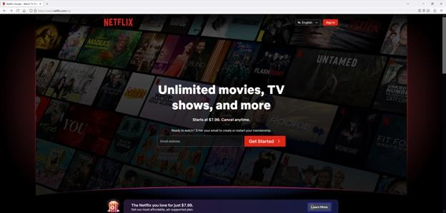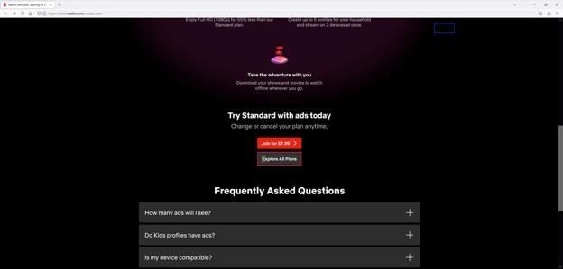
No accessibility problems were found on this page.

Choose Subscription Plan
On the “Choose the Plan That’s Right for You” page, there are three plans to choose from: Standard with ads, Standard, and Premium. Underneath each plan is the monthly price, video and sound quality, video resolution, spatial audio support, supported devices, number of concurrent devices, number of download devices, and the amount of ads.
I find the plan comparison table a little difficult to follow because the features that are being compared across plans do not line up. Some features may be in a different row because one of the plans does not include some other feature. To fix this, features that are unique to a plan should be at the bottom of the table.
After selecting a plan, a checkmark will appear beside the plan name. Then I scrolled down to the next button to proceed to the next step.
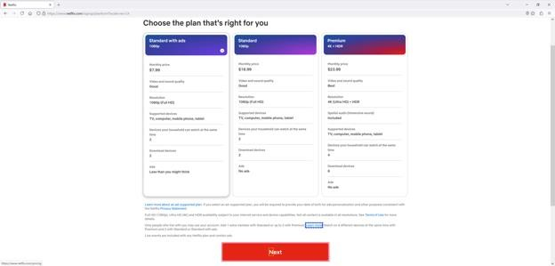
No accessibility problems were found on this page.

Create Account
After selecting a subscription plan, the create account form appears. The page description reminds me which plan I selected. There is a field to enter a new account email address and password. Form input validation is present like for the password length. Underneath that is a checkbox to not get emails about special offers and a next button.
Putting a checkbox to check if I do not want something to happen breaks design patterns and is considered to be bad practice. However, this is not an accessibility issue.
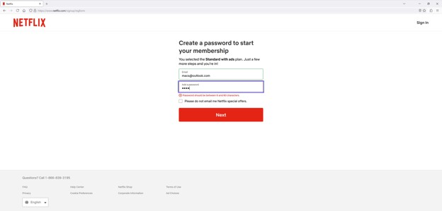
No accessibility problems were found on this page.

Set Up Payment
After clicking the next button on the create account page, the set up payment page appears. On this page, there is a list of buttons for different payment methods that can be added like credit or debit card, PayPal, or a Netflix gift code. There are pictures beside each button like different credit card logos, the PayPal logo, and the Netflix logo. The logos have alt text. I selected the credit or debit card option.
On the credit or debit card page, there is the usual form asking for the card number, expiration date, CVV, and name on the card. Underneath that the monthly charge before tax for the selected plan. There is a button to choose another plan. Below that is a checkbox to agree to the terms of use, privacy statement, and the auto renewal policy.
Finally, there is a start membership button.
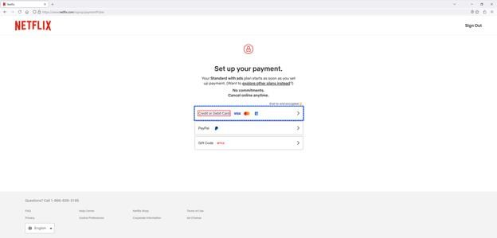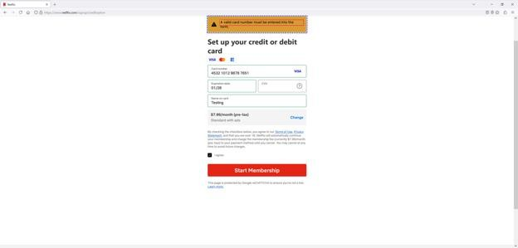

NVDA Screen Reader
On the “Set up your credit or debit card” screen, the CVV help button cannot be selected with the NVDA screen reader. People who do not know what the CVV is or how to find it may not be able to complete this step.

Account Verification
After submitting the payment information, there is an account verification step. On this page, I need to provide a mobile phone number to receive a one-time code. There is a “Text me” button below.
Unlike other form fields, the phone number field does not have client-side validation to ensure the phone number format is correct before submitting it. This is a usability problem, not an accessibility problem.
After clicking the “Text me” button, there is another page to enter the code I received on my mobile phone.
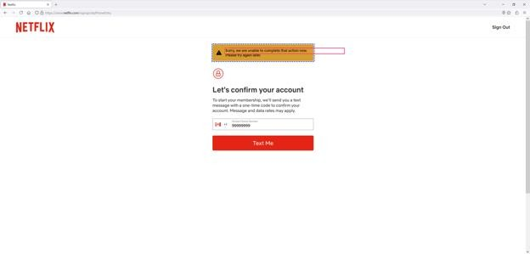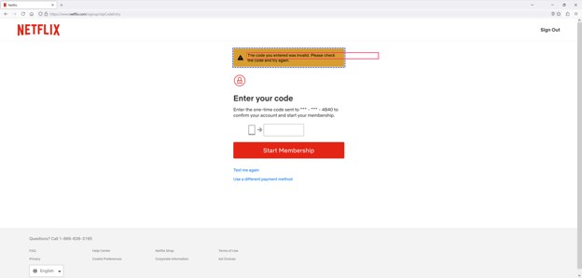

Initial Setup
After completing the account verification process, there are six account initial setup steps.
Step one is to select the devices I plan to watch Netflix on. There is a list of different devices that can be checked off like TV, phone or tablet, computer, game console, streaming device, cable set top box, or something else.
Step two is to enter the names of up to five users who will be watching Netflix on the same account. There is a list of text fields to enter the name of each user. There is a note that only people who live with me can use my account with a learn more link.
Step three is to choose which of the new profiles will be set as a kids' profile with age restrictions. I only entered the name of one user so this step was skipped.
Step four is to select my date of birth and gender for ad personalization, maturity settings, and other purposes consistent with Netflix’s privacy statement.
Step five is to select the languages I like to watch shows and movies in to set up the audio and subtitle settings.
Step six is to select some shows that I like from a list. This will help Netflix find TV shows and movies I’ll love.
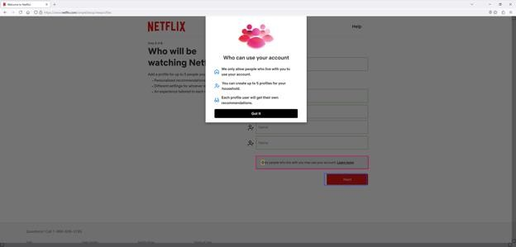
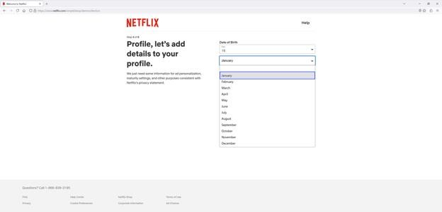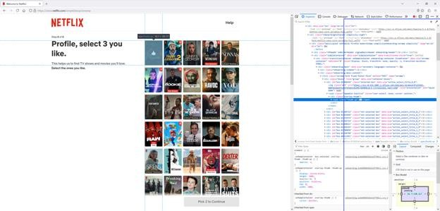

NVDA Screen Reader
On step two, “Who will be watching Netflix?”, there is a “Learn more” link beside “Only people who live with you may use your account.” Clicking the link with the NVDA screen reader does not move the screen reader selection to the popup modal window. The screen reader selection is still on the form. I need to press the down arrow until the selection is past the Next button to reach the popup window. After closing the popup window, the selection does not return to the “Learn more” link.
On step four, “Let’s add details to your profile”, there are drop down lists to specify my date of birth and gender. When selecting a value, the selected value overlaps with the placeholder text until I press enter to make my selection.
On step six, “Select 3 TV shows and movies you like”, I must select three shows from the list to continue. Unfortunately, I cannot select any of these with the NVDA screen reader because they are not marked as form elements.

Welcome
When the Netflix app opens and no account is signed in, an introduction video automatically plays. On the video, there is a get sign in, get started, and get help button. In the navigation bar above the video, there is a home, trending now, and plans button. The navigation bar only appears ten seconds later.
On the trending now screen, there is a carousel showing several shows. Each show has the show name followed by the show metadata like the genre, year released, number of seasons, age rating, and a brief description. There is also a “Join to watch” button.
On the plans screen, there are three plans to choose from: Premium, Standard, and Standard with ads. Underneath each plan is the video and sound quality, spatial audio support, number of concurrent devices, the amount of ads, and the monthly price. This feature comparison omits several important details that the website version has. This includes the video resolution, supported devices, and number of download devices.
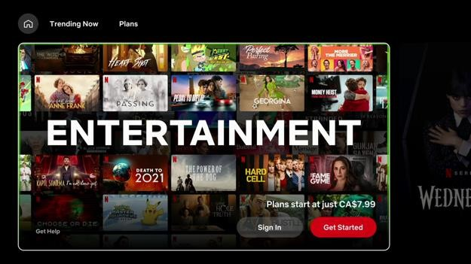
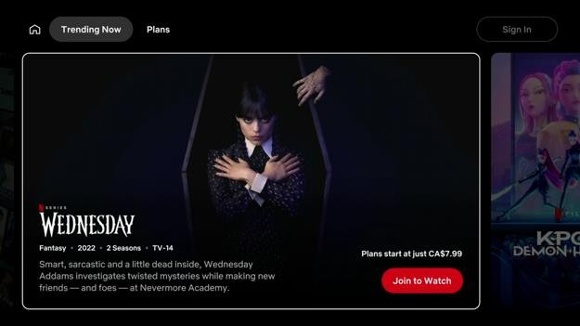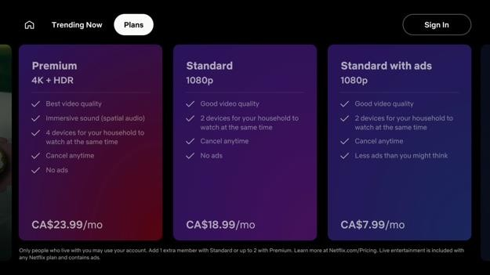

Google Streamer
The screen reader voice does not match the text in the intro video. This can make it more difficult for people with reading difficulties to understand.

Roku Ultra
The screen reader voice does not match the text in the intro video. This can make it more difficult for people with reading difficulties to understand.

Fire TV Stick
On the welcome screen, there is a “Get help” button to the right of the sign in and get started buttons. Clicking on the “Get help” button shows a loading spinner. The screen never loads.

Recommendations
We recommend the following changes to the Netflix welcome screen:
- Follow the screen reader settings set in the system settings app.
- Do more testing of the screen reader feature to catch race scenario bugs.

Sign In
On the Netflix sign in screen, two options to sign in are presented. The user can either sign in with their smartphone or use the TV remote control.
To sign in using a smartphone, the user can either scan a QR code on the screen or enter a website address in their web browser. Then they have to type in a numeric code that is shown on their TV screen.
If the user chooses the “Use Remote” tab, on the left is an on-screen keyboard to enter the username and password. Under the keyboard are buttons to go to the previous step, next step, reset password, and hide password. To the right is a username field, password field, sign up button, and a help link. The password is visible by default.
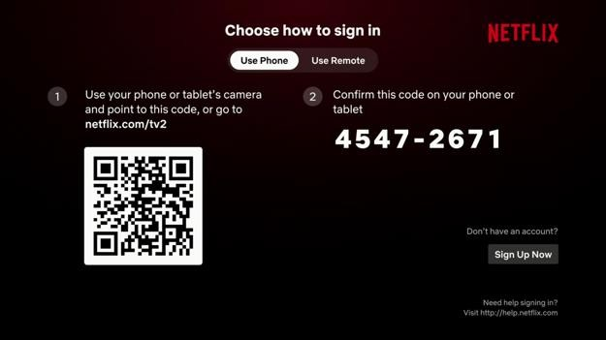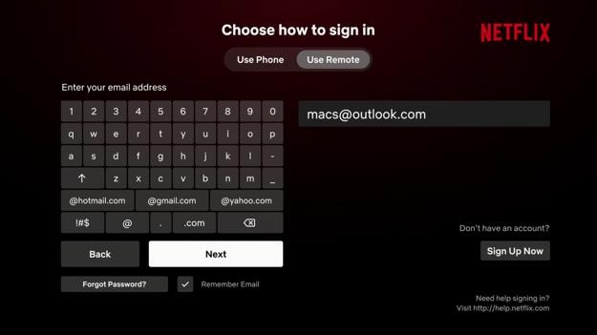
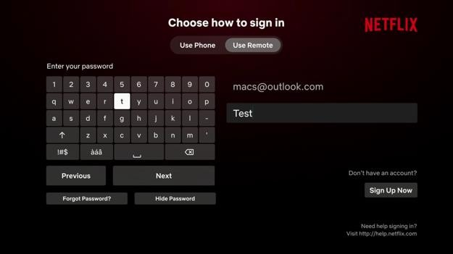

Google Streamer
On the Netflix sign in screen, two options to sign in are presented. The user can either sign in with their smartphone or use the TV remote control.
To sign in using a smartphone, the user can either scan a QR code on the screen or enter a website address in their web browser. Then they have to type in a numeric code that is shown on their TV screen.
The web sign in link, “Netflix dot com forward slash tv two” is mispronounced as “Netflix com tv two slash v”. The help link, “http colon forward slash forward slash help dot Netflix dot com” is mispronounced as “http colon slash slash help Netflix com”. This can cause screen reader users to type out the incorrect link.
The on-screen keyboard under the “Use remote” has buttons for “@hotmail.com”,
“@gmail.com”, and “@yahoo.com”, but the screen reader announces them as Hotmail, Gmail, and Yahoo. A screen reader user does not know that the “@” and “.com” has been inputted as well.
The trouble with typing on the remote is the chance for typos. Although the keyboard input is spoken out letter-by-letter as it is typed in, there is no way to move the screen reader focus to the username and password fields to verify the input to ensure it is correct before continuing. For security reasons, the app will not tell the user if the username is wrong or the password is wrong so the user would have to enter both in again.
Although the remote control has a built-in microphone, it cannot be used to input the username and password by voice letter-by-letter. It also cannot be used to select or edit text.
The other trouble is with using TalkBack navigation on grid layouts that have merged cells. Navigating tables with merged cells is known to be difficult for screen reader users because it makes it more difficult to know where they are. In this case, unless the user knows there is a “Hide Password” button under the “Next” button, they may never find it. If they press the right button on the remote control, the “Sign Up Now” button on the right is selected. If they press the down button on the remote control, nothing happens because there is no button under the “Sign Up Now” button.

Apple TV
The password field on the Netflix sign in screen supports voice dictation. The instructions say to “speak in letters, numbers, and symbols”, but I find it impossible to use. The voice dictation types in characters when I am not speaking.
The email and password text fields on the “Choose how to sign in” screen do not have enough contrast.
After I finished entering my account email address and password, I moved the focus to the sign in button. The screen reader would not stop saying sign in when the button is selected.

Roku Ultra
The web sign in link, “Netflix dot com forward slash tv two” is mispronounced as “Netflix com tv two slash v”. The help link, “http colon forward slash forward slash help dot Netflix dot com” is mispronounced as “http colon slash slash help Netflix com”. This can cause screen reader users to type out the incorrect link.
The on-screen keyboard under the “Use remote” has buttons for “@hotmail.com”,
“@gmail.com”, and “@yahoo.com”, but the screen reader announces them as Hotmail, Gmail, and Yahoo. A screen reader user does not know that the “@” and “.com” has been inputted as well.
When I press the microphone button and speak while on the “Enter your email address” screen, Roku tells me the feature is not available. However, after logging in, I discovered my voice input was put in the search field.

NVDA Screen Reader
On the Netflix sign in page, there is an email, password, and sign in button. After typing in the email address and password, I pressed the tab key to try and move the screen reader focus to the sign in button. However, the screen reader focus instead moved to select the whole page. Pressing tab again moves the focus to the Netflix logo in the header then to the email field. This means I cannot tab to other things on the page such as the sign in button, the “use a sign-in code” button, the forgot password link, the remember me checkbox, and the sign up now link. To reach these items, I must navigate the items on the page in reverse by pressing shift and tab. This is very unintuitive.

Recommendations
We recommend the following changes to the Netflix sign in screen:
- Fix the pronunciation of the web links
- Require pressing the select button on the remote control to switch from the “Use Phone” to “Use Remote” tab.
- Make TalkBack on Google TV work similar to Android to make it more familiar to use.
o Check the Home screen recommendations section for details on an alternative implementation.

Select Profile
The select profile screen shows a list of profiles that can be logged into. There is an edit icon beside each profile to edit the profile’s settings. There is an add button at the end of the list to add a new profile. The screen background is an advertisement.
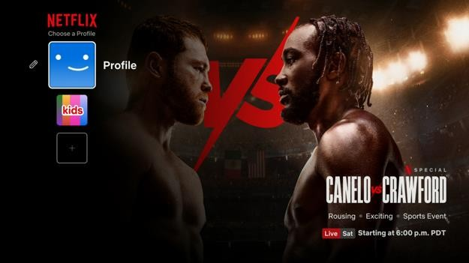

Apple TV
When the “Add Profile” button is selected, the Netflix screen reader does not announce anything even though Apple’s hover text accessibility feature shows the item’s text label in bigger text. Selecting the previous item and going back made the Netflix screen reader announce the item.
The select profile menu in the top left cannot be selected while in switch access item mode. I must switch to remote mode to do this.
The edit profile button beside each profile cannot be selected while in switch access item mode. I must switch to remote mode to do this.
The select profile screen has ads that slides around and cycles through. This happens even though the “auto-play video previews” setting is off and the “reduce motion” setting is on in the system settings app.

Google Streamer
When a mouse or touchpad is connected, the pointer is visible, but I cannot click on anything. I also cannot scroll vertically or horizontally through screens and carousels.

Fire TV Stick
The select profile screen has ads that slides around and cycles through. This happens even though the “allow video autoplay” and “allow audio autoplay” settings are off in the system settings app.

Edit Profile
On the edit profile screen, there is a list of buttons to change the profile name, icon, game handle, and language. At the bottom is a done button to return to the select profile screen.
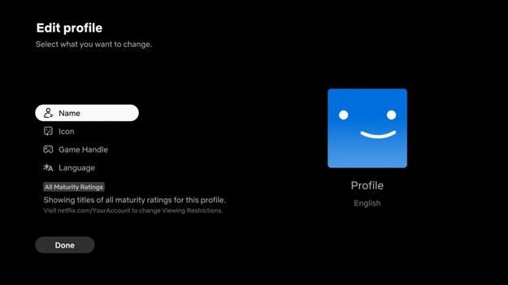

Apple TV
When the “Edit Profile” screen appeared, the screen title was automatically selected, but not read out. Apple’s hover text accessibility feature correctly shows the item’s text label in bigger text. Moving the focus down to the title description also did not announce anything. I had to move between a few items and back to make the Netflix screen reader announce the item.
On the “Edit Profile” screen, under the Icon button is an invisible button with no label. Clicking on it does nothing.
On the “Edit Profile” screen, there is a checkbox to mark the account as a kid account. The checkbox is announced as a generic button by the screen reader. The checkbox state is also not announced even after it is clicked. Screen reader users do not know if the account is marked as a kid profile or not.
When the “Delete Profile” screen appears, the screen title and description can be selected, but it is not read out. Apple’s hover text accessibility feature correctly shows the item’s text label in bigger text. I had to move between a few items and back to make the Netflix screen reader announce the item.
The Netflix app has a bug where when I go to add a new profile and select delete profile instead of selecting done, there is an error message that reads, “Something went wrong while attempting to add this profile.” The button should be labeled cancel instead of delete profile.

Edit Profile Avatar
On the edit profile avatar screen, there are several carousels showing avatars that can be selected. After selecting an avatar, there is a confirmation message asking if the user wants to change from old avatar to new avatar.
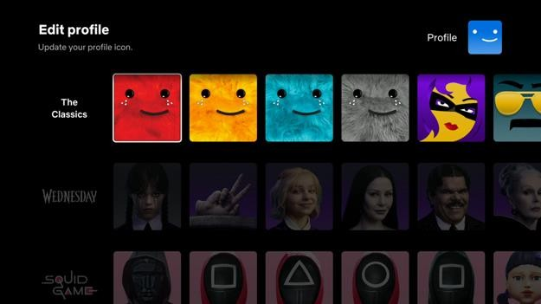

Apple TV
When an avatar is selected, the Netflix screen reader reads the group name the avatar belongs in, but not the avatar name. Sometimes the screen reader does not say anything. Apple’s hover text accessibility feature correctly shows the item’s text label in bigger text.
When the “Add Profile” button is selected, the Netflix screen reader does not announce anything even though Apple’s hover text accessibility feature shows the item’s text label in bigger text. Selecting the previous item and going back made the Netflix screen reader announce the item.
Profile avatars cannot be selected while in switch access item mode. I must switch to remote mode to do this.

Edit Game Handle
On the edit game handle screen, there is a short explanation of what a game handle (ingame username) is. Below that is an on-screen keyboard. The keyboard has a cancel, done, and get a new suggestion button. The suggestion button generates a random game handle. The profile’s current game handle is shown at the right side of the screen.
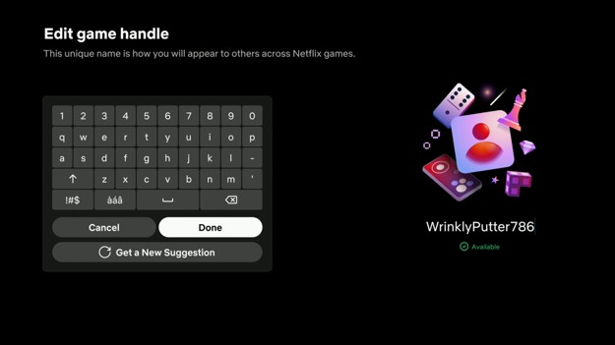

Google Streamer
The user’s current game handle is not read out by the screen reader and cannot be selected to be read out.
After typing a new game handle or clicking on the “Get a new suggestion” button, the game handle is updated, but it is not read out by the screen reader. It cannot be selected to be read out.

Edit Profile Language
On the edit profile language screen, there is a list of selectable languages split into four columns. When a language is selected with the screen reader, the language is not read out in the native voice. For example, “中文” is read as “Chinese” instead of “Zhong wen”.
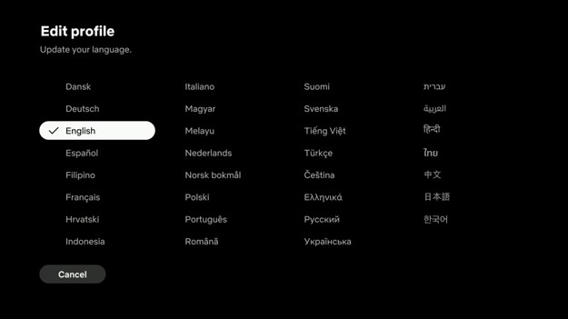

Google Streamer
The currently selected language is not announced as selected by the screen reader. The user can easily figure this out, but it is good practice to announce the radio button state.

Search
The search screen is split into two columns. The left column has an alphanumeric keyboard and a list of predefined search categories like, for outcasts only, Halloween, your zodiac watchlist, comedies, action, kids & family, horror, and more. If a search term is entered, the search categories will be variations of the search term like, Squid Game challenge, Squid Game making series, Squid Game fireplace, Squid Game, for Squid Game Fans, Squid Game collection, and more.
The right column contains the search field and a grid of search results. The search results are shown as movie posters with the show name in the image. There is no text underneath each poster. If no search term is entered, the search results will show search recommendations. Voice dictation is supported without having to move the focus onto the search field first.
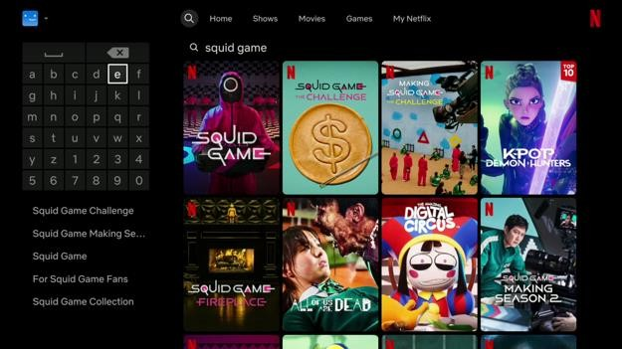

Apple TV
The on-screen keyboard buttons cannot be selected while switch access is in item mode. I must switch to remote mode to do this.

Fire TV Stick
When a mouse or touchpad is connected, the pointer is visible, but I cannot click on anything. I also cannot scroll vertically or horizontally through screens and carousels.

Home
The home screen has a featured show banner at the top of the screen. Below that are carousels like made in Korea, continue watching, animation critics love, critically acclaimed TV shows, coming soon, top searches, working for home? Just leave it on, and more. The items in the home screen loop around once I get to the last carousel. There is no indication I reached the end so I had a déjà vu feeling.
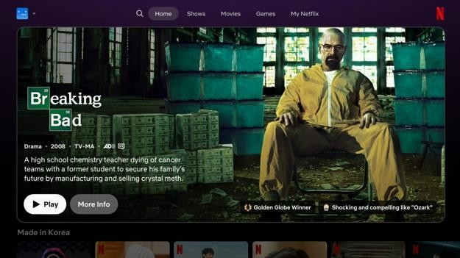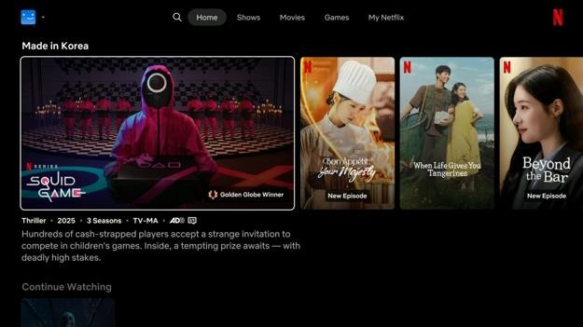

NVDA Screen Reader
After finishing the initial setup, the home screen appears. On the web version, there is a popover bubble to highlight things in the user interface. The screen reader selection is moved to the popover bubble text. However, after clicking the next button, the screen reader selection is no longer in the popover bubble. I need to move the screen reader focus past the Netflix logo in the nav bar to find the popover bubble.
Netflix sometimes does not follow the reduce motion setting in Windows like right after logging in. When the setting is not followed, the featured shows section on the home screen will play the whole trailer of the selected movie with sound on. There is a mute button. After refreshing the page, autoplay stops.
The notifications icon and the exit kids button in the navigation bar cannot be clicked on by pressing space or enter.

Google Streamer
Unlike other streaming media apps, Netflix uses its own screen reader solution. This can create problems where system screen reader settings are not followed. In the system settings app, there is the option to turn on screen reader captions, change the highlight ring colour, and adjust the screen reader verbosity. Some people with reading difficulties use screen reader captions to aid in reading comprehension. The loss of the highlight ring can make it more difficult to spot what is currently selected, especially if the focus state appearance is subtle and the focus order is irregular. The Netflix screen reader speaks out button and usage hints whenever an item is highlighted. For experienced users, this is unneeded noise. However, there is no option to turn it off.
The Netflix screen reader also has its own implementation bugs that can cause accessibility issues. When the Netflix app is opened or is awoken from standby, sometimes nothing is read out by the screen reader because it did not start properly. Turning the system screen reader off and back on again by holding the back and down button for three seconds does not fix the problem. This causes another bug where the arrow buttons on the remote control do not move between items on screen. The select, back, and home buttons still work. To fix the problem, the app must be force restarted, but not everyone knows how to do that.
Netflix has more screen reader tips than other streaming media apps. This is helpful for new users. Like “Use the up arrow to get to the navigation menu and profiles and down to browse movies, shows, and games.” However, there is no way to turn this off for experienced users.
The Netflix screen reader has lag issues. The screen reader may still be reading the previous item when I have moved the focus to a new item. This is especially noticeable when the screen reader reads long descriptions. This forces me to slow down and wait until the screen reader has read everything before continuing. Because of the additional screen reader tips that I cannot turn off, this is a very slow process. The built-in Google screen reader does not have this problem.
When a mouse or touchpad is connected, the pointer is visible, but I cannot click on anything. I also cannot scroll vertically or horizontally through screens and carousels.

Apple TV
The Netflix custom screen reader solution works poorly on the Apple TV. When some items are selected, the Netflix screen reader does not announce anything even though Apple’s hover text accessibility feature shows the item’s text label in bigger text. Sometimes selecting the next item and going back will make the Netflix screen reader announce the item. The Apple TV also has options to adjust the screen reader speech verbosity like, “Speed detected text” and “Media descriptions”. However, this setting is ignored by the Netflix screen reader.
When I visited the home screen for the first time, a modal appeared. The modal reads, “Welcome to your new Home. Netflix has a new look! Shortcuts to shows and movies are at the top, with everything you’ve saved, watched and loved in My Netflix.” The “got it” button is selected by default. The text and button labels are not read out by the screen reader and cannot be selected to be read out.
When a show in the carousel is selected, the show name is read out by the screen reader. However, when I press the down button to select the show attributes and description, those are not read out. Apple’s hover text accessibility feature correctly shows the item’s text label in bigger text. Moving the screen reader focus between a few items and back may make the Netflix screen reader announce the item.
When I move the screen reader focus to another carousel item, the screen reader does not stop reading the previously selected item. I must wait until the screen reader stops reading before I continue. If the description is long, this may take a few seconds.
When I move the screen reader focus to the next or previous carousel item, there is a bug where the screen reader will sometimes read the title of the next carousel item then the title of one of the previous carousel items. This can confuse screen reader users into thinking they selected another show. Apple’s hover text accessibility feature still shows the correct carousel item title. This bug only happens with the remote control, not with a keyboard.
It is impossible to move quickly through the user interface with the Netflix screen reader enabled. This is because the screen reader continues to read long item labels even when the screen has changed or another item is selected. Items that are selected afterwards are added to the end of the screen reader speech.
Pressing the escape or back button on the keyboard does not move the screen reader focus to the navigation bar. There is no back to top button. A screen reader user will have to press the up arrow many times to reach the top of the screen. This happens for all screens except the search screen.
When switch access is in item mode, I cannot select a show and go to the show details screen. Selecting a show brings me to the search screen instead. I must switch to the remote mode to view the show details.
When the last carousel item is reached, the carousel just loops around to the first item without telling the user. This can waste a user’s time by showing them things they already saw.
Netflix automatically plays video trailers when a video is selected. This happens even though the “auto-play video previews” setting is off and the “reduce motion” setting is on in the system settings app. The only way to stop video trailers from automatically playing is to turn the screen reader on.

Roku Ultra
Netflix has more screen reader tips than other streaming media apps. This is helpful for new users. Like “Use the up arrow to get to the navigation menu and profiles and down to browse movies, shows, and games.” However, there is no way to turn this off for experienced users.
The Netflix screen reader has lag issues. The screen reader may still be reading the previous item when I have moved the focus to a new item. This is especially noticeable when the screen reader reads long descriptions. This forces me to slow down and wait until the screen reader has read everything before continuing. Because of the additional screen reader tips that I cannot turn off, this is a very slow process. The built-in Google screen reader does not have this problem.

Fire TV Stick
When a mouse or touchpad is connected, the pointer is visible, but I cannot click on anything. I also cannot scroll vertically or horizontally through screens and carousels.
Netflix automatically plays video trailers when a video is selected. This happens even though the “allow video autoplay” and “allow audio autoplay” settings are off in the system settings app. The only way to stop video trailers from automatically playing is to turn the screen reader on.

Shows
The shows screen has a featured show banner at the top of the screen. Below that are carousels like today’s top picks for you, continue watching, made in Korea, my list, only on Netflix, boredom busters, your next watch, and more. The items in the shows screen loop around once I get to the last carousel. There is no indication I reached the end so I had a déjà vu feeling.
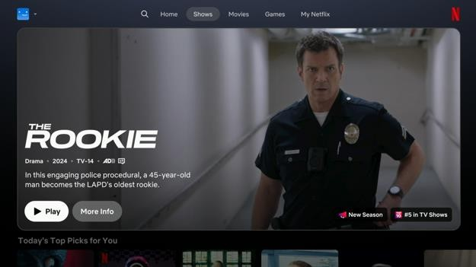
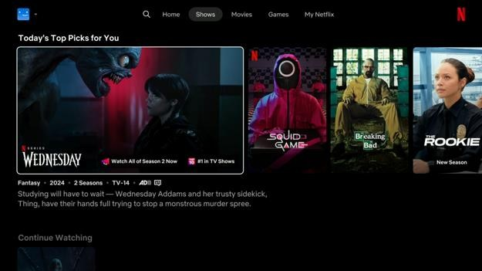

Apple TV
When a show in the carousel is selected, the show name is read out by the screen reader. However, when I press the down button to select the show attributes and description, those are not read out. Apple’s hover text accessibility feature correctly shows the item’s text label in bigger text. Moving the screen reader focus between a few items and back may make the Netflix screen reader announce the item.
When I move the screen reader focus to another carousel item, the screen reader does not stop reading the previously selected item. I must wait until the screen reader stops reading before I continue. If the description is long, this may take a few seconds.
When I move the screen reader focus to the next or previous carousel item, there is a bug where the screen reader will sometimes read the title of the next carousel item then the title of one of the previous carousel items. This can confuse screen reader users into thinking they selected another show. Apple’s hover text accessibility feature still shows the correct carousel item title. This bug only happens with the remote control, not with a keyboard.
Pressing the escape or back button on the keyboard does not move the screen reader focus to the navigation bar. There is no back to top button. A screen reader user will have to press the up arrow many times to reach the top of the screen. This happens for all screens except the search screen.
When switch access is in item mode, I cannot select a show and go to the show details screen. Selecting a show brings me to the search screen instead. I must switch to the remote mode to view the show details.
When the last carousel item is reached, the carousel just loops around to the first item without telling the user. This can waste a user’s time by showing them things they already saw.
Netflix automatically plays video trailers when a video is selected. This happens even though the “auto-play video previews” setting is off and the “reduce motion” setting is on in the system settings app. The only way to stop video trailers from automatically playing is to turn the screen reader on.

Fire TV Stick
When a mouse or touchpad is connected, the pointer is visible, but I cannot click on anything. I also cannot scroll vertically or horizontally through screens and carousels.
Netflix automatically plays video trailers when a video is selected. This happens even though the “allow video autoplay” and “allow audio autoplay” settings are off in the system settings app. The only way to stop video trailers from automatically playing is to turn the screen reader on.

Google Streamer
When a mouse or touchpad is connected, the pointer is visible, but I cannot click on anything. I also cannot scroll vertically or horizontally through screens and carousels.

Movies
The movies screen has a featured show banner at the top of the screen. Below that are carousels like your next watch, suspenseful movies, heartfelt movies, comedy movies, Indian movies, tight on time? Hit movies under 90 minutes, and more. The items in the movies screen loop around once I get to the last carousel. There is no indication I reached the end so I had a déjà vu feeling.
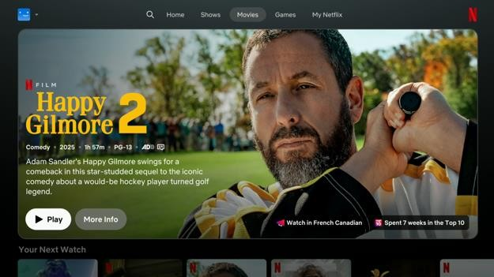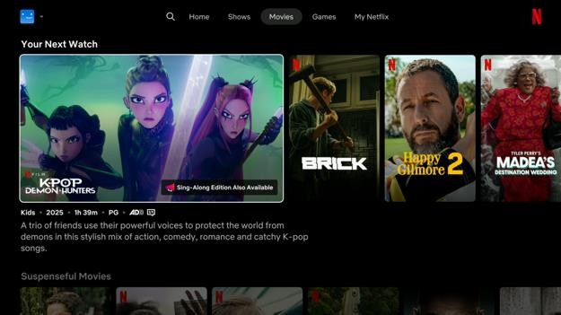

Apple TV
When a show in the carousel is selected, the show names is read out by the screen reader. However, when I press the down button to select the show attributes and description, those are not read out. Apple’s hover text accessibility feature correctly shows the item’s text label in bigger text. Moving the screen reader focus between a few items and back may make the Netflix screen reader announce the item.
When I move the screen reader focus to another carousel item, the screen reader does not stop reading the previously selected item. I must wait until the screen reader stops reading before I continue. If the description is long, this may take a few seconds.
When I move the screen reader focus to the next or previous carousel item, there is a bug where the screen reader will sometimes read the title of the next carousel item then the title of one of the previous carousel items. This can confuse screen reader users into thinking they selected another show. Apple’s hover text accessibility feature still shows the correct carousel item title. This bug only happens with the remote control, not with a keyboard.
Pressing the escape or back button on the keyboard does not move the screen reader focus to the navigation bar. There is no back to top button. A screen reader user will have to press the up arrow many times to reach the top of the screen. This happens for all screens except the search screen.
When switch access is in item mode, I cannot select a show and go to the show details screen. Selecting a show brings me to the search screen instead. I must switch to the remote mode to view the show details.
When the last carousel item is reached, the carousel just loops around to the first item without telling the user. This can waste a user’s time by showing them things they already saw.
Netflix automatically plays video trailers when a video is selected. This happens even though the “auto-play video previews” setting is off and the “reduce motion” setting is on in the system settings app. The only way to stop video trailers from automatically playing is to turn the screen reader on.

Fire TV Stick
When a mouse or touchpad is connected, the pointer is visible, but I cannot click on anything. I also cannot scroll vertically or horizontally through screens and carousels.
Netflix automatically plays video trailers when a video is selected. This happens even though the “allow video autoplay” and “allow audio autoplay” settings are off in the system settings app. The only way to stop video trailers from automatically playing is to turn the screen reader on.

Google Streamer
When a mouse or touchpad is connected, the pointer is visible, but I cannot click on anything. I also cannot scroll vertically or horizontally through screens and carousels.

Games
The games screen has a featured game banner at the top of the screen. Below that are carousels like games, learn about Netflix games, popular mobile games for you, pick up and play mobile games, and find more games in the mobile app. There is no indication I reached the end so I had a déjà vu feeling.
Please note that games are out of scope for this accessibility audit. This screen is only included for completeness.
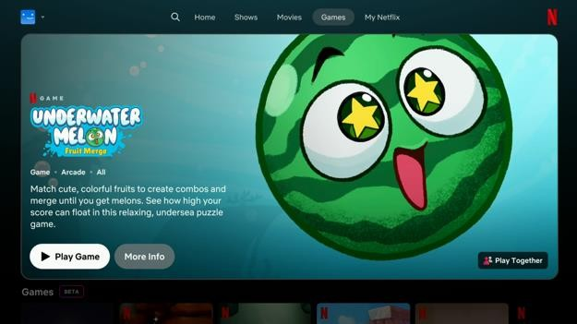
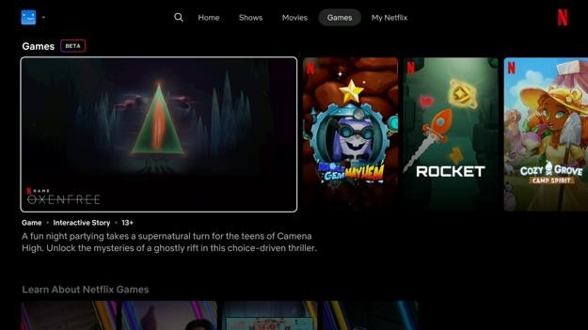

Watchlist
The “My Netflix” screen has a list of shows organized into carousels like my list, continue watching, trailers you’ve watched, TV shows & movies you’ve liked, and reminders you’ve set. The items in the “My Netflix” screen loop around once I get to the last carousel. There is no indication I reached the end so I had a déjà vu feeling.
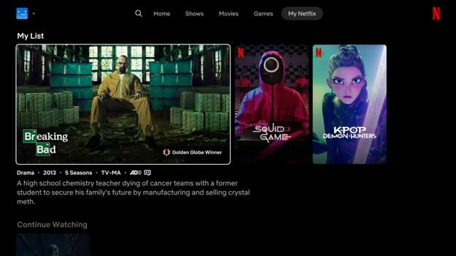
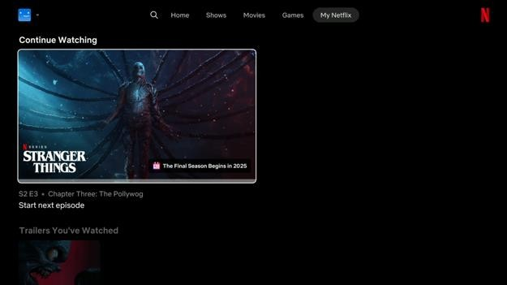

Apple TV
When a show in the carousel is selected, the show names is read out by the screen reader. However, when I press the down button to select the show attributes and description, those are not read out. Apple’s hover text accessibility feature correctly shows the item’s text label in bigger text. Moving the screen reader focus between a few items and back may make the Netflix screen reader announce the item.
When I move the screen reader focus to another carousel item, the screen reader does not stop reading the previously selected item. I must wait until the screen reader stops reading before I continue. If the description is long, this may take a few seconds.
When I move the screen reader focus to the next or previous carousel item, there is a bug where the screen reader will sometimes read the title of the next carousel item then the title of one of the previous carousel items. This can confuse screen reader users into thinking they selected another show. Apple’s hover text accessibility feature still shows the correct carousel item title. This bug only happens with the remote control, not with a keyboard.
Pressing the escape or back button on the keyboard does not move the screen reader focus to the navigation bar. There is no back to top button. A screen reader user will have to press the up arrow many times to reach the top of the screen. This happens for all screens except the search screen.
When switch access is in item mode, I cannot select a show and go to the show details screen. Selecting a show brings me to the search screen instead. I must switch to the remote mode to view the show details.

Fire TV Stick
When a mouse or touchpad is connected, the pointer is visible, but I cannot click on anything. I also cannot scroll vertically or horizontally through screens and carousels.

Google Streamer
When a mouse or touchpad is connected, the pointer is visible, but I cannot click on anything. I also cannot scroll vertically or horizontally through screens and carousels.

Show Details
On the show details screen, there is the show name followed by the show metadata like the year released, genre, number of seasons, video formats, audio formats, accessibility accommodations, age rating, and a brief description. Underneath that are buttons to rate the show as dislike, like, or love. Below that is a list of buttons to play the show, view the episodes list, change the audio and subtitle settings, watch the show, add the show to the watchlist, watch the trailer, and get detailed show info. Below that are tabs to view the episodes, view suggested shows, and view show extras. There is a back to top button at the bottom.
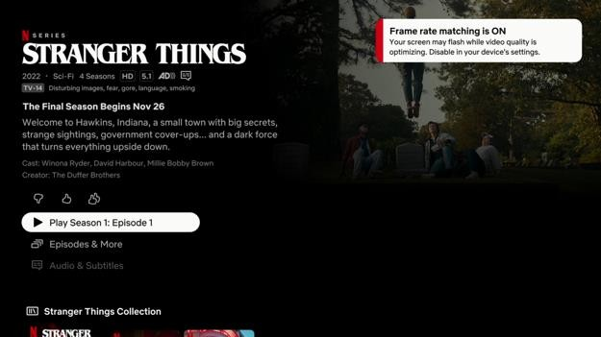
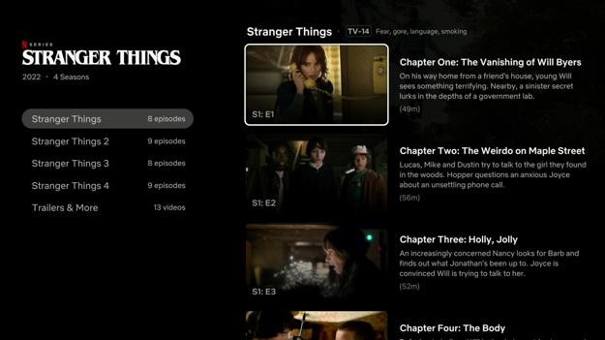

Google Streamer
When the show details screen appears, the movie name and description is automatically read out by the screen reader. However, I find it confusing that the screen reader reads out the description for the first episode instead of the show description text that is shown on screen. The text for the first episode is not shown anywhere on the screen. This can make it more difficult for people with reading difficulties to follow.
The movie name and description text cannot be selected to be read out again by the screen reader. I must go to another screen and return to it for this to happen.
On the show details screen, there is a toast message in the top right that reads, “Frame rate matching is on. Your screen may flash while video quality is optimizing. Disable in your device's settings.” This message is not announced by the screen reader.
In the audio and subtitles menu, there is a list of subtitle language options and a list of audio language options. Although the list is visually separated into subtitle and audio lists, the screen reader does not make this distinction. The screen reader also does not announce which of these options is selected.
The Netflix screen reader has lag issues. The screen reader may still be reading the previous item when I have moved the focus to a new item. This is especially noticeable when there are long labels. Having very long descriptive labels is an accessibility issue. For example, every time I open a menu from the show details screen and return back, the screen reader says, “HD 5.1. Pilot Clueless Dunder Mifflin manager Michael Scott welcomes a documentary crew to observe the office just as he learns that his branch could be downsized. TV 14. Language, sex, substances, suggestive dialogue. Cast: Steve Carell, John Krasinski, Jenna Fischer. Creators: Greg Daniels, Ricky Gervais, Stephen Merchant. 7 of 7 buttons. Audio & Subtitles. More like this.” Before the screen reader is finished, I already moved the screen reader selection to the “More like this” button, but I do not know what is currently selected until the screen reader finishes speaking. This makes using the screen reader much slower and more annoying to use since I have to hear the same long description being read out multiple times. To fix this, the screen reader should immediately start reading the label of the currently selected item. The built-in Google screen reader does not have this problem.
At the bottom of the Squid Game show details screen, there is a Squid Game Collection carousel. Some of the show titles and show descriptions are not read out by the screen reader and there is no text to select for it to be read out. All I hear is the names of cast members. Sometimes I hear nothing read out. There is also no sound feedback when switching between items like screen readers usually do. The weird part is when I click on the show to view more details, then go to the credits & more info menu, then I go back to the show details screen, the show description is then read out.
When a mouse or touchpad is connected, the pointer is visible, but I cannot click on anything. I also cannot scroll vertically or horizontally through screens and carousels.

Apple TV
On the show details screen, the show name, show format, and accessibility accommodation images cannot be selected to be read out by the screen reader.
On the show details screen, when the “Episodes and more” button is selected, a list of episodes appears. The first episode is automatically selected, but it is not read out by the screen reader. When the down arrow is pressed, the first episode is read out. When the arrow is pressed again, the third episode is read out. This means the second episode name and description is skipped unless the user presses the up arrow button.
On the show details screen, there are buttons to rate the show as thumbs down, thumbs up, or double thumbs up. When in switch access item mode, I can only select the first rating button. I must switch to remote mode to select the other rating buttons.
On the “Episodes and more” screen, selecting a category on the left while in switch access mode may not update the episodes list on the right. This happens the first time a category is selected. This bug does not happen when in remote mode.
Netflix automatically plays video trailers when a video is selected. This happens even though the “auto-play video previews” setting is off and the “reduce motion” setting is on in the system settings app. The only way to stop video trailers from automatically playing is to turn the screen reader on.

Roku Ultra
When the show details screen appears, the movie name and description is automatically read out by the screen reader. However, I find it confusing that the screen reader reads out the description for the first episode instead of the show description text that is shown on screen. The text for the first episode is not shown anywhere on the screen. This can make it more difficult for people with reading difficulties to follow.
The movie name and description text cannot be selected to be read out again by the screen reader. I must go to another screen and return to it for this to happen.
In the audio and subtitles menu, there is a list of subtitle language options and a list of audio language options. Although the list is visually separated into subtitle and audio lists, the screen reader does not make this distinction. The screen reader also does not announce which of these options is selected.
The Netflix screen reader has lag issues. The screen reader may still be reading the previous item when I have moved the focus to a new item. This is especially noticeable when there are long labels. Having very long descriptive labels is an accessibility issue. For example, every time I open a menu from the show details screen and return back, the screen reader says, “HD 5.1. Pilot Clueless Dunder Mifflin manager Michael Scott welcomes a documentary crew to observe the office just as he learns that his branch could be downsized. TV 14. Language, sex, substances, suggestive dialogue. Cast: Steve Carell, John Krasinski, Jenna Fischer. Creators: Greg Daniels, Ricky Gervais, Stephen Merchant. 7 of 7 buttons. Audio & Subtitles. More like this.” Before the screen reader is finished, I already moved the screen reader selection to the “More like this” button, but I do not know what is currently selected until the screen reader finishes speaking. This makes using the screen reader much slower and more annoying to use since I have to hear the same long description being read out multiple times. To fix this, the screen reader should immediately start reading the label of the currently selected item. The built-in Roku screen reader does not have this problem.
At the bottom of the Squid Game show details screen, there is a Squid Game Collection carousel. Some of the show titles and show descriptions are not read out by the screen reader and there is no text to select for it to be read out. All I hear is the names of cast members. Sometimes I hear nothing read out. There is also no sound feedback when switching between items like screen readers usually do. The weird part is when I click on the show to view more details, then go to the credits & more info menu, then I go back to the show details screen, the show description is then read out.

Fire TV Stick
When a mouse or touchpad is connected, the pointer is visible, but I cannot click on anything. I also cannot scroll vertically or horizontally through screens and carousels.
Netflix automatically plays video trailers when a video is selected. This happens even though the “allow video autoplay” and “allow audio autoplay” settings are off in the system settings app. The only way to stop video trailers from automatically playing is to turn the screen reader on.

Video Player
The video player controls appear when the video is paused. The controls remain on screen until the back button is pressed. In the top left are buttons to exit the video player, play from the beginning, or play the next episode. In the top right is the show name and episode name. At the bottom is the play button, video timeline, and language and subtitle options.
For the language and subtitle options, there are two predefined options like “English [Original]” and “English [Original] with subtitles”. Then beside it is an “Other language options” menu that opens a list of different subtitles and audio options to choose from. There is also a “Subtitle and display controls” menu that allows the user to pick a subtitle size and style.
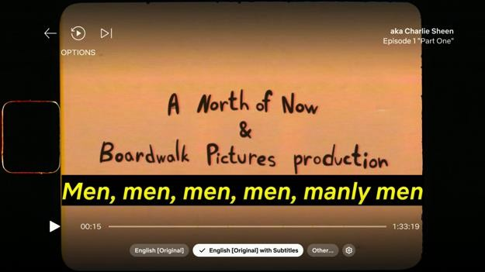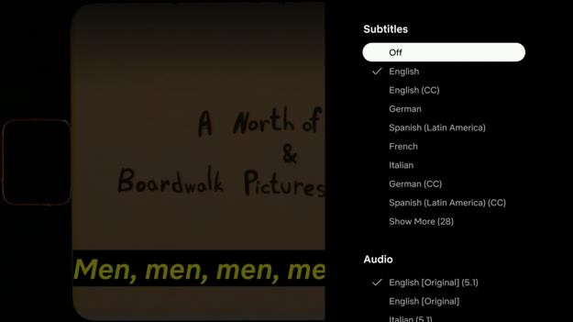
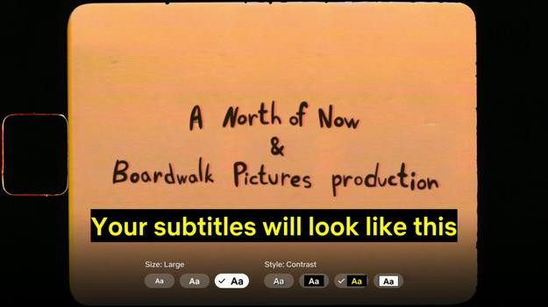

Google Streamer
On the video screen, there is a “Skip recap” button but it is not announced by the screen reader. Pressing the arrow buttons on the remote control does not announce or highlight anything. Pressing the select button reloads the video player and plays the movie. I was confused the first time this happened because other streaming apps skip to another point in the video without reloading the video player.
The language controls in the video player have several predefined language and subtitle options like English [Original], English [Original] with subtitles, and Other language options. The screen reader does not announce which of the three options is selected.
In the other language options menu, there is a list of subtitle language options and a list of audio language options. Although the list is visually separated into subtitle and audio lists, the screen reader does not make this distinction. The screen reader also does not announce which of these options is selected.
In the subtitle display control menu, there is a list of subtitle sizes and styles to choose from. The screen reader does not announce which of these options is selected. These options do not follow the subtitle styles in the system settings app.
After pausing the video for a few seconds, the video player is replaced with a full screen overlay containing the show and episode name or a full screen advertisement. This may make it harder for someone who paused the video to get more time to read the text.
The video player aggressively shows ads while the video is paused. Dismissing an ad by pressing the up button will show another ad after a few seconds while the video is still paused. This does not give enough time for the screen reader to finish reading what is on the screen before being interrupted again. One of those things is a message to rate the video. I was never able to have the message read out by the screen reader before being interrupted more than three times.
When a show is paused, the screen reader announces when the advertisement appears and the number of seconds remaining, but it does not read the text in the advertisement. However, when starting to play a new show, the screen reader may not announce when an ad is playing, how many ads, or how many seconds are remaining. The screen reader just says “playing”.
The video player has a bug where the video is paused but only the language controls options are visible. There is no gradient overlay. This happens when the video is paused and I press play right when the full screen advertisement appears.
If the language and subtitles button at the bottom of the video player is selected when the back button on the remote control is pressed, the video player closes. If the play button is selected instead, the video controls hide as expected. This is a weird design pattern that other streaming media apps do not have.
The Netflix screen reader has lag issues. The screen reader may still be reading the previous item when I have moved the focus to a new item. This is especially noticeable when there are long labels. Having very long descriptive labels is an accessibility issue. For example, when the video is paused, the screen read says, “Paused. 29 minutes 4 seconds remaining. The Office (U.S.) S3: E7 Branch Closing. Press OK to play. Press up for more options. Press down for playback language controls. In options menu. Play from beginning.” Before the screen reader is finished, I already moved the screen reader selection to the “Play from beginning” button. By doing so, the “Press OK to play” instruction is wrong because that assumes the screen reader focus is still on the play button. This also slows me down because I have to wait for the screen reader to finish speaking to know what I have selected. To fix this, the screen reader should immediately start reading the label of the currently selected item. The built-in Google screen reader does not have this problem.
When the video screen loads, the video player has a bug where the screen reader does not speak out the names of the video controls. This bug is fixed when the video is paused or when the video subtitle styles are changed.

Apple TV
Fast forwarding through a video while playback is paused it very difficult because a full screen ad may appear. When this happens, fast forwarding is automatically cancelled and the screen reader says paused 1 hour 11 minutes remaining. Also, unlike other streaming media devices, the screen reader does not announce that an ad appeared.
When a full screen ad appears, the only things that can be selected are the play button, the ad label, and the flag ad icon. The text in the ad is not read out and cannot be selected to be read out by the screen reader.
There is a bug where the full screen ad cannot be dismissed if the video is paused and the screen reader focus is on the info panel, the subtitle button, or the audio adjustment button. All video player buttons can still be selected with the screen reader while the ad is visible. The only way to dismiss the ad is to exit the video player. The ICI TOU.TV video player also has the same problem.
Sometimes after selecting a subtitle language, the screen reader focus moves to the Info button. The info button moves up as if the info panel is supposed to appear, but nothing appears. Pressing the arrow buttons on the remote control moving the screen reader focus to an invisible “Play from beginning” button. The screen reader focus is then stuck there. I have to press the back button to exit the video player.
The video player does not apply the caption text color and text size from the system settings. This can make the captions more difficult to read for people with low-vision. The rest of the caption styling including the text outline, text background colour, and window background colour is correctly applied.
When the subtitles and audio adjustments menus are open, the screen reader interrupts reading the menu options with reading the episode rating. Screen reader users must wait until the interruption ends before continuing. This slows down screen reader users.
Pressing the down button in the video player shows a card with the episode name, description, and play from beginning button. Only the play from beginning button label is read out by the screen reader even after selecting the items multiple times. Apple’s hover text accessibility feature correctly shows the item’s text label in bigger text.
When the episode details card is hidden, the screen reader reads the episode name three times. This happens every time.
For Squid Game, in the subtitles menu, there are two “English SDH” options. I am not sure what is the difference between the two entries. I also did not know what SDH stood for until I looked it up. It is better to replace “English SDH” for “English – described audio”.

Roku Ultra
The language controls in the video player have several predefined language and subtitle options like English [Original], English [Original] with subtitles, and Other language options. The screen reader does not announce which of the three options is selected.
In the other language options menu, there is a list of subtitle language options and a list of audio language options. Although the list is visually separated into subtitle and audio lists, the screen reader does not make this distinction. The screen reader also does not announce which of these options is selected.
After pausing the video for a few seconds, the video player is replaced with a full screen overlay containing the show and episode name or a full screen advertisement. This may make it harder for someone who paused the video to get more time to read the text.
The screen reader announces when the advertisement appears and the number of seconds remaining, but it does not read the text in the advertisement.
The video player has a bug where the video is paused but only the language controls options are visible. There is no gradient overlay. This happens when the video is paused and I press play right when the full screen advertisement appears.
If the language and subtitles buttons at the bottom of the video player are selected when the back button on the remote control is pressed, the video player closes. If the play button is selected instead, the video controls hide as expected. This is a weird design pattern that other streaming media apps do not have.
The Netflix screen reader has lag issues. The screen reader may still be reading the previous item when I have moved the focus to a new item. This is especially noticeable when there are long labels. Having very long descriptive labels is an accessibility issue. For example, when the video is paused, the screen read says, “Paused. 29 minutes 4 seconds remaining. The Office (U.S.) S3: E7 Branch Closing. Press OK to play. Press up for more options. Press down for playback language controls. In the options menu. Play from beginning.” Before the screen reader is finished, I already moved the screen reader selection to the “Play from beginning” button. By doing so, the “Press OK to play” instruction is wrong because that assumes the screen reader focus is still on the play button. This also slows me down because I have to wait for the screen reader to finish speaking to know what I have selected. To fix this, the screen reader should immediately start reading the label of the currently selected item. The built-in Google screen reader does not have this problem.

Fire TV Stick
When a mouse or touchpad is connected, the pointer is visible, but I cannot click on anything.

Crave
Unlike other streaming media apps, Crave has a few limitations that most other streaming apps do not have. In Crave, the subtitles, audio, and user interface are available in English or French only. Although Crave does not need to support other languages other than English and French, these limitations need to be made clear to people before they subscribe.
Unlike video players on other streaming media apps, the video cannot have subtitles and audio in two different languages. Also, not all show trailers are available with English and French captions or audio even though the show has it.
It is not clear when subscribing that the basic subscription cannot be used to watch shows on Roku streaming media devices. This is an important omission because of all the streaming media devices we tested, Roku is the most popular.
The structure and organization of content for the Apple TV version of Crave is very different compared to the Crave version on other streaming media devices. Some of the differences include the welcome screen, the navigation bar position, the kids section, the show genre filters, and the on air TV schedule. This can make it harder for people to seamlessly use Crave between different streaming media devices. Bell media should update the Apple TV version of Crave to create a unified experience across all streaming media devices.
The Crave app has several accessibility problems and bugs, but these problems are for common actions. Opening the Crave app twice without selecting the exit option can cause it to get stuck on the loading screen. Browsing shows in the carousel can skip over items. Selecting a show in the carousel may select the next or previous show. There is no button to go back or move the focus back to the navigation bar when using a mouse. Playing a video may crash the whole app. The closed captions or audio language menus can only be opened with the mouse once. The Roku Ultra Crave app is completely unusable with a screen reader because nothing is read out except for some navigation bar items and carousel titles.
The Crave app also ignores the text caption styles set in the system settings app. This is normally not a big deal, but in this case, the caption text sizes and styles are very limited. The biggest caption text size setting may not be big enough for some people with vision loss. The Apple TV Crave app is the exception as it does follow the system text caption styles.
Using the Crave app with Apple TV switch access is difficult. When in item mode, some items like the episodes tabs and episodes list items cannot be selected. I must switch to the remote mode. Also, selecting some things can cause switch access to lock up. It cannot be used again until the Apple TV is restarted.

Crave Promo Page
On the Crave summer offer promo page, there are decorative banners letting visitors know of the promo offer. Underneath that are the different subscription plans: Premium Ad-free, Standard with Ads, and Basic with Ads. The features for each plan are shown as an image on the left side. On the right side is the plan name, promo price, regular price, and a “Subscribe Now!” button. Clicking the “Subscribe Now!” button loads the sign in page.
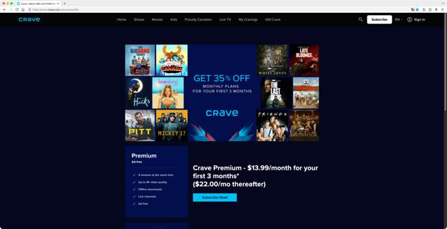

NVDA Screen Reader
On the promo page, there are several plans listed, but a screen reader user will not know what features are included in which plan. This is because the features list is shown as an image with no alt text.
The promo page footer has two columns of links. The links can be selected with a screen reader, but the selection order does not match the visual order. I expect to move through the links one column at a time, but the screen reader section moves between columns.
Some of these links are visually grouped in one column so moving between columns loses the meaning.

Sign In or Create Account
The sign-up form is split into three steps.
The first step asks the user to input their email address to log into their Bell Media account. If there is no account associated with that address, they will be prompted to create a new account. There is an email input field, followed by a continue button.
If the account does not exist, the second step asks the user to choose a password for the account. There is a password input field. The password requirements appear in a popover once the user starts entering a password. Underneath that is a “Continue” button that is only enabled when all the password requirements are met. There are also links to terms and conditions and the privacy policy that opens in a new tab.
After entering an email address and password, the “Check Your Email” page appears. The user will receive an email that has a confirmation code and activation link. The user can either type in the confirmation code they got into the web page or click the activation link. There are input fields to enter each digit of the confirmation code along with a “Verify” button. If the confirmation code is correct, clicking the “Verify” button loads the “Choose Subscription” page.
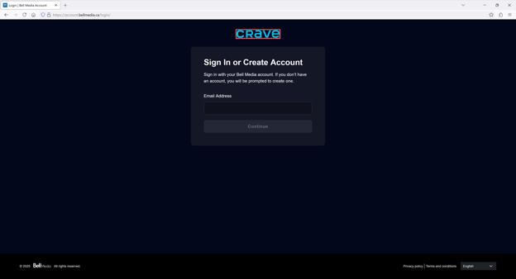
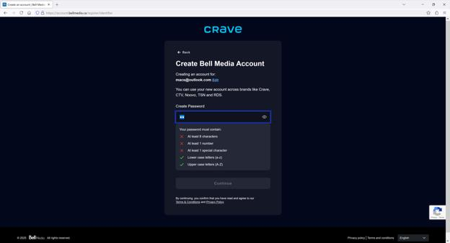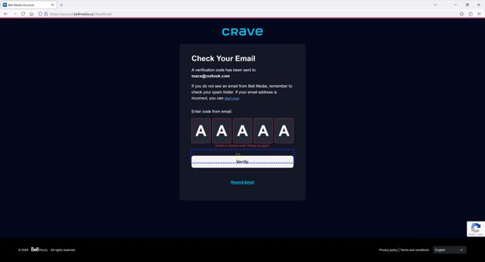

NVDA Screen Reader
The Crave logo at the top is marked as a main landmark, but it has no alt text. Screen reader users will not know what that landmark is for.
The footer has a Bell Media logo that has no alt text. It is read as blank.
If the user enters an invalid email address, the form error is not read out. The continue button will remain disabled.
The show password button is unlabeled. Screen reader users will not know what that button does. Activating the button also does not announce its state.
A list of password requirements appears under the “Create Password” text field, but these requirements are not announced to the screen reader. If the password requirements are not all met, the “Continue” button will remain disabled. A screen reader user will have to use the up and down arrow keys to hear the password requirements read out.
After entering an email address and password, the “Check Your Email” page appears. The input field to enter the first digit of the confirmation code is automatically selected. The input field is announced as “Input 1 edit field”. There should be a more descriptive name like “Enter the first digit of the verification code sent to your email”.
If the verification code is invalid, the error message is not read out. A screen reader user will need to use the up and down arrow keys to have the error read out.

Choose Subscription Plan
On the “Choose the Plan That’s Right for You” page, there are three tabs to switch between monthly plans, annual plans, and bundled plans. The Bundled plans tab is selected by default. The plan details are shown below as cards.
Each card has the plan name, monthly cost, and included features. For cards that have lots of features, there is a “See More” link to show all the features. Two bundle cards are shown by default. There is a “More Bundles” link to show more bundled plans below. After selecting a subscription plan, another page appears with plan add-on options. After choosing the plan add-on options, the “Review & Pay” page loads.
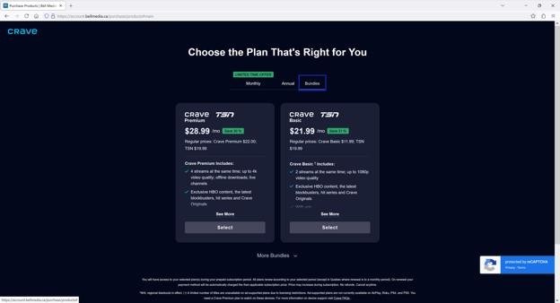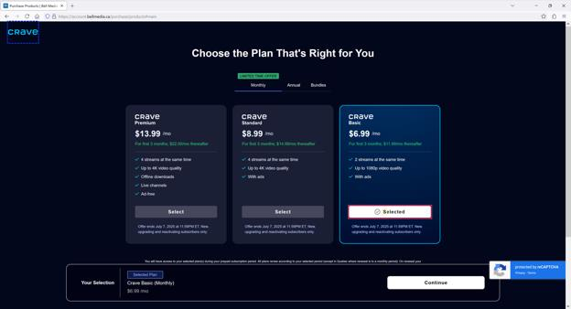
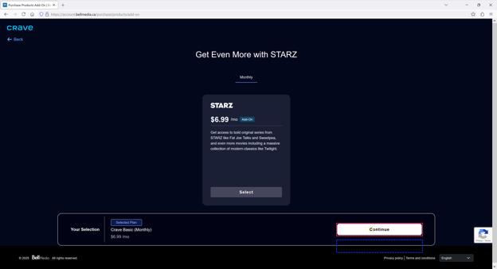

NVDA Screen Reader
The Crave logo at the top is marked as a header banner landmark, but it has no alt text. Screen reader users will not know what that landmark is for.
The footer has a Bell Media logo that has no alt text. It is read as blank.
When the “More Bundles” link is clicked, the screen reader focus remains on the same link instead of moving the focus to the first newly loaded bundle. A screen reader user will have to use the up arrow to move to the first bundle.
When I clicked the “Select” button under the plan I wanted, the screen reader announced “Selected” and a panel appeared at the bottom of my screen showing the plan I selected with a continue button. Unfortunately, the screen reader selection does not move to the bottom panel so I have to tab my way to the continue button.
When I select a plan on the “Choose the Plan That’s Right for You” page and click the “Continue” button, I am shown another page with plan add-ons options. The screen reader focus remains on the “Continue” button so I have to use the up arrow to hear the plan addon info read out.
When I click the “Back” button on the plan add-on options page, I expect the plan I selected previously to be remembered. Unfortunately, it is not and the plans tab is reset to show the bundled plans.

Other Issues
When the “Choose the Plan That’s Right for You” page appeared with the “Bundles” tab selected by default, I was confused. On the Crave promo page, I clicked the “Subscribe Now!” plan beside the plan I wanted so I expect that plan will automatically be selected or will be visible by default. When I checked the promo page again, I discovered the “Subscribe Now!” button link is the same for all listed plans.

Review & Pay
After selecting a subscription plan and plan add-on options, there is a “Review & Pay” page. This page has an option to add either a credit/debit card or use a gift card balance. The amount to pay is shown in a column on the right. At the bottom of the page is a “Back” button and a “Agree & Subscribe” button.
When the “Add Credit/Debit Card” button is clicked, the “Add Credit/Debit Card” form loads. There are fields to add the credit card and billing address details. There is a checkbox to set the credit card as the default payment method. There is a “Back” button and an “Save” button.
When the “Add gift card” link is clicked, the “Add New Gift Card” form loads. There are fields to add the gift card number, PIN, and address information. There is a “Back” button and an “Add” button.
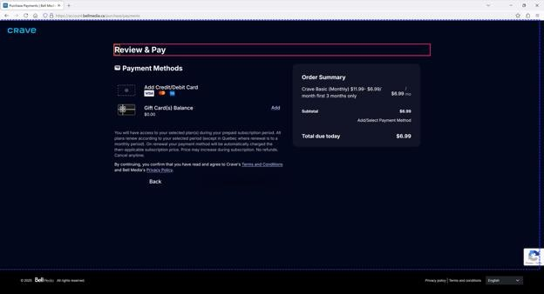
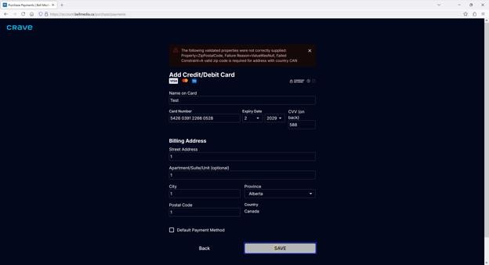

NVDA Screen Reader
The “Add Credit/Debit Card” button has an image below showing the credit and debit cards the website accepts. This image has no alt text, so screen reader users do not know what credit cards are accepted until they try. From testing, if the credit card number is wrong or it is not one the website accepts, there is no error message shown or announced.
The “Add gift card” link cannot be selected by tabbing. I have to use the arrow keys to select it.
The “Connexion sécurisée” question mark popover at the top of the form only shows on hover. It cannot be selected by the screen reader. The popover text explains that the website connection is secured by an SSL certificate. Knowing this information is not required to complete the payment process.
All of the form fields on the “Add Credit/Debit Card” and “Add New Gift Card” forms do not have the text labels associated with the fields. Screen reader users tabbing through form fields will not hear the field labels read out.
When the “Add Credit/Debit Card” form has errors, those errors are not announced to the screen reader. The “Save” button is enabled, but nothing happens when it is clicked.
When the “Add New Gift Card” form has errors, those errors are not announced to the screen reader. The only error that is announced is if the gift card code is invalid. The “Add” button is enabled, but nothing happens when it is clicked.

When the form has an error, the error message is not announced to the screen reader. The screen reader focus does not automatically move to the first error. The error message at the top of the form also does not have a link to skip to the first error. This makes errors harder to find.

Other Issues
The “Add Credit/Debit Card” button has no link underline or button shape to show that it can be clicked. The only indication is a hand cursor when hovering over it.
The first time I clicked the “Add Credit/Debit Card”, the screen reader announced “Add Credit/Debit Card”, but the screen was blank and there was nothing to select. When I refreshed the page, the “Review & Pay” page appeared and I can select “Add Credit/Debit Card” again.
The “Add Credit/Debit Card” form has insufficient form validation. The only form validation is that the fields are not empty, the CVV format is correct, and the postal code is at least one digit long. If the credit card is not one of the accepted ones, the credit card number is incorrectly entered, or the address information is wrong, nothing happens when the “Save” button is clicked. There are techniques to use credit card checksums, address auto complete, and address suggestions, but none of them are used here.
The “Add New Gift Card” form has insufficient form validation. The only form validation is that the fields are not empty. Although the gift card number and PIN has an expected length, there is no validation on the length. I am not sure if an invalid address will stop the user from adding a gift card.
Form field error messages have a warning icon in front of it, but it is invisible because it is black on a dark blue background.
Form error messages should be more user friendly instead of, “The following validated properties were not correctly supplied: Property=ZipPostalCode, Failure
Reason=ValueWasNull, Failed Constraint=A valid zip code is required for address with country CAN”. Furthermore, Canada does not use zip codes.
There is a “Connexion sécurisée” icon at the top of the “Add Credit/Debit Card” page to tell the user the connection is secured. However, I do not know why the text is in French when the website language is in English.
The credit card expiry year dropdown list does not have a visible text label.
The error message for the “Postal Code” field reads, “Zip Code is required”.
If all the fields on the “Add Credit/Debit Card” form is filled out, the CVV is in the correct format, the postal code is in the correct format, but the credit card number is invalid, there is no error message but also nothing happens. It may be because the credit card number is entered incorrectly or the credit/debit card is not one the website accepts.

Welcome
On the Google TV Streamer, Fire TV Stick, and Roku Ultra, there is no welcome screen. The user is instead shown the home screen. There is a sign in button in the right corner. Clicking this will show the profiles screen with a sign in button. After clicking the sign in button, there is another screen with buttons to sign in through Crave or sign in through the TV provider.
On the Apple TV, there is a welcome screen. On the welcome screen, there are buttons to subscribe, sign in, or browse the catalogue. After clicking the sign in button, there is another screen with buttons to sign in through Crave or sign in through the TV provider.
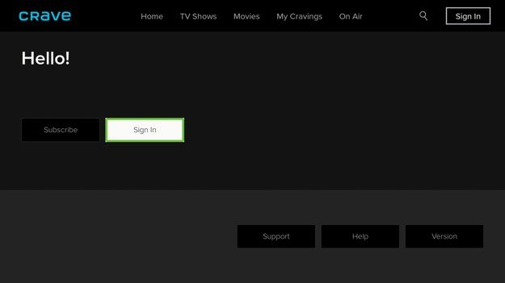
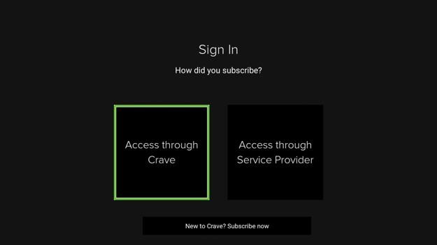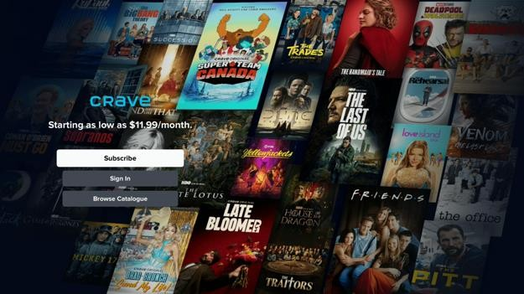
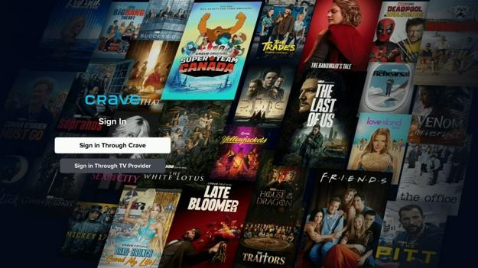

Google Streamer
The Crave app on the Google Streamer sometimes does not open. It gets stuck on the splash screen. I have to force stop the app to get it to work again. To reproduce this issue, open the Crave app, press the home button on the remote, then open the Crave app again.

Roku Ultra
On the Crave TV welcome screen, the subscribe, sign in, and browse catalogue buttons can be selected, but the button labels are not read out.

Apple TV
On the Crave welcome screen, the subscribe, sign in, and browse catalogue buttons are sometimes not read out by the screen reader.

Login
The log in process is slightly different on the Google TV Streamer, Fire TV Stick, and Roku Ultra. After selecting the “sign in through Crave” button, it asks me to type in my account email address and password in two separate steps. Voice dictation may be available.
For the Apple TV, after selecting the “sign in through Crave” button, the login screen appears. There is a tab at the top to switch between using the phone to sign in or using the remote. The use phone option shows two ways to sign in. I can either scan a QR code with the phone camera or go to a webpage and type in an activation code. The use remote option asks me to type in my account email address and password in two separate steps. Voice dictation is unavailable.
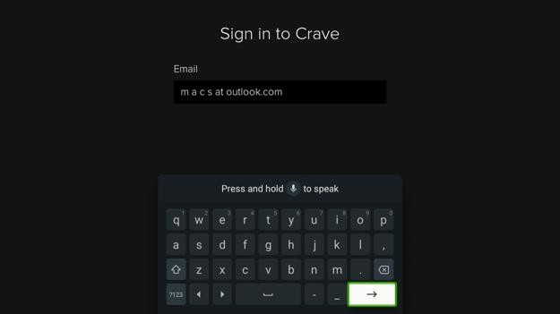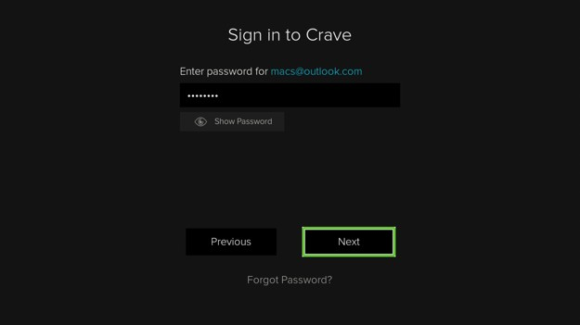
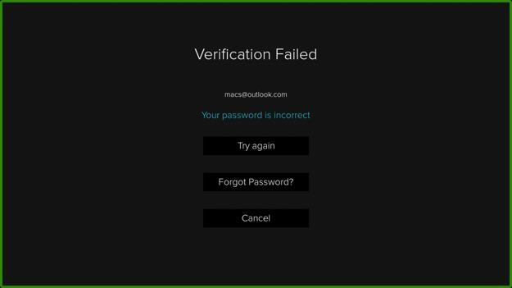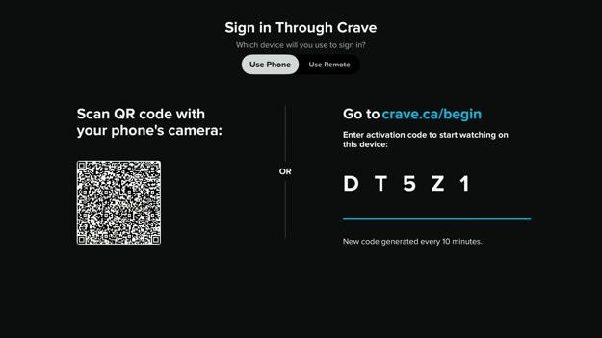
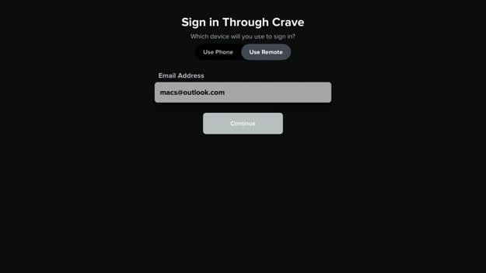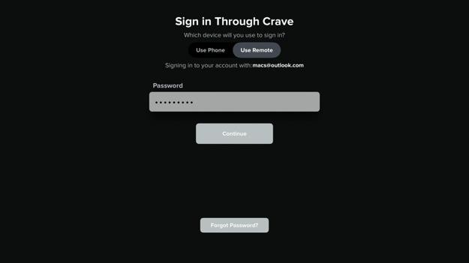

Google Streamer
The email text field allows using voice dictation by holding down the microphone button and speaking. However, spelling out letters and numbers does not work well because the Google keyboard adds spaces in between the spoken characters. Email addresses cannot have spaces.
If an incorrect password is entered, a verification failed screen appears, but it is not announced to screen reader users. The verification failed title, “your password is incorrect” text, try again button, forgot password button, and cancel buttons cannot be selected with the screen reader. An invisible email edit box, invisible next button, and invisible previous button is all that can be selected.
If the next or previous button is pressed, the screen returns to the enter password screen with the password field automatically selected.

Roku Ultra
On the Crave TV sign in screen, the “Access through Crave” and “Access through service provider” buttons can be selected, but they are not read out by the screen reader.
After typing an incorrect password, the verification failed screen appears. It is not announced by the screen reader. None of the text or buttons on the screen is read out by the screen reader. The buttons can be selected.
After signing in, the “You need a Crave premium plan to watch on this device” screen appears. None of the text or buttons are read out by the screen reader. The button can be selected.

Apple TV
On the “Sign in through Crave” screen, there are two options shown as tabs: use phone or use remote.
For the use phone option, the QR code and activation code instructions are not read out by the screen reader and cannot be selected to be read out.
For the use remote option, the email text field is announced as “text field” by the screen reader. I do not know what I need to enter there.
If an incorrect password is entered, the invalid password error message is not announced by the screen reader.
The “continue” and “Forgot password?” buttons on the “Sign in through Crave” screen do not have enough contrast.

Select Profile
The “Who’s watching?” screen shows a list of profiles that can be logged into. If the account is protected by a PIN, there will be a lock icon beside it.
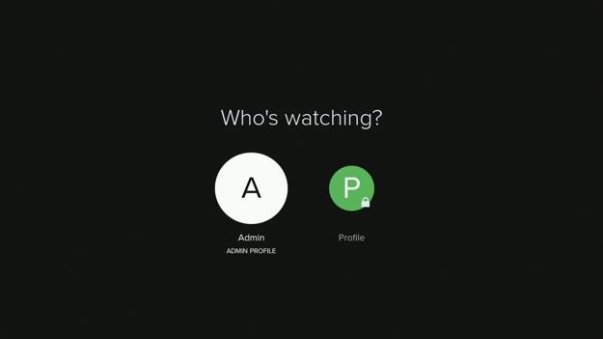
No accessibility problems were found on this screen.

Enter PIN
If a PIN protected profile is selected from the “Who’s watching?” screen, the enter PIN screen will appear. The enter PIN screen has a text field to enter the PIN.
On the Google TV Streamer, Fire TV Stick, and Roku Ultra, after entering the PIN, the checkmark button on the on-screen keyboard must be clicked. There is no continue button on screen. On the Apple TV, there is a continue button. There is also a reset PIN button in the top right.
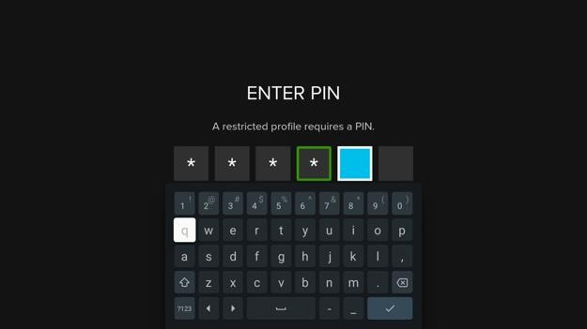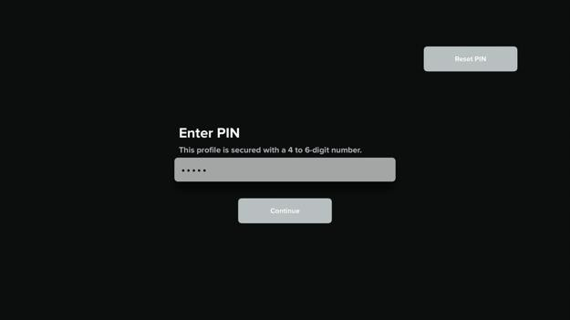

Apple TV
The continue and reset PIN buttons do not have enough contrast. People may have trouble reading the text, especially people with vision-loss.
I cannot enter the PIN while in switch access item mode. Selecting the enter PIN field opens the reset PIN screen. I must switch to remote mode.

Fire TV Stick
If a profile is protected by a PIN, I get the enter PIN screen when I try to access it. I can type in the PIN with my external keyboard, but pressing the enter key does not submit the input. I have to use the remote control to make the on-screen keyboard appear, then select the next button to submit.
If I only have a mouse, I cannot get the on-screen keyboard to appear while on the enter pin screen. This means I cannot access that profile.

Google Streamer
If a profile is protected by a PIN, I get the enter PIN screen when I try to access it. The onscreen keyboard appears, but clicking on the keyboard letters with the mouse does nothing.
On the enter PIN screen, after I type in the PIN with my external keyboard, I need to use the arrow keys on my keyboard to move the screen reader selection to the checkmark button. However, there is a bug where when I type an incorrect pin, I can type the PIN again, but the screen reader selection is stuck on the PIN input field instead of the on-screen keyboard. This means I cannot submit the PIN because I cannot select the checkmark button on the on-screen keyboard. Pressing the enter button on my external keyboard does nothing. Pressing the escape key goes back to the previous screen.

Home
The home screen has an auto-advancing carousel for featured shows at the top of the screen. Below that are logo buttons to view shows by some major content providers and show categories. Following that are carousels for trending now, popular comedies, recently added TV, recently added movies, Crave recommends, previews, and more. Users who are not logged in will get the same view.
Please note that the Apple TV user interface has the navigation bar on the left instead of at the top. There is a kids section in the nav bar. The carousels that are shown are also slightly different. For example, there are no logo buttons to view shows by some major content providers and show categories.
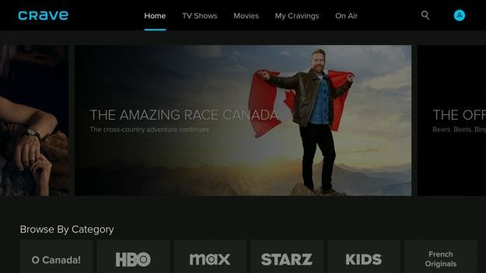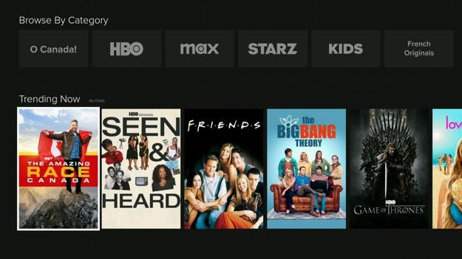
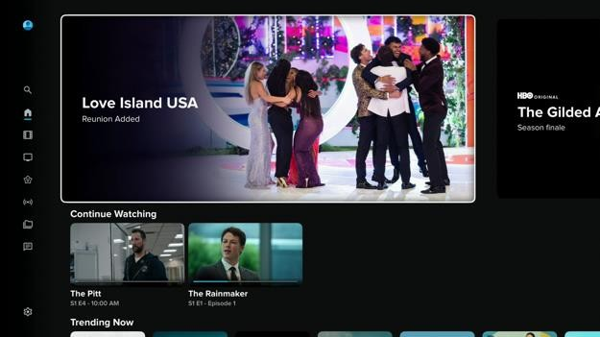

Google Streamer
Sometimes a carousel item is skipped over when pressing the left and right arrow buttons. When the select button is pressed, the show details screen shows the details of the movie that is one movie before or after the one I selected. I need to back out of the show details screen and then select the movie again. This is very confusing and requires more button presses. This bug happens for the screen reader and keyboard.
There is no button to click on to show the nav bar. I must use the keyboard to show it instead of relying on the mouse. Not everyone’s mouse has a back button to show the nav bar. The Fire TV Stick version has the same problem.

Roku Ultra
Nothing on the home screen is read out by the screen reader except the carousel titles. The items can still be selected by the screen reader. All the navigation bar items are read out except the search and profile buttons.

Fire TV Stick
When going back from the show details screen to the home screen, the last viewed show is automatically selected, but the show image is partially off the screen.
An external keyboard can be used to navigate and select items. The escape and back button on the keyboard works to go back a screen. Using the up arrow at the top of the screen shows the nav bar.
The external mouse pointer is visible and items can be clicked on. Scrolling works. The screen reader reads the item under the pointer but only for some screens. Items on the home screen are not read out when hovered over with the pointer. I hear the no item sound when I hover over them.
There is no button to click on to show the nav bar. I must use the keyboard to show it instead of relying on the mouse. Not everyone’s mouse has a back button to show the nav bar.
Carousels do not have left and right arrow buttons for me to click on using the mouse. Trackpad left and right swipe works to scroll through all carousels except the featured shows carousel at the top of the screen. Hold and drag works on all carousels however some people have difficulty doing this gesture. This is especially true for the featured shows carousel because the large cards require a big drag motion or else it snaps back to the previous position.
The Fire TV high contrast system setting is followed by the Crave TV app. A black outline is added around text on all screens.

TV Shows
The TV shows screen has an auto-advancing carousel for featured shows at the top of the screen. Below that are logo buttons to view shows by some major content providers and show categories. Following that are carousels for trending now, recently added TV, dramas, Crave recommends, previews, and more. Users who are not logged in will get the same view.
Please note that the Apple TV user interface has a list of buttons to filter shows by genre like comedy, crime, documentary, drama, romance, and reality. The Crave app on other streaming media devices do not have this feature.
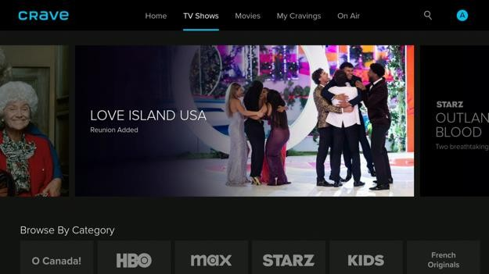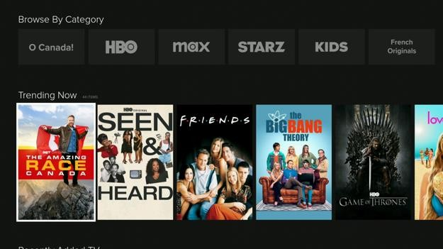
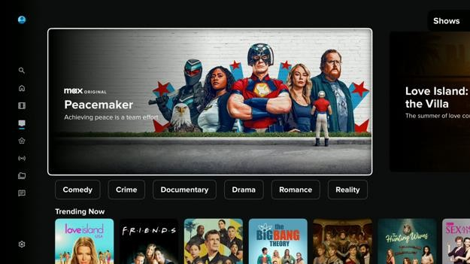

Google Streamer
On the “TV shows” screen under the featured shows carousel, there is a “browse by categories” carousel. Selecting one of the categories refreshes the screen to show only those shows. Unfortunately for sighted and screen reader users, selecting some of these categories does not change the page title to indicate that category is selected. If there is a page title, it is not read out and cannot be selected to be read out by the screen reader. The screen reader does not announce anything when the screen refreshes to apply the filter.
Finding TV shows by genre is difficult because there is no option to filter by genre on the TV shows screen and on the search screen. When I scroll further down the screen, there are some categories of TV shows mixed in with other unrelated categories. The movies screen has the same problem.

Roku Ultra
Nothing on the tv shows screen is read out by the screen reader except the carousel titles. The items can still be selected by the screen reader. All the navigation bar items are read out except the search and profile buttons.

Fire TV Stick
Items on the TV shows screen are not read out when hovered over with the external mouse pointer. I hear the no item sound when I hover over them.
There is no button to click on to show the nav bar. I must use the keyboard to show it instead of relying on the mouse. Not everyone’s mouse has a back button to show the nav bar.
Carousels do not have left and right arrow buttons for me to click on using the mouse. Trackpad left and right swipe works to scroll through all carousels except the featured shows carousel at the top of the screen. Hold and drag works on all carousels however some people have difficulty doing this gesture. This is especially true for the featured shows carousel because the large cards require a big drag motion or else it snaps back to the previous position.
Finding TV shows by genre is difficult because there is no option to filter by genre on the TV shows screen and on the search screen. When I scroll further down the screen, there are some categories of TV shows mixed in with other unrelated categories. The movies screen has the same problem.

Movies
The movies screen has an auto-advancing carousel for featured shows at the top of the screen. Below that are carousels for trending now, recently added movies, previews, blockbuster movies, acclaimed movies, and more. Users who are not logged in will get the same view.
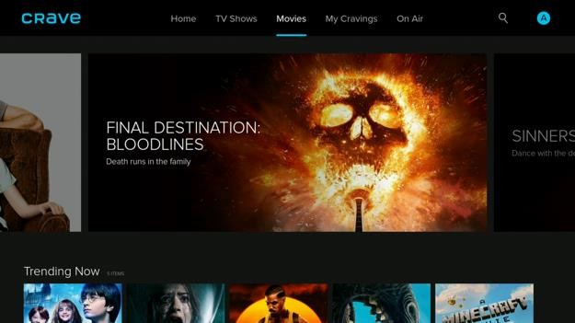
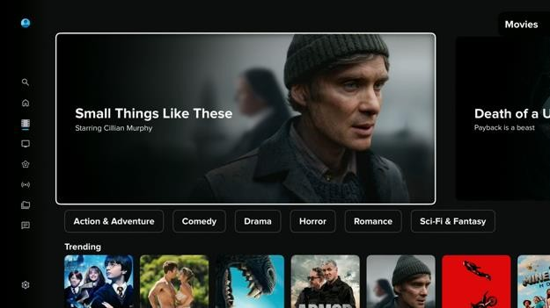

Roku Ultra
Nothing on the movies screen is read out by the screen reader except the carousel titles. The items can still be selected by the screen reader. All the navigation bar items are read out except the search and profile buttons.

Apple TV
Under the featured shows carousel on the movies and shows screens, there is a row of buttons to filter the shows by genre. When a filter button is pressed, the screen refreshes to show a list of shows that fit the criteria. The first show is automatically selected by the screen reader, but it is not read out. The screen title like "comedy 70 items" is not read out until another item on screen is selected. The screen title should be announced when the screen loads. Fire TV Stick
Items on the movies screen are not read out when hovered over with the external mouse pointer. I hear the no item sound when I hover over them.
There is no button to click on to show the nav bar. I must use the keyboard to show it instead of relying on the mouse. Not everyone’s mouse has a back button to show the nav bar.
Carousels do not have left and right arrow buttons for me to click on using the mouse.
Trackpad left and right swipe works to scroll through all carousels except the featured shows carousel at the top of the screen. Hold and drag works on all carousels however some people have difficulty doing this gesture. This is especially true for the featured shows carousel because the large cards require a big drag motion or else it snaps back to the previous position.
Finding movies by genre is difficult because there is no option to filter by genre on the movies screen and on the search screen. When I scroll further down the movies screen, there are carousels with some categories of movies like comedy, dramas, action & adventure, romance, sci-fi & fantasy. However, browsing through lots of content in a carousel one by one is slow. Also, genre carousels are mixed in with other carousels for other unrelated categories like the wizarding world collection, for the whole family, and allCanadian.

Google Streamer
Finding movies by genre is difficult because there is no option to filter by genre on the movies screen and on the search screen. When I scroll further down the movies screen, there are carousels with some categories of movies like comedy, dramas, action & adventure, romance, sci-fi & fantasy. However, browsing through lots of content in a carousel one by one is slow. Also, genre carousels are mixed in with other carousels for other unrelated categories like the wizarding world collection, for the whole family, and allCanadian.

On Air
The on air screen has an auto-advancing carousel for featured live shows at the top of the screen. Below that are carousels showing the program schedule for each TV channel. Users who are not logged in will get the same view.
Please note that the Apple TV user interface groups the TV shows differently. Shows are grouped by all channels, English channels, and French channels. There is no featured live shows carousel at the top of the screen.
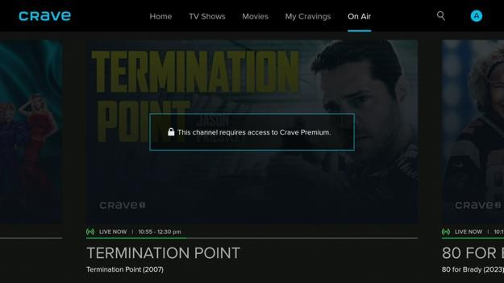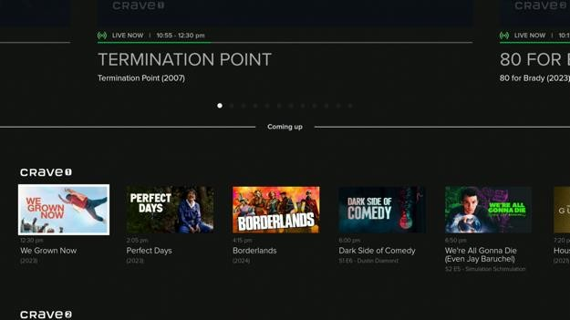
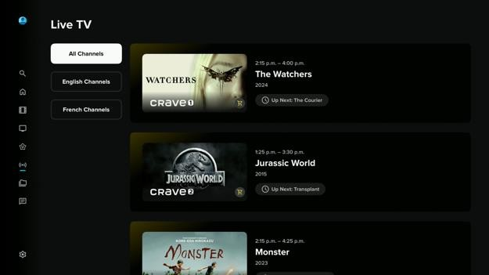

Google Streamer
On the “On air” screen, there is a carousel with featured shows. The carousel pagination dots can be selected, but do not announce anything. With the pagination dots selected, pressing the right arrow selects the next card, but nothing is announced.
On the “On air” screen, under the featured shows carousel, there is a live tv schedule shown as a carousel. Pressing the left or right arrows can sometimes skip over shows. Pressing the up or down arrow to move between carousels sometimes selects the item above it below the current item, but one off. This can cause confusion for vision loss users.
Pressing the down arrow scrolls the screen down, but does not select the carousel below. I have to press the down arrow twice every time to move to the next carousel.
The live tv carousels each have a title above it to tell the user what channel it is. Those titles are not read out and cannot be selected by the screen reader.

Roku Ultra
Nothing on the on air screens is read out by the screen reader except the carousel titles. The items can still be selected by the screen reader. All the navigation bar items are read out except the search and profile buttons.

Fire TV Stick
On the Fire TV Crave on air screen, there are carousels for each channel. The carousel title containing the channel name is not read out by the screen reader.
On the Fire TV Crave on air screen, there are carousels for each TV channel. When I select a show, nothing happens. The screen reader does not tell me the button is disabled and there is no alert telling me I need to upgrade my subscription.
Items on the on air screen are not read out when hovered over with the external mouse pointer. I hear the no item sound when I hover over them.
There is no button to click on to show the nav bar. I must use the keyboard to show it instead of relying on the mouse. Not everyone’s mouse has a back button to show the nav bar.
Carousels do not have left and right arrow buttons for me to click on using the mouse. Trackpad left and right swipe works to scroll through all carousels except the featured shows carousel at the top of the screen. Hold and drag works on all carousels however some people have difficulty doing this gesture. This is especially true for the featured shows carousel because the large cards require a big drag motion or else it snaps back to the previous position.
When I left the TV on overnight and then turned it back on to open the Crave TV app, the “on air” screen showed an error message that reads, “Sorry, there was a temporary error connecting to the system. Please try again later.” This message is not read out by the screen reader and cannot be selected to be read out. I had to quit the app and reopen it again for the error message to go away.

Watchlist
The “My cravings” screen has a list of shows organized into carousels like continue watching, my list, and watch history. There is a back to top button at the bottom.
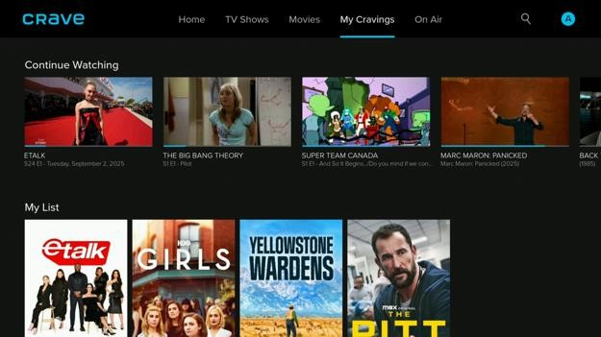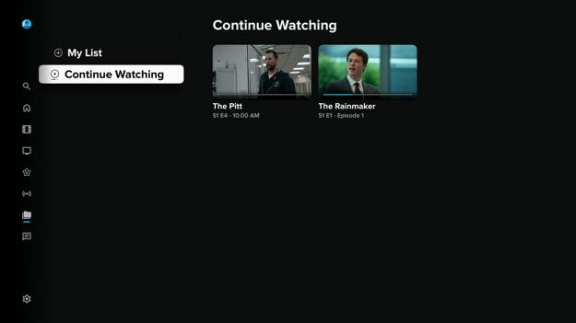

Apple TV
The naming for the “My Cravings” screen is inconsistent. In the navigation bar, the link to the screen is called “My Cravings”. On the home, TV shows, and movies screens, the list of shows is under the continue watching heading. On the “My cravings” screen, the screen title is “continue watching”.

Google Streamer
On the “My Cravings” screen and show details screen, there is a back to top button at the bottom of the screen. Pressing this button does not take me back all the way to the top of the screen. The screen scrolls up and then select an item half way up the screen.
Using the mouse to click on the “My cravings” link in the nav bar does nothing. There is no other way to access this screen, so this feature is unavailable to mouse-only users.

Fire TV Stick
On the “My cravings” screen, after reaching the first item on the screen and hearing the end of list sound, pressing the left or right arrow buttons goes to the movies or on air screen. However, the nav bar selection still shows that I am still on the “My cravings” screen. The same bug happens when I press the back to top button then press the left or right arrow button.
Items on the “My cravings” screen are not read out when hovered over with the external mouse pointer. I hear the no item sound when I hover over them.
Clicking the “My cravings” link in the nav bar reloads the last viewed screen. I cannot access this screen using only the mouse.
There is no button to click on to show the nav bar. I must use the keyboard to show it instead of relying on the mouse. Not everyone’s mouse has a back button to show the nav bar.

Show Details
On the show details screen, there is the show name followed by the show metadata like the year released, number of seasons, age rating, genre, and a brief description. Underneath that are buttons to watch the show, add the show to the watchlist, watch the trailer, and get detailed show info. Below that are tabs to view the episodes, view suggested shows, and view show extras. There is a back to top button at the bottom.
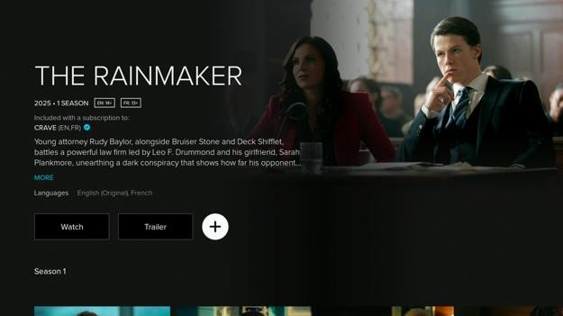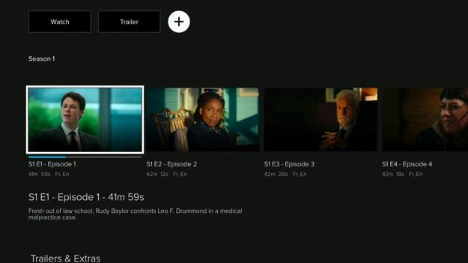
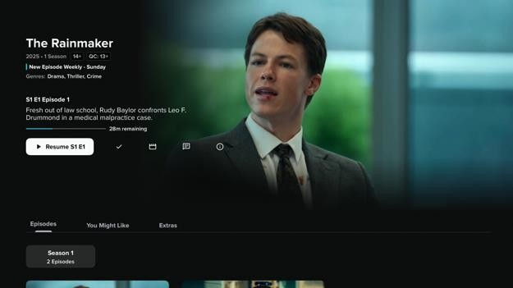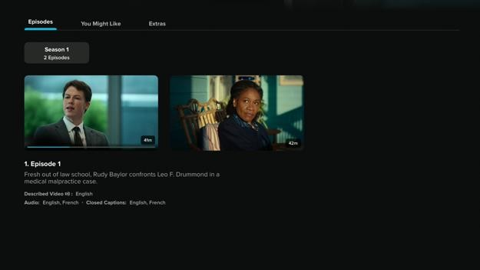

Google Streamer
When I select a movie on the home screen, I get the show details screen. When I press the back button, the home screen remembers my movie selection. However, when I move the selection to the navigation bar, pressing the back button will forget the movie selection and scroll position.
On the “Show details” screen, the show episodes may be grouped into one tab per season. These tabs are activated by just moving the focus to it instead of having to press the select button first. This creates a problem because accidentally selecting a tab while moving through the episodes carousel will refresh the carousel items for the selected season. This will cause the user to lose their place.
When an episode is selected, the episode description is shown below. When I move down to the description and then move back up to the episodes carousel, sometimes a different episode is selected. Sometimes moving down to the episode description skips over the episode title.
Pressing the down arrow to navigate through items does not always select the left most item in the grid. This makes it hard for a screen reader user to navigate since they may be missing things to the left.
Unlike other streaming media apps, Crave TV tells users when shows are about to disappear from the app. For example, “The Big Lebowski” is available until January 31. This avoids the problem where the show disappears before the user is finished watching it.
On the show details screen, clicking the seasons tabs with the mouse does nothing.
The escape button on the keyboard cannot be used to go back to a screen. I need to use the command left arrow shortcut. This is different from other streaming media apps.

Roku Ultra
Nothing on the show details screen is read out by the screen reader. When I add or remove a show from the watch list, nothing is announced by the screen reader. When trying to play a show, the “You need a Crave premium plan to watch on this device” message appears. Nothing is read out by the screen reader except the OK button.

Apple TV
The top of the show details screen lists the show title, description, and content rating, and genre. The text on this screen is not always read out by the screen reader. The text cannot be reliably triggered to be read out by the screen reader. The text cannot be selected to be read out by the screen reader.
The show details screen has a more info button to get more details about the show like the cast, writer, and executive producers. The text on this screen is not always read out by the screen reader. The text cannot be reliably triggered to be read out by the screen reader. The text cannot be selected to be read out by the screen reader. The languages button has the same problem.
On the show details screen under the episodes tab, there is a list of episodes each with a title and description. The order the screen reader reads the text does not match the visual order things appear on screen. This can be bad because it reads the video attributes before the episode description. For a show, it is expected that all episodes will have the same video attributes.
Under each episode description is a more button. Pressing the button shows a screen with the same information making this redundant. Moreover, the text on this screen is not always read out by the screen reader and cannot be reliably triggered to be read out.
When the show details screen appears, the show release year and age rating text is automatically selected. When I press the select item button on my switch access keyboard, switch access locks up and cannot be used again until the Apple TV is restarted. Turning switch access on and off does not fix the problem. The Crave app cannot be forced to close on the Apple TV.
On the show details screen, only the first episode tab and first episode can be selected while switch access is in item mode. I must switch to remote mode. Scrolling horizontally switches from the episodes tab to the “You might like” tab.

Fire TV Stick
Sometimes when selecting a show from the home screen, the show details screen shows the incorrect show.
The Fire TV Crave show details screen has an end of list sound when the top of the show details screen is reached. Pressing the up arrow button again shows the nav bar.
On the show details screen, the watch button is automatically selected when the screen appears. The watch button name is too long because it includes the show name, number of seasons, languages, description, and finally the watch seasons 1 episode 1 button label. This makes it harder to know the watch button is selected because I have to listen to everything else first.
Underneath the show details, there is a list of episodes split by seasons. Selecting an episode with the screen reader does not read out the episode length and description. The text cannot be selected to be read out by the screen reader.
On the show details screen, moving the screen reader selection up from the seasons tab to the trailer button does not say anything.
On the show details screen, there is an episode carousel and a more like this carousel. The last selected carousel item may reset when pressing the up and down arrows past these sections. This can cause confusion.
Items on the show details screen are read out when hovered over with the external mouse pointer.
On the show details screen, episodes are sorted by seasons with a tab for each. Clicking on these tabs with the mouse does nothing. If I only have a mouse, I cannot view episodes past the first season.
On the show details screen, the movie description’s more button cannot be clicked on with a mouse.
On the show details screen under the movie name, there are tags like “EN:E” and “FR:E”, but there is no description of what this means. I guess the “E” means everyone. It would be better to change the label to “EN:All Ages” or “EN:Everyone” to be easier to understand.
On the show details screen, if a show is missing a season or episode, it does not tell me it is missing and where I can find it.

Video Player
If the user profile is set to ask to select an audio playback language every time, the “Choose audio playback language” screen will appear. There are choices to switch between English and French.
The video player has buttons that automatically show and hide when a button on the remote control, keyboard, or mouse is pressed or when the video is paused. These buttons let the user play the video, open the closed captions menu, and open the audio language menu.
The closed captions menu can turn the captions on or off. There is no option to switch to showing captions in another language. There is also an edit CC style button that shows an overlay to select between different caption sizes and caption text styles. There is a preview of what the closed caption changes will look like
The audio language menu can switch between English, English with described video, French, and French with described video. Changing the audio language will also change the closed captions language to match.
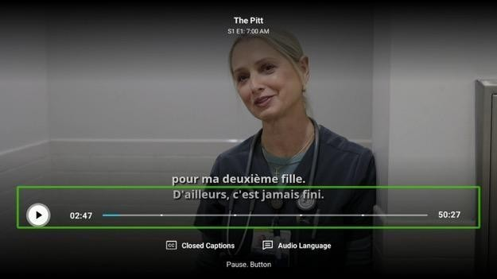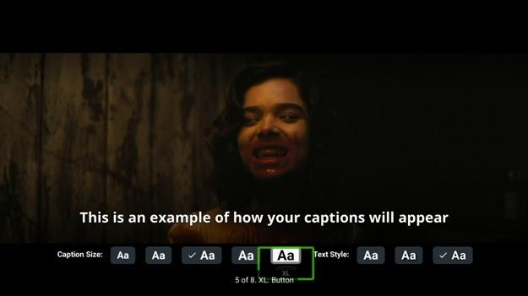
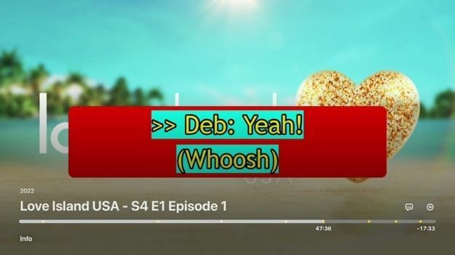

Google Streamer
The video player does support having closed captions in a different language than the audio track. The closed captions menu only has a toggle to turn the closed captions on or off.
In the video player controls, there is a button to edit the closed captions styling. Clicking this button shows a menu with buttons to change the caption size and text style. Unfortunately, selecting these buttons only announces the button label, not the radio button group name. I do not know if the radio buttons are for the caption size or for the text style.
The caption text sizes and styles are very limited. The biggest caption text size setting may not be big enough for some people with vision loss.
In the video player for some show trailers, the spoken audio may be in English even though the audio language is shown as French in the audio language options. The closed caption settings do not show English as an option. The video details screen shows the movie is available in English and French.
When an ad is playing, the screen reader announces “ad playing”, but it doesn't say how many more seconds until the ad ends even when the text label is selected.
When I pause the video on the Google Streamer Crave video player screen, the video controls appear. When I resume the video, the video controls remain on screen. Since the pause button is selected, the screen reader keeps saying pause until I hide the video controls by pressing the back button.
When I use the mouse to click on the closed captions or audio language buttons in the Google Streamer Crave video player controls, the menu opens. However, when I close the menu and try to open it again, the menu immediately closes. I have to exit the video player to open the menu again.
Clicking or dragging the mouse pointer on the video timeline looks like it would skip through the video, but nothing happens because the change is automatically undone.
When the Google streamer screen reader is off, the mouse cannot be used to show and hide the video player controls. Clicking on the video player screen does nothing. Pressing the back button exits the video player. If the screen reader is on, clicking the video player with the mouse shows the video player controls. Pressing the back button hides the controls.

Roku Ultra
On the movie player screen, the subtitles use the Roku system subtitle styling.
The movie player controls are not read out by the screen reader. They can still be selected. The screen reader does not announce anything when starting and stopping fast forward. When the subtitle button is pressed, the subtitle selection menu opens and the screen reader announces the current selection. However, when I close and open the subtitle menu, it is not read out again by the screen reader.

Apple TV
When I choose a video to play, I am asked to select a video language. The audio and subtitles selection screen title is not always read out by the screen reader when it appears.
The video player has a bug where the screen is stuck with a loading icon when I press the back button on the audio/subtitles screen. Nothing is announced by the screen reader and nothing can be selected. I need to press the back button again to get out.
Once the video starts playing, I cannot change the video audio and subtitle language without exiting the video player even if that movie is available in multiple languages.
On the video player screen, the subtitles can be turned on from the subtitles menu. The subtitle styling follows the Apple TV system setting.
On the video player screen, there is an option to enhance dialogue in the audio menu.
However, it cannot be selected with the screen reader and is defaulted to off. The Apple TV settings app has an enhance dialogue option, but turning it on does not enable that setting on the video player
When I try to fast forward through a video beyond an ad break, the video progress is reset to just before the nearest ad break and then the ad plays.
The crave video player just keeps crashing without any accessibility technology enabled. It happened twice for one video.
The video player subtitle and audio menu cannot be selected using switch access item mode. I must switch to remote mode to select it.

Fire TV Stick
The subtitle language and audio language choices must be the same language. Other streaming media apps do not have this limitation.
Some shows are available in both English and French, but the trailer is only available in English or only available in French.
When I try to fast forward through a video beyond an ad break, the video progress stays in the same position and then the ad plays.
The Crave video player on the Fire TV Stick does not follow the Fire TV Stick subtitle system settings. This includes the text style, text size, text colour, opacity, text background, and window colour settings. There is no equivalent for some of these settings like text style, text colour, and opacity.
The Fire TV Crave video player has options to change the subtitle text size and background. These options act like radio buttons, but its selected state is not announced by the screen reader. I do not know which options are selected without looking at the screen. I also do not know which options are for the text size and which are for the text background because the radio button group names are not spoken by the screen reader.
On the video player screen, changing the audio language may resume the video before or after the current timestamp. This may cause confusion.
If the subtitle and audio language is in French, the advertisements are still in English. If I fast forward past an ad break, it may take 10 seconds before the ad starts playing. The screen reader does not announce anything when the ad starts playing. There also is a bug when it skipped the first ad and starts playing ad 2 of 3.
On the video player screen, there are buttons to change the caption and audio language. I can only use the mouse to open one of the option menus once. Afterwards, the menu keeps closing automatically when I click the button to show it. I must exit the video player for the option menus to work again, but only once.
There is no back button to click on with a mouse to exit the video player. I must use the keyboard to do that. Not everyone’s mouse has a back button.
The play, pause, fast forward, and rewind keys on the keyboard works with the video player.
The fast forward and rewind buttons on the remote control do not work when the text banner accessibility feature is enabled. This is because those buttons are used to flip to the next and previous page of the text banner. The play button still works.
The ETALK show description screen shows it has EN and FR languages, but this is not the case. When I play an episode, it does not ask me to choose a language. My profile setting is set to ask me to choose a language every time. The show only has English audio and subtitle choices in the video settings.

Search
The search screen has a search input field followed by a list of search results below. If the search input field is blank, there will be a list of recent searches.
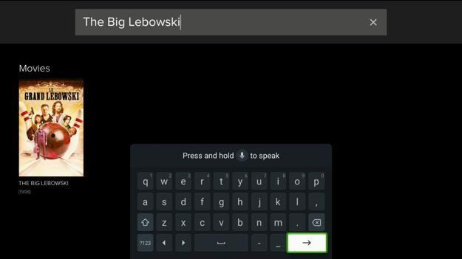
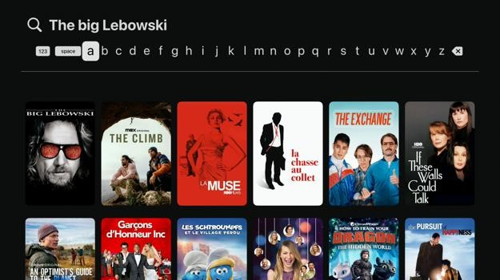

Apple TV
Voice dictation is supported on the search screen. Focus does not have to be on the search field for this to work.
The search results show unrelated shows and movies that do not contain my search term. This can make it harder for me to find what I am looking for.
The movie posters do not have text labels underneath it. Some of the titles on the posters can be hard to read.
There is no option to filter shows by genre like I can on the movies screen. Roku Ultra
Voice dictation is not supported on the search screen. I must use the on-screen keyboard.
The search screen keyboard buttons are not read out by the screen reader until I press it to type the selected character. This means the on-screen keyboard is unusable unless I can see it or I have memorized the keyboard layout.

Google Streamer
Voice dictation is supported on the search screen. However, the search field must be selected with the on-screen keyboard visible for this to work.
Using the mouse to click on the “Search” link in the nav bar does nothing. There is no other way to access this screen, so this feature is unavailable to mouse-only users.
When I go to the search screen, the on-screen keyboard appears. Using the mouse to click on the keyboard buttons does nothing.

Fire TV Stick
On the search screen, the microphone button can be used to say a show name. If there are no results found, the screen reader does not announce anything. The no results found message cannot be selected to be read out by the screen reader.
The on-screen keyboard does not speak out the search term that was typed. I cannot check if I typed out the word correctly without looking at the screen. If I select the search text field, the text input is not read out either. If I select the search field again, the text input is read out, but there is a bug where an “a” is automatically added to the end. This is because “a” is the first letter selected on the keyboard.
Items on the search screen are not read out when hovered over with the external mouse pointer. I hear the no item sound when I hover over them.
Clicking the “Search” link in the nav bar reloads the last viewed screen. I cannot access this screen using only the mouse.
When I go to the search screen, the on-screen keyboard may appear even though I have an external keyboard connected. I cannot hide the on-screen keyboard by pressing the escape key on my physical keyboard or by clicking the next button on the on-screen keyboard. I have to press the back button on my physical keyboard to hide it, but not all keyboards have this button. This is a problem because the on-screen keyboard covers the whole screen.

Profiles
On the profiles screen, there is a list of user profiles associated with the account. Clicking on a profile will go to the edit profile screen. Below that is a list of buttons to view account management info, sign out, view support info, view help info, view the app version, and delete the account.
Please note that the Apple TV user interface has a settings navigation bar on the left instead of having a list of buttons at the bottom to access different screens. Some features are also missing on the Apple TV version like to toggle the autoplay reminder and delete the account.
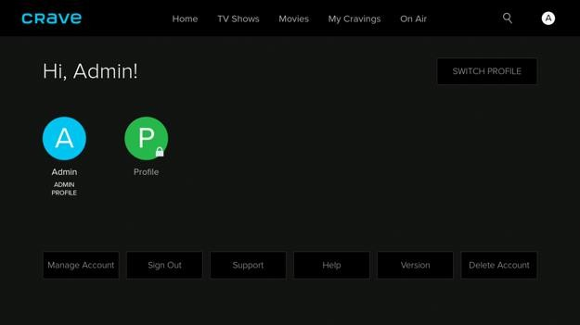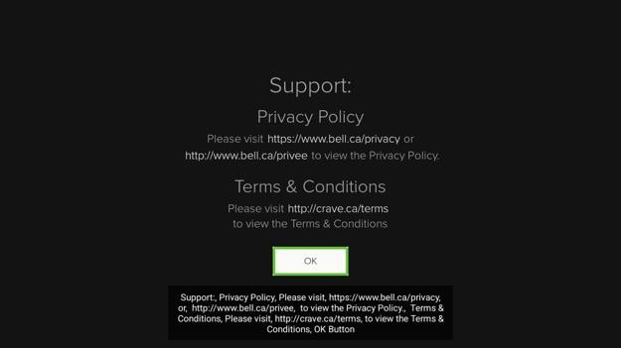
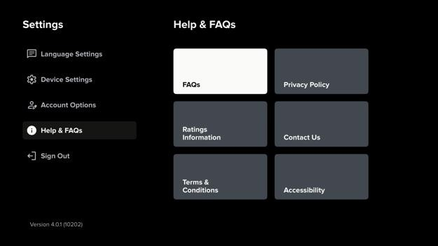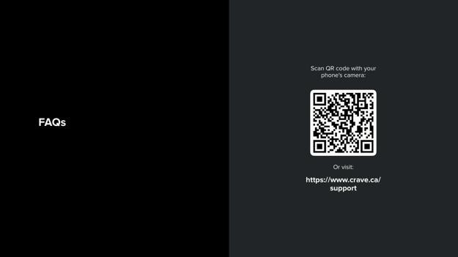

Google Streamer
On the profile screen, the manage account text is not read out by the screen reader unless it is manually selected. A screen reader user may not know which screen they are currently on.
The support, help, and version text are not read out by the screen reader if the mouse is used to click on it. If the keyboard is used, the text is read out by the screen reader.

Roku Ultra
None of the buttons on the profile screen like manage subscriptions, sign out, support, help, and version are read out. The text on the info screens that are shown after pressing those buttons are not read out either.

Apple TV
The title on the profile name screen is not read out immediately by the screen reader when it appears.
All screens under device settings, account options, and help & FAQs has text on the screen that may not be read out by the screen reader. The text cannot be reliably triggered to be read out by the screen reader.

Fire TV Stick
On the “My profile” screen, clicking the help button shows a phone number to contact for help. This phone number is separated by en dashes. This causes the screen reader to not read the phone number correctly.
Items on the profile settings screen are read out when hovered over with the external mouse pointer.

Add Profile
The option to add profiles is unavailable on the Google TV Streamer, Fire TV Stick, and Roku Ultra. Users must login to the Crave website to do this.
On the Apple TV, the option to add profiles is available. On the switch profile screen, there is a button to add a profile. When creating a new profile, it asks me for the profile name and content access age rating. There is also the option to set a PIN, change the closed caption language, and change the audio language.
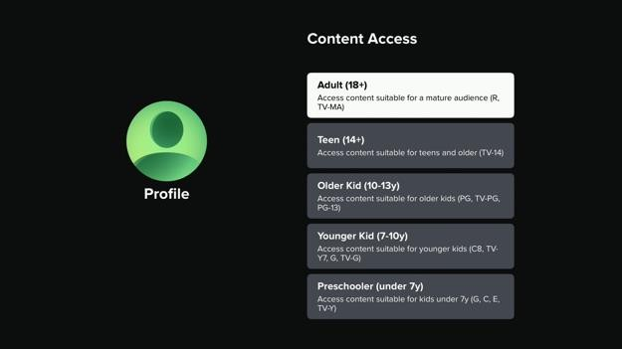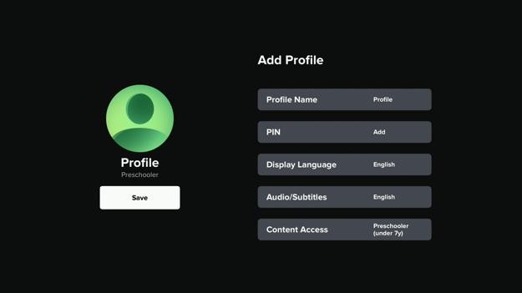

Apple TV
When adding a new profile, I can restrict which age rated content the new profile can access. Some age rating labels are not read properly by the screen reader like “older kid ten negative thirteen y”. Hyphens for number ranges should be replaced with “to”.
Abbreviations like “y” or “yrs” should be avoided.
After adding or resetting a PIN on the add profile screen, a PIN added alert appears with an OK button underneath. The OK button cannot be selected by the screen reader. I need to press the back button to get out. This problem does not happen when removing a PIN.
Sometimes I cannot set a PIN on the add profile screen because the text input field cannot be selected. I have to press the back button to try again.

Edit Profile
After selecting a profile on the profile screen, the edit profile screen will appear. On the edit profile screen, there is a list of buttons to change the profile language, change the audio playback language, and change the autoplay settings. The content access button is also there, but it does nothing.
The option to add a PIN to a profile is unavailable on the Google TV Streamer, Fire TV Stick, and Roku Ultra. Users must login to the Crave website to do this. Only the Apple TV version can do it from the TV app.
If the profile is protected by a PIN, the PIN must be entered before the profile can be edited.
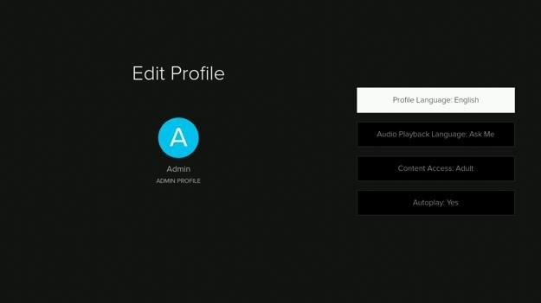
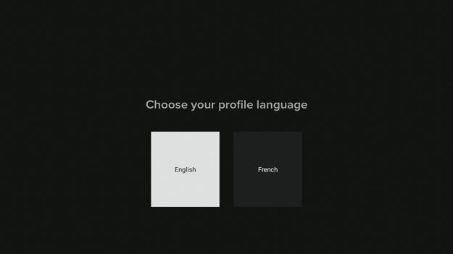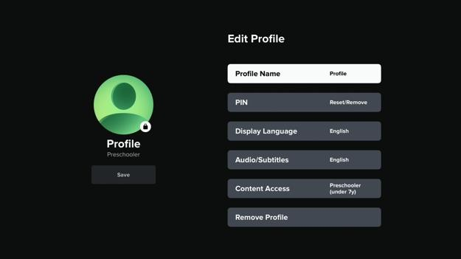
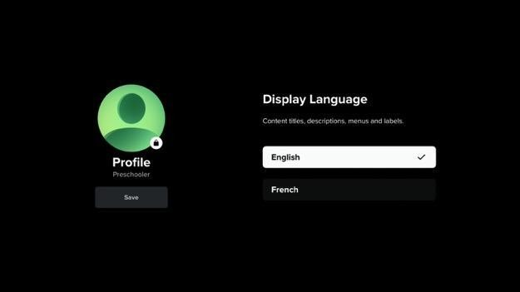

Google Streamer
The edit profile screen has options to change the profile language, audio playback language, content access, and autoplay. The option buttons like yes, no, enable, and disable act like radio buttons but the screen reader does not announce its state. I do not know what the current settings are without looking at the screen.
The content access button is disabled, but it does not announce its disabled or dimmed state to the screen reader. Pressing the button just does nothing. The button does not look disabled.
On the edit profile screen, there is a button to change the autoplay settings. The autoplay settings screen has two individual options. One option is to “allow autoplay on this device” and the other is for “autoplay reminders”. Even though these settings have individual options, choosing an option for one setting will close the screen.

Roku Ultra
On the edit profile screen, none of the buttons are read out by the screen reader. None of the option buttons for each preference is read out by the screen reader.

Apple TV
The title on the edit profile screens are not read out immediately by the screen reader when it appears.
On the language settings screen, there are buttons to change the display language and audio/subtitles language. The text on the screen may not be read out by the screen reader and cannot be reliably triggered to be read out by the screen reader. The radio button choices do not announce its state.
When the display language or audio/subtitles language screen appears, the profile avatar can be selected with switch access. When I press the select item button on my switch access keyboard, switch access locks up and cannot be used again until the Apple TV is restarted. Turning switch access on and off does not fix the problem. The Crave app cannot be force closed on the Apple TV.

Fire TV Stick
On the edit profile screen, there are settings to change the profile language, audio playback language, and autoplay. The content access button is not visually different from the other buttons even though it is disabled. The button is not announced as dimmed by the screen reader. The screen reader just skips over the button.
Each setting has a description followed by option buttons. The option buttons act like radio buttons, but the screen reader does not announce its state. Only the first setting description is read out when the screen appears. This is a problem when there are multiple settings to change on one screen. For example, the autoplay screen shows “Allow autoplay on this device” and “autoplay reminder”. The “autoplay reminder description” is not read out and the enable and disable button labels are not descriptive enough.

Disney+
The Disney+ app has numerous problems that affect all users on all streaming media apps. Some of these are accessibility issues. Pressing the down arrow button may not select the next item directly underneath. Some form error messages are not announced by the screen reader. Some text is not read out by the screen reader and cannot be selected to be read out. Some checkboxes do not announce its state. Ads are not announced by the screen reader when they appear. The screen reader does not announce when the video is in fast forward mode and how much of the video is skipped. The preferred subtitle language and subtitle audio system setting is ignored even if the preferred language is available for the movie. Subtitle or audio languages displayed as non-Latin characters may be pronounced incorrectly or not pronounced at all by the screen reader. The search field placeholder text reads, “Search by title, character, or genre” but it is not clear how to apply the character or genre filter.
Some of these are software bugs and performance issues that can cause the app to crash or become unresponsive. In more severe cases, the streaming media device can become unresponsive. Pausing and resuming a video may cause the video player to get stuck in a loop pausing and playing the video. Clicking on some movies with the mouse always crashes the app. The app selection and screen reader selection may go out of sync when moving through items causing the wrong label to be read out. Selecting a subtitle or audio language may cause all languages to appear checked. Changing audio and caption settings may crash the app. There may be input delays of several seconds when moving through items in the privacy preferences screens.
The Disney+ streaming media app has many accessibility features. However, the overall experience is much worse due the high frequency of accessibility issues, software bugs, and performance issues I encountered.

Disney+ Home Page
On the Disney+ website home page, when the user is not logged in, there is a large banner at the top to let visitors know there is a promotion for the Disney+ standard with ads subscription plan. Underneath that is a link to view all plans. Clicking on the view all plans link scrolls the page down to a table that has all the subscription plans listed along with the enabled features. The plan name at the top of the table is a button that starts the process to sign in or create an account.
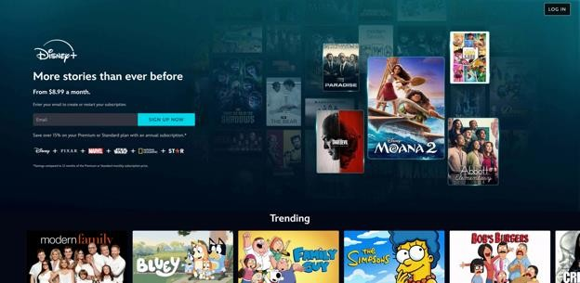

NVDA Screen Reader
Tapping the. “View all plans” link scrolls the page down to the “Choose your plan” section, but it does not move the screen reader focus there so it seems like nothing happened.
The “Choose your plan” table had empty cells in the heading. Table headings are also not defined. This makes it harder to know which feature is included in each plan.

Sign In or Create Account
The sign-up form is split into two steps.
The first step asks the user to input their email address to log into their MyDisney account. If there is no account associated with that address, they will be prompted to create a new account. There is an email input field, followed by a continue button, followed by logos of the Walt Disney company sub-brands.
If the account does not exist, the second step asks the user to choose a password for the account. There is a password input field with the password requirements listed below. Underneath that is a checkbox to opt-in to receive updates, special offers, and other information from Disney. There are also links to privacy policy, terms of use, and subscriber agreement pages that open in a new tab. Below that is the “Agree & Continue” button, followed by logos of the Walt Disney company sub-brands. Clicking the “Agree & Continue” button loads the billing page.
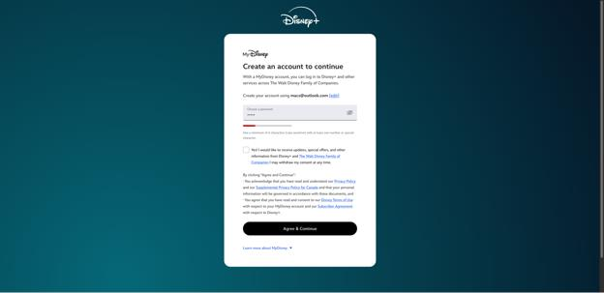

Android Screen Reader
On the “Enter your email to continue” screen, the logos at the bottom of the screen use the file name as alt text such as, “mydisney_logo_parade_disney_alt_text” instead of a descriptive label.
On the “Enter your password” screen, the “Learn more about MyDisney” plus button has a down arrow letting visual users know it is an expandable section. For screen reader users, the button is not marked as collapsed or expanded. A screen reader user may assume that tapping this button will open the web browser.

Set Up Billing
On the billing page, there is a small subheading at the top to let the user know which step they are on in the sign-up process. Underneath that is a page title to let the user know which plan they are signing up for along with the promotion details and terms. Below that is a form to input the billing details. There are two tabs to switch between paying by credit card or using PayPal. The billing details form asks the user for the name on the credit card, card number, expiration date, security code, postal code, etc.
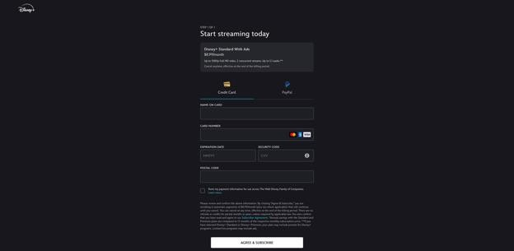

NVDA Screen Reader
When the “Billing step 1 of 1” page loads, the focus moves to the Recaptcha banner at the end of the page. Focus should move to the first form field. I had to tab back up to the top.
If you click the “CVV info” button, a modal opens. After closing the modal, the focus returns to the top of the page instead of selecting the info button again
Selecting the “Skip to main content” link on the billing page refreshes the page and takes the visitor to the “Choose your plan” page instead of skipping to the form
When a plan is selected to return to the billing page, the header says step 2 of 2 instead of step 1 of 1.

Privacy Preferences
The Privacy Preferences are split into two main screens.
The Privacy Preference Center screen is split into two columns. The left column has categories of advertising preferences that can be viewed or modified. This includes the list of partners (vendors), essential, store and/or access information on a device, targeting & advertising, performance & analytics, and special purposes & features. The right column contains a description of what and how information is collected from the user. It also allows the user to turn on or off certain tracking and advertisement targeting. Selecting a category in the left column will update the right column.
Clicking the list of partners (vendors) in the previous screen will load the IAB vendors screen. The IAB vendors screen has two columns: one for the list of vendors and one for the description. Selecting a vendor loads the description
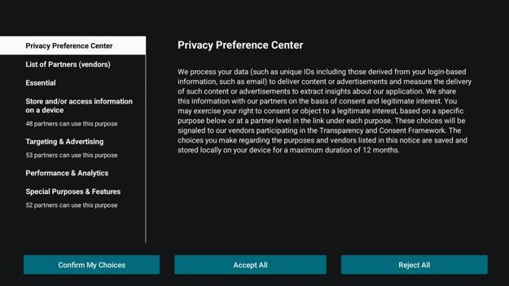

Fire TV Stick
The “Privacy settings” text is not read out even when selected.
The Disney logo is unlabeled.
When the “View privacy policy” button is clicked, the screen has a grey overlay, but the “IAB vendor privacy policy” modal window does not appear.
The consent checkbox is not declared as a checkbox and does not announce its state until it is clicked.
On the “Illustrations” screen, the text description is not read out even when it is selected with the screen reader.
The SDK list has unlabeled buttons. The back button and filter button are unlabeled.
No buttons on the “manage privacy preferences” screen can be clicked on with the mouse or trackpad.

Apple TV
When the privacy settings screen appears, the “Accept all” and “Reject all” button labels are partially read out. The beginning word may be cut off and it just says “All button”.
On the privacy settings screen, there is an option to view the list of partners (vendors). However, the vendor names in the list are not read out by the screen reader. Same thing for the SDK list.
Selecting the view privacy policy or view legitimate interest claim buttons shows a QR code on screen, but the screen reader does not announce anything.
The consent and legitimate interest checkbox are not declared as checkboxes and does not announce its state even when they are activated. Activating the checkbox moves the screen reader focus back to the top of the list instead of staying selected on the checkbox. After checking a checkbox with the remote control, the checkbox cannot be unchecked without leaving the section and coming back. The problem with checking checkboxes does not happen with the keyboard.
The IAB vendors screen has two columns: one for the list of vendors and one for the description. Selecting a vendor loads the description, but the screen reader does not start reading the description from the top. Instead, it may start somewhere in the middle.
On the IAB vendors and SDK list screens, the back and filter buttons are unlabeled
The filter vendors list has a list of checkboxes to filter vendors by, but the checkboxes are not declared as checkboxes and they do not announce their state.
On the store and/or access information on a device, there is a button to view illustrations. The view illustrations screen has text, but it is not read out by the screen reader. It just says one of two, two of two.
The “Targeting and advertising” section has multiple sub-categories listed with options to turn on or off certain forms of personalized advertising. There is a short description under each option, but these descriptions are not read out by the screen reader.

Roku Ultra
On the Roku Disney+ app, the “Your privacy settings” screen has two columns. On the left is scrollable text containing the privacy conditions. On the right are buttons to accept all, reject all, customize choices, and view the list of partners. The spoken description of the buttons on the right says navigate left or right to explore more options. The options are actually above or below.
For each IAB vendor, there is a “view privacy policy” and “view legitimate interest claim” screen. The link text can be selected to be read out, but the colour contrast text going from unselected to selected is very slight. The “customize choices” description text has the same problem.
Each IAB vendor screen has a small snippet of text that describes the data storage, retention and uses. The paragraph can be selected to go to another screen with the full details, but the text containing the full details is not read out and cannot be selected to be read out by the screen reader.
On the “targeting and advertising” customization screen, there are a bunch of subcategories. The subcategory label shows which ones are turned on or off, but the screen reader does not say it. A screen reader user would need to go into each subcategory to check.
The details text for each targeting and advertising subcategory is not read out and cannot be selected to be read out by the screen reader.
Roku Disney+ app does not have the option to filter the vendors and SDK list in the privacy settings unlike on other apps.

Google Streamer
When the Disney plus app is first opened on the Google streamer, the “Your privacy settings” screen appears. The “accept all” button on the right column is automatically selected. This means the privacy statement is not read out automatically by the screen reader.
The Disney plus logo is an unlabeled image. When I press the down arrow, the “Your privacy settings” heading is selected. When I press the down arrow again, I expect the body text under the heading to be selected, but the screen reader focus moves to the accept all button on the right column. This can cause confusion because the focus order does not match the visual layout.
The Google streamer Disney+ app privacy settings screen is inaccessible when the screen reader is on. The accept all, reject all, customize choices, and list of partners buttons do not work. The app cannot be used until the user accepts or rejects the privacy agreement.
When the list of partners screen appears, there is a sidebar on the left and a details pane on the right. Above the sidebar is a back button, four unlabeled buttons, and a filter button. None of these buttons have accessibility labels. The screen reader does not say anything when they are selected.
When an IAB vendor is selected on the sidebar, the details pane automatically updates. If the user presses the select button on the sidebar item, the screen reader does not automatically move the focus to the details pane. The user needs to press the right arrow to select the details pane. When the user scrolls through the details pane and then presses the left arrow button to move back to the sidebar, the focus does not return to the last selected vendor. Instead, the focus moves to the sidebar item that is closest to the currently selected item. Since the sidebar selection skipped a few items and the details pane automatically updates for the currently selected vendor, it is very easy for a screen reader user to lose their place. Also, pressing the back button does not move the focus from the details pane to the sidebar. The back button goes back to the previous screen.
The privacy policy and legitimate interest claim buttons dim the screen, but no text appears. I have to press the back button to go back
On the IAB vendors screen, checkboxes do not announce their state unless they are toggled.
The blue buttons on the IAB vendors screen do not work when the screen reader is enabled. I cannot filter vendors, confirm my privacy choices, accept all, or reject all
When TalkBack is disabled, the IAB vendors filter button does not change colour when it is selected.
The Google streamer user interface lags when the screen reader is turned on. Sometimes buttons pressed on the remote control are ignored or take a second or two before the selection moves.
On the IAB vendors screen, getting to the filter options with a keyboard is unintuitive. I have to select the filter icon, move all the way to the left past the filter icon, select some invisible items, then press the down arrow once. If I do not do that the focus moves to the list of vendors on the left sidebar.

Login
The login screen has a “Get started” button and a “Log in” button. Both of these buttons do the same thing, which is to show the login form. The login form asks for the user’s email address and password on separate screens.
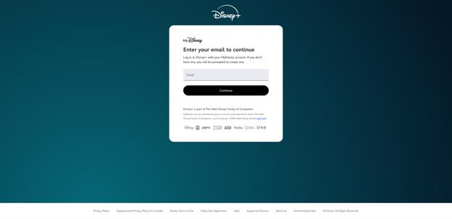

Fire TV Stick
The “Use a mobile device to log in” option text beside the “Log in” button is not read out and cannot be selected to be read out. Screen reader users will not know there are other ways to log in.
When the “Log in” button is selected, an onscreen keyboard appears. However, I cannot use voice dictation to type in the email address and password. I must enter in each character using the remote control. The password is not spelled out. The text input field cannot be selected.
Afterwards the one-time code screen appears. However, the “Enter your one-time code” title is not read out and cannot be selected to be read out. The screen reader just says PIN input field.
When the one-time code input field is selected, the PIN input keypad appears. The screen reader says to scan a QR code to log in easier, but no QR code is visible on screen. This problem does not happen when logging in with a password

Apple TV
On the Disney+ log in screen, only the log in button can be selected and is read out. The label telling the user that they cannot sign up on the TV app and they can also log in using the Disney+ mobile app is not read out.
On the Disney+ log in page, if the email field is left empty, there is an error message, but it is not read out by the screen reader and cannot be selected to be read out. The error message is also misleading as it says “We are having trouble creating your account”, but accounts cannot be created on the TV app as the login screen already states.
If an invalid email address is entered, a dialogue appears saying "we couldn't find an account". The text is not read out fully by the screen reader as the focus jumps to the try again button. The dialogue text cannot be selected
On the "enter your one-time code screen", after typing in the code and pressing the down button to continue, I get the resend code button. There is nothing to the right. Pressing the left arrow I get the login with password button. The continue button is above.

Roku Ultra
The Roku Disney+ email text field allows voice dictation one letter at a time. Delete and clear voice command is supported. The backspace voice command does not say what character was deleted, but it makes a button press sound. If the letter is a capital, the screen reader says “capital A alpha” and so on.
Voice input does not speak back input text after entry. If the text field is selected, the input is spelled, but there is no differentiation for upper and lower-case characters. Some symbols like the exclamation mark are not spoken. This is important for case sensitive inputs like passwords.
The back button can be pressed to hide the keyboard after input is finished.

Google Streamer
The Google streamer Disney+ app requires a mobile device or computer to log in. Other streaming devices allow using the remote control to enter the email address and password.

Select Profile
After logging in, the “Who’s watching?” screen appears. There is a list of user profiles, presumably for each person in the family as well as a button to add a new profile.
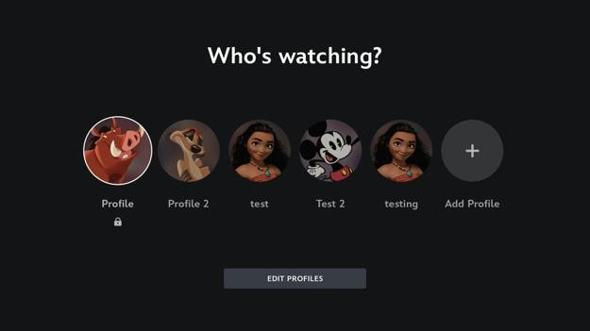

Roku Ultra
After selecting the edit profiles button, there is a screen that shows the profiles that can be edited. The edit profile heading is not spoken and cannot be selected. The button labels for each profile is only the profile name, not edit x's profile.

Edit Profile
The edit profile screen has options to customize the user profile avatar, rename the user’s profile, change the birth date, toggle autoplay, toggle background video playback, change the app language, change the content rating, add a profile PIN, and toggle demographic targeting for advertisements.
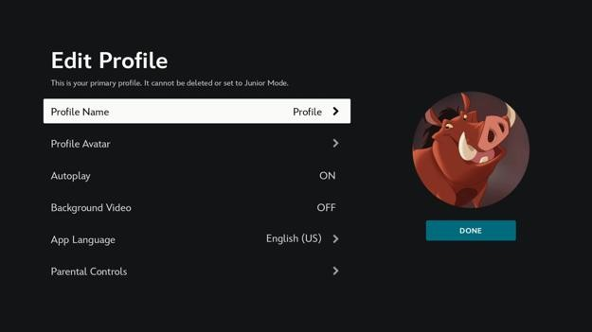

Fire TV Stick
The Disney+ app on the Fire TV Stick has text to speech problems if the system language does not match the app language.
The app text and text banner (screen reader caption banner) switches to match the app language, but the screen reader voice will speak the text with the wrong accent or may not be able to speak the text at all.
A small glitch, but when switching the app language, some user interface text and screen reader caption text may still be shown in the previous language before updating. When the screen updates, the previously selected item is forgotten. Other systems force the user to wait until the user interface is updated

Apple TV
If the Apple TV primary language is different from the Disney+ app language, the text-tospeech will try to speak words with a broken accent.
If the text-to-speech does not support a foreign character, it may fall back to another language or not speak the characters. The fallback language may be incorrect.
I am unsure why the app language should not follow the system language setting. The Disney+ app language is shared across all profiles and text-to-speech does not work properly if it does not match the system language.

Roku Ultra
The Roku Disney+ app does not support some app languages. On the selection screen to change the app language, there is a note that reads, “Please note, not every language is currently available on Roku”. This note is not spoken by the screen reader and cannot be selected to be read out.
If an unsupported language is selected, there is a dialogue box that reads, “This language is unavailable for this device”. There is an OK button, but no button to select another language. The dialogue text cannot be selected to be read out again.
On the select app language screen, the colour contrast between available languages and unavailable languages is too little. Chinese is not available, but Dansk is. Even if it is a supported language like Greek, the text to speech cannot pronounce some labels. If the system language does not match the app language in Roku Disney+, the text is not spoken properly.
If a user has the Disney+ app on another device in a language not supported by Roku and then logs in on Roku, there is no warning that the app language is unavailable. Some movie names and section labels are displayed as placeholder characters and the text is not read out.
The parental controls and privacy & data pages has a dialogue that says to go online to change the settings. The dialogue text cannot be selected to be read out again

Google Streamer
The Google Streamer Disney+ “parental controls” and “privacy & data” screens are not read out when they appear, but the text can still be selected to be read out by the screen reader.
The Google Streamer Disney+ app profile settings screen has a bug where the app selection and screen reader selection go out of sync when moving down the list of settings. Moving up the list works normally. This means the screen reader says the app language setting is selected, but pressing the select button does nothing.
When the app language is changed, the user is automatically sent back to the profile settings screen. All the text labels are changed except for the description for the currently selected item. When the selection changes, the item description is correctly updated.

Add Profile
After tapping the “Add profile” button, there is a screen to choose your profile avatar. Then there is a “Add Profile” form. The form requires the user to enter their profile name, birth date, and content rating. There is also a toggle to turn junior mode on or off.
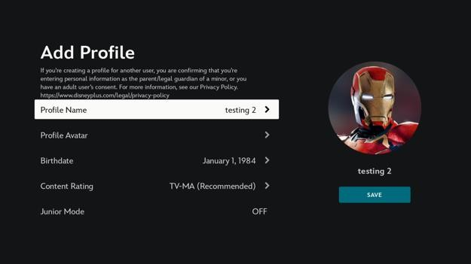

Fire TV Stick
When creating a new profile, it asks for my birth date. However, the page title is not read out. The screen reader just says 5 because the number 5 is selected on the keypad by default.
The birth date text field cannot be selected. The date format is not announced.
If an invalid birth date is entered, the error is not read out.
These three problems make it difficult for screen reader users to complete this mandatory step.
When the save profile button is highlighted, the screen reader reads the whole add profile blurb again before reading the button label.

Roku Ultra
On the choose avatar screen, there are multiple carousels each with a different group heading. When moving between groups, the screen reader does not say the group name unless I move to another group before the screen reader finishes speaking. Also, sometimes the screen reader says the group name as "In Disney+"
Form input errors on the “Add profile” screen are not announced when the done button is pressed. Selecting the form fields does not announce the error
Profile field inputs are shown beside the label, but are not spoken by the screen reader unless the user selects to edit it

Set Profile PIN
On the “Profile PIN” screen, there is an option to turn the profile PIN setting on or off.
Below that is a PIN input field. The PIN input field is disabled when the PIN setting is off.
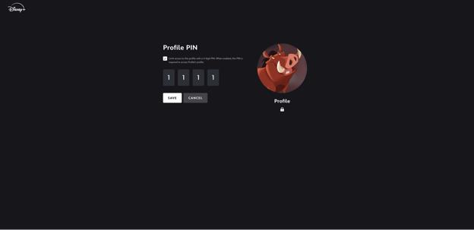
No accessibility problems were found on this screen.

Choose Profile Avatar
On the “Choose avatar” screen, there are multiple carousels each with a grouping label such as, featured, Disney, Pixar, Marvel, and Star Wars.
s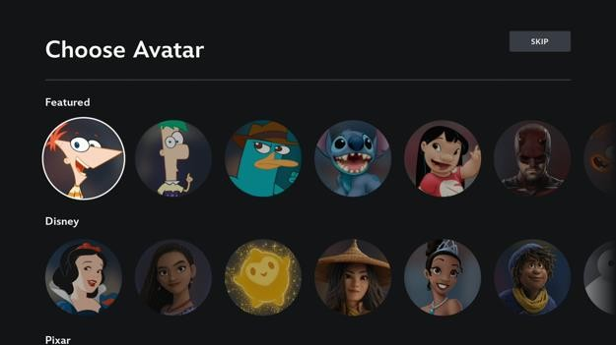
No accessibility problems were found on this screen.

Settings
The settings screen has a list of buttons to view or edit account profiles, edit the app settings, view the terms of use and subscriber agreement, and log out. Clicking the account, subscription, and help links tell the user to go to the Disney+ website to view or manage the settings.
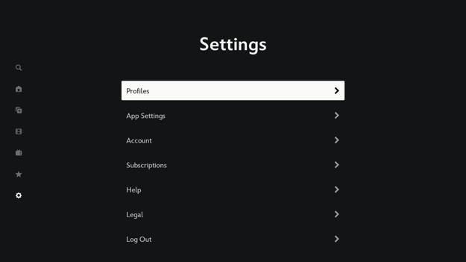

Fire TV Stick
The text on the account page telling the user to scan a QR code to manage their MyDisney account online is not read out by the screen reader and cannot be selected to be read out.
The text on the help page telling the user to go to the help section on the Disney+ website is not read out by the screen reader and cannot be selected to be read out.

Apple TV
On the Apple TV Disney+ app settings screen, the profile and subscriptions buttons do not have labels. This is not a problem on the Fire TV stick.
The account screen has text on the screen that reads, "To manage your account, go to Disney+ or MyDisney on the Web." That text is not read out by the screen reader and cannot be selected to be read out. Only the back button label is read out. Same problem on the Fire TV stick.
The legal screen has multiple long agreements. There are no headings to make it easier to skip to relevant sections of the agreement. Same problem on the Fire TV stick.
On the Apple TV settings screen, the screen reader descriptions do not tell the user which buttons are a simple toggle and which buttons go to another page with more options.

App Settings
On the “App Settings” screen, there is a list of buttons to toggle the stream over wi-fi only setting, change the wi-fi data usage setting, and change the cellular data usage setting.
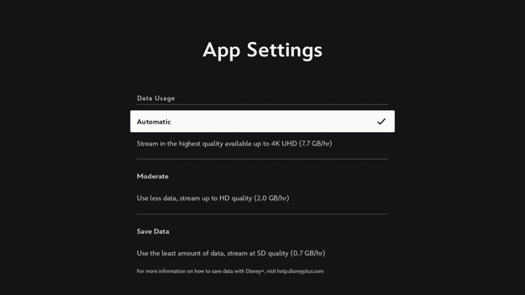
No accessibility problems were found on this screen.

Legal
The legal screen is split into two columns. The left column has a list of different legal documents that can be viewed. This includes the privacy policy, terms of use, and subscriber agreement. The right column contains the legal document text. Select a legal document in the left column will update the right column.
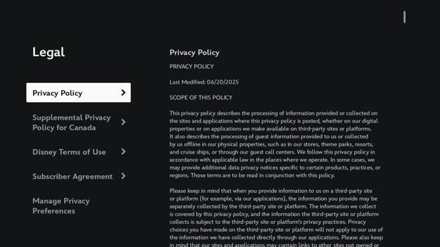
No accessibility problems were found on this screen.

Home
The home screen has an auto-advancing carousel for featured shows at the top of the screen. Below that are logo buttons to view movies for some of Disney’s partner companies. Following that are carousels for recommended shows, continue watching, new to Disney+, shows you may like, action and adventure shows, top 10 shows in Canada today, documentaries and reality shows, adult animation shows, and more.
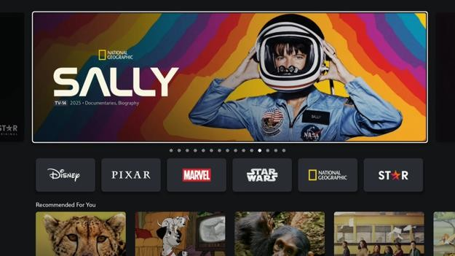

Apple TV
On the Apple TV Disney+ app, once I move out of the featured shows carousel on the home screen, I cannot press the up arrow to select it again.
On the home screen, the carousel selection defaults to the third or fourth item when moving from a carousel heading to a carousel item. It does not matter if another carousel item was selected before. This is disorienting for blind users.
The Apple TV Disney+ app does not follow the system light appearance, display zoom large, and bold text settings. Only the privacy center screens follow the bold text setting. I am not sure if the increased contrast system setting is followed because there is no low contrast text.
The Apple TV system setting to disable auto-play video previews and reduce motion is not followed by the Disney plus app. The top banner on the Disney partner company screens like for Pixar, Marvel, and Star Wars are still animated.
Hover text is not supported for some button labels like background video on the edit profile screen, settings profiles, settings subscriptions, and the details tab contents on the movie details screen. On the movie details screen, the trailer button is incorrectly labeled as “buttonGaDetailsTrailerV2”.

Fire TV Stick
When the screen reader is in review mode, movies in the continue watching section can be highlighted but not selected. The screen reader says, “Item not clickable”. Movies in other sections are fine
If the user exits the Disney plus app to go to the home screen and then opens the app again, the screen reader does not announce the currently selected item. The text banner shows details of the selected item.
If the user selects anything other than the featured shows carousel before exiting the app and then opens the app again, moving the screen reader selection up to the featured shows does not announce anything. The text banner also does not update to show the currently selected item.
Fire TV has an increased text contrast system setting, but Disney+ does not follow it.
The Fire TV Stick Disney+ app handles the external track pad and mouse slightly better than the Fire TV home and settings screens, but it is still too buggy to use. The pointer is visible, left click works, the back button works, but moving the pointer on some screens like the movie details screen or clicking on some movies always crashes the app. There is also no button to click on to show the navigation side bar. The back button on the remote control is used to show the navigation side bar, but not all mice have a back button.
Horizontal scrolling by holding shift and scrolling does not work on carousels.

Roku Ultra
The Roku Disney+ home screen has logos under the featured show banner. When I select the third logo, move up to the featured show banner, then mine back down to the logos, the third logo is always automatically selected. On the Fire TV Stick Disney+ app, the second logo is automatically selected each time.

Google Streamer
The Google streamer bold text accessibility setting made no difference in Disney Plus except in the privacy preferences screen.
The large and small text size Google setting makes a difference in all Disney plus screens.
The Google streamer high contrast text system setting had no effect on the Disney plus app. The Disney plus app has no text contrast issues in the first place.
On the Google Streamer Disney+ home screen, selecting the logo carousel below the featured shows carousel always selects the second item in the carousel. There is also a Disney channel original movies carousel that selects the second item when I select it using the down arrow. The third item is selected when I select it using the up arrow.

Show Details
On the show details screen, there is the show name followed by the show metadata like the rating, format, year released, number of seasons, genre, and a brief description. Underneath that are buttons to watch the show, watch the trailer, and add the show to the watchlist. Below that are tabs to view the episodes, view suggested shows, and view additional details about the show.

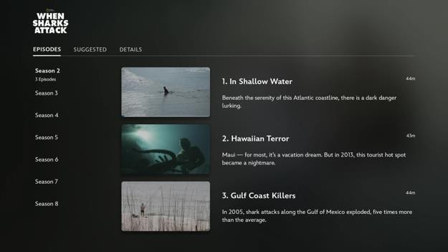

Fire TV Stick
When a movie is selected, the play button is automatically highlighted and the movie title is read out. But the movie description is not read out. Screen reader users will need to press the up arrow to hear the movie description.
While on the movie details screen, when the down arrow is pressed to go to the suggested tab, the first item is automatically selected without reading the tab title.
If I am part way watching a season, there is a continue button, but the screen reader does not tell me where I left off. I have to press the up button twice to find out.
At the bottom of the movie details screen, there are three tabs: suggested, extra, and details. These are not declared as tabs so the screen reader does not say how many tabs there are. A screen reader user may think there is a suggested heading and nothing to the right of it. This is not a problem on the Apple TV.
On the movie details screen, there is a “Remove from continue watching” button. When the button is pressed, there is a confirmation screen. The confirmation screen has an additional description that reads, “You won't see this title in continue watching, but your watch progress will stay the same.” This description is not read out by the screen reader and it cannot be selected to be read out unless the screen reader is in review mode.
On the movie details screen, there is a button to add the movie to the watch list. The confusing part is that the screen reader says the movie has been removed from the watch list when it has in fact been added to the watch list and vice versa. This threw me for a loop because the screen reader told me I removed a movie that I never added to the watch list. This is not a problem on the Apple TV.
On the Fire TV stick Disney+ app movie details screen, there is a details tab that shows additional information in two columns. The movie name and description is in the left column. The duration, release date, genre, rating, director, starting, and available in the following formats is in the right column. When moving from an item in the left column to the right column, rather than selecting the top item in the next column, the screen reader selects the closest item in the next column. For a sighted user, that makes sense, but for a blind user, the reading order does not make sense. A blind user also needs to guess that there are more items around the correctly selected item.
On the movie details screen, the trailer, add to watchlist, and removed from continue watching buttons need text labels. Maybe text labels can appear beside the icon when the button is selected.
The suggested and details tabs are not labeled as tabs on the movie details page. This is important because screen reader users may not know they are tabs. Also, moving between tabs may have different control methods.

Apple TV
The Disney+ app crashed on Apple TV by just leaving it on the movie details screen.
On the show details screen, the show name, rating, description, etc. is not read out and cannot be selected by pressing the up button on the remote control. The details tab at the bottom of the screen contains the same information, but the contents of that tab cannot be selected to read the information out.
The movie details page automatically speaks the movie details when the screen loads. The text cannot be selected to be read out again. The contents of the details tab on the movie details screen is automatically read out when the tab loads. The text cannot be selected to be read out again. When hover text is enabled, the movie details text can be selected to be read out, but not the details tab contents.
The show details tab contents cannot be selected with the keyboard.
On the show details screen, episodes listed under the episodes tab are not read out when using the keyboard and the screen reader.

Roku Ultra
The Roku Disney+ movie details screen reads the movie title, rating, year released, category, and description when the screen appears. The text cannot be selected with a screen reader to be read out again. The details tab can be used to get this info.
Tabs are inactive when focused and must be selected to switch tabs. This is a good thing compared to other streaming media apps.

Google Streamer
In the Google Streamer Disney+ app, the confirmation message when a show has been added or removed from the watch list is reversed. The Fire TV Stick version has the same problem.

Other Issues
Some parts of the Disney+ app can have some usability and quality-of-life improvements that we list below. These are not accessibility issues.
Avoid using abbreviations like TV-MA. Instead, use “mature audience only”.
The watch trailer and add to watchlist buttons should have text labels because not everyone knows what the icon represents.

Video Player
The video player has buttons that automatically show and hide when the mouse pointer moves, when a button on the remote control is pressed, or when the video is paused. These buttons let the user go back to the show details screen, open the subtitle settings overlay, restart the video, go back 10 seconds, play the video, go forward 10 seconds, skip to the next episode, adjust the volume, go full screen, and skip through the video. In the mobile app, there is also the option to lock the video controls.
The subtitles settings overlay has two lists. One list allows the user to change the video audio language. The other list lets the user change the video subtitle language. There is a button to close the overlay and another button to open the subtitle styling settings overlay.
The subtitle styling settings overlay has a preview of what the subtitle changes will look like. Below that is a list of options to change the font, font colour, font opacity, font size, font edge style, text background colour, text background opacity, subtitle window colour, and subtitle window opacity.
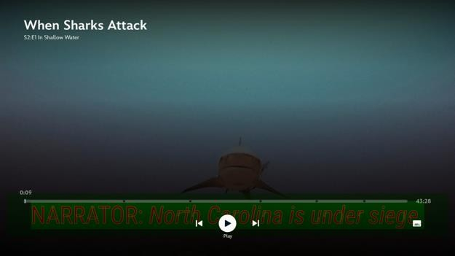


Fire TV Stick
Disney+ applies the caption text styles that are specified in the Fire TV Stick settings app.
The fast forward and rewind buttons on the remote controls can be used to move through the video, but the screen reader does not say the button was pressed and how much of the video was skipped. A screen reader user may accidentally press the button and not know.
If the left or right arrow buttons on the remote control are pressed, the screen reader will say, "video skipped back 10 seconds to 1 minute 30 seconds". If the arrow buttons are held down instead to skip past several seconds or minutes, the screen reader only says "playback resumed" when the arrow button is released.
When an audio or subtitle language is selected, the other audio and subtitle options are automatically checked even when they are not actually enabled. This is a software bug.
When a video is playing, the settings button can be selected, but it does nothing. The video must be paused first. Sometimes it works, sometimes it does not.
Zoom works, but the subtitles are cut off as they do not move to stay on the screen.
If the audio or subtitle name uses foreign characters, the language name is not read out by the screen reader when it is selected.
Audio and subtitle settings are not remembered across videos
When selecting the video player controls, the video title is read out by the screen reader before the button name. If the movie title is long, the video controls will automatically hide before the button name is read out
Disney+ crashed when I tried changing the audio and caption setting.
The Audio and subtitle tabs also can't be selected while the screen reader is in review mode. The screen reader says, “Item not clickable”.
Ads play without any notification from the screen reader. There should be an announcement to tell viewers when an ad starts, when an ad ends, and how many ads there are.
If skipping through a video past a point where an ad will show, a message appears at the bottom of the screen that reads "your video will continue from this point after the break". This is not read out by the screen reader.
Just like the Apple TV Disney+ app, the Fire TV version also has a problem where selecting the play pause button on screen sometimes does not resume the video. It only hides the player controls.
When the video is paused, sometimes a fast forward 10 seconds icon appears above the play button. This is a visual glitch as no fast forwarding happened. This screen reader does not say anything about fast forwarding.
While playing videos in the Disney plus app, the text banner disappeared even though the text banner setting is still on. I had to toggle the text banner off then back on again. Apple TV
When the video loads, there is a photo epilepsy warning along with the show rating.
The audio and subtitle language is remembered across movies as long as the movie has audio and subtitles in that language.
The left and right buttons on the remote can be pressed to skip back or forward 10 seconds, but the screen reader does not announce this. The screen reader just says playback resumed.
In the video settings modal, there is an info tab, but the details cannot be selected to be read out
For the “Chinese (繁體)” option, the Japanese voice is used to read the Chinese characters resulting in an incorrect pronunciation
Advertisements do not have subtitles or descriptive audio. Ads may also be shown in a language that is different from the Disney+ app or Apple TV system language.
The screen reader does not announce that an advertisement is playing. Advertisers may be able to make advertisements that seem like it is part of the movie to mislead viewers.
When the video controls bar appears, sometimes the video player scrubber and video duration details show the current time and time the video will finish. This is helpful, but the screen reader just reads times with no labels.
The left and right arrow buttons cannot be held down to fast forward or rewind in Disney plus Apple TV. You must press the button multiple times or use the middle button like a joystick. This control method may not be suitable for people with dexterity issues.
The video player does not work at all with hover text enabled. I cannot play, pause, adjust the timeline, go back, or use the arrow buttons.
Some of the Disney plus audio tracks are too quiet. The TV volume needs to be at least twice the volume before I can hear the dialogue comfortably, but then the screen reader is too loud. This happened for both the English and French voice tracks. There is no setting to adjust to screen reader voice volume.
The Apple TV settings to show captions when the audio track is a different language, show captions when muted, and show captions when the skip back button is pressed does not work on the Apple TV Disney+ app.

Roku Ultra
The Roku Disney+ app follows the system caption toggle and caption text styling. There is no option to change these settings in the Disney+ player. Descriptive audio is spoken, but not displayed.
Roku Disney plus does not follow the Roku preferred subtitle language and subtitle audio even if the preferred language is available for the movie. Unlike other streaming media devices, there is no option in the video player to change the subtle and audio language. In this case, the preferred language is French, but I get Italian. The only workaround is to set the desired audio and subtitle language on another device and wait for the Roku to update the setting.
Fast forward, fast forward double speed, and fast forward triple speed is announced by Roku Disney plus player.
Ads interrupt video playback with no announcement. Video resumes with no announcement.
If scrubbing past an ad break point, the screen reader will announce, “Your video will continue from this point after the break”.
Roku Disney+ video player stops working when pressing restart and play button constantly. The screen reader focus remains stuck on the restart button. The only way to get out is to press the back button on the remote control. The Fire TV Stick has the same bug, but going to the video settings to choose another audio language reloads the video and fixes the problem.

Google Streamer
In the caption text styles section of the Google Streamer settings app, there is an option to enable text outlines. When this setting is turned on, the Disney+ app shows the text outlines, but parts of the text outline cover the letter. This problem does not happen in the Google settings app caption style preview.
The Google Streamer caption text styles can be changed in the system app, but the Disney+ video player does not apply these changes until the audio or subtitle settings are changed in the video player.
When a video is paused and then played using the remote control, oftentimes the video player gets stuck in a loop pausing and playing the video. The arrow buttons and select buttons on the remote control no longer respond. The only way out is to press the back button to exit the video player. When I press the back button, the video may continue playing and the screen reader becomes unresponsive.

Other Issues
Some parts of the Disney+ app can have some usability and quality-of-life improvements that we list below. These are not accessibility issues.
The video player has no video speed controls or an option to select the video resolution.

Search
The search screen has a search input field followed by a list of search results below. If the search input field is blank, the results list has a list of suggested shows split by popular searches, trending searches, featured, and all collections. Each list is a carousel. There are buttons to the left and right to move through the carousel items.
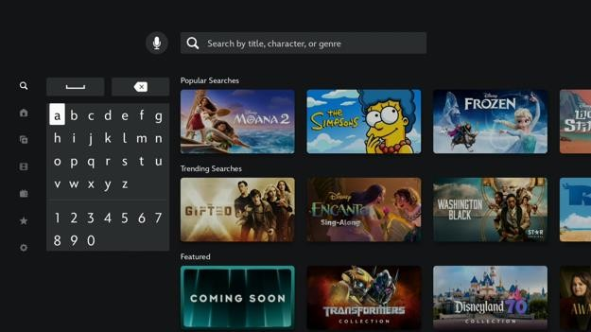

Fire TV Stick
On the search page, the keyboard is automatically selected, but voice dictation is unavailable. Using voice dictation searches for the movie outside the Disney app. To use voice dictation, I have to select the search field and then hold down the dictation button.
The search field is unlabeled. If the field is selected, nothing is spoken, not even the current text input.
On the Fire TV stick Disney+ app search screen, I cannot select the search field even when the screen reader and text banner is off. I used to be able to select the search field. This means I cannot use the speak to search feature
The search field placeholder text reads, “Search by title, character, or genre” but it is not clear how to apply the character or genre filter. When I search for adventure, how does it know I want to find shows of the adventure genre and not shows with adventure in the name? It is also hard to get people to recall the names of genres.

Apple TV
On the Apple TV Disney+ app, the microphone button can be held down to search without having to select the search field first. This works well, but I wish holding the microphone button does a search without being on the search page.

Google Streamer
The Google Streamer Disney+ voice search does not say if it did not hear my voice correctly or if it found any search results. The only way to tell is to see the screen or differentiate between the slight difference in the search completed sound.
The voice search recognition may take up to three times to correctly recognize all the words I spoke. The Google voice assistant search has a much higher success rate.
Using a remote control to select things on the search screen is unintuitive, especially when the person cannot see the screen. On the left side is an on-screen keyboard and on the right is a search results list. If I accidentally move out of the onscreen keyboard and into the search results list, upon moving back, another key on the keyboard may be selected. This is because the on-screen keyboard and search results list have a different number of rows.
The search field placeholder text reads, “Search by title, character, or genre” but it is not clear how to apply the character or genre filter. When I search for adventure, how does it know I want to find shows of the adventure genre and not shows with adventure in the name? It is also hard to get people to recall the names of genres.

Other Issues
It is difficult for people with hearing loss, vision loss, and foreigners to search for shows that have the accommodations they are looking for like subtitles, dubs, and audio descriptions. That is not even mentioning the bigger problem of finding which streaming service currently has the license for a certain show, show season, or show episode.
Shows, show seasons, and show episodes that the streaming media provider has no license for are not listed at all in the app. This means the user needs to do additional research. Also, the license to stream a show may end before the user finishes watching the show. There needs to be more warning before the show disappears.
In the Apple TV Disney+ app, the search keyboard buttons are all in one row. This means more key presses are required to go between letters and numbers. Pressing the arrow button on the remote only moves the selection by one character. The backspace button is in the far right beside z.

Watchlist
The watchlist screen has tabs to filter watchlist items by “My movies & series”, “My live & upcoming”, and “My replays”. Underneath is a list of shows added to the watchlist. Shows can be added to the watchlist by clicking on the “add to watchlist” button on the show details screen.
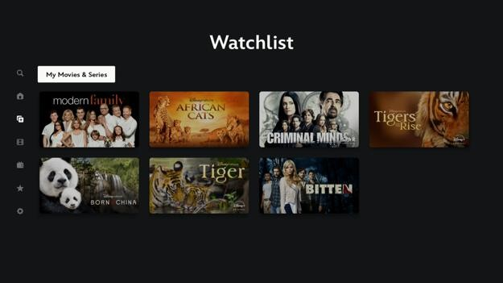

Roku Ultra
The watchlist screen on the Roku has a minor bug where if the “my live & upcoming” or “my replays” tabs are selected twice, the empty placeholder text disappears.

Movies
The movies screen has tabs to filter movie items by “Featured”, “Action/Adventure”, “Animation”, “Comedy”, “Documentary”, “Drama” and more. Underneath is a list of shows that fit each filter.
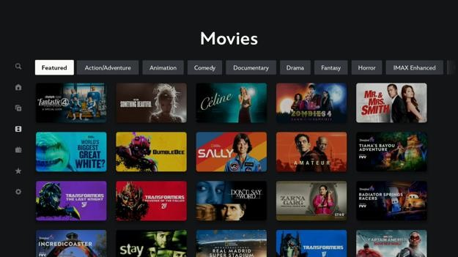

Google Streamer
On the movies and series screens, when moving between the third cell from the top up to the filters does not work properly. The filters either could not be selected or it selects the furthest rightmost filter that is off the screen. The Google Streamer and Fire TV both have this problem.

Series
The series screen has tabs to filter series items by “Featured”, “Action/Adventure”, “Animation”, “Comedy”, “Docuseries”, “Drama” and more. Underneath is a list of shows that fit each filter.
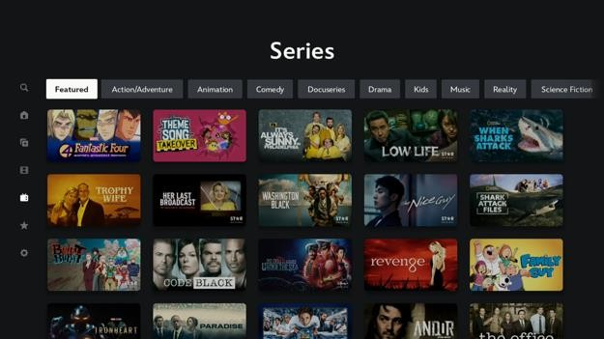

Originals
The originals screen has lists of shows split by featured, Hulu originals, series, movies, Star featured originals, shorts, and specials. Each list is a carousel. There are buttons to the left and right to move through the carousel items.
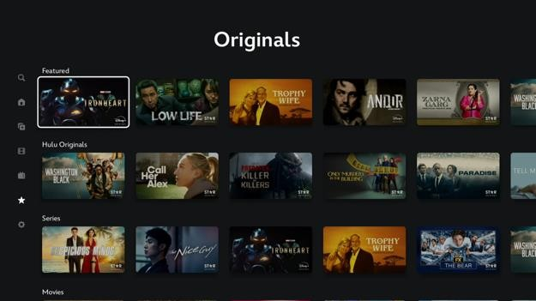

Fire TV Stick
On the Fire TV Stick Disney+ app, the movies and series screens have tabs for each category while the home and originals screens do not. The problem is the tabs are not announced as tabs so a screen reader user may think it is a heading and keep pressing the down arrow button on the remote control. This is not a problem on Apple TV.

Prime Video
The accessibility of the Prime Video app is primarily hindered by four major accessibility issues that makes the app unusable for screen reader, switch access, and mouse users. If not for these small, but high impact issues, the app’s accessibility will be much better.
The most major accessibility issue is that when the Talkback screen reader is turned on, the select button on the Google Streamer remote control does not work reliably. It only works sometimes to select items. When the screen reader is turned off, the select button works fine again. This makes it difficult to select things in the user interface.
The second major accessibility issue is that on the Apple TV version of the Prime Video app, the screen reader and hover text banner accessibility features frequently stop working. This happens when moving between screens or items on screen. The workaround is to go to the Apple TV home screen and open the Prime Video app again, but this problem happens very often.
The third major accessibility issue is that the mouse or trackpad cannot be used with the Fire TV Stick version of the Prime Video app. This is because the pointer is invisible.
The fourth major accessibility issue is that the app cannot be reliably controlled using the Apple TV switch access accessibility feature in item mode. Selecting some items often causes the switch access feature to freeze up and stop working. Switch access cannot be used again until the Apple TV is restarted. The workaround is to only use switch access in remote mode. The downside of this is that there is always a remote control overlay covering a small part of the screen.
Just like Netflix, there appears to be a custom screen reader solution. The screen reader caption and verbosity settings are ignored on the Google Streamer and Fire TV Stick.
Another common problem the Prime Video app has on some streaming media devices is that the video subtitle styles set in the system app are ignored. This can make the subtitles more difficult to read for people with low-vision.

Prime Video Home Page
On the Prime Video website home page, when the user is not logged in, there is a large banner at the top to let visitors know what Prime Video is and the monthly subscription rate. There are buttons to either sign in to an Amazon account or start a 30-day free trial. I clicked the “Start your 30-day free trial” button.
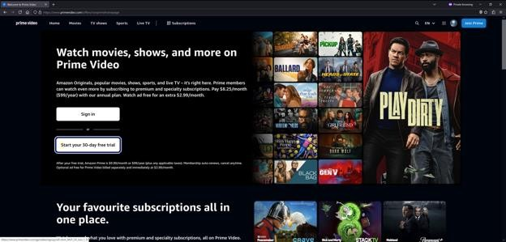
No accessibility problems were found on this page.

Website Sign In
After clicking the free trial button, the sign in page appears. The sign in page is the same as when signing onto the Amazon marketplace. The user is asked to enter their email, password, and two-step verification code as three separate steps.
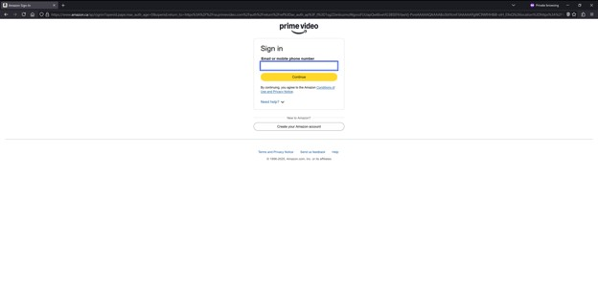
No accessibility problems were found on this page.

Confirm Subscription Plan & Payment Method
After signing in, there is a page to confirm the subscription plan and payment method. The subscription plan defaults to the free trial charged monthly. The payment method is the default payment method used when purchasing from the Amazon marketplace.
I wanted to check the other subscription plans and choose a different payment method so I clicked the change button beside each.
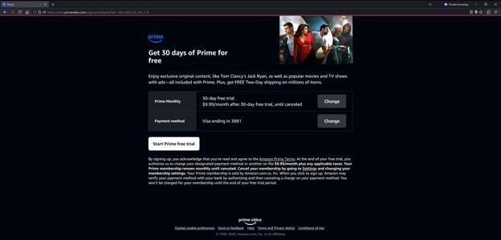
No accessibility problems were found on this page.

Change Subscription Plan
After clicking the change button beside the subscription plan, the change subscription plan page appears. There is a table showing the price of the monthly and annual plan along with the included features for each. The only difference between the plans is saving up to 17% by paying annually.
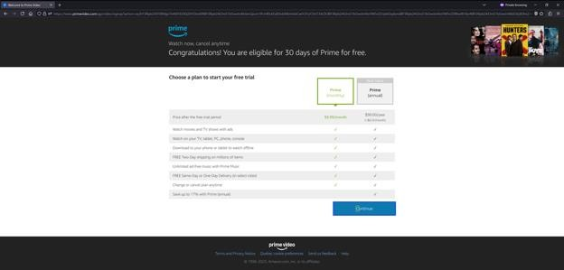

Other Issues
The subscription plan table has a heading for Prime (monthly) and Prime (annual). These table headings are radio buttons, but the radio button is invisible. The only way to tell which plan is selected is by the green outline and text colour. For accessibility, colours should not be used as the only way to differentiate things. To make it clear, the radio button should be made visible. Also, the “Continue” button below the table should be renamed to “Choose Prime (monthly) for $9.99/month”. This removes all confusion.

Change Payment Method
After clicking the change button beside the payment method, the change payment method page appears. There is a table showing the different payment methods that are added to the Amazon account with a radio button beside each one. There is a form below that to add another credit or debit card. At the bottom of the page, there is a continue button.
I wanted to add another payment method so I clicked the “Add a credit or debit card” link, which displayed a form to input the card information.
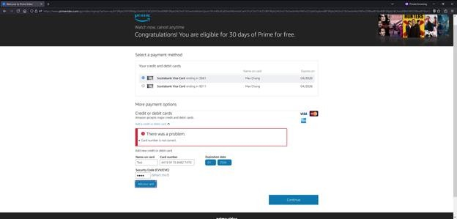
After entering in the credit card information, I clicked the “Add your card” button. Then the form updated and asked me to enter the billing address information.
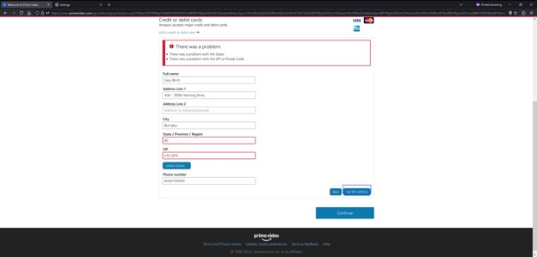
After filling out the billing address information, I clicked the “Use this address” button. Then the form updated and asked me if I want to accept a correction to the address I submitted. There is a button to choose if I want to use the suggested address or the one I entered. There is also a button to edit the address I entered.
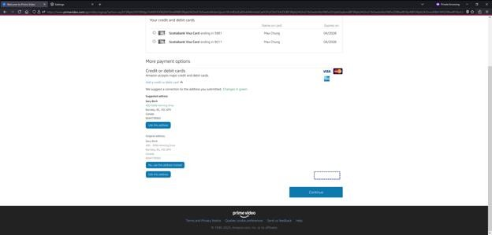

NVDA Screen Reader
On the change payment method page, there is a table that lists the different saved payment methods. The table has headings, but they are not marked as headings so the screen reader does not speak out the heading name before the cell value. This can make it a little harder to understand what each value means.
There is a picture of the accepted payment methods beside the add a credit or debit card link. The images are decorative and have no text equivalent. Screen reader users do not know which credit or debit cards are accepted until they try. The picture shows the Visa, Mastercard, and American Express logos, but JCB card numbers are accepted. Credit card autofill works.
The form to add a new credit or debit card has a security code field. The field label is not spoken by the screen reader when it is selected. This is because the form label is missing the for attribute that links the label to the field. This means screen reader users do not know what this field is for.
After inputting the credit card information, I am asked to input the billing address information. If the form has an error, the error message is not announced to the screen reader user. Form fields with errors are not marked with the aria-invalid attribute so the error is not announced when the field is selected. The screen reader focus also does not move to the first field with an error. These problems make it hard for screen reader users to know what went wrong.
After filling out the billing address information, Amazon suggests a correction to the address I entered. There are buttons to choose which address to use. Nothing is announced to the screen reader user. Also, the button descriptions are all read as “button submit query” instead of the button text label shown on screen. This makes it hard for screen reader users to know what the buttons do.

Other Issues
There is not enough contrast between the grey dropdown menu arrow and the blue dropdown menu background.
The continue button at the bottom of the page should be renamed to “Continue with Scotiabank Visa Card ending in 3881” to make it clear which payment method is selected. This is important because there are separate forms to enter the card information, enter the billing address, and choose an address correction. The button to move to the next step in adding a new card is a small button. Below that is a large continue button. People may click the continue button, which will cancel adding the new card.

Welcome
When the Prime Video app opens and no account is signed in, a welcome screen appears. On the welcome screen, there is a short description of what Prime video is and what it offers. Below that are buttons to sign in, create an account, or browse videos.
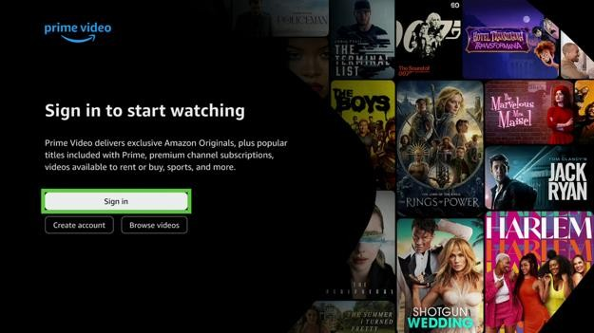

Google Streamer
The “Sign in to start watching” title and description text is only read out once by the screen reader when the screen appears. It cannot be selected to be read out again.

Roku Ultra
The “Sign in to start watching” title and description text is only read out once by the screen reader when the screen appears. It cannot be selected to be read out again.

Apple TV
The “Sign in to start watching” title and description text is only read out once by the screen reader when the screen appears. It cannot be selected to be read out again.
There is no option to create an account or browse videos as a guest.

App Sign In
After selecting the sign in button on the welcome screen, instructions on how to sign in appear. The user can either scan a QR code with their smartphone camera or go to a website and type in a code. The instructions are automatically read out by the screen reader. The user can press the up button to hear the instructions read out again.
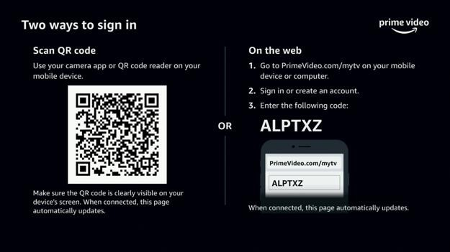

Google Streamer
The “primevideo.com/mytv” link is spoken like a word by the screen reader instead of spelling it out. This makes it more difficult for screen reader users to get the right link.
The screen reader tells me that I can “press the up button to repeat the code”. However, when I do that, the screen reader says “navigation not possible”. I will have to press back and try again if I missed the code.
The sign in code is spelled out without pauses. This can make it more difficult to type in the code correctly because there are too many letters to remember.

Roku Ultra
The “primevideo.com/mytv” link is spoken like a word by the screen reader instead of spelling it out. The dot in “primevideo.com” is also omitted. This makes it more difficult for screen reader users to get the right link.
The sign in code is spelled out without pauses. This can make it more difficult to type in the code correctly because there are too many letters to remember.

Apple TV
The “mytv” part of the “primevideo.com/mytv” link is spoken correctly by the screen reader because they put a space in between the two words. However, they did not put a space between prime and video so that is still mispronounced.
Unlike the other streaming media apps, the Apple TV version has a “Get a new code” button, but is not announced by the screen reader.

Select Profile
The select profile screen shows a list of profiles that can be logged into. There is an edit icon beside each profile to edit the profile’s settings. There is an add button at the end of the list to add a new profile. The screen background is an advertisement.
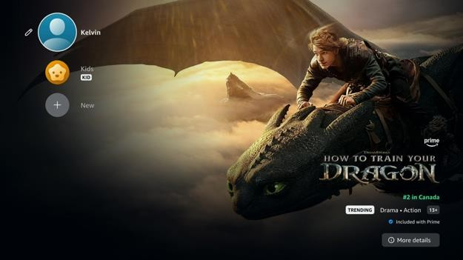

Google Streamer
The Prime Video app has a reduced motion accessibility setting. The advertisement slide in animation stops when this setting is enabled.
Some buttons sometimes cannot be selected when the screen reader is on. On this screen, this includes the more details button for the ad in the bottom right. Moving between items or switching to another screen and back sometimes fixes the problem. This problem applies to the external keyboard as well.

Roku Ultra
The Prime Video app has a reduced motion accessibility setting. The advertisement slide in animation stops when this setting is enabled.

Edit Profile
the edit profile screen, there is a list of buttons to change the profile avatar, name, and streaming language. There is also the option to remove the profile.
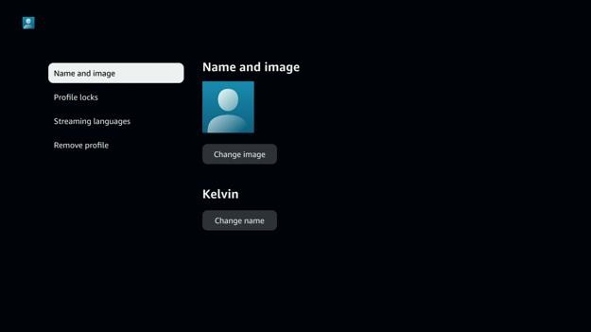
No accessibility problems were found on this screen.

Edit Profile Avatar
On the edit profile avatar screen, there are several carousels showing avatars that can be selected. After selecting a new avatar, the profile’s avatar is changed immediately. There is no confirmation message.
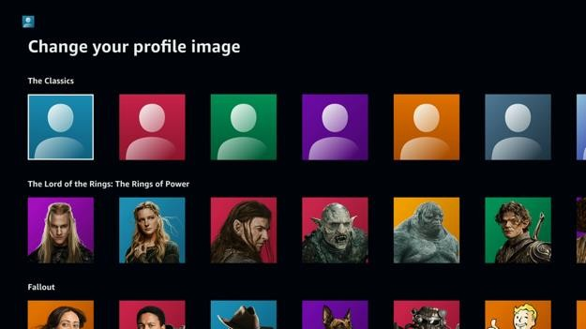
No accessibility problems were found on this screen.

Edit Profile Streaming Language
On the edit profile streaming languages screen, there is a radio button to switch from automatic language detection to choosing a manually specifying a language. This setting will ensure video recommendations are in the user’s preferred audio and subtitle languages. If the manual option is selected, there is a button to select a language. This will show a list of languages to choose from. Languages that use non-Latin characters are read as the English equivalent.
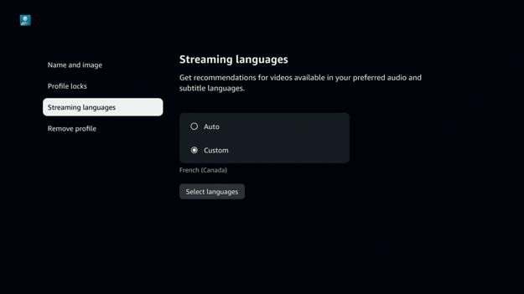

Other Issues
I found the implementation of the language setting to be confusing and unintuitive. On the edit profile streaming language screen, there is an option to change the streaming language per profile. This will ensure that video recommendations are available with the preferred audio and subtitle language. It will also change the language of advertisements. However, this setting is separate from the user interface and video player language setting. That setting is set per device. This means the video player audio and subtitle language settings are the same for all profiles. If members of the family sharing the same account have different language preferences, they will keep having to change the video language settings.

Add Profile
The add profile screen is split into three columns. On the left, there is an on-screen keyboard. In the middle is the profile’s name, a checkbox to mark the profile as a kid’s profile, a save button, and a cancel button. On the right is the profile’s avatar and a button to change it.
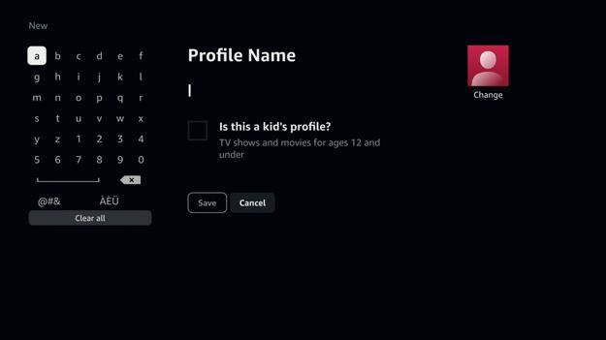

Google Streamer
When the screen reader is on, sometimes I type with the on-screen keyboard. I can select the buttons, but pressing the select button on my remote control does nothing.
When the screen reader is on, the save button appears to be clickable even if the profile name is left blank. However, nothing happens when I click the button. No errors are shown on screen and no errors are announced. If I disable the screen reader, the save button will appear disabled and an error message appears as expected.
On the add profile screen, I can select the on-screen keyboard buttons, but I cannot type with the external keyboard.

Search
The search screen is split into two columns. The left column has a search input field and an alphanumeric keyboard. Voice dictation is not supported. Using voice dictation will pull up search results on the streaming media device’s built-in voice assistant.
The right column contains search suggestions and a grid of search results. The search results are shown as movie posters with the show name in the image. There is no text underneath each poster. Selecting a search suggestion will narrow the search results. If no search term is entered, the search results will show search recommendations.
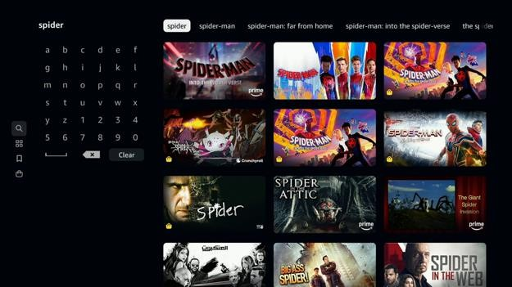

Roku Ultra
Voice dictation is not supported on the search screen. Using the microphone button on this screen and speaking pulls up the Roku system search results. These results include shows that are not part of Prime Video.
After typing in a search term, search results appear along with other search suggestions. The search suggestions are not useful because shows that do not contain the search term also appear.

Google Streamer
When the screen reader is on, sometimes I type with the on-screen keyboard. I can select the buttons, but pressing the select button on my remote control does nothing.
Voice dictation is not supported on the search screen. Using the microphone button on this screen and speaking pulls up the Google Assistant search results. These results include shows that are not part of Prime Video.
After typing in a search term, search results appear along with other search suggestions. The search suggestions are not useful because shows that do not contain the search term also appear.

Apple TV
When the search screen appeared, the search field was highlighted so I tried to use voice dictation. That pulled up the Siri voice assistant search results instead of searching within the Prime Video app. It turns out I have to press the select button on the remote control while the search field is selected to enable voice search. Afterwards, the voice search worked.

Fire TV Stick
If there are no matching search results, there is no placeholder message. The search results just show relevant results. This is not helpful.

Home
The home screen has a featured show banner at the top of the screen. Below that are carousels like because you liked, kids and family movies, fresh picks with subscriptions, continue watching, featured originals and exclusives, and more. The items on the home screen do not loop around once I get to the last carousel.
Unlike other streaming media apps, shows that require additional subscriptions are mixed in with shows included in the current subscription. This makes it harder to find watchable content.
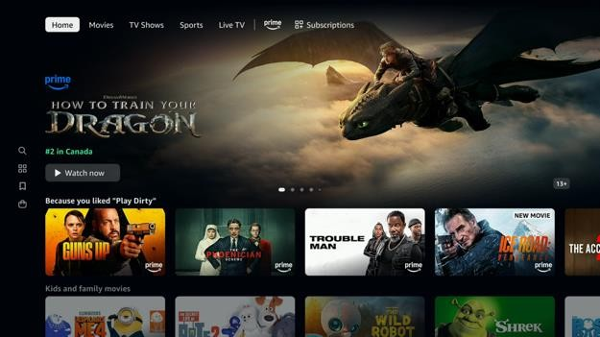

Google Streamer
Unlike other streaming media apps, Prime Video uses its own screen reader solution. This can create problems where system screen reader settings are not followed. In the system settings app, there is the option to turn on screen reader captions and adjust the screen reader verbosity. Some people with reading difficulties use screen reader captions to aid in reading comprehension. The Prime Video screen reader speaks out the button and usage hints whenever an item is highlighted. For experienced users, this is unneeded noise. However, there is no option to turn it off.
The Prime Video screen reader also has its own implementation bugs that can cause accessibility issues. The select button sometimes does not work for navigation bar items, carousel items, video player controls, on-screen keyboard buttons, the exit application button, and more. Moving between items or switching to another screen and back sometimes fixes the problem. This one problem makes the Prime Video screen reader unusable on the Google Streamer.
Prime Video has more screen reader tips than other streaming media apps. This is helpful for new users. Like “Press and hold select for more options. Move right to find an item. Move left to navigate to the main menu. Press select to choose. Move up and down to browse lists.” However, there is no way to turn this off for experienced users.
When the home screen appears, there is a “Personalized recommendations” dialogue box. The message asks if the user wants to enable personalized recommendations for videos on this device. I can press the OK or “Go to settings” buttons to dismiss the dialogue box. The dialogue box text is not read out by the screen reader so I do not know what the OK and “Go to settings” buttons are for.
There is a bug where the “Personalized recommendations” dialogue box keeps appearing after dismissing it. When I select a show to go to the show details screen and go back, the same dialogue box appears again. The disable recommendations setting is also not saved. When I turn off the screen reader and select OK, there is another dialogue box that reads, “Go ad free for $2.99/month”. Once I select “Not now” to that message, the “Personalized recommendations” dialogue box no longer appears.
It is not clear what would happen when I press the back button on the remote control. Pressing the back button does not always move the focus to the navigation bar like in other streaming media apps. Pressing the back button may move the focus to the first carousel item, back up to the show details section, or back to the previous screen.

Roku Ultra
When the home screen appears, there is a “Personalized recommendations” dialogue box. The message asks if the user wants to enable personalized recommendations for videos on this device. I can press the OK or “Go to settings” buttons to dismiss the dialogue box. The dialogue box text is not read out by the screen reader so I do not know what the OK and “Go to settings” buttons are for.
There is a bug where the “Personalized recommendations” dialogue box keeps appearing after dismissing it. When I select a show to go to the show details screen and go back, the same dialogue box appears again. The disable recommendations setting is also not saved. When I turn off the screen reader and select OK, there is another dialogue box that reads, “Go ad free for $2.99/month”. Once I select “Not now” to that message, the “Personalized recommendations” dialogue box no longer appears.
It is not clear what would happen when I press the back button on the remote control. Pressing the back button does not always move the focus to the navigation bar like in other streaming media apps. Pressing the back button may move the focus to the first carousel item, back up to the show details section, or back to the previous screen.

Apple TV
The “primevideo” part of the “primevideo.com/privacy” link is misspoken by the screen reader because they did not put a space in between the two words. This makes it more difficult for screen reader users to get the right link.
Sometimes when moving through screens like from the settings screen back to home or selecting another carousel item, the screen reader stops speaking the selected item. Apple’s hover text accessibility feature also stops working. The selection rectangle and navigation sounds still work. Going to another screen and back does not fix the problem. This means screen reader users cannot navigate the home screen. A workaround when this happens is to go to the Apple TV home screen and open the Prime Video app again, but this problem happens very often.
Moving the screen reader focus to another item before the screen reader has finished speaking does not interrupt the speech to read the newly selected item. This can slow down screen reader users especially if the item description is long.
Selecting an invisible box in the bottom right corner of the home screen may cause switch access item mode to get stuck. I must restart the Apple TV device to use switch access again.

Fire TV Stick
I cannot use a mouse or trackpad on the Fire TV Prime Video app because the pointer is invisible.

NVDA Screen Reader
After signing up for the free one-month trial, the home screen appears.
Prime video does not follow the reduce motion setting in Windows. The featured shows section on the home screen will play the whole trailer of the selected movie with sound off. There is a button to unmute the sound.

Movies
The movies screen has a featured show banner at the top of the screen. Below that are carousels like recommended movies, featured originals and exclusives, recommended movies with subscriptions, popular movies – sponsored, shop: donate to Spirit North, and more. The items on the movies screen do not loop around once I get to the last carousel.
Unlike other streaming media apps, shows that require additional subscriptions are mixed in with shows included in the current subscription. This makes it harder to find watchable content.
One of the carousels on the movies screen has filters for different genres like children and family, mystery and thrillers, drama, romance, and horror. However, it is mixed in with the other carousels and is not where I expect to find it.
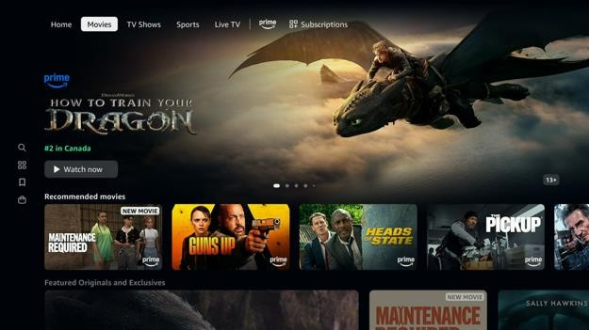

TV Shows
The TV shows screen has a featured show banner at the top of the screen. Below that are carousels like top TV, featured originals and exclusives, recommended TV with subscriptions, TV bundles: full series, TV shows we think you’ll like, and more. The items on the TV shows screen do not loop around once I get to the last carousel.
Unlike other streaming media apps, shows that require additional subscriptions are mixed in with shows included in the current subscription. This makes it harder to find watchable content.
One of the carousels on the TV shows screen has filters for different genres like children and family, mystery and thrillers, drama, romance, and horror. However, it is mixed in with the other carousels and is not where I expect to find it.
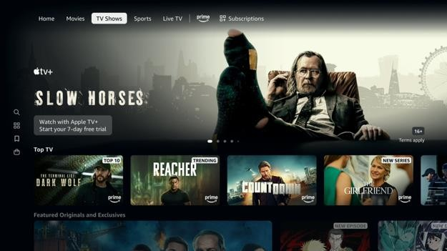

Sports
The sports screen has a featured show banner at the top of the screen. Below that are carousels like explore more leagues, live and upcoming events, Prime Monday night hockey: live and upcoming, sports subscriptions, Sportsnet: live and upcoming games, and more. The items on the sports screen do not loop around once I get to the last carousel.
Unlike other streaming media apps, shows that require additional subscriptions are mixed in with shows included in the current subscription. This makes it harder to find watchable content.
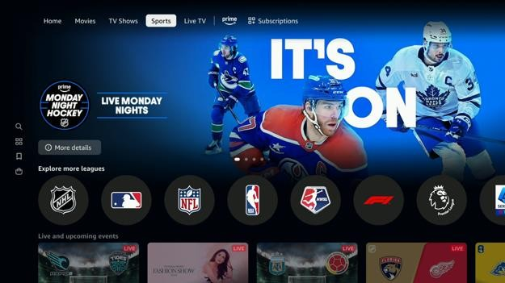

Apple TV
The sports screen has a featured show banner at the top of the screen. In the banner is a “More details” or “Start browsing” action button. I am not sure what the action button is supposed to do. Pressing the button changes the top banner to another one, which has the same action button text. The contents underneath the banner refreshes, but only the first time I press the action button. In short, I do not know what this feature does. After browsing more, it looks like the action button filters the sports by channel or team. It will be better if the action button label was more descriptive like, “Browse SportsNet events” and when clicked the banner title changes to be more descriptive like, “SportsNet events”.
Further down the sports screen is a carousel for different teams. Selecting a team refreshes the screen and moves the screen reader focus back to the top. However, the new content is not filtered to only show content for the selected team or the specific sport. In short, I do not know what this feature does.
Sometimes when moving through screens like from the settings screen back to home or selecting another carousel item, the screen reader stops speaking the selected item. Apple’s hover text accessibility feature also stops working. The selection rectangle and navigation sounds still work. Going to another screen and back does not fix the problem. This means screen reader users cannot navigate the home screen. A workaround when this happens is to go to the Apple TV home screen and open the Prime Video app again, but this problem happens very often.

Live TV
The live TV screen has a featured live TV channel banner at the top of the screen. Below that is a two-column layout. On the left is a list of TV channel categories like all, favorites, sports, news, TV shows, entertainment, movies, family, other, and subscribe. On the right is a carousel for live and upcoming events. Below that is a TV schedule with one row per channel. Shows that are currently airing are shown on the left. Upcoming shows are shown beside it on the right. Selecting a TV channel category on the left will filter the shows shown in the TV schedule on the right.
Unlike other streaming media apps, TV channels that require additional subscriptions are mixed in with TV channels included in the current subscription. This makes it harder to find watchable content.
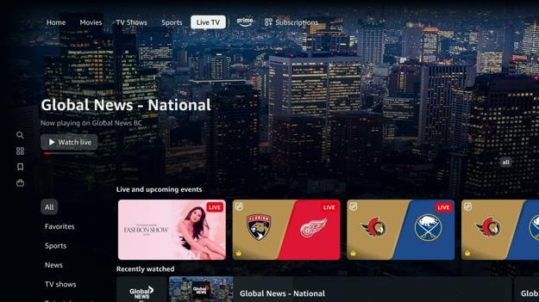

Apple TV
When a show airing in the future is selected in the TV schedule, there is a message that reads, “This program will be available at a later time”. This message is not spoken by the screen reader. Apple’s hover text accessibility feature also does not show this message in larger text. Screen reader users may not know what happened.
Sometimes when moving through the TV schedule, the screen reader stops speaking out the selected item. Apple’s hover text accessibility feature also stops working. The selection rectangle and navigation sounds still work. Going to another screen and back does not fix the problem. This means screen reader users cannot navigate the live TV screen. A workaround when this happens is to go to the Apple TV home screen and open the Prime Video app again, but this problem happens very often.
Fire TV Stick
The live TV sidebar categories cannot be selected with the keyboard.

Prime Exclusive
The Prime exclusive screen has a featured show banner at the top of the screen. Below that are carousels like recommended movies, top movies, classic movies, recently added movies, TV shows we think you’ll like, and more. The items on the prime exclusive screen do not loop around once I get to the last carousel.
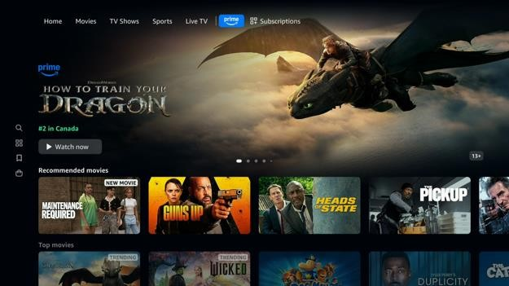

Google Streamer
The Prime button does not have a descriptive screen reader label. It is read as “button 6 of 7”.

Subscriptions
The subscriptions screen has a featured show banner at the top of the screen. Below that are carousels like fresh picks with subscriptions, subscriptions you might like, recently added with subscriptions, top 10 with subscriptions, Crave: most popular, and more. The items on the subscriptions screen do not loop around once I get to the last carousel.
As expected from the screen title, all shows listed here require additional subscriptions not included with Prime.
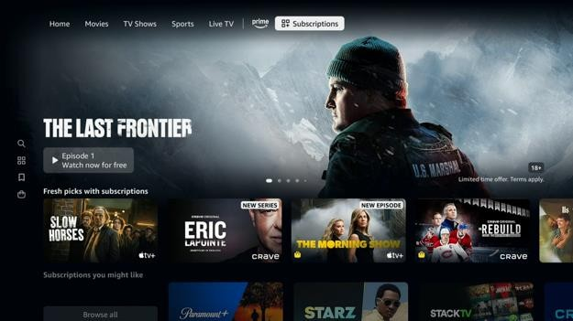

Watchlist
The “My stuff” screen has a list of shows organized into carousels like watchlist – movies and watchlist – TV. The items on the “My stuff” screen do not loop around once I get to the last carousel.
I find it confusing that the watchlist is called “My stuff”. Every streaming media app has its own name for this screen even though they all consistently use the “Add to watchlist” terminology. I also find the screen name misleading as none of the shows listed here is owned by the user. They all disappear at the end of the subscription or rental period.
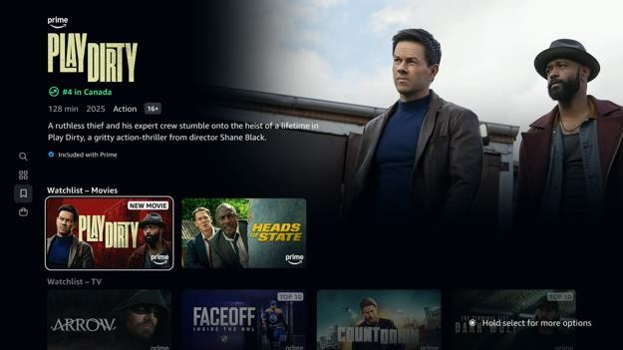

Google Streamer
Some buttons sometimes cannot be selected when the screen reader is on. On this screen, this includes the “My stuff” navigation bar button and the watchlist carousel items. Moving between items or switching to another screen and back sometimes fixes the problem. Apple TV
If the watchlist is empty, the screen reader says “Zero. My stuff”. The placeholder text is not read out by the screen reader. Screen reader users may not know what the “My stuff” screen is for because of the non-descriptive name.

Settings
The settings screen is split into two columns. The left column has a list of device settings that can be viewed or modified. This includes the Prime membership management, subscription management, accessibility, permissions, recommendations, language, video, autoplay, buying, renting, cookie preferences, contact us, legal notices, and sign out. The right column contains a description of what the setting does and a button to change the setting. Some settings can only be viewed and changed online. Selecting a category in the left column will update the right column.
Some settings like video autoplay, reduced motion, video language preferences, and HDR must be set in the Prime Video app per device. These settings override the streaming media device’s system app settings.
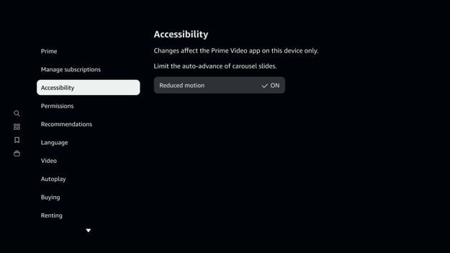

Google Streamer
Some buttons sometimes cannot be selected when the screen reader is on. On this screen, this includes the “Settings” navigation bar button, the device settings button in the left column, and the settings radio button. Moving between items or switching to another screen and back sometimes fixes the problem.
Text on each settings section is only read out once by the screen reader when the section loads. It cannot be selected to be read out again.
The Google Streamer version of the Prime Video app has a bug where HDR is sometimes applied to a video even when HDR is turned off in the video settings. This results in washed out colours. Sometimes this is fixed by re-opening the video player.

Roku Ultra
Text on each settings section is only read out once by the screen reader when the section loads. It cannot be selected to be read out again.

Fire TV Stick
Selecting the “Manage my subscriptions” button loads a screen to manage subscriptions. The logo on the screen does not have descriptive alt text, instead it defaults to the image file name.

Show Details
On the show details screen, there is the show name followed by the show metadata like the episode length, year released, genre, age rating, genre, video formats, audio formats, accessibility accommodations, and a brief description. Underneath that are buttons to watch the show, view more purchase options, watch the trailer, add the show to the watchlist, like the show, dislike the show, and get detailed show info. Below that are tabs to view the episodes, view related shows, and view show extras.
Unlike other streaming media services, there is a “flashing or strobing in program” icon in the show metadata section. Other streaming media services only show the warning in the video player when the show starts playing.
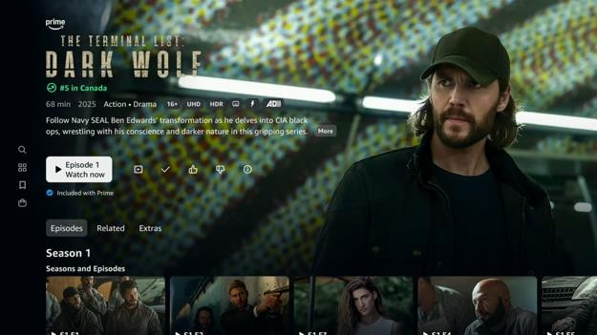
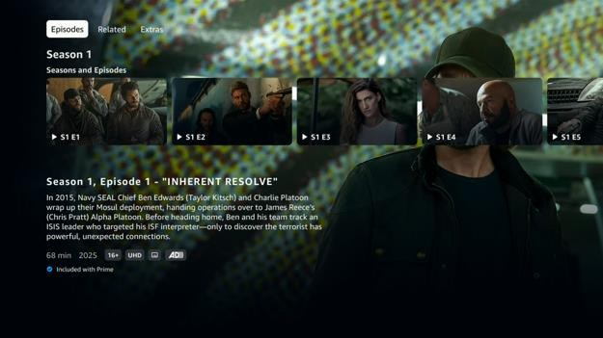

Roku Ultra
At the top of the show details, there is text, icons, and buttons on top of an image background. It is hard to read the text and see the buttons because there is not enough contrast. To read the text, I must move the focus to the text so that a dark background appears underneath.
When a show is added to the watchlist, a “Added to Watchlist” message appears at the bottom of the screen and the screen reader says “Added to watchlist”. However, when the show is then immediately removed from the watchlist, the “Removed from Watchlist” message appears, but the screen reader does not announce anything.
The closed captions icon under the show title and under each episode description is shown as a box with two lines. This icon is non-standard. The closed captions icon is commonly recognized as a CC icon. I would not have guessed what that icon represents until the screen reader spoke.
The high dynamic range label is misspelled as “dyanamic”. This makes the screen reader mispronounce the word.
In the “Languages and more” menu, the show’s audio languages are listed. Languages that do not use Latin characters are skipped by the screen reader. People who do use those languages will not know their language is supported.
On the show details screen under the episodes tab, there is a dropdown menu to switch between different seasons. When this dropdown menu is selected, the screen reader also says “Season 1” even though another season is selected. This may confuse screen reader users.
On the show details screen under the episodes tab, there is a list of episodes each with a title and description. The order the screen reader reads the text does not match the visual order things appear on screen. This can be bad because it reads the video attributes before the episode description. For a show, it is expected that all episodes will have the same video attributes.
On the show details screen there are tabs for episodes, related shows, and show extras.
The tabs are announced as buttons so screen reader users do not know they are tabs. Screen reader users also do not know which one is selected.

Google Streamer
At the top of the show details, there is text, icons, and buttons on top of an image background. It is hard to read the text and see the buttons because there is not enough contrast. To read the text, I must move the focus to the text so that a dark background appears underneath.
Some buttons sometimes cannot be selected when the screen reader is on. On this screen, this includes the watch now button, more purchase options button, watch trailer button, add to watchlist button, like button, languages and more button, the OK button for languages and more, the season dropdown menu, and the “Customers also watched” carousel items. Moving between items or switching to another screen and back sometimes fixes the problem.
On the show details screen under the episodes tab, there is a dropdown menu to switch between different seasons. When this dropdown menu is selected, the screen reader also says “Season 1” even though another season is selected. This may confuse screen reader users.
On the show details screen under the episodes tab, there is a list of episodes each with a title and description. The order the screen reader reads the text does not match the visual order things appear on screen. This can be bad because it reads the video attributes before the episode description. For a show, it is expected that all episodes will have the same video attributes.
On the show details screen there are tabs for episodes, related shows, and show extras.
The tabs are announced as buttons so screen reader users do not know they are tabs. Screen reader users also do not know which one is selected.

Apple TV
Sometimes when moving through screens like from the languages and more screen back to show details or selecting another carousel item, the screen reader stops speaking the selected item. Apple’s hover text accessibility feature also stop working. The selection rectangle and navigation sounds still work. Going to another screen and back does not fix the problem. This means screen reader users cannot navigate the show details screen. A workaround when this happens is to go to the Apple TV home screen and open the Prime Video app again, but this problem happens very often.
The “More purchase options” button is read as “More purchase less than br slash greater than options”. This is because a break tag is accidentally left in.
The high dynamic range label is misspelled as “dyanamic”. This makes the screen reader mispronounce the word.
Sometimes when the “languages and more” screen appears, the text on screen is not read out by the screen reader. Apple’s hover text accessibility feature correctly shows the text on screen in bigger text.
The like and dislike button icons do not change when activated by switch access in item mode. This problem does not happen when switch access is in remote mode.
Selecting the info button on the show details screen with switch access in remote mode crashes the app every time. Switch access users will not be able to read detailed show information.

Fire TV Stick
Selecting the more info button on the show details screen shows a detailed description of the show along with the audio languages, subtitle languages, starring actors, and directors. However, only the show description is read out by the screen reader. For shows listed under the Prime Video and Subscription screens, only the OK button label is read out by the screen reader. The rest of the text is not read out by the screen reader and cannot be selected to be read out.
The screen reader does not change the watch list button label when the show has been added or removed from the watch list. There is no status message on screen or alert spoken by the screen reader to confirm the action.

Video Player
The video player controls appear when the video is paused or when the down button is pressed. The controls remain on screen until the back button is pressed. At the top is the show name and episode name. At the bottom is the X-Ray info bar, video timeline, start over button, next episode button, subtitle options button, and audio options button.
The X-Ray info bar shows a list of actors in the current scene. Selecting the X-Ray button will pull up a list of actors in the current scene and in the current show. It will provide information on other shows the actor was in, the actor’s biography, and fun facts about the actor. There is also the option to skip through different scenes in the show.
In the subtitles and closed captions menu, there is a list of subtitle languages, sizes, and styles to choose from. Users can go to “primevideo.com/cc” to add more subtitle styles.
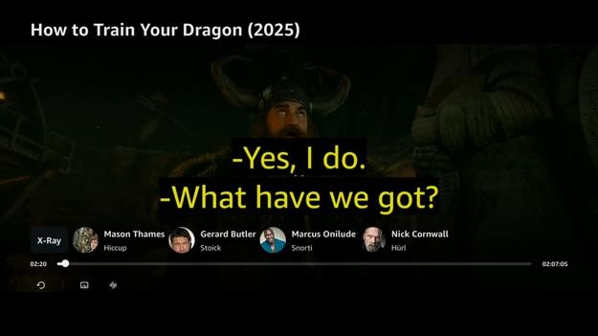
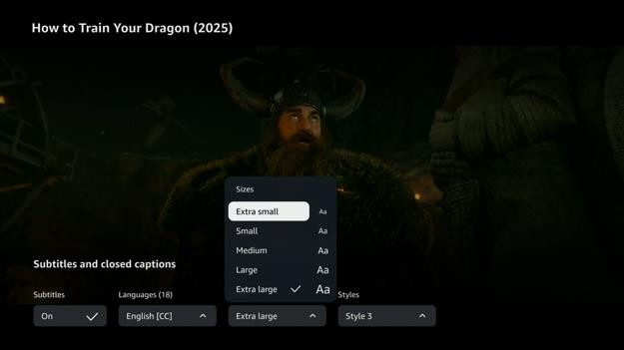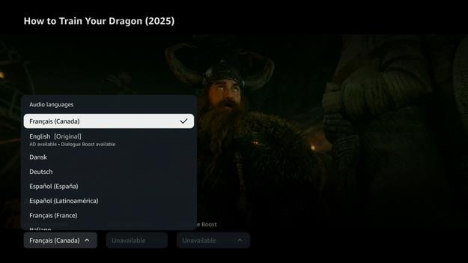

Google Streamer
When the video loads, there is a photo epilepsy warning.
The video subtitles do not follow the subtitle styles set in the system settings app.
When the Talkback screen reader is turned on, the select button on the Google Streamer remote control does not work reliably. It only works sometimes to select items. I had to turn off the screen reader to change subtitle languages, subtitle sizes, subtitle styles, and audio languages. The play, resume, and start over buttons sometimes may not work.
Although the screen reader tells me to hold right to fast forward and hold left to rewind, this does not work when the screen reader is enabled. I have to press the left or right buttons multiple times to skip through large portions of the video. If the screen reader is off, this works.
In the audio languages menu, some languages are marked as “AD available, dialogue boost available”, but the screen reader does not announce it. Screen reader users may not know that language has descriptive audio.
When an ad is playing, the screen reader announces “Ad is playing. Your video resumes in 1 minute and 25 seconds.”. There is no option to change subtitles, closed captions, and audio languages while the ad is playing. When fast forwarding through an ad break, the screen reader announces “Ad 1 of 1”.
For live TV, if subtitles are turned on, it may take ten seconds before the text captions appear. The audio is also half a second out of sync from the video. This makes it harder for people with hearing loss who read lips to re-enforce what they hear.
If the show has multiple seasons, an episode list appears partially cut off at the bottom of the video controls. When I press the down button while the video player controls are visible, the episodes list appears in full. The screen reader reads the selected episode description, but the list disappears before the screen reader is finished. The video controls should remain visible until the user presses the back button. Furthermore, after reading the episode description, the screen reader says, “Move left or right to browse items. Move up for player options.” Since the video player controls automatically hides, this instruction no longer applies. If I try, the screen reader says, “Navigation not possible”. This makes the navigation more confusing.
For shows with multiple seasons, the video player controls can still be selected by the screen reader while they are hidden. However, there is no focus ring. This can confuse screen reader users with partial eyesight.
For shows with multiple seasons, there is a bug where the episode list remains partially cut off at the bottom of the video controls even when it is selected with the screen reader. Roku Ultra
When the video loads, there is a photo epilepsy warning.
The play, pause, rewind, and fast forward buttons on the remote control works.
The video player does not apply the caption text style, edge effect, and window colour from the system settings. This can make the captions more difficult to read for people with lowvision. The rest of the caption styling including the text size, text colour, and background colour is correctly applied.
When I select a subtitle option from the dropdown menu, the screen reader reads out the previous option that was selected instead of the new option. This may confuse screen reader users into thinking their new setting was not saved.
For live TV, if subtitles are turned on, it may take ten seconds before the text captions appear. The audio is also half a second out of sync from the video. This makes it harder for people with hearing loss who read lips to re-enforce what they hear.

Apple TV
The first time a show is played on the Apple TV Prime Video app, the “Connect Prime Video to the Apple TV app” dialogue appears on top of the playing video. The screen reader reads the dialogue, but it is more difficult to hear the screen reader speaking with the video playing at the same time.
When the video controls are hidden, the screen reader selection rectangle remains on screen. This can be distracting when watching video content.
Sometimes the text shown by Apple’s hover text accessibility feature does not match what is shown on screen and what is spoken by the screen reader. For example, when the audio description is on, hover text shows that audio description is off. The same problem exists for the subtitle dropdown menu where hover text shows subtitles are off even though they are on.
The subtitle language setting is not saved when the video player is exited. If the subtitle language is set to French, upon opening the video player again for the same show, the subtitles revert back to English. The audio language and description audio preference is saved.
The video player does not apply the caption text colour from the system settings. This can make the captions more difficult to read for people with low-vision. The rest of the caption styling including the text size, text outline, window colour, and background colour is correctly applied. Oddly enough, the caption text colour setting is applied for show trailers, but only for English subtitles.
If there is only one language available in the audio options menu, the screen reader does not read out the selected language even when it is selected. Apple’s hover text accessibility feature correctly shows the selected language in bigger text.
When the player progress bar handle is selected, Apple’s hover text accessibility feature shows the selected item is a missing character.
When trying to fast forward and rewind live TV, the “Fast forward and rewind unavailable” message appears on screen. This is not announced by the screen reader.
For live TV, if subtitles are turned on, it may take ten seconds before the text captions appear. The audio is also half a second out of sync from the video. This makes it harder for people with hearing loss who read lips to re-enforce what they hear.
Video controls do not give enough time for switch access users to navigate before the controls automatically hide even when the video is paused.
Subtitles sometimes do not show up for live TV channels even when they are turned on. People with hearing-loss will not be able to reliably use the live TV feature.
Turning subtitles off may cause switch access item mode to get stuck. I must restart the Apple TV device to use switch access again.

Fire TV Stick
The video player has a bug where when the mouse is used and an advertisement is playing, the screen reader keeps speaking out the number of sections left in the ad break. This happens even when the video controls are hidden. This makes it impossible to hear the video dialogue.
When subtitles are set to extra large or large, they get clipped off on the right side instead of going onto the next line. This makes the subtitles unusable.
Not all the pre-defined subtitle text styles are readable, especially ones without a text background. Black subtitles on a dark video background is not readable. The pre-defined styles must be readable against all background colours.
The video player has a bug where when the mouse is used and a show is playing with subtitles, the screen reader keeps speaking out the subtitle text. This happens even when the video controls are hidden. This makes it impossible to hear the video dialogue. It also makes it difficult to use the X-Ray feature while the video is playing.
When watching live TV, there is a bug where subtitles may not appear even though they are enabled in the video player settings. Restarting the video player fixes the problem.
Fast forward and rewind works with the external keyboard by holding down the arrow keys then pressing enter to confirm.
The restart video, subtitles CC, and audio option buttons cannot be pressed with the keyboard.
There is a bug where using the mouse can cause the screen reader to read the video subtitle text. To stop it, I must exit the video player and re-open it, but doing so may play another few minutes of ads.
When subtitles are closed captions are off, there are instructions on how to turn on subtitles and edit subtitles styles. These instructions are not read out by screen reader and cannot be selected to be read out.
Subtitles sometimes do not show up for live TV channels even when they are turned on. People with hearing-loss will not be able to reliably use the live TV feature.

Video Player: X-Ray
Selecting the X-Ray button in the video player controls will show the X-Ray screen. This screen is split into three sections. The scenes section lists the different scenes in the show. Selecting a scene will skip to another point in the video. The in-scene section lists the actors in the current scene. The cast section lists all the actors in the show. Selecting an actor will show the actor’s biography, photos, and fun facts about the actor.
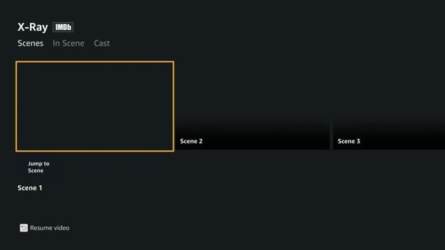
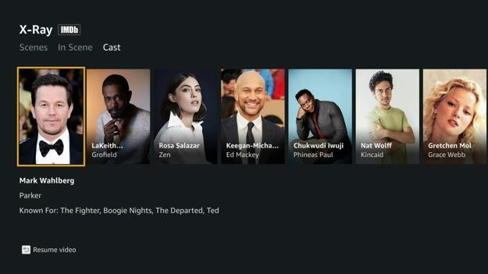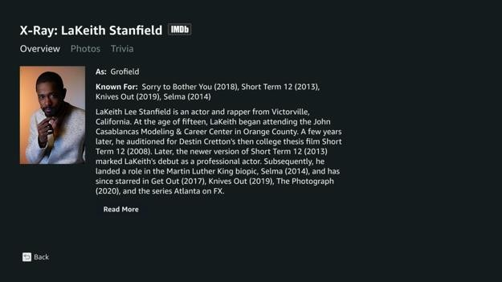

Google Streamer
When the Talkback screen reader is turned on, the select button on the Google Streamer remote control does not work reliably. It only works sometimes to select items. I had to turn off the screen reader to move between the scenes, in-scene, and cast tabs. The jump to scene button for scenes and the read more button in the actor overview sometimes may not work.
The scenes, in-scene, and cast tabs at the top are announced as tabs, but they do not announce its state. I do not know which tab is currently active.
In the x-ray menu, there are multiple scenes listed for the movie, but the scenes have no thumbnails and no titles. I do not know what scene I am moving to. Some shows do have scene thumbnails and titles, but most shows I checked do not.

Roku Ultra
The scenes, in-scene, and cast tabs at the top are announced as tabs, but they do not announce its state. I do not know which tab is currently active.
In the x-ray menu, there are multiple scenes listed for the movie, but the scenes have no thumbnails and no titles. I do not know what scene I am moving to.

Fire TV Stick
Unlike on other streaming media devices, the Fire TV Stick version of Prime Video opens the X-Ray menu in a sidebar rather than a full screen. This shrinks the video down. However, the subtitles do not shrink as well. Text that does not fit gets clipped off making the subtitles unusable.
I must press the back button on the remote control or the escape key on the keyboard to collapse the actor details, but that also resumes the video. The screen reader is more difficult to understand with the video audio playing.
There is a bug where the screen reader reads the video subtitle text when the “View bio, photos, and more” link in the X-Ray panel is opened. Closing the X-Ray panel does not stop this from happening. I must exit the video player and re-open it, but doing so may play another few minutes of ads.
On the X-Ray panel, sometimes the “View bio, photos, and more” link for the first actor cannot be selected with the keyboard or remote. Closing the X-Ray panel and opening it again fixes the problem.
The in-scene, cast, music, biography, known for, and photos tabs in the X-Ray panel are announced as tabs, but they do not announce its state. I do not know if I need to press the select button to switch to it.

ICI TOU.TV
The overall accessibility of the ICI TOU.TV streaming media app is one of the best that were tested. There were only two accessibility issues that really stuck out.
The most major accessibility issue is the inability to use the mouse to click on buttons and scroll through screens and carousel items. This means that although the mouse is technically supported, it cannot be used to complete common actions like to log in, browse the show catalog, search for shows, and play videos.
The second major accessibility issue is that the app cannot be reliably controlled using the Apple TV switch access accessibility feature in item mode. Selecting some items often causes the switch access feature to freeze up and stop working. Switch access cannot be used again until the Apple TV is restarted. The workaround is to only use switch access in remote mode. The downside of this is that there is always a remote control overlay covering a small part of the screen.
The third major accessibility issue is that the ICI TOU.TV app on some streaming media devices ignores the video subtitle styles set in the system app. There are no pre-defined subtitle text styles or sizes to choose from. The subtitles can either be turned on or off. This can make the subtitles more difficult to read for people with low-vision.

Home Page
The home page is in the French language. The home page contains a header with a navigation bar and a logo. Beneath it is a single image with a heading, a description, and a link to a featured piece of media, as well as a button with a link to view the media. There are clickable arrows on each side of the large image to navigate the carousel. A cookie banner pops up at the bottom of the page, with choices to view more information or close the banner.
I clicked the “Connexion” button to sign in.
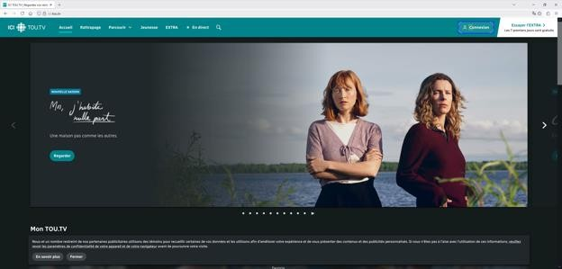
No accessibility problems were found on this page.

Create Account
The ‘Create Account’ page contains the same navigation bar. The content of the webpage contains an icon and the heading ‘My Radio-Canada account’. It also contains two clickable buttons: one for logging in and the other for creating an account. The bottom banner is visible, containing links to other webpages and icons with links to social media sites.
I clicked the “Créer mon compte” button to create a new account.
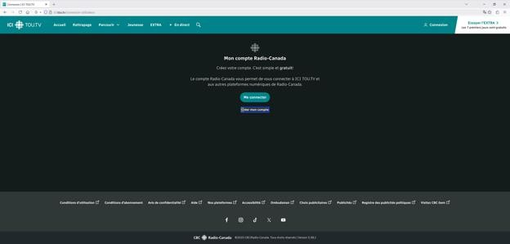
The webpage below is the first part of a wizard form, with the heading “Create Your Account Radio-Canada". Underneath, there is a link to access the log in page in case one already has an account. Then there is an email field, as well as a password field which has a ‘display characters’ button. The ‘Continue’ button is underneath in blue. There is a footer at the bottom of the page with links to other pages and sites. When you enter a wrong email or password combination, you receive a message in the form of a light red text field with a red outline, telling you there is something wrong. Then, underneath their respective text fields, you can find more information about what is wrong with the input credentials, in red letters.
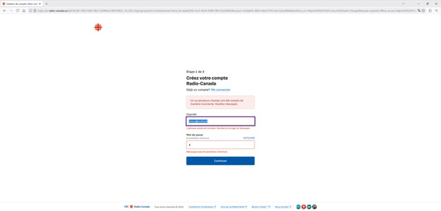
This is part two of the ‘Create Your Account’ wizard form, containing the heading ‘Create Your Profile’. There is a link to view more about why the site requires the information you are inputting. Three text fields follow: name, surname, date of birth. Underneath, the page asks you to identify your gender, with four grey buttons you can choose to click on, depending on your response. The button you select turns light blue with a darker blue border.
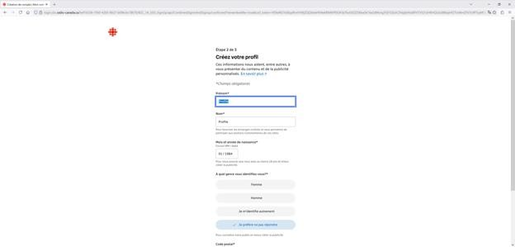
Below is part three of the ‘Create Your Account’ wizard form, containing the heading ‘Activate Your Account’. Underneath, there is instructional text explaining that a validation code has been sent by email, with approximately 2 minutes to enter it. There is a single text field labeled ‘Enter your code’ to enter a numeric validation code. The ‘Verify code’ button is underneath in blue. There is a footer at the bottom of the page with links to other pages and sites. When you enter an incorrect code, you receive a message in the form of a light red text field with a red outline, telling you the code is invalid, with additional red text underneath the field specifying that the code is wrong or has expired.
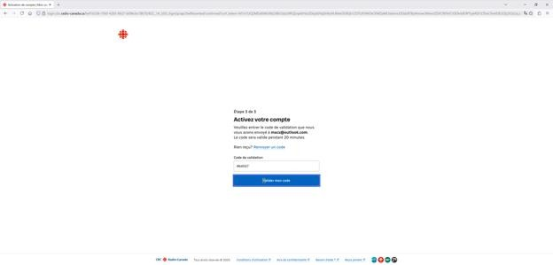
No accessibility problems were found on this page.

Welcome
The screen below is the welcome screen, with the heading ‘The ICI TOU.TV app offers on all your devices’. Underneath, there are three bullet points with icons highlighting the benefits: a play button icon for ‘Continue your viewing on all your devices’, a heart icon for ‘Quickly access your favorite content’, and an envelope icon for ‘Receive your personalized newsletter’. To the right is an illustration of a smiling young man in a teal shirt holding up a large teal heart with a play button and refresh arrow overlay. At the bottom are three buttons: a teal ‘Log in’ button, a gray outlined ‘Create my account’ button, and plain text 'Not now’. The background is dark gray with teal accents throughout.
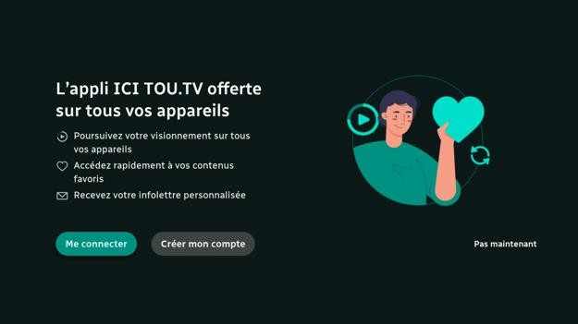

Fire TV Stick
The text on the welcome screen is not read out by the screen reader and cannot be selected to be read out. Only the buttons are read out when they are selected.
The mouse cannot be used to click on any of the sign in buttons.

Roku Ultra
The text and the buttons on the welcome screen is not read out by the screen reader and cannot be selected to be read out. Screen reader users will not know what is on the screen.
Google Streamer
The mouse cannot be used to click on any of the sign in buttons.

App Sign In
The screen below is the app sign-in page. There are three button options at the top:
“Continue with code”, “Continue with remote”, and “Continue with TV command”. Underneath is a QR code labeled “Scan this QR code” with instructions: “1. Go to this address on a computer or mobile device: tou.tv/androidtv” or “2. Enter this code:” followed by the pre-filled 6-character code “880-6383” in individual segmented boxes.
Below that is instructional text: “Then follow the steps to connect or create an account.
Once the process is complete, your TV will automatically update.” At the bottom is a note: “The code expires in 20 minutes” with a “Generate new code” button. The background is dark gray with teal accents throughout.
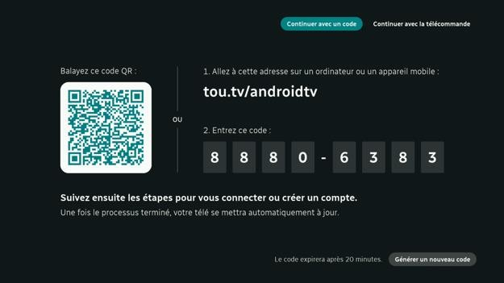
The screen has two buttons on the top right-hand side. One of the buttons is for continuing with a code. The other button is for continuing with a remote control. Then, there is a heading that says, ‘Connect Yourself’. There are two text fields beneath, one for an email and the other for the password. There is a button underneath to log in. In case you forget your password, there is a link to recover it at the bottom.
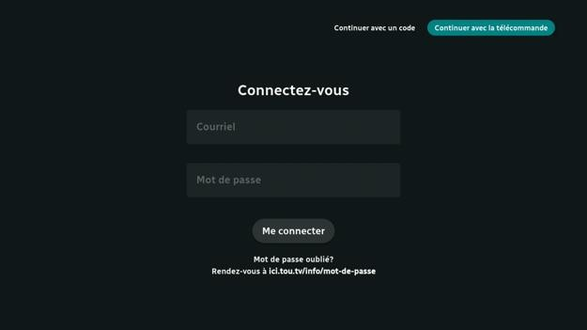

Google Streamer
There are two tabs at the top of the app sign in screen. When the “continue with remote” tab is selected and I press the left arrow button, I expect the screen reader focus to move to the “continue with code” tab that is to the left of it. Instead, the focus moves to the “login” button at the bottom of the screen. The screen reader focus should follow the screen layout to avoid confusion.
On the login screen, when I select the email field, the on-screen keyboard appears. When I press the down arrow button to move the on-screen keyboard selection to type, the screen reader focus moves to the password field. I ended up typing my email address in the password field. To fix this, I switched to the “continue with a code” screen then back to the “continue with the remote control” screen.
The mouse cannot be used to click on any of the tabs or buttons on the app sign in screen.
The mouse cannot be used to click on the on-screen keyboard buttons to type.

Fire TV Stick
The text on the app sign in screen is not read out by the screen reader and cannot be selected to be read out. Only the buttons are read out when they are selected. Screen reader users will have trouble signing in because they do not know the website link and the sign in code.
The log in successful message appears on screen, but it is not announced by the screen reader. Other streaming media devices announce this message.
The mouse cannot be used to click on any of the tabs or buttons on the app sign in screen.

Roku Ultra
The text and buttons on the app sign in screen are not read out by the screen reader and cannot be selected to be read out. Screen reader users will have trouble signing in because they do not know the website link and the sign in code.

Home
The home screen contains a header with a navigation bar and a logo. Beneath it is a single image with a heading, a description, and a link to a featured piece of media, as well as a button with a link to view the media. Underneath, there is a multi-item carousel with images that act as links to popular media.
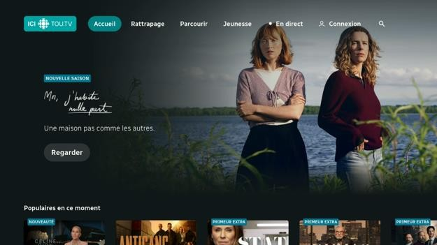

Google Streamer
When the screen reader is on, I cannot select the next or previous featured show carousel item by pressing the left or right arrow buttons on the remote control. I hear a no action sound.
Carousel headings above each carousel are not read out. Screen reader users may not know what each carousel is for.
When a show in one of the carousels is selected, the screen reader tries to read the show title twice. The first show description includes tags followed by the show name. The second show description is just the show name. Because the reading of the first show description is quickly interrupted, screen reader users will not hear the show tags read out.
The keyboard cannot be used to select the next or previous featured show carousel item by pressing the left or right arrow buttons. I hear a no action sound.
The mouse cannot be used to click on any navigation bar links. The mouse cannot drag the featured show carousel or click the pagination dots.
The mouse cannot be used to scroll down the screen or scroll through carousels. The screen and carousel snaps back to the original scroll position.
There is no button to click on to show the nav bar. I must use the keyboard to show it instead of relying on the mouse. Not everyone’s mouse has a back button to show the nav bar.

Fire TV Stick
The Fire TV high contrast system setting is followed by the ICI TOU.TV app. A black outline is added around text on all screens.
Carousel headings above each carousel are not read out. Screen reader users may not know what each carousel is for.
The mouse cannot be used to click on any navigation bar links. The mouse cannot drag the featured show carousel or click the pagination dots.
The mouse cannot be used to scroll down the screen or scroll through carousels. The screen and carousel snaps back to the original scroll position.
There is no button to click on to show the nav bar. I must use the keyboard to show it instead of relying on the mouse. Not everyone’s mouse has a back button to show the nav bar.

Roku Ultra
Buttons in the header are read as “button 1 of 7”, “button 2 of 7” and so on. Screen reader users will not know what is on the screen.
The text and the buttons on the home screen is not read out by the screen reader and cannot be selected to be read out. Only the carousel headings are read out.

Catching Up
The screen below is the "Catching Up" page, with the active tab highlighted in teal as "Catching Up" among other navigation bar options. The main heading is ‘Catching Up TV’ in white. Content is organized into dated multi-item carousel sections: ‘Today October 20’ and ‘Yesterday October 19’. Each section has clickable images as items in the carousel. Two of the eight fully visible images have a title. The background of the screen is dark gray with teal accents throughout.
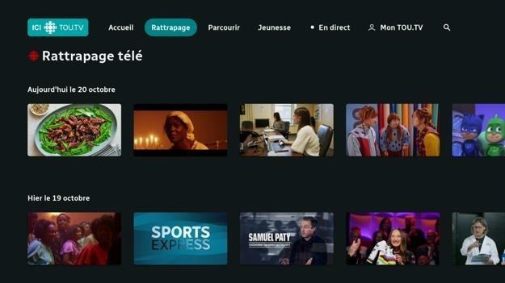

Google Streamer
Carousel headings above each carousel, like the dates, are not read out. Screen reader users may not know what each carousel is for.
The mouse cannot be used to scroll down the screen or scroll through carousels. The screen and carousel snaps back to the original scroll position. When scrolling up or down, the top banner does not update to show the selected show.
There is no button to click on to show the nav bar. I must use the keyboard to show it instead of relying on the mouse. Not everyone’s mouse has a back button to show the nav bar.

Fire TV Stick
Carousel headings above each carousel, like the dates, are not read out. Screen reader users may not know what each carousel is for.
The mouse cannot be used to scroll down the screen or scroll through carousels. The screen and carousel snaps back to the original scroll position. When scrolling up or down, the top banner does not update to show the selected show.
There is no button to click on to show the nav bar. I must use the keyboard to show it instead of relying on the mouse. Not everyone’s mouse has a back button to show the nav bar.

Roku Ultra
Buttons in the header are read as “button 1 of 7”, “button 2 of 7” and so on. Screen reader users will not know what is on the screen.
Carousel headings above each carousel, like the dates, are not read out. Screen reader users may not know what each carousel is for.

Browse
The top of the Browse page contains a header with a logo and a navigation bar. Then there are two multi-item carousels. The first one contains clickable images with a title for the category of the media you may select. The next carousel contains clickable logos of different streaming channels.
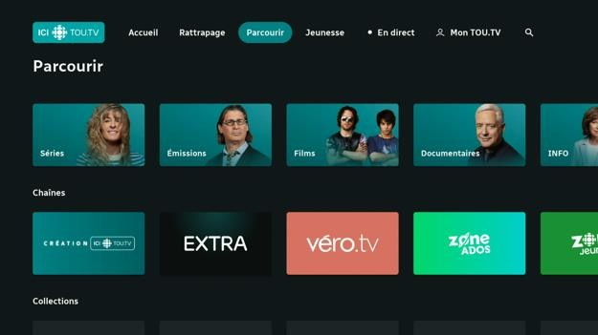

Google Streamer
Carousel headings above each carousel, like the show genre, are not read out. Screen reader users may not know what each carousel is for.
The mouse cannot be used to scroll down the screen or scroll through carousels. The screen and carousel snaps back to the original scroll position. When scrolling up or down, the top banner does not update to show the selected show.
There is no button to click on to show the nav bar. I must use the keyboard to show it instead of relying on the mouse. Not everyone’s mouse has a back button to show the nav bar.
When switch access is on, the escape key cannot be pressed to go back. I need to select the back button in switch actions to do this. Other apps do not have this problem.

Fire TV Stick
Carousel headings above each carousel, like the show genre, are not read out. Screen reader users may not know what each carousel is for.
The mouse cannot be used to scroll down the screen or scroll through carousels. The screen and carousel snaps back to the original scroll position. When scrolling up or down, the top banner does not update to show the selected show.
There is no button to click on to show the nav bar. I must use the keyboard to show it instead of relying on the mouse. Not everyone’s mouse has a back button to show the nav bar.

Roku Ultra
Buttons in the header are read as “button 1 of 7”, “button 2 of 7” and so on. Screen reader users will not know what is on the screen.
Carousel headings above each carousel, like the dates, are not read out. Screen reader users may not know what each carousel is for.

Kids
The top of the Kids screen contains a header with a logo and a navigation bar. Underneath is a logo of the ‘Kids Zone’. Then, there is a multi-item carousel. Each item contains an image of the content you may view, a heading, and a description. There is another multiitem carousel, this one with smaller images of content and respective headings but no description below.
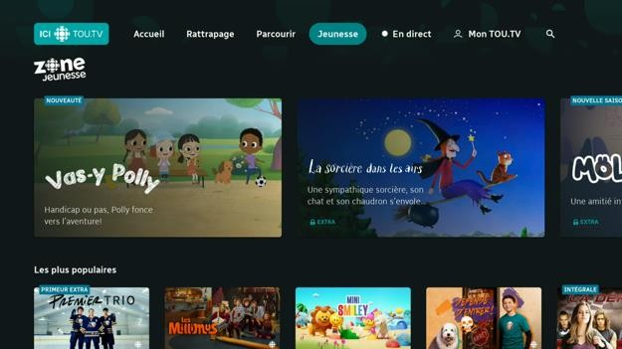

Google Streamer
Carousel headings above each carousel are not read out. Screen reader users may not know what each carousel is for.
When a show in one of the carousels is selected, the screen reader tries to read the show title twice. The first show description includes tags followed by the show name. The second show description is just the show name. Because the reading of the first show description is quickly interrupted, screen reader users will not hear the show tags read out.
Mouse cannot be used to click on any navigation bar links. The mouse cannot drag the featured show carousel or click the pagination dots.
The mouse cannot be used to scroll down the screen or scroll through carousels. The screen and carousel snaps back to the original scroll position. When scrolling up or down, the top banner does not update to show the selected show.
There is no button to click on to show the nav bar. I must use the keyboard to show it instead of relying on the mouse. Not everyone’s mouse has a back button to show the nav bar.

Roku Ultra
Buttons in the header are read as “button 1 of 7”, “button 2 of 7” and so on. Screen reader users will not know what is on the screen.
Carousel headings above each carousel are not read out. Screen reader users may not know what each carousel is for.

Fire TV Stick
Carousel headings above each carousel are not read out. Screen reader users may not know what each carousel is for.
The mouse cannot be used to click on any navigation bar links. The mouse cannot drag the featured show carousel or click the pagination dots.
The mouse cannot be used to scroll down the screen or scroll through carousels. The screen and carousel snaps back to the original scroll position. When scrolling up or down, the top banner does not update to show the selected show.
There is no button to click on to show the nav bar. I must use the keyboard to show it instead of relying on the mouse. Not everyone’s mouse has a back button to show the nav bar.

Live TV
The top of the Live TV screen contains a header with a logo and a navigation bar.
Underneath it is a heading with the title of the page. Another logo sits beneath it. There is a large image of viewable content that contains the title as well as a progression bar. Next to the image, there is information about the content, such as the time when the stream started, the title, the season, subtitle availability, rating, and episode name. There are also two buttons, one for viewing the content and another that shows the location of where the content is being streamed. There is also information about when and what the next content is being streamed. Underneath, there is a multi-item carousel. Each item contains an image, a title, as well as a yellow banner that marks the content as live.
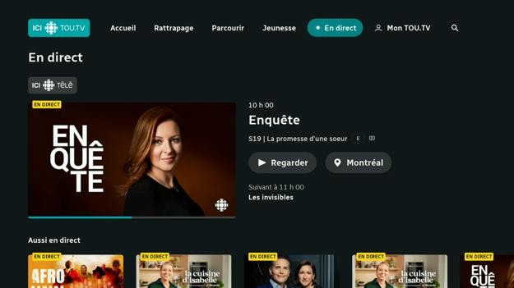

Google Streamer
Carousel headings above each carousel are not read out. Screen reader users may not know what each carousel is for.
The mouse cannot be used to scroll down the screen or scroll through carousels. The screen and carousel snaps back to the original scroll position. When scrolling up or down, the top banner does not update to show the selected show.
The mouse cannot be used to click on any navigation bar links.
There is no button to click on to show the nav bar. I must use the keyboard to show it instead of relying on the mouse. Not everyone’s mouse has a back button to show the nav bar.

Apple TV
When the screen reader is on, I cannot select the featured live TV show at the top of the screen. Pressing the down arrow button on the remote control skips over it and selects the next heading. As a workaround, I need to play a video and then go back.

Fire TV Stick
Carousel headings above each carousel are not read out. Screen reader users may not know what each carousel is for.
The mouse cannot be used to scroll down the screen or scroll through carousels. The screen and carousel snaps back to the original scroll position. When scrolling up or down, the top banner does not update to show the selected show.
There is no button to click on to show the nav bar. I must use the keyboard to show it instead of relying on the mouse. Not everyone’s mouse has a back button to show the nav bar.

Roku Ultra
Buttons in the header are read as “button 1 of 7”, “button 2 of 7” and so on. Screen reader users will not know what is on the screen.
Carousel headings above each carousel are not read out. Screen reader users may not know what each carousel is for.

Show Details
The ‘Show Details’ screen has a background image of the specific content you want to view. There is a blue text box with white writing that announces there is a new season of the content. Underneath is the title as well as a description of the viewable content. There are two buttons, one for showing more and the other to add the content into the user’s favorites list. Then there is a button to play the content, a progression bar, and information on what season and episode the user has last played.
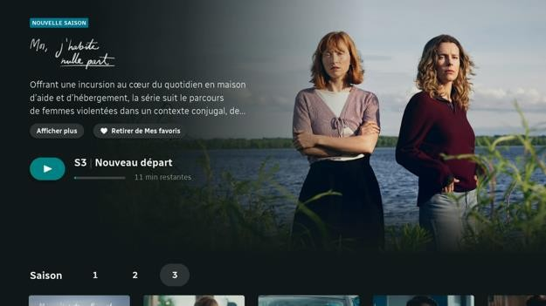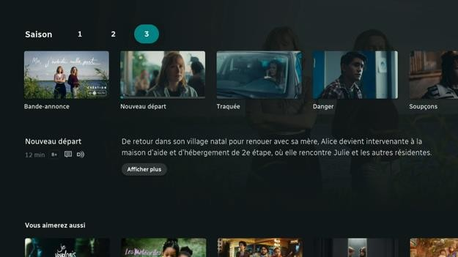

Google Streamer
On the show details screen, there is a heading for seasons and a list of seasons shown as numbered buttons. Some of these buttons have locks beside them. When the numbered buttons are selected, the screen reader just says the number. It does not say season or that the content is locked behind a subscription.
Carousel headings above each carousel, like the “Season”, and “You may also like”, are not read out. Screen reader users may not know what each carousel is for.
When a show in one of the carousels is selected, the screen reader tries to read the show title twice. The first show description includes tags followed by the show name. The second show description is just the show name. Because the reading of the first show description is quickly interrupted, screen reader users will not hear the show tags read out.
The mouse cannot be used to click on the season tabs.
The mouse cannot be used to scroll down the screen or scroll through carousels. The screen and carousel snaps back to the original scroll position.
The mouse cannot be used to click on any navigation bar links.
There is no button to click on to show the nav bar. I must use the keyboard to show it instead of relying on the mouse. Not everyone’s mouse has a back button to show the nav bar.
When switch access is on, the escape key cannot be pressed to go back. I need to select the back button in switch actions to do this. Other apps do not have this problem.

Fire TV Stick
The text on the show description’s “show more” screen is not read out by the screen reader and cannot be selected to be read out. Only the show category buttons are read out when they are selected. Screen reader users cannot read the show description and find out the accessibility features for the show.
Carousel headings above each carousel, like the “Season”, and “You may also like”, are not read out. Screen reader users may not know what each carousel is for.
On the show details screen, there is a heading for seasons and a list of seasons shown as numbered buttons. Some of these buttons have locks beside them. When the numbered buttons are selected, the screen reader just says the number. It does not say season or that the content is locked behind a subscription.
The description text underneath each episode is not read out by the screen reader and cannot be selected to be read out. I need to select the show more button to hear it read out.
The “show more” screen has additional details about the episode like the duration, production year, release date, production company, country, and more. However, only the episode description is read out. The additional details are not read out by the screen reader and cannot be selected to be read out.
The mouse cannot be used to click on the season tabs.
The mouse cannot be used to scroll down the screen or scroll through carousels. The screen and carousel snaps back to the original scroll position.
There is no button to click on to show the nav bar. I must use the keyboard to show it instead of relying on the mouse. Not everyone’s mouse has a back button to show the nav bar.

Roku Ultra
The text and the buttons on the show details screen are not read out by the screen reader and cannot be selected to be read out. Screen reader users will not know what is on the screen.

Video Player
The video player screen has the show name and season in the middle. Below that is the play button and video timeline. At the bottom are buttons to restart the video, toggle subtitles, and toggle the audio description.
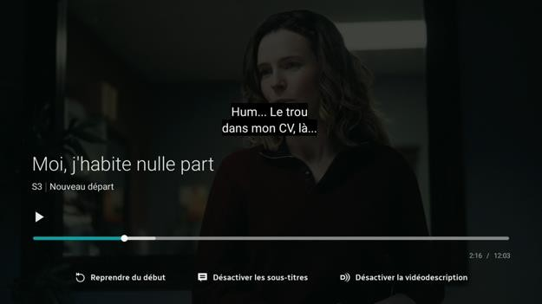

Google Streamer
When the screen reader is on, I cannot fast forward or rewind using the remote control. The screen reader tells me slider mode is started and I can press the arrow buttons to change the value, but nothing happens when I press the arrow buttons.
The video player does not follow the caption text styles set in the system settings app.
There are also no options to choose other caption text styles in the video player. Sometimes the captions are white text on a solid black background. At other times it is white text with a black outline on a semi-transparent black background. People with vision loss may find the captions to be too small or too low contrast to read.
If the video is buffering, the screen reader does not announce anything.
When the video controls are visible, clicking with the mouse pauses or plays the video. Mouse cannot drag video timeline handle. Mouse cannot be used to make the video controls appear. When the controls are hidden, clicking or dragging does nothing.
When the screen reader is on, I cannot fast forward or rewind using the external keyboard. The screen reader tells me slider mode is started and I can press the arrow buttons to change the value, but nothing happens when I press the arrow buttons.
When switch access is on, the escape key cannot be pressed to go back. I need to select the back button in switch actions to do this. Other apps do not have this problem.
The AdChoices logo that appears in some advertisements is unlabeled.

Apple TV
When the video is paused, an advertisement appears above the video timeline. The advertisement image has no alt text. Screen reader users do not know what is in the image.
Sometimes after selecting a subtitle language, the screen reader focus moves to the Info button. The info button moves up as if the info panel is supposed to appear, but nothing appears. Pressing the arrow buttons on the remote control moving the screen reader focus to an invisible “Play from beginning” button. The screen reader focus is then stuck there. I have to press the back button to exit the video player. The Netflix video player also has the same problem.
The video player does not apply the caption text colour from the system settings. This can make the captions more difficult to read for people with low-vision. The rest of the caption styling including the text size, text outline, window colour, and background colour is correctly applied.
I cannot hold down the switch access arrow button to fast forward or rewind. I must press the arrow button many times.
The subtitle, audio, and popout video player buttons cannot be selected while switch access is in item mode. I must switch to remote mode to select them.
If an announcement is playing at the beginning of a video, I cannot press the arrow buttons to fast forward or rewind the video, but there is no error message telling me that.

Fire TV Stick
The video player does not follow the caption text styles set in the system settings app.
There are also no options to choose other caption text styles in the video player. Sometimes the captions are white text on a solid black background. At other times it is white text with a black outline on a semi-transparent black background. People with vision loss may find the captions to be too small or too low contrast to read.
There is no screen reader feedback after fast forwarding or rewinding a show. Screen reader users do not know how much they fast forwarded or rewound.
For external keyboards, the play/pause function key works for the video player, but the fast forward and rewind keys do not. Arrow keys can be used to do fast forward and rewind.
When the video controls are visible, clicking with the mouse pauses or plays the video. Mouse cannot drag video timeline handle. Mouse cannot be used to make the video controls appear. When the controls are hidden, clicking or dragging does nothing.
The video player has a bug where when the video controls are selected and the mouse is used, the screen reader keeps speaking out the video played duration. This happens even when the video controls are hidden. This makes it impossible to hear the video dialogue.

Roku Ultra
When the video player is playing an advertisement, the screen reader just says “loading, playing”. It does not announce that an ad is playing, how many ads there are, and how long the ads are.
The video player has no options to change the toggle the video subtitles and audio description. There is only the option to restart the video.
The video player applies the caption text style, text colour, edge effect, and background colour from the system settings. However, it does not apply the window colour setting.
There is no screen reader feedback after fast forwarding or rewinding a show. Screen reader users do not know how much they fast forwarded or rewound. The screen reader just says, “loading, resuming”.

Settings
The screen below is the ‘Settings’ page, with the heading ‘Connection’ in large white text. On the left is a vertical menu with a teal ‘My TOU.TV’ button at the top, followed by links: ‘Try EXTRA’, ‘Help’, ‘Accessibility’, ‘Terms of Use’, and ‘Privacy’. The main section on the right is titled ‘My Radio-Canada Account’ with a subheading ‘Create your account. It’s simple and free!’ Below are three icons in a row: a play button labeled ‘Continue your viewing where you left off’, a sync arrow labeled ‘Enjoy synchronization on all your devices’, and a heart labeled ‘Quickly access your favorite content’. Further down is a line of text: ‘The Radio-Canada account allows you to connect to ICI TOU.TV and other RadioCanada digital platforms’. At the bottom are two gray buttons: ‘Log in’ and ‘Create my account’. The background is dark gray.
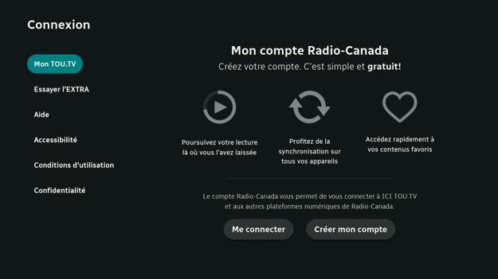

Google Streamer
Placeholder text on the “My TOU.TV” and “My favourites” screens are not read out.
Sometimes I cannot log out by pressing the log out button on the settings screen. Going to another screen and back or force stopping and re-opening the app did not fix the problem.
Turning off the screen reader did not fix the problem either. I had to clear the app settings.
Mouse cannot be used to click on any navigation bar links.
There is no button to click on to show the nav bar. I must use the keyboard to show it instead of relying on the mouse. Not everyone’s mouse has a back button to show the nav bar.

Fire TV Stick
The text on the settings screen is not read out by the screen reader and cannot be selected to be read out. Only the buttons are read out when they are selected.
Sometimes I cannot log out by pressing the log out button on the settings screen. Going to another screen and back or force stopping and re-opening the app did not fix the problem. Turning off the screen reader did not fix the problem either. I had to clear the app settings.
The mouse cannot be used to click on the section buttons in the sidebar. The watchlist and some settings cannot be accessed.
There is no button to click on to show the nav bar. I must use the keyboard to show it instead of relying on the mouse. Not everyone’s mouse has a back button to show the nav bar.

Roku Ultra
Buttons in the sidebar are read as “button 1 of 4”, “button 2 of 4” and so on. The text and the buttons in each section is not read out by the screen reader and cannot be selected to be read out. Screen reader users will not know what is on the screen.
Videos listed in the watched videos and my favourites sections can be selected by the screen reader, but the show names are not read out. Screen reader users will not know what show is selected.

Apple TV
Selecting a settings category in the sidebar may cause switch access item mode to get stuck. I must restart the Apple TV device to use switch access again.

Search
A search bar sits at the top of the ‘Search’ screen. The page also features a clean card grid layout where each item displays an image, title, brief description, and a count of contained elements. The cards are arranged in a responsive grid, allowing users to browse and click through to more detailed pages for each category or collection.
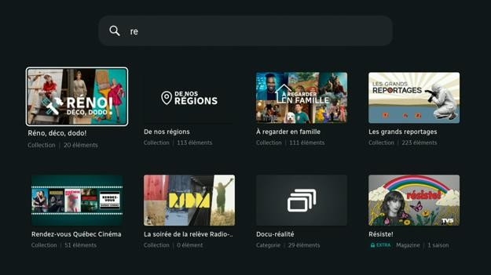

Roku Ultra
Buttons in the header are read as “button 1 of 7”, “button 2 of 7” and so on. Screen reader users will not know what is on the screen.
The on-screen keyboard buttons are read out by the screen reader. However, the search results are not read out. Screen reader users will not be able to use the search feature.

Fire TV Stick
The mouse cannot be used to click on any navigation bar links.
There is no button to click on to show the nav bar. I must use the keyboard to show it instead of relying on the mouse. Not everyone’s mouse has a back button to show the nav bar.

Google Streamer
The mouse cannot be used to click on the on-screen keyboard buttons to type.
When using an external keyboard to type a search term, the search button on the onscreen keyboard must be pressed to hide the on-screen keyboard. Pressing the escape key on the external keyboard hides the on-screen keyboard, but the focus remains stuck on the search field.
The mouse cannot be used to click on any navigation bar links.
There is no button to click on to show the nav bar. I must use the keyboard to show it instead of relying on the mouse. Not everyone’s mouse has a back button to show the nav bar.

Assistive Feature Conflicts
From the accessibility audit, we found that using some assistive technologies at the same time creates conflicts. Sometimes the system turns off one assistive technology if another is turned on. Below are some of these cases.
The Google streamer switch access feature cannot be used with a mouse. When switch access is on, the mouse cannot be used to click on things or scroll.
For the Google Streamer switch access feature, the enter key should not be assigned as select. When I did that, selecting a switch access action like the down arrow will do that action and press the enter key. This causes undesirable results. There should be a warning to not do this.
On the Apple TV, switch access cannot be used with the Voiceover screen reader. If Voiceover is turned on, switch access is automatically turned off and vice versa. Voiceover can be turned on by pressing the back button or escape button three times quickly. However, there is no shortcut to turn on switch access. This is a problem when pressing the escape button to go back a few screens. While using switch access, sometimes I accidentally turn on Voiceover, which turns off switch access. A person with severe mobility-loss may not be able to turn switch access back on by themselves.
On the Fire TV Stick, when the text banner is turned on, the fast forward and rewind buttons cannot be used. This is because the fast forward and rewind buttons are also used to move between pages in the text banner.
On some streaming media services like Prime Video and ICI TOU.TV, the screen reader and mouse should not be used at the same time. Using this combination of assistive devices causes the screen reader to read the show captions or video duration timestamp constantly. This means the original video audio cannot be heard.

Discussion

Main Findings
In the report, the researchers tested Netflix, Prime Video, Disney+, Crave, and ICI TOU.TV on popular devices like the Apple TV 4K, Google TV, Roku Ultra, and the Fire TV Stick.
Netflix, Prime Video, Disney+, Crave, and ICI TOU.TV are specific streaming services or
Apps and each have their own unique accessibility features. Apple TV 4K, Google TV, Roku Ultra, and the Fire TV Stick are streaming media devices that have their own accessibility features also. Sometimes the accessibility features in the Apps and streaming media devices complement each other and sometimes they do not. The findings of this report revealed a clear gap between technical compliance and real-world accessibility.
While many systems appeared to implement and support accessibility features, in practice, their features often failed to work properly or meet the expectations for people with disabilities. For example, testing showed on one system that while the mouse pointer is visible, the navigation bar links on the screen could not be clicked on to activate them. This blocked users from accessing certain screens. Another example involved users that are blind. They tend to think of content on the screen as a list of items as they access them sequentially, one at a time, as they are spoken aloud. Many of the streaming media apps use grids to present a list of features or a list of TV programs. Most blind users expect to only have to use the up and down arrow keys to move through a list. It does not occur to them that they need to use the left and right arrow keys. As a result, they can miss interacting with much of the content.
This shows why simply meeting technical requirements is not enough. Accessibility must be tested and designed from the perspective of real users to create experiences that are genuinely inclusive. This section of the report will summarize the findings, discuss their significance relative to existing accessibility standards, guidelines, and practices, and recommend ways to improve the accessibility of the streaming media ecosystem. Device Ranking by Accessibility and Popularity
From testing the most popular streaming media devices, the researchers found that the accessibility of these devices varies greatly. Some devices make it much easier for people with disabilities to use and enjoy their favorite shows, while others make it unnecessarily difficult. Apple TV 4K and Google TV Streamer had the most comprehensive accessibility features, while Fire TV Stick and Roku Ultra had the least. Apple TV had 27 of the 32 accessibility features the researchers checked for, Google TV had 18, Fire TV had 17, and Roku only had 9.
Of the accessibility features that were implemented, some of them had major accessibility problems or blockers that made it difficult or impractical to use for people with disabilities. Roku Ultra had the most problems where 33% of its accessibility features had issues, followed by Google TV at 22%, Apple TV at 19%, and Fire TV at 18%.
The audit showed that accessibility problems found across streaming devices and apps are not just random mistakes. Instead, they fall into specific groups of design problems that appear again and again. These problems often happen because designers and developers do not fully understand accessibility standards or how people with disabilities actually use technology. The issues can be grouped into five main types: task obstruction, weak assistive technology support, unclear interface structure, poor navigation and feedback, and lack of recovery options.

1. Task Obstruction and Functional Blockage
The most serious problems are those that stop users from completing important actions, like setting up the device, finding a show, or starting playback. These barriers can completely block people with disabilities from using the system. This usually happens because designers focus only on how tasks look visually, instead of thinking about how someone using assistive technology (like a screen reader or switch input) would complete the same task. When accessibility is added late instead of being part of the design from the start, it becomes a patch instead of a real solution.

2. Incomplete or Surface-Level Support for Assistive Technologies
A group of problems involves assistive technology such as screen readers, voice control, and switch devices. Many systems technically include these tools, but they are only partly functional. They often lack the options that users expect, like changing speech speed, adjusting feedback tones, or customizing navigation. This happens because designers treat accessibility as a simple “yes or no” requirement instead of understanding that it needs to work at different levels for different users. People with disabilities have long experience using assistive tools on phones and computers, so when streaming media devices behave differently, it causes frustration and makes the tools harder to use. It also makes it harder to switch between using different devices because the controls can differ greatly.

3. Inconsistent Labels and Interface Structure
A third type of problem is inconsistent labeling and structure. Sometimes buttons, menus, and other controls are missing labels or are labeled incorrectly, so assistive technologies cannot describe them properly. For people who are blind or have low vision, this makes navigation confusing or even impossible. These issues happen because many designers focus only on the screen’s visual layout rather than how the system is structured underneath in the code. Accessibility depends on this hidden structure—the “semantic layer”—to communicate meaning correctly to users who cannot see the display.

4. Poor Feedback and Navigation Design
A fourth type of problem involves navigation and feedback. Screen readers on streaming media devices often use grid layouts designed for sighted users, rather than simple lists that can be followed by sound or speech. This makes it much harder for users who are blind or have cognitive disabilities to move through content in an organized way. Poor sound feedback—such as the lack of clicks or tones when a user moves between items— also makes it unclear whether the system is responding. These mistakes show that designers are often thinking about visual interaction only, not about how people who rely on hearing or touch experience the interface.

5. Lack of Recovery and Error Handling
The last type of problem is the lack of recovery options when something goes wrong. Apps and assistive technologies can freeze or crash, and many devices do not give users an easy way to restart or reset them. This is especially harmful for users with disabilities who rely completely on these tools. Designers often assume users can fix problems manually, which may not be true if someone cannot see or move easily. Accessible systems must include built-in recovery features like automatic restarts or reset buttons that work with assistive technologies, so users can stay in control.

Understanding Why These Problems Happen
Overall, these types of accessibility failures do not happen because technology is too hard to design. They happen because of gaps in knowledge and experience. Many developers treat accessibility as a list of rules to check off instead of as a way of designing for different human abilities. Few design teams test their products with people who have disabilities or have the ability to put themselves in the place of people with disabilities, so they miss how users actually interact with technology in real life.
Without this understanding, teams often think of accessibility as an optional add-on instead of something that should guide how input, output, and feedback systems are built. This leads to inconsistent and unreliable accessibility features across different apps and devices. In the end, the problem is not just with individual products—it reflects the technology industry’s lack of awareness in accessibility and user focused design.

The Need For Best Practice Guidelines
Formal accessibility standards—like the Web Content Accessibility Guidelines (WCAG) and EN 301 549—set the minimum technical rules for making a product “accessible.” In fact, they are adopted to cover streaming media in a number of countries around the world. These rules are important, but on their own they do not guarantee that a system is easy to use. They describe what must exist, not how it should behave in real-world situations.
Best practice guidelines fill this gap. They translate technical standards into practical design expectations that show how assistive technologies (AT) should perform and how users actually use them. For example, people who use screen readers, switch devices, or voice controls have learned specific patterns—like how menus should be read aloud, how fast speech should sound, or how keyboard navigation should move from one item to the next. These patterns are based on years of use of assistive technology with smartphones and computers, forming a “shared language” between users and technology.
When designers of new systems, such as streaming media apps, do not follow these familiar patterns, the result can be confusing or unusable—even if the product technically meets accessibility standards. For example, a screen reader might read items out of order, confusing a blind user. Captions might disappear too quickly, causing deaf people to miss movie dialogue. Buttons might have vague labels like “More info” , so they do not know what would happen when they click it. There is a difference between complying with a rule and providing a usable experience. Best practice guidelines close this gap by giving designers concrete examples of how features should work, what performance users expect, and how to match the behavior of mature assistive technologies on other devices.
Standards define compliance, but best practices define quality of the experience. They help designers who may not be experienced with accessibility understand the expectations of users with disabilities. Without them, products risk being “technically accessible” but functionally unusable. For streaming media specifically, unfortunately there is currently no formal document that collects all those practices in one place. Designers are left to implicitly learn them through trial and error.

The Case for Performance Criteria
Standards and best practices working together still cannot always guarantee a designer will create a fully accessible and usable system. This is especially true for designers that are new to accessibility standards and best practices. They may have little to no experience working with people with disabilities. These designers often need context to understand who they are designing for in the form of personas. A persona is a detailed description of a fictional person who represents a real group of users. Designers and researchers create or adopt existing personas to help them understand the needs, goals, and challenges of the people who will use a product or service. It tells them who they are designing for. In this case, it is for people with disabilities who have mobility loss, hearing loss, vision loss, speech loss and people with intellectual disabilities or cognitive impairments. They also will have varying degrees of ability loss.
Designers also need to create a list of tasks that the end user will want to do with the streaming media system. This may be signing on to the system for the first time, selecting a movie to play, playing a movie, or setting up the assistive technology they will use with the system so it reflects their preferences. From the task list, designers can create a workflow for each task. A workflow is the step-by-step process a person follows to complete a task from start to finish. With the personas and the workflows, the designer can design the steps in each task to be more efficient and effective.
For example, selecting a movie to play may normally require multiple steps where the user taps the screen or uses the remote control if they do not have a disability. But if they could only use voice control, the process should be totally different. Instead of navigating through a series of complex menus that require a lot of interaction with what is on the screen, the user could simply say the following commands in order:
- Open StreamPlus.
- Find action movies. 3. Play the first movie.
4. Turn on captions.
In this version, the workflow is shorter and more efficient for someone using voice commands. The app could be designed with clear voice labels, predictable menus, and simple voice commands that reduce the number of steps.
It is important for designers to understand who the user is and what the workflow is to create efficient and usable designs. These same personas and task lists also create a framework that can be used to test against. This is a process that draws on the personas and techniques defined in the American Section 508 Functional Performance Criteria guidelines for information and communications technologies (ICT). ¹⁵ These processes can be customized for streaming media.

What’s Working
The preceding parts of this report focused on the accessibility issues that were encountered in the streaming media systems tested. This section of this report will highlight what is working. This includes the design choices, built-in features, and adaptive technologies that already make streaming more inclusive. These successes show that accessibility is not a limitation but a pathway to innovation. Accessible design improves the user experience for everyone, whether that means smoother navigation, clearer menus, or more customizable playback options. By studying these positive trends, designers and developers can better understand how inclusive thinking contributes to usability, discoverability, and customer satisfaction. Accessibility, when treated as an integrated design value, creates a virtuous cycle: satisfied users stay longer, engage more, and recommend the service to others. While the focus of this discussion will be on the positives of the systems, it is still important to note they can not be evaluated in isolation.
They depend on other parts of the system being compatible with these accommodations. There are still issues with the features of the technology or steps in some of the critical tasks that have bugs or accessibility issues that prevent the completion of those key tasks.

Easier Controls: Keyboards and Switch Access
Not all people with dexterity and arm mobility issues can interact with the remote controls of the streaming media systems. Some streaming devices already make it easier for people to control them without using a standard remote. For example, Apple TV, Google TV, and Fire TV all work with external keyboards. Small buttons, complex directional pads, or limited tactile feedback make even basic tasks like entering passwords or searching for shows frustrating. Recognizing this, several streaming device manufacturers have taken important steps toward providing alternative input methods. Apple TV, Google TV, and Fire TV all support external keyboards—an improvement that benefits users far beyond the disability community. Typing directly into a search bar or login field is faster, more accurate, and reduces cognitive strain for everyone, especially when complex passwords are required.

From an accessibility standpoint, the integration of switch access marks a major step forward. Switch access allows individuals with limited mobility to use single-switch devices, sip-and-puff systems, or adaptive controllers to navigate menus, activate playback, and confirm selections. Apple TV and Google TV are the only streaming media devices we have tested that also support switch access, which lets people with limited mobility use a button or other simple device to move through options and make selections. Apple TV’s implementation works smoothly within its interface, enabling users to configure scanning speed, highlight color, and auto-select timing—critical adjustments for individuals with motor impairments. Google TV, similarly, integrates switch access through its Android Accessibility Suite, which is compatible with both USB and Bluetooth input devices. This flexibility is especially valuable in clinical and rehabilitation settings where adaptive devices vary widely.
Such design innovations illustrate a key accessibility principle: when systems are built to accommodate the edge cases, everyone benefits. Keyboard shortcuts and switch scanning not only improve access for people with disabilities but also enhance convenience for users who may temporarily have limited mobility—such as someone holding a child or recovering from an injury. They also make devices more practical for educational, public, or shared environments where traditional remotes are not ideal. Going forward, the expansion of universal input support should be a top industry priority, as it demonstrates that inclusive design is compatible with commercial success and product differentiation.

Screen Readers and Voice Feedback
Accessibility for vision loss is another area where significant progress is visible across major streaming platforms. All four leading devices—Apple TV, Google TV, Fire TV, and Roku—include built-in screen readers designed to assist people who are blind or have low vision. These tools translate visual content into spoken feedback, describing menu items, buttons, and focus positions so users can navigate interfaces non-visually.
Apple TV’s VoiceOver remains one of the most advanced examples of this technology in a consumer media device. Its intelligent language detection allows seamless reading of multilingual menus, film titles, and subtitles. Users can adjust the verbosity, rate, and voice tone to match personal preferences, which is essential for comfort during long navigation or playback sessions. VoiceOver also integrates well with Apple’s ecosystem— users can pair a Braille display or Bluetooth keyboard, magnify portions of the screen, or enable audio hints that describe controls in context.
Google TV’s TalkBack, Fire TV’s VoiceView, and Roku’s screen reader all offer different levels of customization. These improvements matter because they reflect a shift from basic compliance to user-centered functionality. Users are not only hearing what’s on screen—they are being given meaningful feedback that enables confident interaction. Moreover, voice feedback helps more than blind users: it assists older adults, those with cognitive impairments, and even multitasking users who prefer auditory guidance while not looking directly at the screen.
In future iterations, manufacturers could extend these benefits by ensuring better consistency in labeling across apps. When streaming app developers properly tag their interface elements using standard accessibility APIs, the device’s screen reader can convey complete and accurate information. The collaboration between platform providers and app developers will therefore determine whether accessibility remains a feature or becomes a standard expectation. As noted in the main body of the report, barriers to using this technology to complete all tasks still exist, but acknowledging the need for this technology is an important step forward.

Captions, Languages, and Audio Descriptions
Accessible content presentation—through captions, subtitles, and audio descriptions— represents another bright spot in the accessibility landscape. Every major streaming platform now supports closed captions, multiple subtitle languages, and, increasingly, descriptive audio tracks. These features are vital for people who are deaf, hard of hearing, blind, or low-vision, but their benefits extend widely. Captions assist language learners, help viewers in noisy environments, and support comprehension for neurodiverse audiences who rely on text reinforcement. This means people who are deaf or hard of hearing can read captions. People who are blind can listen to audio descriptions that explain what is happening on screen. All the streaming services tested—Netflix, Disney+, Prime Video, Crave, and ICI TOU.TV—support captions and audio descriptions.
The Netflix video player lets users change the caption text size and colour. Disney+ follows the caption style settings set in the system settings app and also provides descriptive audio in multiple languages. This demonstrates that accessibility and global reach can coexist. Crave and ICI TOU.TV, while smaller in global scale, have also made commendable efforts to standardize their caption and description metadata, ensuring consistent playback across device types.
Audio descriptions deserve particular attention. These tracks narrate visual elements— actions, gestures, and scene changes—between lines of dialogue, providing blind viewers with essential context. Increasingly, streaming services are commissioning or remastering content with professionally produced descriptions. Some, like Netflix, even produce descriptive tracks in several languages to make the content accessible for more people.
Looking ahead, one of the most promising developments is the potential integration of adaptive captioning and AI-generated real-time descriptions, which could expand access to live streaming, sports, and news broadcasts. When properly implemented, these technologies could make the streaming ecosystem not just compliant, but truly inclusive— supporting multiple sensory channels for a diverse global audience.

Clear Menus and Helpful Features
Many streaming apps have similar layouts and menus, which helps users move between different services without having to learn everything again. The familiar pattern—home screen, show details, search, watchlist, settings—reduces cognitive load, particularly for users with learning disabilities, memory challenges, or those new to technology. When combined with well-structured focus order and clear visual hierarchy, this uniformity enables faster, more confident navigation.
Crave and Prime Video exemplify best practices by allowing prospective subscribers to explore previews, trailers, and feature lists before paying. This transparency is essential for accessibility: it lets users confirm whether captions or audio descriptions are available in their preferred language before committing to a subscription. Other thoughtful design touches, like notices that indicate when content will leave the platform, support planning and decision-making—valuable for users who rely on assistive tools and prefer not to navigate hastily under time pressure.
Netflix, Disney+, and Prime Video have icons in the show description to let users know if the show has captions, audio descriptions, or contains flashing content. This helps users with disabilities find content they can watch. It also raises general awareness that these accessibility features exist.
From a usability standpoint, clarity also means visual simplicity. The adoption of large, legible text, sufficient contrast ratios, and focus indicators benefits everyone. People with low vision or color blindness experience fewer barriers, but sighted users also gain a cleaner, more modern interface. These are prime examples of universal design—principles that make technology usable by the widest possible audience without the need for separate accommodations.

Accessibility Feature Summary
Below is a summary of the availability of key accessibility features by platform along with their strengths.

Input & Control Options
Apple TV: Supports Bluetooth keyboards, mice, trackpads, and switches.
Google Streamer: Supports USB and Bluetooth keyboards, mice, trackpads, and switches.
Fire TV Stick: Supports USB and Bluetooth keyboards. Limited support for mice and trackpads.
Roku Ultra: No support for alternative inputs and controls despite having a USB port and supporting Bluetooth.
Netflix: Navigable by keyboard, switch, screen reader, or voice input (where supported).
Disney+: Navigable by keyboard, switch, screen reader, or voice input (where supported).
Prime Video: Navigable by keyboard, switch, or screen reader.
Crave: Navigable by keyboard, switch, screen reader, or voice input (where supported). The Roku version cannot be used with a screen reader.
ICI TOU.TV: Navigable by keyboard, switch, screen reader, or voice input (where supported).

Screen Reader and Voice Feedback
Apple TV: Screen reader has many customizations including multiple voices per language, speech volume, speech rate, pitch, braille support, speech verbosity, and screen reader captions.
Google Streamer: Screen reader has some customizations including speech volume, speech rate, speech verbosity, highlight colour, and screen reader captions.
Fire TV Stick: Screen reader has customizations including speech rate, speech verbosity, screen reader captions
Roku Ultra: Screen reader has few customizations including speech rate, speech volume, and pitch.
Netflix: Netflix replaces the system screen reader with their own. This version ignores the system settings including the speech verbosity, highlight colour, screen reader captions, and navigation sounds. The screen reader frequently stops working when the app wakes up from standby mode.
Disney+: Works with device screen readers. All features and settings are applied. The video player has many bugs and stability issues that makes it difficult to use with a screen reader on all the streaming media devices we tested.
Prime Video: Works with device screen readers. All features and settings are applied. On the Google Streamer, the select button does not work reliably causing many features to not be accessible. On the Apple TV, the screen reader frequently stops speaking the selected item.
Crave: Works with device screen readers except on the Roku Ultra. All features and settings are applied. The Roku version of the app cannot be used with the screen reader because most items are not read out.
ICI TOU.TV: Works with device screen readers. All features and settings are applied. The Roku version of the app cannot be used with the screen reader because most items are not read out or have generic labels like ‘button 1 of 7’.

Captions and Subtitles
Apple TV: Text captions has many customizations including changing the text font, text size, text colour, text opacity, text outline style, background colour, background opacity, window colour, and window opacity.
Google Streamer: Text captions has many customizations including changing the text font, text size, text colour, text opacity, text outline style, background colour, background opacity, window colour, and window opacity.
Fire TV Stick: Text captions has many customizations including changing the text font, text size, text colour, text opacity, text outline style, background colour, background opacity, window colour, and window opacity.
Roku Ultra: Text captions has many customizations including changing the text font, text size, text colour, text opacity, text outline style, background colour, background opacity, window colour, and window opacity.
Netflix: Supports captions and descriptive audio in multiple languages. The system caption styles are ignored on the Google Streamer, Roku Ultra, and Fire TV Stick. The caption styles are partially applied on the Apple TV. There is the option to change the caption text size and style from a list of presets.
Disney+: Supports captions and descriptive audio in multiple languages. The system caption styles are followed on the Apple TV, Google Streamer, and Roku Ultra. The caption styles are partially applied on the Fire TV Stick.
Prime Video: Supports captions and descriptive audio in multiple languages. The system caption styles are ignored on the Google Streamer and Fire TV Stick. The caption styles are partially applied on the Apple TV and Roku Ultra. There is the option to change the caption text size and style from a list of presets. Additional caption styles can be created on the Prime Video website.
Crave: Captions and descriptive audio are only available in English and French. The caption language must match the audio language. Some trailers are only available in English or French even though the main show supports both languages. The system caption styles are ignored on the Google Streamer and Fire TV Stick. The system caption styles are followed on the Apple TV and Roku Ultra. There is no option to change the caption text size and style. The text may not be large and high contrast enough for people with vision-loss.
ICI TOU.TV: Captions and descriptive audio are only available in French. The system caption styles are ignored on the Google Streamer and Fire TV Stick. The caption styles are partially applied on the Apple TV and Roku Ultra. There is no option to change the caption text size and style. The text may not be large and high contrast enough for people with vision-loss.

Audio Description and Subtitles for the Deaf and Hard of Hearing
Apple TV: The system settings app has an option to automatically play audio descriptions if it is available. There is also an option to use deaf and hard of hearing captions when available.
Google Streamer: The system settings app has an option to automatically play audio descriptions if it is available.
Fire TV Stick: The system settings app has an option to automatically play audio descriptions if it is available, but only for Prime Video content.
Roku Ultra: The system settings app has no option to automatically play audio descriptions if it is available.
Netflix: Many, but not all shows have audio descriptions. Shows with audio descriptions have an AD icon beside them on the home and show details screens. The AD icon is not shown on the search screen. There is no way to search for shows that have audio descriptions.
Disney+: Many, but not all shows have audio descriptions. Shows with audio descriptions have an AD icon beside them on the show details screen. The AD icon is not shown on the home and search screens. There is no way to search for shows that have audio descriptions.
Prime Video: Some shows have audio descriptions. Shows with audio descriptions have an AD icon beside them on the show details screen. The AD icon is not shown on the home and search screens. There is no way to search for shows that have audio descriptions.
Crave: Some shows have audio descriptions, but there is no AD icon or label to let the user know it is available until they check the audio language menu in the video player. Trailers may not have audio descriptions even though the main show does. Subtitles for the deaf and hard of hearing are available for the main show and trailers.
ICI TOU.TV: Most if not all shows have audio description.

Interface and Navigation Features
Apple TV: Many user interface customizations are available including increased contrast, differentiate without colour, colour filters, reduce white point, zoom, reduced motion, auto-play videos, and dim flashing lights. The voice assistant is available to do basic search queries.
Google Streamer: Many user interface customizations are available including increased contrast, bold text, increased text size, increased time to take action, and reduced motion. The voice assistant is available to launch apps and do basic search queries.
Fire TV Stick: Some user interface customizations are available including increased contrast, zoom, auto-play videos, and auto-play audio. The voice assistant is available to launch apps and do basic search queries.
Roku Ultra: No user interface customizations are available. The voice assistant is available to launch apps and do basic search queries.
Netflix: Clear user interface, accessible menus, and screen reader usage hints that are consistent across all streaming media devices.
Disney+: Simple, high-contrast interface with large clickable areas and clear section headings. The user interface is consistent across all streaming media devices.
Prime Video: Simple, high-contrast interface with large clickable areas and clear section headings. The user interface is consistent across all streaming media devices. Allows browsing the catalogue and viewing trailers without a subscription.
Crave: Simple, high-contrast interface with large clickable areas and clear section headings. Allows browsing the catalogue and viewing trailers without a subscription.
ICI TOU.TV: Simple, high-contrast interface with large clickable areas and clear section headings. The user interface is consistent across all streaming media devices. Allows browsing the catalogue and viewing trailers without a subscription.

Conclusion
The report showed that all the streaming media devices and applications the researchers tested had accessibility issues. In many cases, there were catastrophic issues that prevented a user of a specific assistive technology from completing a task they needed to do. These systemic issues fell into five categories: task obstruction, weak assistive technology support, unclear interface structure, poor navigation and feedback, and lack of recovery options.
The audit results also indicated that the adoption of accessibility standards such as WCAG and EN 301 549 is a critical first step. Designers and accessibility testers within the streaming media ecosystem could also strongly benefit from the creation of best practices and performance criteria guidelines. The formal adoption of standards, best practice guidelines, and performance criteria would make the monitoring and enforcement of accessibility compliance easier for the regulatory agencies like the Canadian RadioTelevision and Telecommunication Commission (CRTC). It is recognized though that some regulatory agencies prefer to let industry dictate their own standards and guidelines.
Regardless of the final approach of the regulatory agencies, there is a recognized need to create and publish best practice and performance criteria for streaming media products and services. This would help the industry achieve accessibility compliance sooner and more effectively. The companion report to this document indicates that letting industry establish their own compliance criteria can significantly delay usable and appropriate accessibility from occurring. These two additional documents would help to accelerate that process and resolve the issues identified in this report.

Acknowledgments

We acknowledge the financial support of Accessibility Standards Canada/the Government of Canada.

https://dl.acm.org/doi/10.1145/3300176
https://webaim.org/standards/wcag/checklist
https://www.etsi.org/deliver/etsi_en/301500_301599/301549/03.02.01_60/en_301549v030201p.pdf
https://www.who.int/news-room/fact-sheets/detail/disability-and-health
https://www.neilsquire.ca/wp-content/uploads/2023/05/V7-Cumulative-Checklist-Procurement-of- Accessible-Mobile-Devices.docx
https://www.cepro.com/news/which-smart-tv-operating-systems-are-the-most-popular/138726/
https://www.theverge.com/lowpass-newsletter/724970/google-tv-ads-monetization-problem
https://old.reddit.com/r/Chromecast/comments/1foj23k/google_tv_streamer_usb_hub/
https://youtu.be/EOvkqseRAaU
https://troypoint.com/adjust-aspect-ratio-screen-size-android-google-tv/
https://xdaforums.com/t/mouse-toggle-workaround-if-it-is-not-working-no-root.4672954/
https://www.amazon.com/gp/help/customer/display.html?nodeId=202105320#GUID-CB8E6650-82124EB5-849D-150A55002A56__SECTION_2AA2A70C901849CA8DA867596061B7C5
https://support.roku.com/en-ca/article/360009552694
https://digital.va.gov/section-508/wp- content/uploads/sites/9/2024/02/VASection508StandardsChecklist-FunctionalPerformance.pdf ¹⁵ https://www.section508.gov/develop/mapping-wcag-to-fpc/

